TASK-1

AGE WISE CLASSIFICATION

The data is the one I using for the project.

|  |  |  |
| --- | --- | --- |
| Age-group | Frequency | Percentage |
| Below 17 years | 24 | 6.1 |
| 18-30 years | 337 | 86.2 |
| 30-60 years | 28 | 7.2 |
| +60 years | 2 | 0.5 |
| Total | 391 | 100.0 |

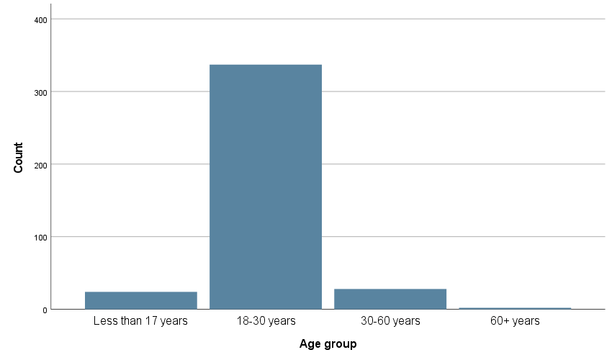

Out of a total sample of 391, 24 (6.1%) respondents are of below 17 years,337(86.2%) are of 18-30 years,28(7.2%) are of 30-60 years and 2(0.5%) are of more than 60 years. Hence it is clear that most of the respondents are of 18-30 years.

GENDER WISE CLASSIFICATION

|  |  |  |
| --- | --- | --- |
| Gender | Frequency | Percentage |
| Male | 150 | 38.4 |
| Female | 241 | 61.6 |
| Total | 391 | 100.0 |

Out of a total sample of 391, 241 (61.6%) respondents are female and 150 (38.4%) are male. Hence it is clear that most of the respondents are female.