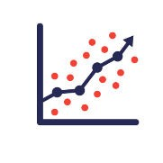

**Azure ML Classic Studio**

**Predicting Automobile prices using Regression Model in Azure ML Classic Studio.**

**This model (Pipeline) trains a linear regressor to predict a car's price based on technical features such as make, model, horsepower, and size. Because you're trying to answer the question "How much?" this is called a regression problem. However, you can apply the same fundamental steps in this example to tackle any type of machine learning problem whether it be regression, classification, clustering, and so on.**

**Gallery Link:**

Automobile Price prediction [20K45A0215]

Automobile price prediction using pre-available dataset and training the model using Linear Regression. Tags: Linear Regression, Automobile, Azure ML, Microsoft



https://gallery.cortanaintelligence.com/Experiment/Automobile-Price-prediction-20K45A0215

**navigate to the link to see the Workflow and you can download the project as well.**

# Machine Learning Project Workflow

1. **Import Data**
2. **Explore Data (Missing values, outliers)**
3. **Preprocess data (Missing value imputation, outlier treatment, normalization)**
4. **Model Selection**
5. **Model Training**
6. **Model Testing**
7. **Model Deployment**

## Workflow

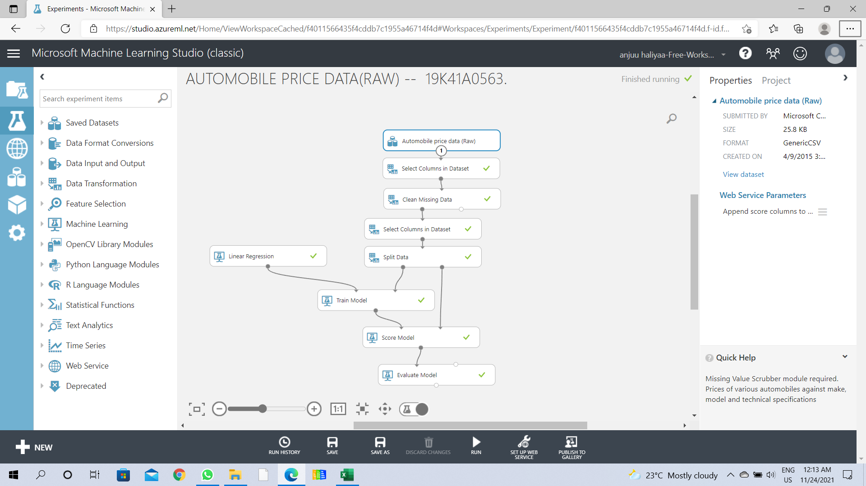

**Project Workflow**

**Import Data:**

importing the RAW dataset which is in CSV format.

the dataset is pre-available in the Azure ML Classic Studio

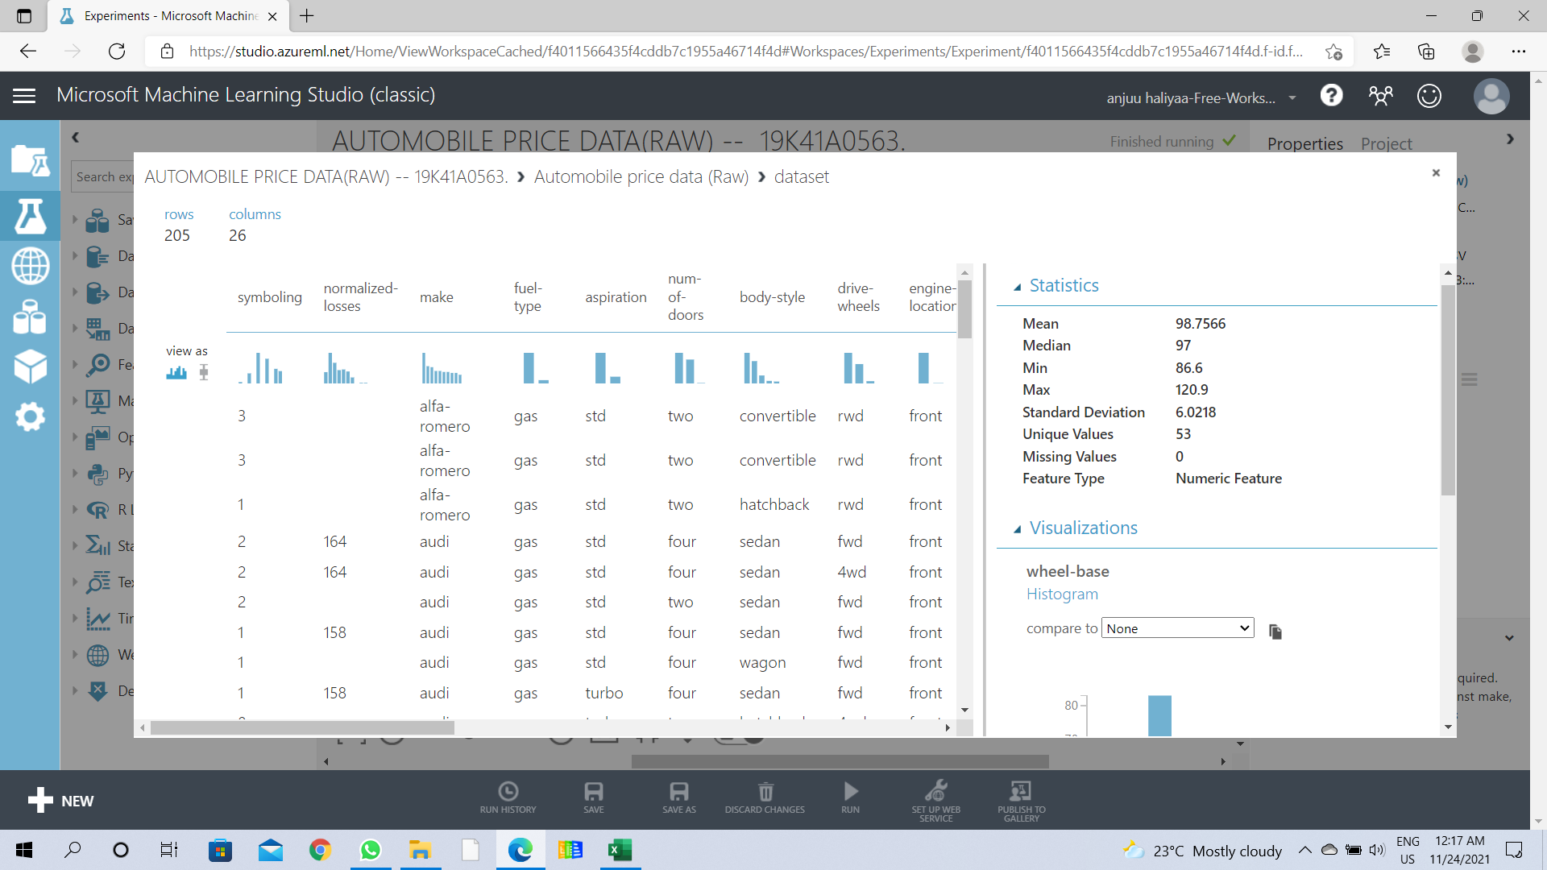

## Explore Data

this basically includes data visualization to search for any missing values in the Dataset.

if any missing values are found, then they needs to be cleaned.

selecting the required columns and clean the data using the Clean Missing Value module (Just Drag n' Drop )

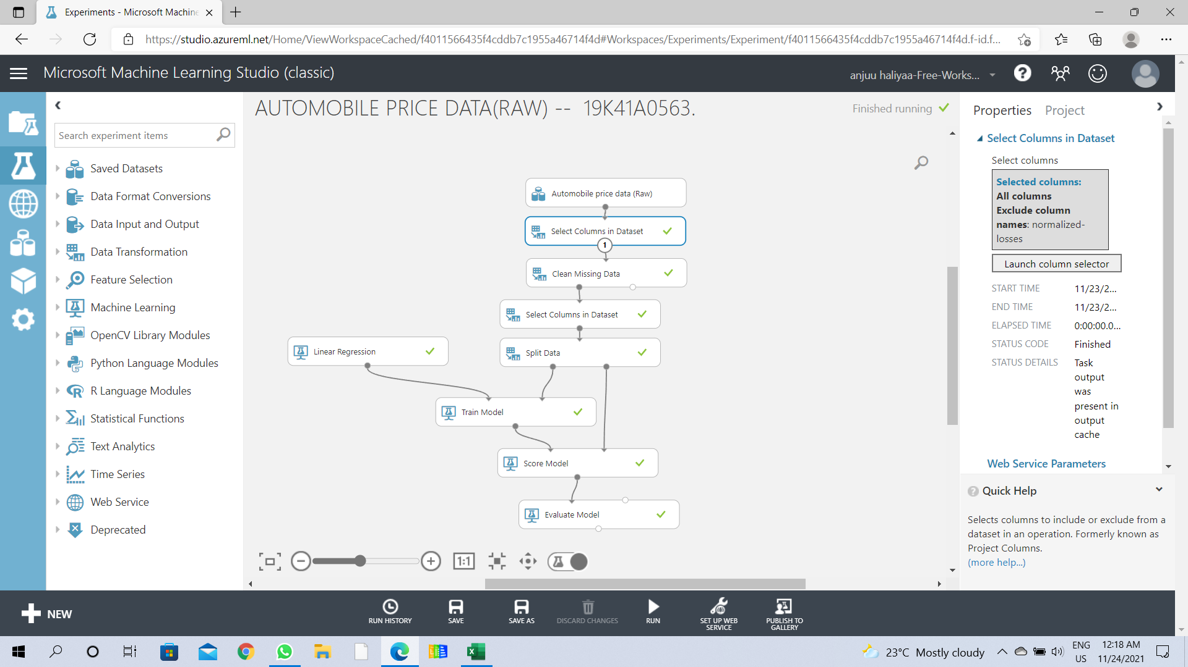

**as the normalized loss has 41 missing values in the Dataset, those missing values are to be cleaned.**

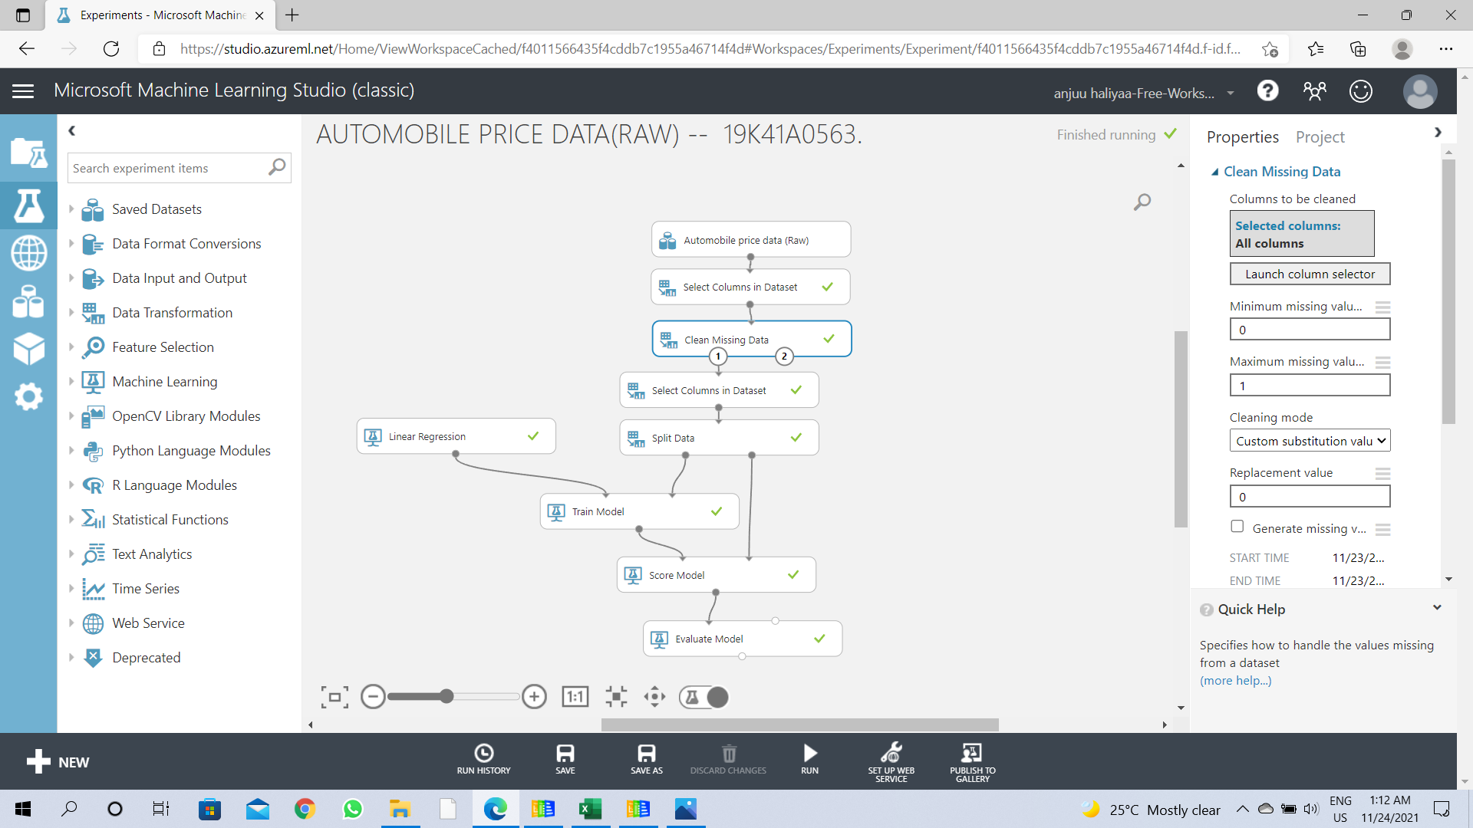

**Data Cleaning**

## Split Data

Use the Split Data module to randomly divide the input data so that the training dataset contains 70% of the original data and the testing dataset contains 30% of the original data.

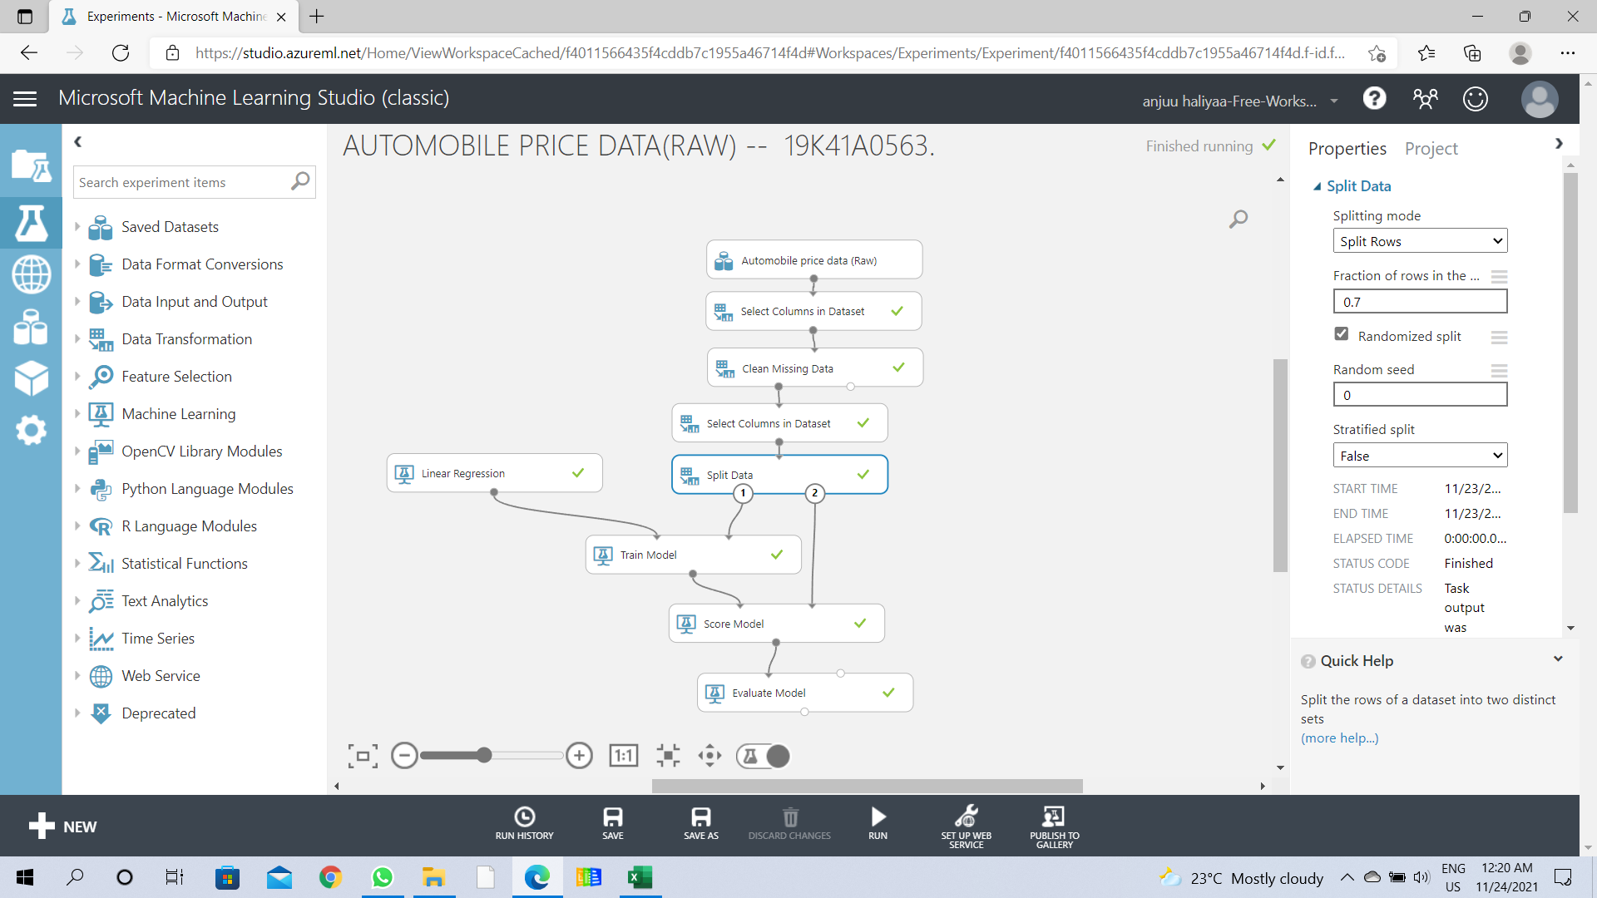

**Data Splitting**

## Model Training and Algorithm

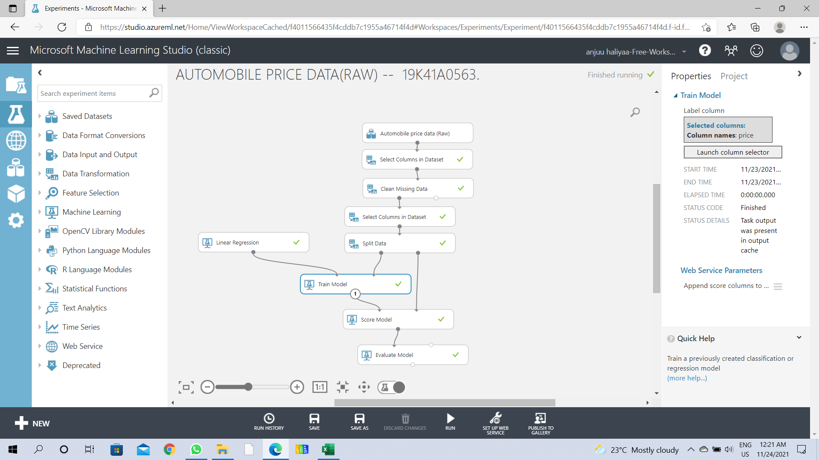

**Model Training**

### using Linear regression to train the model

Since the goal of this sample is to predict automobile prices, and because the label column (price) is continuous data, a regression model can be a good choice. We use Linear Regression for this pipeline.

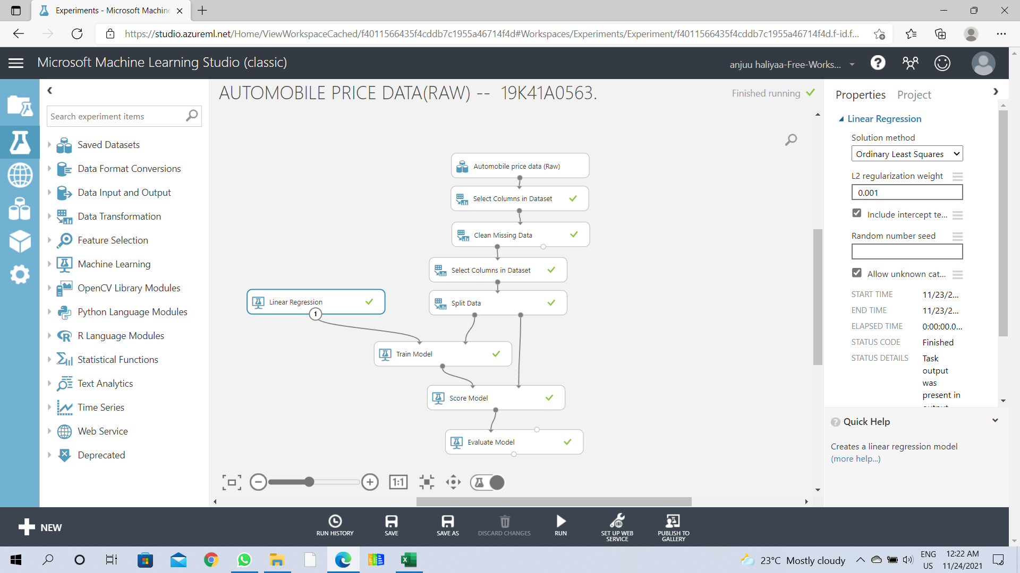

**Linear Regression**

## Score Model and Evaluate Model

After the model is trained, we can use the Score Model and Evaluate Model modules to generate predicted results and evaluate the models.

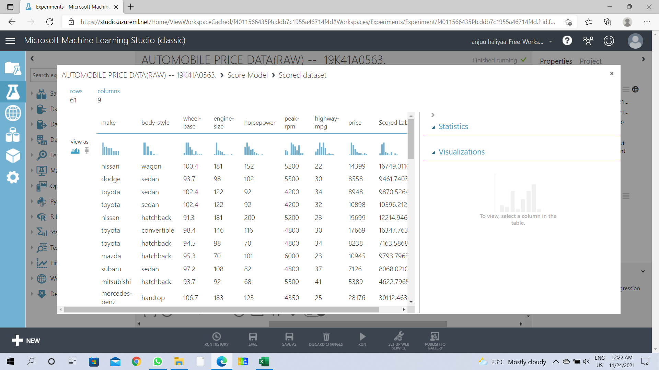

**Score Labels**

### Evaluation Results

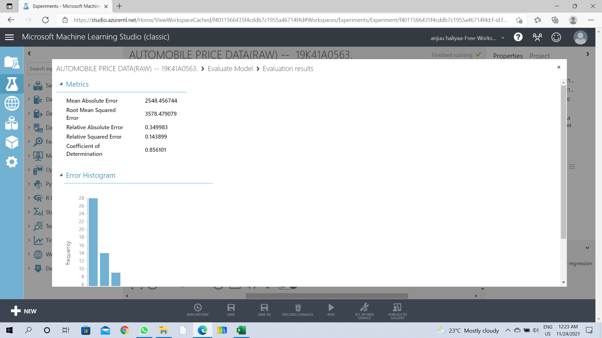

**Model Evaluation Results**