**SBA1**

**Name: Anju K**

**UID : 211473**

1. Create an array of 10 elements and print them using the for each loop.

**package** SBA1;

**public** **class** Question1 {

**public** **static** **void** main(String[] args) {

// **TODO** Auto-generated method stub

**int**[]numbers= {1,2,3,4,5,6,7,8,9,10};

**for**(**int** number:numbers)

{

System.***out***.println(number);

}

}

}

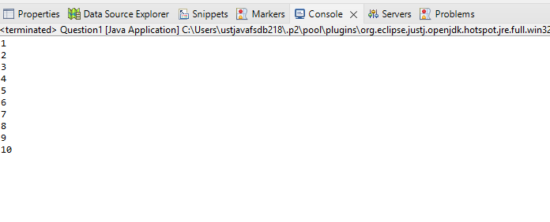

2.Take the number input from the console and add all the positive numbers.(not consider negative numers if entered)

**package** SBA1;

**import** java.util.*;

**public** **class** Question2 {

**public** **static** **void** main(String[] args)

{

System.***out***.println("Enter the Number of elements :");

Scanner sc =**new** Scanner(System.***in***);

**int** num;

num=sc.nextInt();

**int**[] a= **new** **int**[num];

System.***out***.println("Enter the elements :");

**for** (**int** i = 0; i < num; i++)

{

a[i]=sc.nextInt();

}

**int** sum=0;

**for** (**int** i = 0; i < num; i++)

{

**if**(a[i] >=0)

sum=sum+a[i];

}

System.***out***.println("The sum of positive numbers are " +sum);

}

}

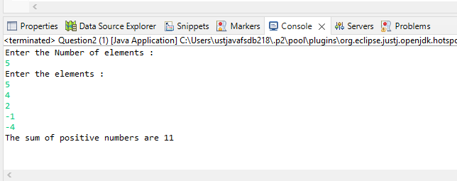

3.Create a labeled break and write a simple logic and execute the program.

**package** SBA1;

**public** **class** Question3 {

**public** **static** **void** main(String[] args)

{

**int** i=5;

loop1:

**while**(i<15)

{

**if**(i==10)

**break** loop1;

System.***out***.println("i ="+i);

i++;

}

System.***out***.println("Out of the loop");

}

}

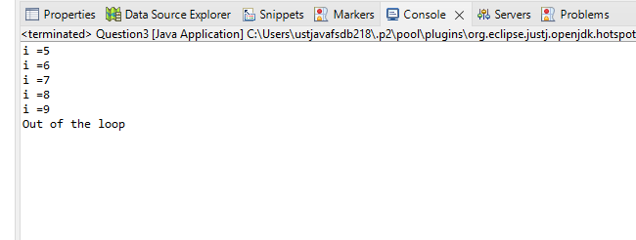

4. Do the addition of around 10 even numbers, but use the continue statement in the logic.

**package** SBA1;

**import** java.util.*;

**public** **class** Question4 {

**public** **static** **void** main(String[] args) {

// **TODO** Auto-generated method stub

**int** number, sum=0;

Scanner input=**new** Scanner (System.***in***);

**for**(**int** i=1;i<11;++i)

{ System.***out***.println("Enter a number" + i +":");

number=input.nextInt();

**if**(number<=0)

{**continue**;

}

sum+=number;

}

System.***out***.println("Sum=" +sum);

input.close();

}

}

