SBA10

Name: Anju K

UID: 211473

1. Write a Binary search program to search the elements of the integer Array.

public class BinarySearch {

static int binarySearch(int a[], int beg, int end, int val)

{

int mid;

if(end >= beg)

{

mid = (beg + end)/2;

if(a[mid] == val)

{

return mid+1; /\* if the item to be searched is present at middle

\*/

}

/\* if the item to be searched is smaller than middle, then it can only

be in left subarray \*/

else if(a[mid] < val)

{

return binarySearch(a, mid+1, end, val);

}

/\* if the item to be searched is greater than middle, then it can only be

in right subarray \*/

else

{

return binarySearch(a, beg, mid-1, val);

}

}

return -1;

}

public static void main(String[] args) {

// TODO Auto-generated method stub

int a[] = {8, 10, 22, 27, 37, 44, 49, 55, 69}; // given array

int val = 37; // value to be searched

int n = a.length; // size of array

int res = binarySearch(a, 0, n-1, val); // Store result

System.out.print("The elements of the array are: ");

for (int i = 0; i < n; i++)

{

System.out.print(a[i] + " ");

}

System.out.println();

System.out.println("Element to be searched is: " + val);

if (res == -1)

System.out.println("Element is not present in the array");

else

System.out.println("Element is present at " + res + " position of array");

}

}

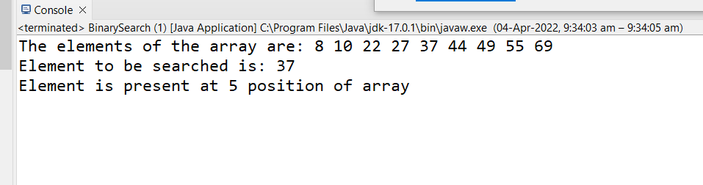

2. Create a login page using the Bootstrap and also include the Typescript and ES6 features like Loops, If-else conditions.

