**SBA2**

Name:Anju K

UID:211473

**1.Write a program to reverse the string(use char[] or string built in method)**

**package** SBA2;

**import** java.util.*;

**public** **class** Question1 {

**public** **static** **void** main(String[] args)

{ **int** i,j;

Scanner sc = **new** Scanner(System.***in***);

System.***out***.println("Enter the String");

String s1 = sc.next();

**char**[] arr = s1.toCharArray();

**char**[] arr2 = **new** **char**[arr.length];

j=arr.length-1;

**for**(i=0;i<arr.length;i++)

{

arr2[i]=arr[j];

j--;

}

System.***out***.println("The elements in Reversed string array are: ");

**for**(i=0;i<arr2.length;i++)

{

System.***out***.print(arr2[i]+" ");

} System.***out***.println();

StringBuilder s = **new** StringBuilder();

**for** (i = 0; i < arr2.length; i++)

{

s.append(arr2[i]);

}

String reversed = s.toString();

System.***out***.println("The reversed array in string format is "+reversed);

}

}

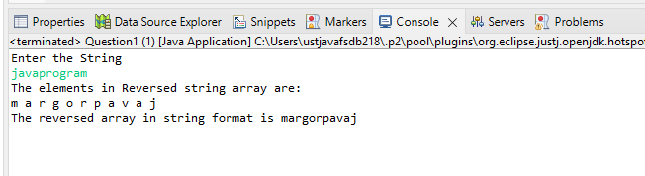

2.Write a program to depict the usage of contains(), length(), replace(), concat(), equals()

**package** SBA2;

**public** **class** Question2 {

**public** **static** **void** main(String[] args) {

//concat

String s="java";

s=s.concat(" Program");

System.***out***.println(s);

System.***out***.println(" ");

//equals

String s1="abc";

String s2="abc";

String s3=**new** String("pqr");

String s4="xyz";

System.***out***.println(s1.equals(s2));

System.***out***.println(s1.equals(s3));

System.***out***.println(s1.equals(s4));

System.***out***.println(" ");

//contains

String str = "hello world";

String str1 = "hello";

String str2 = "java";

System.***out***.println("hello is contains in the hello world so it is " + str.contains(str1));

System.***out***.println("java is not in the hello world so it is " + str.contains(str2));

System.***out***.println(" ");

//replace

String str5 = "abcd";

String replace = str5.replace('b', 'x');

System.***out***.println(str5);

System.***out***.println("Replaced by "+ replace);

System.***out***.println(" ");

//Length

String s11="Good";

String s22="Morning";

System.***out***.println("string length is: "+s11.length());

System.***out***.println("string length is: "+s22.length());

}

}

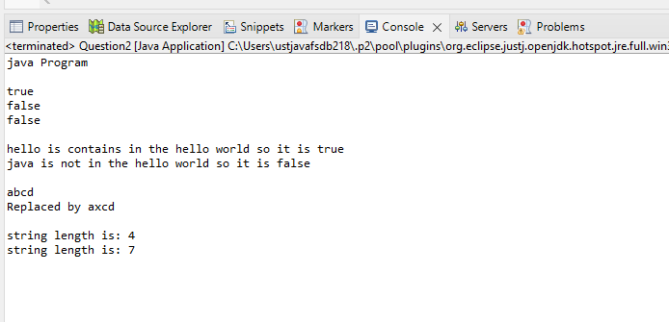

3.write a customized Exception class for a Banking project.

**package** SBA2;

**public** **class** Quesion3 {

**public** **static** **void** main(String[] args)

{ **try**

{ **int** initial=200;

**int** balance=0;

System.***out***.println(" "+(initial/balance));

}

**catch**(ArithmeticException e)

{ System.***out***.println("Arithmetic Exception:balance is zero");

}

**finally**

{ System.***out***.println("Try again later");

}

}

}

