SBA8

Name: Anju K

UID : 211473

1. program to take input of two integer arrays from the user and to find the sum of both the arrays.

Sort the elements of the resultant array in ascending order using selection sort.

**package** training_java_datastructure;

**import** java.util.*;

**public** **class** SelectionSortSumAscending {

**void** sort(**int** arr3[]) {

**int** n = arr3.length;

**for** (**int** i = 0; i < n-1; i++)

{

**int** min = i;

**for** (**int** j = i+1; j < n; j++)

{

**if** (arr3[j] < arr3[min])

min = j;

}

**int** temp = arr3[min];

arr3[min] = arr3[i];

arr3[i] = temp;

}

}

**void** printArray(**int** arr[])

{

**int** n = arr.length;

**for** (**int** i=0; i<n; ++i)

System.***out***.print(arr[i]+" ");

System.***out***.println();

}

**public** **static** **void** main(String[] args) {

// **TODO** Auto-generated method stub

**int** n,i,sum=0;

System.***out***.println("Enter the size of the array");

Scanner sc = **new** Scanner(System.***in***);

n = sc.nextInt();

**int**[] arr1 = **new** **int**[n];

**int**[] arr2 = **new** **int**[n];

**int**[] arr3 = **new** **int**[n];

System.***out***.println("Enter the elements of the array-1");

**for**(i=0;i<n;i++)

{

arr1[i]= sc.nextInt();

}

System.***out***.println("Enter the elemtns of the array-2");

**for**(i=0;i<n;i++)

{

arr2[i]= sc.nextInt();

}

**for**(i=0;i<n;i++)

{

arr3[i]= arr1[i]+arr2[i];

}

System.***out***.println("The sum of elements of the array is:");

**for**(i=0;i<n;i++)

{

System.***out***.print(arr3[i]+",");

}

System.***out***.println(" ");

SelectionSorting ob = **new** SelectionSorting();

ob.sort(arr3);

System.***out***.println("Sorted array");

ob.printArray(arr3);

}

}

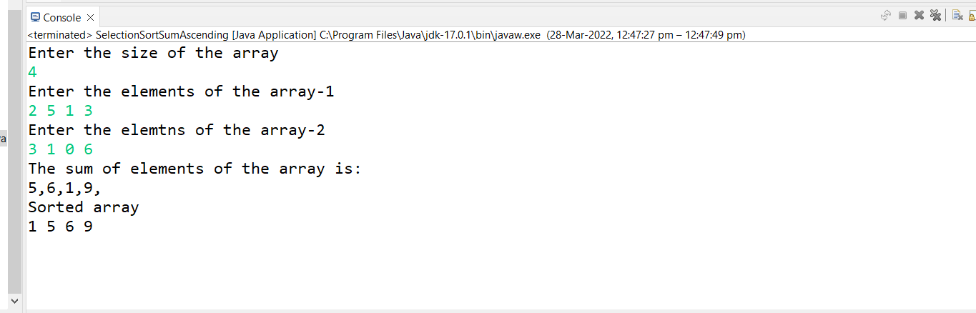

2.program to take input of Two arrays and store the similar elements into the resultant array.

sort the resultant array in ascending order using bubble sort.

NOTE: there must at least be 6 similar elements.

similar elements= the elements occurring in both the arrays.

**package** training_java_datastructure;

**import** java.util.ArrayList;

**import** java.util.Arrays;

**import** java.util.Scanner;

**public** **class** ArrayTwoSort {

**public** **static** **void** main(String[] args) {

// **TODO** Auto-generated method stub

Scanner sc = **new** Scanner(System.***in***);

System.***out***.println("Enter the array size");

**int** size = sc.nextInt();

**int**[] arr1 = **new** **int**[size];

**int**[] arr2 = **new** **int**[size];

ArrayList<Integer> arr3 = **new** ArrayList<Integer>();

System.***out***.println("Enter the elements for array 1: ");

**for**(**int** i=0;i<size;i++)

{

arr1[i] = sc.nextInt();

}

System.***out***.println("Enter the elements for array 2: ");

**for**(**int** i=0;i<size;i++)

{

arr2[i] = sc.nextInt();

}

**for**(**int** i=0;i<size;i++)

{

**for**(**int** j=0;j<size;j++)

{

**if**(arr1[i]==arr2[j])

{

arr3.add(arr1[i]);

**break**;

}

}

}

**int** len = arr3.size();

Integer[] res = **new** Integer[len];

res = arr3.toArray(res);

System.***out***.println();

System.***out***.println("The resultant array before sorting : ");

System.***out***.println(Arrays.*toString*(res));

**for**(**int** i=0;i<len-1;i++)

{

**for**(**int** j=0;j<len-i-1;j++)

{

**if**(res[j] > res[j+1])

{

**int** temp = res[j];

res[j] = res[j+1];

res[j+1] = temp;

}

}

}

System.***out***.println();

System.***out***.println("After sorting: ");

System.***out***.println(Arrays.*toString*(res));

sc.close();

}

}

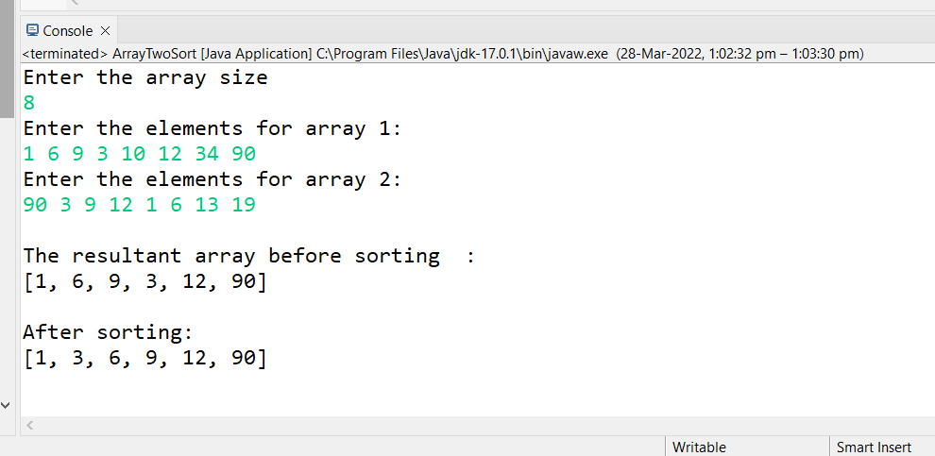

3.program to take input two arrays and store the dissimilar elements into a resultant array.

sort the resultant array in a descending order using bubble sort.

dissimilar elements= the elements not occurring in both the arrays.(unique elements)

**package** training_java_datastructure;

**import** java.util.*;

**import** java.util.Arrays;

**public** **class** DissimilarSort {

**public** **static** **void** main(String[] args)

{

System.***out***.println("Enter the array size:");

Scanner sc=**new** Scanner(System.***in***);

**int** size=sc.nextInt();

System.***out***.println("Enter the array 1 elements:");

**int**[] arr1=**new** **int**[size];

**for**(**int** i=0;i<size;i++)

{

arr1[i]=sc.nextInt();

}

System.***out***.println("Enter the array 2 elements:");

**int**[] arr2=**new** **int**[size];

**for**(**int** i=0;i<size;i++)

{

arr2[i]=sc.nextInt();

}

System.***out***.println("Disimilar elements :");

ArrayList<Integer> arr3=**new** ArrayList<Integer>();

**int** flag=0;

**for**(**int** i=0;i<size;i++)

{

**for**(**int** j=0;j<size;j++)

{

**if**(arr1[i]==arr2[j])

flag=1;

}

**if**(flag==0)

{

arr3.add(arr1[i]);

}

flag=0;

}

**for**(**int** i=0;i<size;i++)

{

**for**(**int** j=0;j<size;j++)

{

**if**(arr2[i]==arr1[j])

flag=1;

}

**if**(flag==0)

{

arr3.add(arr2[i]);

}

flag=0;

}

System.***out***.println(arr3);

**int** len=arr3.size();

Integer[] arr4=**new** Integer[len];

arr4=arr3.toArray(arr4);

**for**(**int** i=0;i<len;i++)

{

**for**(**int** j=0;j<len-1-i;j++)

{

**if**(arr4[j+1]>arr4[j])

{

**int** temp=arr4[j+1];

arr4[j+1]=arr4[j];

arr4[j]=temp;

}

}

}

System.***out***.println("after bubble sort is:");

**for**(**int** i=0;i<len;i++)

{

System.***out***.println(arr4[i]);

}

}

}

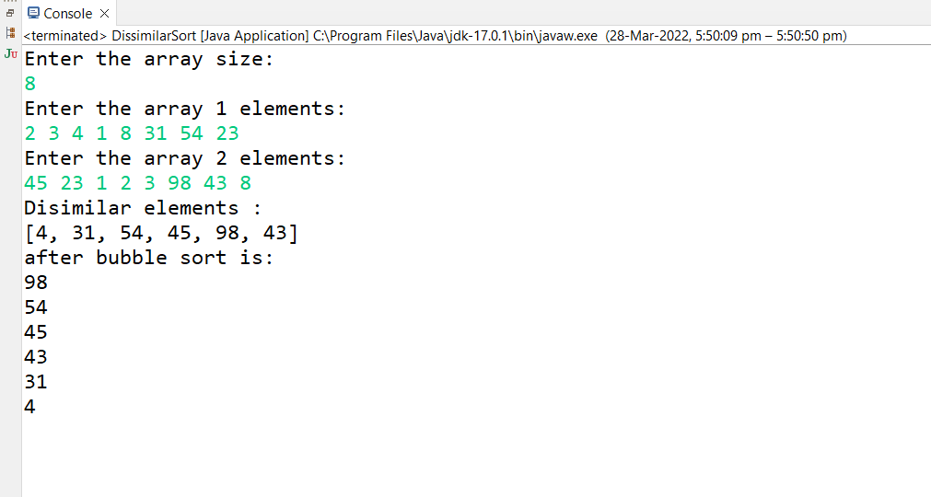

4. Implement Array List and add, remove, elements in the Array List and perform sorting of the elements using the iterator.

**package** training_java_datastructure;

**import** java.util.ArrayList;

**import** java.util.Collections;

**public** **class** Arraylist {

**public** **static** **void** main(String[] args)

{

ArrayList<String>list=**new** ArrayList<String>();

list.add("Volkswagen");

list.add("Toyota");

list.add("Audi");

list.add("Mercedez");

list.add("BMW");

list.add("Hyundai");

System.***out***.println("The elements in ArrayLists are: "+list);

list.remove(5);

System.***out***.println("The contents of list after removing the element at 5th position is: "+list);

Collections.*sort*(list);

System.***out***.println("After sorting the list: "+list);

}

}

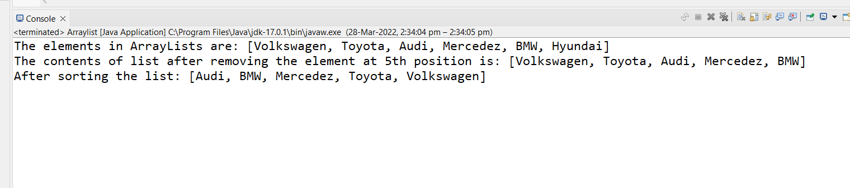

5. Implement LinkedList and add, remove, elements in the LinkedList and perform sorting of the elements using the iterator.

**package** training_java;

**import** java.util.LinkedList;

**import** java.util.ListIterator;

**public** **class** LinkedListEx {

**public** **static** **void** main(String[] args)

{

LinkedList<String>list=**new** LinkedList<String>();

list.add("Red");

list.add("Italy");

list.add("Blue");

list.add("London");

list.add("Paris");

System.***out***.println("Linkedlist: "+list);

ListIterator list_iter=list.listIterator(2);

System.***out***.println("The list is as follows: ");

**while**(list_iter.hasNext()) {

System.***out***.println(list_iter.next());

}

}

}

