SBA-3

**Name: Anju K**

**UID : (211473)**

1.Create Database project_movie_data and deploy table data according to ER diagram.

create database project_movie_data;

use project_movie_data;



2.Create 9 tables which are presented in ER model and load the data with their foreign key and primary key values.

**Table: Actor**

create table Actor

(act_id int not null,act_fname varchar(20),

act_lname varchar(20),

act_gender varchar(1),

primary key(act_id));

insert into Actor values

(101,'James','Stewart','M'),

(102,'Deborah','Kerr','F'),

(103,'Peter','OToole','M'),

(104,'Robert','De Niro','M'),

(105,'F. Murray','Abraham','M'),

(106,'Harrison','Ford','M'),

(107,'Nicole','Kidman','F'),

(108,'Stephen','Baldwin','M'),

(109,'Jack','Nicholson','M'),

(110,'Mark','Wahlberg','M'),

(111,'Woody','Allen','M'),

(112,'Claire','Danes','F'),

(113,'Tim','Robbins','M'),

(114,'Kevin','Spacey','M'),

(115,'Kate','Winslet','F'),

(116,'Robin','Williams','M'),

(117,'Jon','Voight','M'),

(118,'Ewan','McGregor','M'),

(119,'Christian','Bale','M'),

(120,'Maggie','Gyllenhaal','F'),

(121,'Dev','Patel','M'),

(122,'Sigourney','Weaver','F'),

(123,'David','Aston','M'),

(124,'Ali','Astin','F');

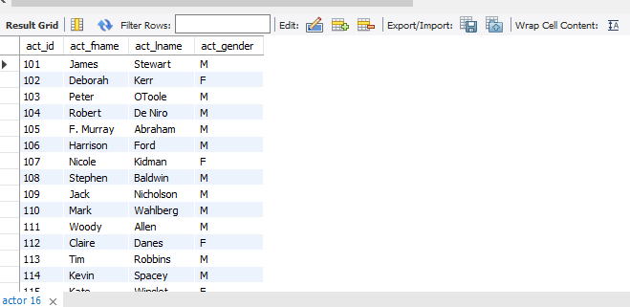

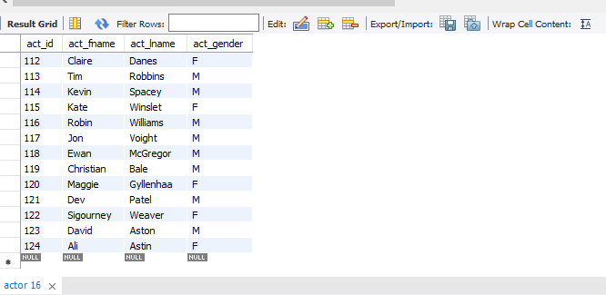

**Table:Director**

create table Director

(dir_id int not null,dir_fname varchar(20),

dir_lname varchar(20),

primary key(dir_id));

insert into Director values

(201,'Alfred','Hitchcock'),

(202,'Jack','Clayton'),

(203,'David','Lean'),

(204,'Michael','Cimino'),

(205,'Milos','Forman'),

(206,'Ridley','Scott'),

(207,'Stanley','Kubrick'),

(208,'Bryan','Singer'),

(209,'Roman','Polanski'),

(210,'Paul','Thomas Anderson'),

(211,'Woody','Allen'),

(212,'Hayao','Miyazaki'),

(213,'Frank','Darabont'),

(214,'Sam','Mendes'),

(215,'James','Cameron'),

(216,'Gus','Van Sant'),

(217,'Jon','Boorman'),

(218,'Danny','Boyle'),

(219,'Christopher','Nolan'),

**(**220,'Richard','Kelly'),

(221,'Kevin','Spacey'),

(222,'Andrei','Tarkovsky'),

(223,'Peter','Jackson');

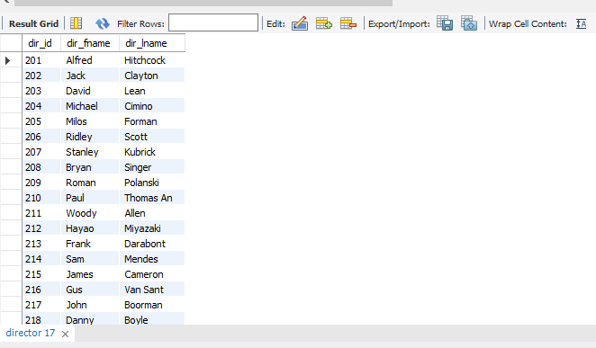

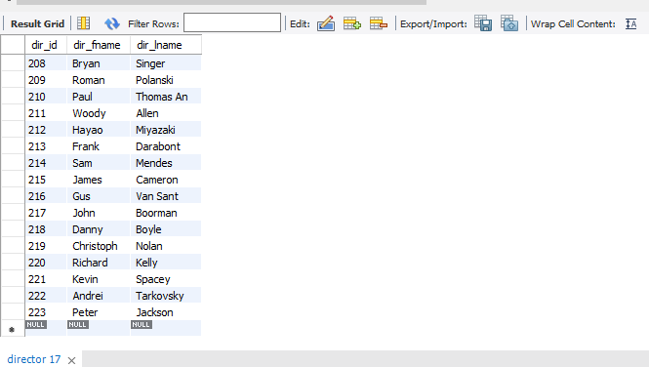

**Table:Genres**

create table Genres

(gen_id int not null,

gen_title varchar(20),

primary key(gen_id));

insert into genres values

(1001,'Action'),

(1002,'Adventure'),

(1003,'Animation'),

(1004,'Biography'),

(1005,'Comedy'),

(1006,'Crime'),

(1007,'Drama'),

(1008,'Horror'),

(1009,'Music'),

(1010,'Mystery'),

(1011,'Romance'),

(1012,'Thriller'),

(1013,'War');

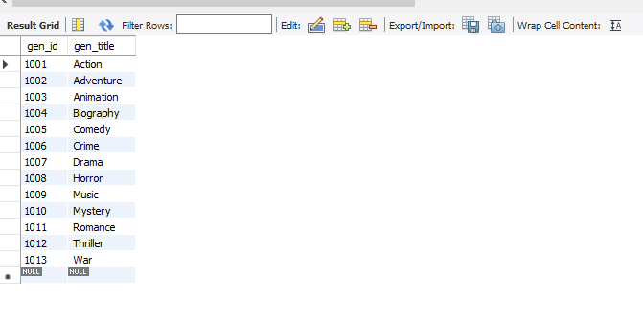

**Table:movie**

create table Movie

(mov_id int not null,

mov_title varchar(50),

mov_year int not null,

mov_time int not null,

mov_lang varchar(50),

mov_dt_rel date,

mov_rel_country varchar(5),

primary key(mov_id));

insert into Movie values

(901,'Vertigo',1958,128,'English','1958-08-24','UK'),

(902,'The Innocents',1961,100,'English','1962-02-19','SW'),

(903,'Lawrence of Arabia',1962,216,'English','1962-12-11','UK'),

(904,'The Deer Hunter',1978,183,'English','1979-03-08','UK'),

(905,'Amadeus',1984,160,'English','1985-01-07','UK'),

(906,'Blade Runner',1982,117,'English','1982-09-09','UK'),

(907,'Eyes Wide Shut',1999,159,'English',null,'UK'),

(908,'The Usual suspects',1995,106,'English','1995-08-25','UK'),

(909,'Chinatown',1974,130,'English','1974-08-09','UK'),

(910,'Boogie Nights',1997,155,'English','1998-02-16','UK'),

(911,'Annie Hall',1977,93,'English','1977-04-20','USA'),

(912,'Princess Mononoke',1997,134,'Japanese','2001-10-19','UK'),

(913,'The shawshank Redemption',1994,142,'English','1995-02-17','UK'),

(914,'American Beauty',1999,122,'English',null,'UK'),

(915,'Titanic',1997,194,'English','1998-01-23','UK'),

(916,'Good Will Hunting',1997,126,'English','1998-06-03','UK'),

(917,'Deliverance',1972,109,'English','1982-10-05','UK'),

(918,'Trainspotting',1996,94,'English','1996-02-23','UK'),

(919,'The prestige',2006,130,'English','2006-11-10','UK'),

(920,'Donnie Darko',2001,113,'English',null,'UK'),

(921,'Slumdog Millionaire',2008,120,'English','2009-01-09','UK'),

(922,'Aliens',1986,137,'English','1986-08-29','UK'),

(923,'Beyond the Sea',2004,118,'English','2004-11-26','UK'),

(924,'Avatar',2009,162,'English','2009-12-17','UK'),

(926,'Seven Samurai',1954,207,'Japanese','1954-04-26','JP'),

(927,'Spirited Away',2001,125,'English','2003-09-12','UK'),

(928,'Back to the Future',1985,116,'English','1985-12-04','UK'),

(925,'Braveheart',1995,178,'English','1995-09-08','UK');

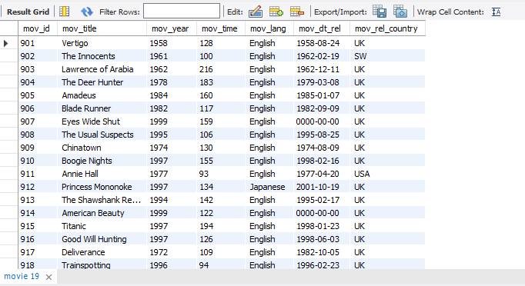

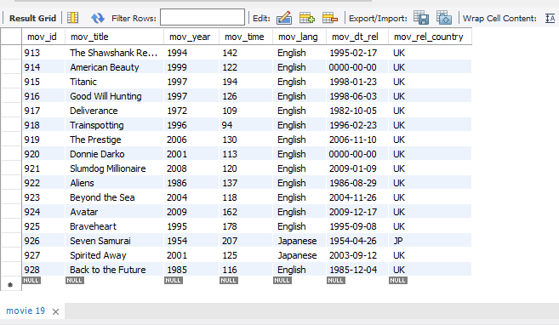

**Table:movie_cast**

create table Movie_cast

(act_id int not null,

mov_id int not null,

role varchar(30),

foreign key(mov_id)references movie(mov_id),

foreign key(act_id)references actor(act_id));

insert into Movie_cast values

(101,901,'John Scottie Ferguson'),

(102,902,'Miss Giddens'),

(103,903,'T.E. Lawrence'),

(104,904,'Michael'),

(105,905,'Antonio Salieri'),

(106,906,'Rick Deckard'),

(107,907,'Alice Harford'),

(108,908,'McManus'),

(110,910,'Eddie Adams'),

(111,911,'Alvy Singer'),

(112,912,'San'),

(113,913,'Andy Dufresne'),

(114,914,'Andy Dufresne'),

(115,915,'Rose DeWitt Bukater'),

(116,916,'Sean Maguire'),

(117,917,'Ed'),

(118,918,'Renton'),

(120,920,'Elizabeth Darko'),

(121,921,'Older Jamal'),

(122,922,'Ripley'),

(114,923,'Bobby Darin'),

(109,909,'J.J. Gittes'),

(119,919,'Alfred Borden');

(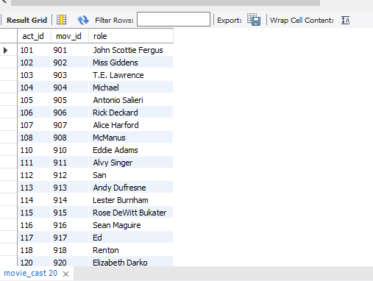

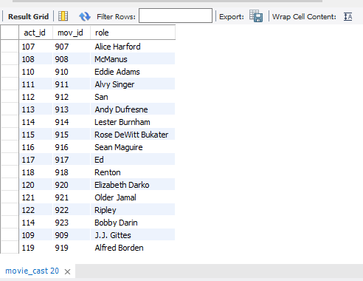

**Table movie_direction**

create table Movie_direction

(dir_id int not null,mov_id int not null,

foreign key(dir_id)references director(dir_id),

foreign key(mov_id)references movie(mov_id));

insert into Movie_direction values

(201,901),

(202,902),

(203,903),

(204,904),

(205,905),

(206,906),

(207,907),

(208,908),

(209,909),

(210,910),

(211,911),

(212,912),

(213,913),

(214,914),

(215,915),

(216,916),

(217,917),

(218,918),

(219,919),

(220,920),

(218,921),

(215,922),

(221,923);

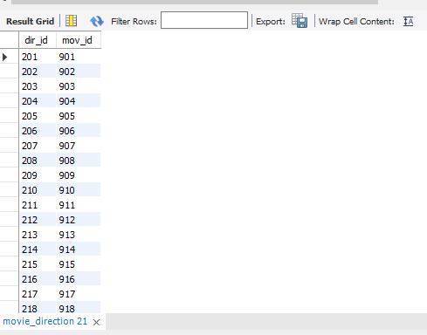

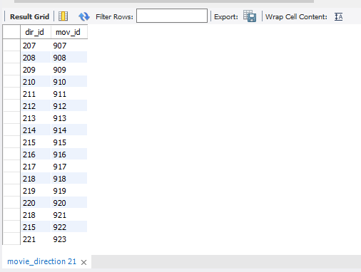

**Table:movie_genres**

create table Movie_genres

(mov_id int not null,

gen_id int not null,

foreign key(mov_id)references movie(mov_id),

foreign key(gen_id)references genres(gen_id));

insert into Movie_genres values

(922,1001),

(917,1002),

(903,1002),

(912,1003),

(911,1005),

(908,1006),

(913,1006),

(926,1007),

(928,1007),

(918,1007),

(921,1007),

(902,1008),

(923,1009),

(907,1010),

(927,1010),

(901,1010),

(914,1011),

(906,1012),

(904,1013);

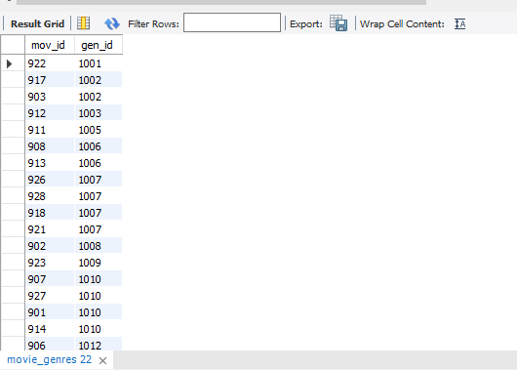

**Table:rating**

create table Rating

(mov_id int not null,

rev_id int not null,

rev_stars int,

num_o_ratings int,

foreign key(mov_id)references movie(mov_id),

primary key(rev_id));

insert into Rating values

(901,9001,8.4,263575),

(902,9002,7.9,20207),

(903,9003,8.3,202778),

(906,9005,8.2,484746),

(924,9006,7.3,null),

(908,9007,8.6,779489),

(909,9008,null,227235),

(910,9009,3,195961),

(911,9010,8.1,203875),

(912,9011,8.4,null),

(914,9013,7,862618),

(915,9004,7.7,830095),

(916,9014,4,642132),

(925,9015,7.7,81328),

(918,9016,null,580301),

(920,9017,8.1,609451),

(921,9018,8,667758),

(922,9019,8.4,511613),

(923,9020,6.7,13091);

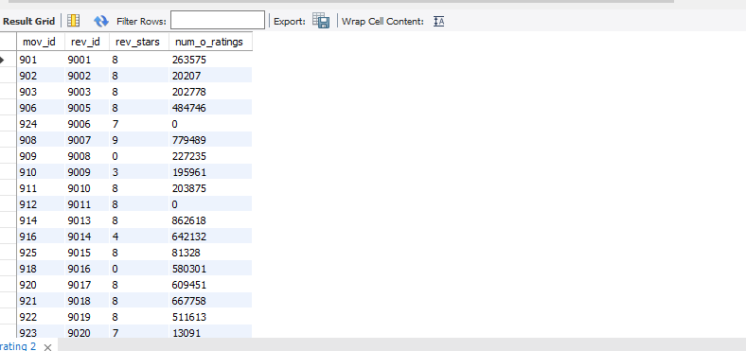

**Table:reviewer**

create table Reviewer

(rev_id int not null,

rev_name varchar(30),

primary key(rev_id));

insert into Reviewer values

(9001,'Right Sock'),

(9002,'Jack Malvern'),

(9003,'Flagrant Baronessa'),

(9004,'Alec Shaw'),

(9005,null),

(9006,'Victor Woeltjen'),

(9007,'Simon Wright'),

(9008,'Neal Wruck'),

(9009,'Paul Monks'),

(9010,'Mike Salvati'),

(9011,null),

(9012,'Wesley S. Walker'),

(9013,'Sasha Goldshtein'),

(9014,'Josh Cates'),

(9015,'Krug Stillo'),

(9016,'Scott LeBrun'),

(9017,'Hannah Steele'),

(9018,'Vincent Cadena'),

(9019,'Brandt Sponseller'),

(9020,'Richard Adams');

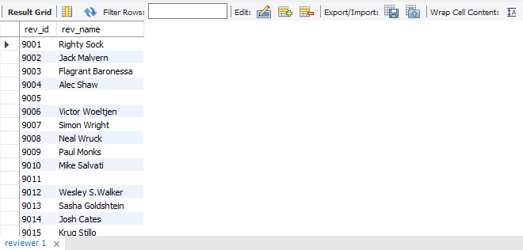

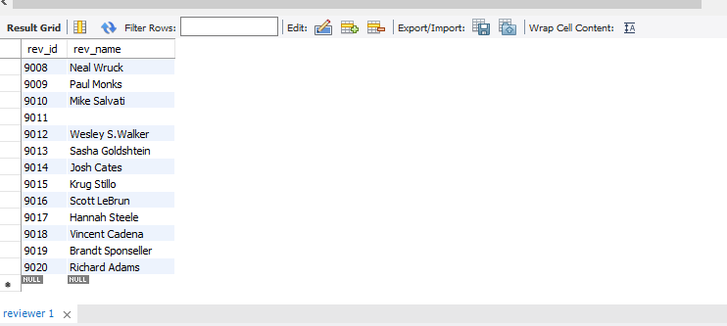

3.Write a query in SQL to list the Horror movies?

select mov_title from movie

where mov_id in (select mov_id from movie_genres

where gen_id in(select gen_id from genres where gen_title="Horror"));

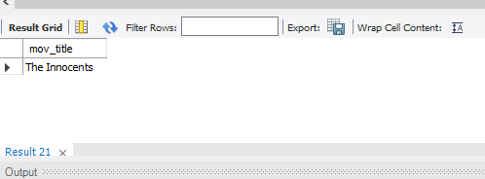

4.Write a query in SQL to find the name of all reviewers who have rated 8 or more stars?

select reviewer.rev_name

from reviewer,rating

where rating.rev_id=reviewer.rev_id

and rating.rev_stars>=8

and reviewer.rev_name is not null;



5.Write a query in SQL to list all the information of the actors who played a role in the movie ‘Deliverance’.

SELECT *

FROM actor

WHERE act_id IN(

SELECT act_id

FROM movie_cast

WHERE mov_id IN (

SELECT mov_id

FROM movie

WHERE mov_title='Deliverance'

));

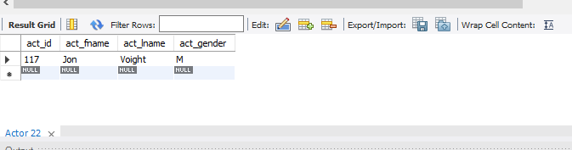

6.Write a query in SQL to find the name of the director (first and last names) who directed a movie that casted a role for ‘Eyes Wide Shut’. (using subquery)

select dir_fname,dir_lname

from director

where dir_id in(

select dir_id

from movie_direction

where mov_id in(

select mov_id

from movie_cast where role=any(

select role

from movie_cast

where mov_id in(

select mov_id

from movie

where mov_title='Eyes Wide Shut'))));

7.Write a query in SQL to find the movie title, year, date of release, director and actor for those movies which reviewer is ‘Neal Wruck’.

SELECT mov_title, mov_year, mov_dt_rel, dir_fname, dir_lname, act_fname, act_lname

FROM movie a, movie_direction b, director c, rating d, reviewer e, actor f, movie_cast g

WHERE a.mov_id=b.mov_id

AND b.dir_id=c.dir_id

AND a.mov_id=d.mov_id

AND d.rev_id=e.rev_id

AND a.mov_id=g.mov_id

AND g.act_id=f.act_id

AND e.rev_name ="Neal Wruck";

