Features Of Java

OOPS :-Object Oriented Programming System.

it a concept of programming language, but to make it easier lets compare with real world.

An entity that has state and behavior is known as an object e.g. chair, bike, marker, pen, table, car etc.For Example: Pen is an object. Its name is Cello, color is red etc. known as its state. It is used to write, so writing is its behavior. Object can be physical or logical.

* [Object](https://www.javatpoint.com/object-and-class-in-java)
* Class
* [Inheritance](https://www.javatpoint.com/inheritance-in-java)
* [Polymorphism](https://www.javatpoint.com/runtime-polymorphism-in-java)
* [Abstraction](https://www.javatpoint.com/abstract-class-in-java)
* [Encapsulation](https://www.javatpoint.com/encapsulation)
* Object
* 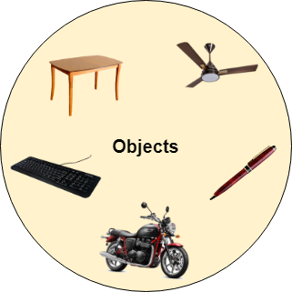
* Any entity that has state and behavior is known as an object. For example a chair, pen, table, keyboard, bike, etc. It can be physical or logical.
* An Object can be defined as an instance of a class. An object contains an address and takes up some space in memory. Objects can communicate without knowing the details of each other's data or code. The only necessary thing is the type of message accepted and the type of response returned by the objects.
* **Example:** A dog is an object because it has states like color, name, breed, etc. as well as behaviors like wagging the tail, barking, eating, etc.
* Class
* *Collection of objects* is called class. It is a logical entity.
* A class can also be defined as a blueprint from which you can create an individual object. Class doesn't consume any space.
* Inheritance
* *When one object acquires all the properties and behaviors of a parent object*, it is known as inheritance. It provides code reusability. It is used to achieve runtime polymorphism.

### Polymorphism

If one task is performed by different ways, it is known as polymorphism. For example: to convince the customer differently, to draw something, for example, shape, triangle, rectangle, etc.

In Java, we use method overloading and method overriding to achieve polymorphism.

Another example can be to speak something; for example, a cat speaks meow, dog barks woof, etc.

#### Abstraction

Hiding internal details and showing functionality is known as abstraction. For example phone call, we don't know the internal processing.

In Java, we use abstract class and interface to achieve abstraction.



### Encapsulation

Binding (or wrapping) code and data together into a single unit are known as encapsulation. For example capsule, it is wrapped with different medicines.

A java class is the example of encapsulation. Java bean is the fully encapsulated class because all the data members are private here.

1) OOPs makes development and maintenance easier whereas in a procedure-oriented programming language it is not easy to manage if code grows as project size increases.

2) OOPs provides data hiding whereas in a procedure-oriented programming language a global data can be accessed from anywhere.

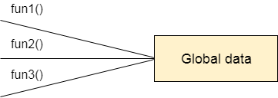

Figure: Data Representation in Procedure-Oriented Programming

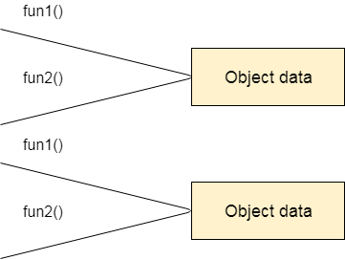

Figure: Data Representation in Object-Oriented Programming

3) OOPs provides the ability to simulate real-world event much more effectively. We can provide the solution of real word problem if we are using the Object-Oriented Programming language.

What is an object in Java

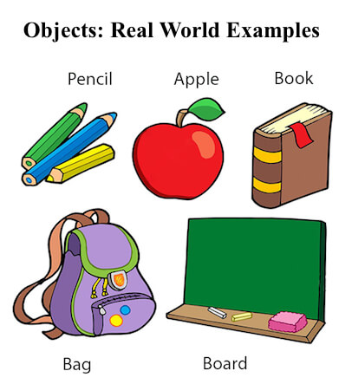

An entity that has state and behavior is known as an object e.g. chair, bike, marker, pen, table, car etc. It can be physical or logical (tangible and intangible). The example of an intangible object is the banking system.

An object has three characteristics:

* **State:**represents the data (value) of an object.
* **Behavior:** represents the behavior (functionality) of an object such as deposit, withdraw, etc.
* **Identity:** An object identity is typically implemented via a unique ID. The value of the ID is not visible to the external user. However, it is used internally by the JVM to identify each object uniquely.

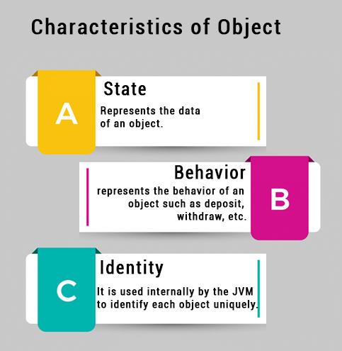

For Example, Pen is an object. Its name is Reynolds; color is white, known as its state. It is used to write, so writing is its behavior.

**An object is an instance of a class.** A class is a template or blueprint from which objects are created. So, an object is the instance(result) of a class.

**Object Definitions:**

* An object is *a real-world entity*.
* An object is *a runtime entity*.
* The object is *an entity which has state and behavior*.
* The object is *an instance of a class*.

## What is a class in Java

A class is a group of objects which have common properties. It is a template or blueprint from which objects are created. It is a logical entity. It can't be physical.

A class in Java can contain:

* **Fields**
* **Methods**
* **Constructors**
* **Blocks**
* **Nested class and interface**

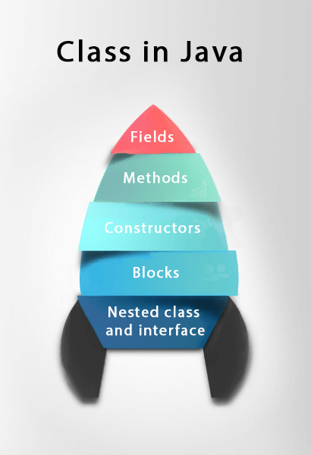

### Syntax to declare a class:

1. **class** <class_name>{
2. field;
3. method;
4. }

The General Form of a Class

● When you define a class, you declare its exact form

and nature. You do this by specifying the instance

variables that it contains and the methods that

operate on them.0020

● Although very simple classes might contain only

methods or only instance variables, most real-world

classes contain both.

● A class is created by using the keyword class. A

simplified general form of a class definition is shown

here:

● Although there is no syntactic rule that enforces it, a

well-designed class should define one and only one

logical entity.

● For example, a class that stores names and

telephone numbers will not normally also store

information about the stock market, average rainfall,

sunspot cycles, or other unrelated information.

● The point here is that well-designed class groups

logically connected information. Putting unrelated

information into the same class will quickly

destructure your code!

Defining a Class

● To illustrate classes, we will develop a class that

encapsulates information about vehicles, such as

cars, vans, and trucks.

● This class is called Vehicle, and it will store three

items of information about a vehicle: the number of

passengers that it can carry, its fuel capacity, and its

average fuel consumption (in miles per gallon).

● The first version of Vehicle is shown next. It defines

three instance variables: passengers, fuelcap, and

mpg. Notice that Vehicle does not contain any

methods. Thus, it is currently a data-only class.

(Subsequent sections will add methods to it.)

● A class definition creates a new data type. In this

case, the new data type is called Vehicle.

● You will use this name to declare objects of type

Vehicle. Remember that a class declaration is only a

type description; it does not create an actual object.

● Thus, the preceding code does not cause anyobjects

of type Vehicle to come into existence.

● To actually create a Vehicle object, you will use a

statement like the following:

Vehicle bigvan = new Vehicle(); // create a Vehicle object

called minivan

After this statement executes, minivan will be an instance

of Vehicle. Thus, it will have “physical” reality

Each time you create an instance of a class, you are

creating an object that contains its own copy of each

instance variable defined by the class. Thus, every

Vehicle object will contain its own copies of the instance

variables passengers, fuelcap, and mpg. To access these

variables, you will use the dot (.) operator. The dot

operator links the name of an object with the name of a

member. The general form of the dot operator is shown

here:

object.member

Thus, the object is specified on the left, and the member

is put on the right.

For example, to assign the fuelcap variable of minivan

the value 16, use the following statement:

minivan.fuelcap = 16;

Vehicle smallvan = new Vehicle();

smallvan.fulecap =17;

minivan.fuelcap

How Objects Are Created

In the preceding programs, the following line was used to

declare an object of type Vehicle:

Vehicle minivan = new Vehicle();

● This declaration performs two functions. First, it

declares a variable called minivan of the class type

Vehicle.

● This variable does not define an object. Instead, it is

simply a variable that can refer to an object. Second,

the declaration creates a physical copy of the object

and assigns to minivan a reference to that object.

This is done by using the new operator.

● The new operator dynamically allocates (that is,

allocates at run time) memory for an object and

returns a reference to it. This reference is, more or

less, the address in memory of the object allocated

by new.

● This reference is then stored in a variable. Thus, in

Java, all class objects must be dynamically allocated.

● The two steps combined in the preceding statement

can be rewritten like this to show each step

individually:

Vehicle minivan;

minivan = new Vehicle();

● The first line declares minivan as a reference to an

object of type Vehicle. Thus, minivan is a variable

that can refer to an object, but it is not an object

itself. At this point, minivan does not refer to an

object.

● The next line creates a new Vehicle object and

assigns a reference to it to minivan.

Now, minivan is linked with an object.

Once done

local instance variable and static variable

### Instance variable in Java

A variable which is created inside the class but outside the method is known as an instance variable. Instance variable doesn't get memory at compile time. It gets memory at runtime when an object or instance is created. That is why it is known as an instance variable.

### Method in Java

In Java, a method is like a function which is used to expose the behavior of an object.

#### Advantage of Method

* Code Reusability
* Code Optimization

### new keyword in Java

The new keyword is used to allocate memory at runtime. All objects get memory in Heap memory area.

### Object and Class Example: main within the class

In this example, we have created a Student class which has two data members id and name. We are creating the object of the Student class by new keyword and printing the object's value.

Here, we are creating a main() method inside the class.

*File: Student.java*

1. //Java Program to illustrate how to define a class and fields
2. //Defining a Student class.
3. **class** Student{
4. //defining fields
5. **int** id;//field or data member or instance variable
6. String name;
7. //creating main method inside the Student class
8. **public** **static** **void** main(String args[]){
9. //Creating an object or instance
10. Student s1=**new** Student();//creating an object of Student
11. //Printing values of the object
12. System.out.println(s1.id);//accessing member through reference variable
13. System.out.println(s1.name);
14. }
15. }

[**Test it Now**](http://www.javatpoint.com/opr/test.jsp?filename=Student)

Output:

0

null

### Object and Class Example: main outside the class

In real time development, we create classes and use it from another class. It is a better approach than previous one. Let's see a simple example, where we are having main() method in another class.

We can have multiple classes in different java files or single java file. If you define multiple classes in a single java source file, it is a good idea to save the file name with the class name which has main() method.

*File: TestStudent1.java*

1. //Java Program to demonstrate having the main method in
2. //another class
3. //Creating Student class.
4. **class** Student{
5. **int** id;
6. String name;
7. }
8. //Creating another class TestStudent1 which contains the main method
9. **class** TestStudent1{
10. **public** **static** **void** main(String args[]){
11. Student s1=**new** Student();
12. System.out.println(s1.id);
13. System.out.println(s1.name);
14. }
15. }

3 Ways to initialize object

There are 3 ways to initialize object in java.

1. By reference variable
2. By method
3. By constructor

1) Object and Class Example: Initialization through reference

Initializing an object means storing data into the object. Let's see a simple example where we are going to initialize the object through a reference variable.

*File: TestStudent2.java*

1. **class** Student{
2. **int** id;
3. String name;
4. }
5. **class** TestStudent2{
6. **public** **static** **void** main(String args[]){
7. Student s1=**new** Student();
8. s1.id=101;
9. s1.name="Sonoo";
10. System.out.println(s1.id+" "+s1.name);//printing members with a white space
11. }
12. }

[**Test it Now**](http://www.javatpoint.com/opr/test.jsp?filename=TestStudent2)

Output:

101 Sonoo

We can also create multiple objects and store information in it through reference variable.

*File: TestStudent3.java*

1. **class** Student{
2. **int** id;
3. String name;
4. }
5. **class** TestStudent3{
6. **public** **static** **void** main(String args[]){
7. //Creating objects
8. Student s1=**new** Student();
9. Student s2=**new** Student();
10. //Initializing objects
11. s1.id=101;
12. s1.name="Sonoo";
13. s2.id=102;
14. s2.name="Amit";
15. //Printing data
16. System.out.println(s1.id+" "+s1.name);
17. System.out.println(s2.id+" "+s2.name);
18. }
19. }

[**Test it Now**](http://www.javatpoint.com/opr/test.jsp?filename=TestStudent3)

Output:

101 Sonoo

102 Amit

2) Object and Class Example: Initialization through method

In this example, we are creating the two objects of Student class and initializing the value to these objects by invoking the insertRecord method. Here, we are displaying the state (data) of the objects by invoking the displayInformation() method.

*File: TestStudent4.java*

1. **class** Student{
2. **int** rollno;
3. String name;
4. **void** insertRecord(**int** r, String n){
5. rollno=r;
6. name=n;
7. }
8. **void** displayInformation(){System.out.println(rollno+" "+name);}
9. }
10. **class** TestStudent4{
11. **public** **static** **void** main(String args[]){
12. Student s1=**new** Student();
13. Student s2=**new** Student();
14. s1.insertRecord(111,"Karan");
15. s2.insertRecord(222,"Aryan");
16. s1.displayInformation();
17. s2.displayInformation();
18. }
19. }

[**Test it Now**](http://www.javatpoint.com/opr/test.jsp?filename=TestStudent4)

Output:

111 Karan

222 Aryan

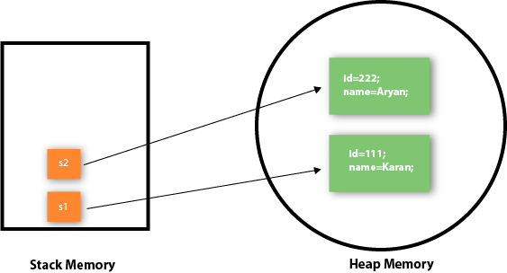

As you can see in the above figure, object gets the memory in heap memory area. The reference variable refers to the object allocated in the heap memory area. Here, s1 and s2 both are reference variables that refer to the objects allocated in memory.

3) Object and Class Example: Initialization through a constructor

We will learn about constructors in java later.

Object and Class Example: Employee

Let's see an example where we are maintaining records of employees.

*File: TestEmployee.java*

1. **class** Employee{
2. **int** id;
3. String name;
4. **float** salary;
5. **void** insert(**int** i, String n, **float** s) {
6. id=i;
7. name=n;
8. salary=s;
9. }
10. **void** display(){System.out.println(id+" "+name+" "+salary);}
11. }
12. **public** **class** TestEmployee {
13. **public** **static** **void** main(String[] args) {
14. Employee e1=**new** Employee();
15. Employee e2=**new** Employee();
16. Employee e3=**new** Employee();
17. e1.insert(101,"ajeet",45000);
18. e2.insert(102,"irfan",25000);
19. e3.insert(103,"nakul",55000);
20. e1.display();
21. e2.display();
22. e3.display();
23. }
24. }

[**Test it Now**](http://www.javatpoint.com/opr/test.jsp?filename=TestEmployee)

Output:

101 ajeet 45000.0

102 irfan 25000.0

103 nakul 55000.0

Object and Class Example: Rectangle

There is given another example that maintains the records of Rectangle class.

*File: TestRectangle1.java*

1. **class** Rectangle{
2. **int** length;
3. **int** width;
4. **void** insert(**int** l, **int** w){
5. length=l;
6. width=w;
7. }
8. **void** calculateArea(){System.out.println(length*width);}
9. }
10. **class** TestRectangle1{
11. **public** **static** **void** main(String args[]){
12. Rectangle r1=**new** Rectangle();
13. Rectangle r2=**new** Rectangle();
14. r1.insert(11,5);
15. r2.insert(3,15);
16. r1.calculateArea();
17. r2.calculateArea();
18. }
19. }

[**Test it Now**](http://www.javatpoint.com/opr/test.jsp?filename=TestRectangle1)

Output:

55

45

What are the different ways to create an object in Java?

There are many ways to create an object in java. They are:

* By new keyword
* By newInstance() method
* By clone() method
* By deserialization
* By factory method etc.

We will learn these ways to create object later.

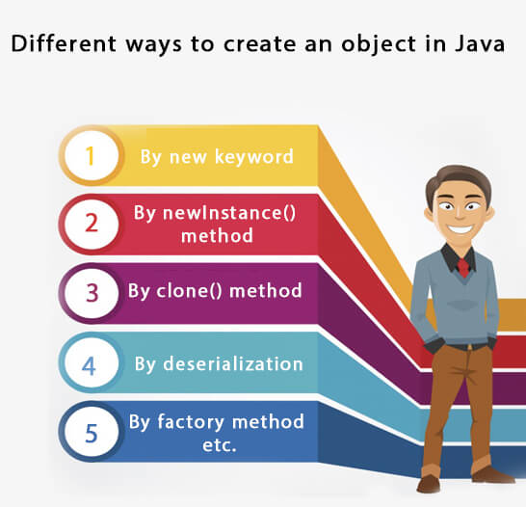

Anonymous object

Anonymous simply means nameless. An object which has no reference is known as an anonymous object. It can be used at the time of object creation only.

If you have to use an object only once, an anonymous object is a good approach. For example:

1. **new** Calculation();//anonymous object

Calling method through a reference:

1. Calculation c=**new** Calculation();
2. c.fact(5);

Calling method through an anonymous object

1. **new** Calculation().fact(5);

Let's see the full example of an anonymous object in Java.

1. **class** Calculation{
2. **void** fact(**int**  n){
3. **int** fact=1;
4. **for**(**int** i=1;i<=n;i++){
5. fact=fact*i;
6. }
7. System.out.println("factorial is "+fact);
8. }
9. **public** **static** **void** main(String args[]){
10. **new** Calculation().fact(5);//calling method with anonymous object
11. }
12. }

Output:

Factorial is 120

Creating multiple objects by one type only

We can create multiple objects by one type only as we do in case of primitives.

Initialization of primitive variables:

1. **int** a=10, b=20;

Initialization of refernce variables:

1. Rectangle r1=**new** Rectangle(), r2=**new** Rectangle();//creating two objects

Let's see the example:

1. //Java Program to illustrate the use of Rectangle class which
2. //has length and width data members
3. **class** Rectangle{
4. **int** length;
5. **int** width;
6. **void** insert(**int** l,**int** w){
7. length=l;
8. width=w;
9. }
10. **void** calculateArea(){System.out.println(length*width);}
11. }
12. **class** TestRectangle2{
13. **public** **static** **void** main(String args[]){
14. Rectangle r1=**new** Rectangle(),r2=**new** Rectangle();//creating two objects
15. r1.insert(11,5);
16. r2.insert(3,15);
17. r1.calculateArea();
18. r2.calculateArea();
19. }
20. }

[**Test it Now**](http://www.javatpoint.com/opr/test.jsp?filename=TestRectangle2)

Output:

55

45

Real World Example: Account

*File: TestAccount.java*

1. //Java Program to demonstrate the working of a banking-system
2. //where we deposit and withdraw amount from our account.
3. //Creating an Account class which has deposit() and withdraw() methods
4. **class** Account{
5. **int** acc_no;
6. String name;
7. **float** amount;
8. //Method to initialize object
9. **void** insert(**int** a,String n,**float** amt){
10. acc_no=a;
11. name=n;
12. amount=amt;
13. }
14. //deposit method
15. **void** deposit(**float** amt){
16. amount=amount+amt;
17. System.out.println(amt+" deposited");
18. }
19. //withdraw method
20. **void** withdraw(**float** amt){
21. **if**(amount<amt){
22. System.out.println("Insufficient Balance");
23. }**else**{
24. amount=amount-amt;
25. System.out.println(amt+" withdrawn");
26. }
27. }
28. //method to check the balance of the account
29. **void** checkBalance(){System.out.println("Balance is: "+amount);}
30. //method to display the values of an object
31. **void** display(){System.out.println(acc_no+" "+name+" "+amount);}
32. }
33. //Creating a test class to deposit and withdraw amount
34. **class** TestAccount{
35. **public** **static** **void** main(String[] args){
36. Account a1=**new** Account();
37. a1.insert(832345,"Ankit",1000);
38. a1.display();
39. a1.checkBalance();
40. a1.deposit(40000);
41. a1.checkBalance();
42. a1.withdraw(15000);
43. a1.checkBalance();
44. }}