Java String

In Java, string is basically an object that represents sequence of char values. An array of characters works same as Java string. For example:

1. **char**[] ch={'j','a','v','a','t','p','o','i','n','t'};
2. String s=**new** String(ch);

is same as:

1. String s="javatpoint";

**Java String** class provides a lot of methods to perform operations on string such as compare(), concat(), equals(), split(), length(), replace(), compareTo(), intern(), substring() etc.

The java.lang.String class implements *Serializable*, *Comparable* and *CharSequence* interfaces.

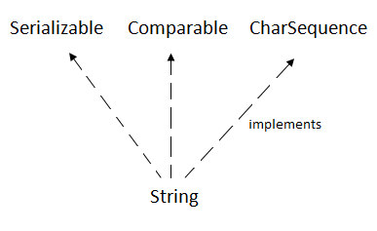

CharSequence Interface

The CharSequence interface is used to represent the sequence of characters. String, StringBuffer and StringBuilder classes implement it. It means, we can create strings in java by using these three classes.

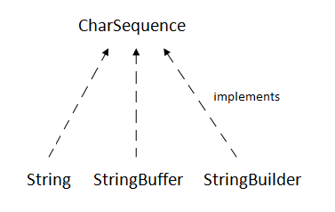

The Java String is immutable which means it cannot be changed. Whenever we change any string, a new instance is created. For mutable strings, you can use StringBuffer and StringBuilder classes.

We will discuss immutable string later. Let's first understand what is String in Java and how to create the String object.

### What is String in java

Generally, String is a sequence of characters. But in Java, string is an object that represents a sequence of characters. The java.lang.String class is used to create a string object.

### How to create a string object?

There are two ways to create String object:

1. By string literal
2. By new keyword

### 1) String Literal

Java String literal is created by using double quotes. For Example:

1. String s="welcome";

Each time you create a string literal, the JVM checks the "string constant pool" first. If the string already exists in the pool, a reference to the pooled instance is returned. If the string doesn't exist in the pool, a new string instance is created and placed in the pool. For example:

1. String s1="Welcome";
2. String s2="Welcome";//It doesn't create a new instance

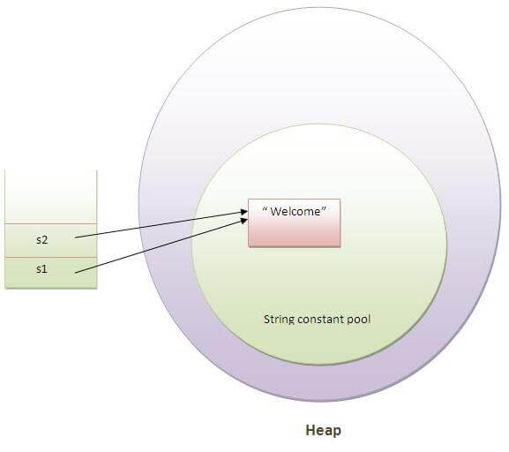

In the above example, only one object will be created. Firstly, JVM will not find any string object with the value "Welcome" in string constant pool, that is why it will create a new object. After that it will find the string with the value "Welcome" in the pool, it will not create a new object but will return the reference to the same instance.

#### Note: String objects are stored in a special memory area known as the "string constant pool".

### Why Java uses the concept of String literal?

To make Java more memory efficient (because no new objects are created if it exists already in the string constant pool).

### 2) By new keyword

1. String s=**new** String("Welcome");//creates two objects and one reference variable

In such case, JVM will create a new string object in normal (non-pool) heap memory, and the literal "Welcome" will be placed in the string constant pool. The variable s will refer to the object in a heap (non-pool).

### Java String Example

1. **public** **class** StringExample{
2. **public** **static** **void** main(String args[]){
3. String s1="java";//creating string by java string literal
4. **char** ch[]={'s','t','r','i','n','g','s'};
5. String s2=**new** String(ch);//converting char array to string
6. String s3=**new** String("example");//creating java string by new keyword
7. System.out.println(s1);
8. System.out.println(s2);
9. System.out.println(s3);
10. }}

[**Test it Now**](http://www.javatpoint.com/opr/test.jsp?filename=StringExample)

java

strings

example

### Java String class methods

The java.lang.String class provides many useful methods to perform operations on sequence of char values.

|  |  |  |
| --- | --- | --- |
| **No.** | **Method** | **Description** |
| 1 | [char charAt(int index)](https://www.javatpoint.com/java-string-charat) | returns char  value for the  particular  index |
| 2 | [int length()](https://www.javatpoint.com/java-string-length) | returns string  length |
| 3 | [static String format(String format, Object... args)](https://www.javatpoint.com/java-string-format) | returns a  formatted  string. |
| 4 | [static String format(Locale l, String format, Object... args)](https://www.javatpoint.com/java-string-format) | returns format  ted string  with given  locale. |
| 5 | [String substring(int beginIndex)](https://www.javatpoint.com/java-string-substring) | returns  substring for  given begin  index. |
| 6 | [String substring(int beginIndex, int endIndex)](https://www.javatpoint.com/java-string-substring) | returns  substring for  given begin  index and end index. |
| 7 | [boolean contains(CharSequence s)](https://www.javatpoint.com/java-string-contains) | returns true  or false after  matching the  sequence of  char value. |
| 8 | [static String join(CharSequence delimiter, CharSequence... elements)](https://www.javatpoint.com/java-string-join) | returns a  joined string. |
| 9 | [static String join(CharSequence delimiter, Iterable<? extends CharSequence> elements)](https://www.javatpoint.com/java-string-join) | returns a  joined string. |
| 10 | [boolean equals(Object another)](https://www.javatpoint.com/java-string-equals) | checks the  equality of  string with  the given  object. |
| 11 | [boolean isEmpty()](https://www.javatpoint.com/java-string-isempty) | checks if  string is  empty. |
| 12 | [String concat(String str)](https://www.javatpoint.com/java-string-concat) | Concatenates  the specified  string. |
| 13 | [String replace(char old, char new)](https://www.javatpoint.com/java-string-replace) | replaces all  occurrences  of the  specified char  value. |
| 14 | [String replace(CharSequence old, CharSequence new)](https://www.javatpoint.com/java-string-replace) | replaces all  occurrences  of the  specified  CharSequence. |
| 15 | [static String equalsIgnoreCase(String another)](https://www.javatpoint.com/java-string-equalsignorecase) | Compares  another  string.  It doesn't  check case. |
| 16 | [String[] split(String regex)](https://www.javatpoint.com/java-string-split) | returns a  split string  matching  regex. |
| 17 | [String[] split(String regex, int limit)](https://www.javatpoint.com/java-string-split) | returns a  split string  matching  regex and limit. |
| 18 | [String intern()](https://www.javatpoint.com/java-string-intern) | returns an  interned  string. |
| 19 | [int indexOf(int ch)](https://www.javatpoint.com/java-string-indexof) | returns the  specified char  value index. |
| 20 | [int indexOf(int ch, int fromIndex)](https://www.javatpoint.com/java-string-indexof) | returns the  specified  char value  index starting  with given  index. |
| 21 | [int indexOf(String substring)](https://www.javatpoint.com/java-string-indexof) | returns the  specified  substring  index. |
| 22 | [int indexOf(String substring, int fromIndex)](https://www.javatpoint.com/java-string-indexof) | returns the  specified  substring  index  starting  with given  index. |
| 23 | [String toLowerCase()](https://www.javatpoint.com/java-string-tolowercase) | returns a  string in  lowercase. |
| 24 | [String toLowerCase(Locale l)](https://www.javatpoint.com/java-string-tolowercase) | returns a  string in  lowercase  using  specified  locale. |
| 25 | [String toUpperCase()](https://www.javatpoint.com/java-string-touppercase) | returns a  string in  uppercase. |
| 26 | [String toUpperCase(Locale l)](https://www.javatpoint.com/java-string-touppercase) | returns a  string in  uppercase  using  specified  locale. |
| 27 | [String trim()](https://www.javatpoint.com/java-string-trim) | removes  beginning  and ending  spaces of  this string. |
| 28 | [static String valueOf(int value)](https://www.javatpoint.com/java-string-valueof) | Converts  given  type into  string. It is an  overloaded method. |

# Immutable String in Java

In java, **string objects are immutable**. Immutable simply means unmodifiable or unchangeable.

Once string object is created its data or state can't be changed but a new string object is created.

Let's try to understand the immutability concept by the example given below:

1. **class** Testimmutablestring{
2. **public** **static** **void** main(String args[]){
3. String s="Sachin";
4. s.concat(" Tendulkar");//concat() method appends the string at the end
5. System.out.println(s);//will print Sachin because strings are immutable objects
6. }
7. }

[**Test it Now**](http://www.javatpoint.com/opr/test.jsp?filename=Testimmutablestring)

Output:Sachin

Now it can be understood by the diagram given below. Here Sachin is not changed but a new object is created with sachintendulkar. That is why string is known as immutable.

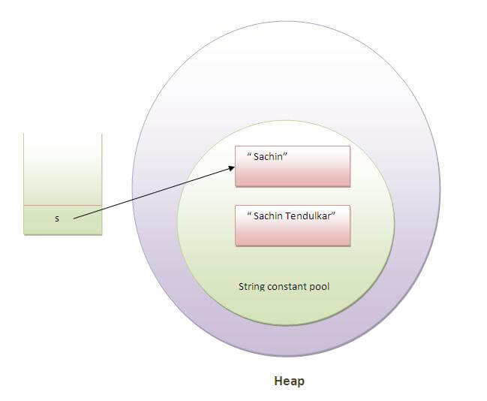

As you can see in the above figure that two objects are created but s reference variable still refers to "Sachin" not to "Sachin Tendulkar".

But if we explicitely assign it to the reference variable, it will refer to "Sachin Tendulkar" object.For example:

1. **class** Testimmutablestring1{
2. **public** **static** **void** main(String args[]){
3. String s="Sachin";
4. s=s.concat(" Tendulkar");
5. System.out.println(s);
6. }
7. }

Output:Sachin Tendulkar

In such case, s points to the "Sachin Tendulkar". Please notice that still sachin object is not modified.

### Why string objects are immutable in java?

|  |
| --- |
| Because java uses the concept of string literal.Suppose there are 5 reference variables,  all referes to one object "sachin".If one reference variable changes the value of the object,  it will be affected to all the reference variables.  That is why string objects are immutable in java. |

Java String compare

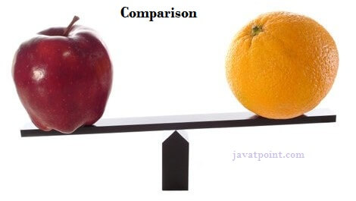

We can compare string in java on the basis of content and reference.

It is used in **authentication** (by equals() method), **sorting** (by compareTo() method), **reference matching** (by == operator) etc.

There are three ways to compare string in java:

1. By equals() method
2. By = = operator
3. By compareTo() method

1) String compare by equals() method

The String equals() method compares the original content of the string. It compares values of string for equality. String class provides two methods:

* **public boolean equals(Object another)** compares this string to the specified object.
* **public boolean equalsIgnoreCase(String another)** compares this String to another string, ignoring case.

1. **class** Teststringcomparison1{
2. **public** **static** **void** main(String args[]){
3. String s1="Sachin";
4. String s2="Sachin";
5. String s3=**new** String("Sachin");
6. String s4="Saurav";
7. System.out.println(s1.equals(s2));//true
8. System.out.println(s1.equals(s3));//true
9. System.out.println(s1.equals(s4));//false
10. }
11. }

[**Test it Now**](http://www.javatpoint.com/opr/test.jsp?filename=Teststringcomparison1)

Output:true

true

false

1. **class** Teststringcomparison2{
2. **public** **static** **void** main(String args[]){
3. String s1="Sachin";
4. String s2="SACHIN";
6. System.out.println(s1.equals(s2));//false
7. System.out.println(s1.equalsIgnoreCase(s2));//true
8. }
9. }

[**Test it Now**](http://www.javatpoint.com/opr/test.jsp?filename=Teststringcomparison2)

Output:

false

true

2) String compare by == operator

The = = operator compares references not values.

1. **class** Teststringcomparison3{
2. **public** **static** **void** main(String args[]){
3. String s1="Sachin";
4. String s2="Sachin";
5. String s3=**new** String("Sachin");
6. System.out.println(s1==s2);//true (because both refer to same instance)
7. System.out.println(s1==s3);//false(because s3 refers to instance created in nonpool)
8. }
9. }

[**Test it Now**](http://www.javatpoint.com/opr/test.jsp?filename=Teststringcomparison3)

Output:true

false

3) String compare by compareTo() method

The String compareTo() method compares values lexicographically and returns an integer value that describes if first string is less than, equal to or greater than second string.

Suppose s1 and s2 are two string variables. If:

* **s1 == s2** :0
* **s1 > s2**  :positive value
* **s1 < s2**  :negative value

1. **class** Teststringcomparison4{
2. **public** **static** **void** main(String args[]){
3. String s1="Sachin";
4. String s2="Sachin";
5. String s3="Ratan";
6. System.out.println(s1.compareTo(s2));//0
7. System.out.println(s1.compareTo(s3));//1(because s1>s3)
8. System.out.println(s3.compareTo(s1));//-1(because s3 < s1 )
9. }
10. }

[**Test it Now**](http://www.javatpoint.com/opr/test.jsp?filename=Teststringcomparison4)

Output:0

1

-1