**Q1 ) Write a function that prints the numbers from 1 to 100. But for multiples of three, print "Fizz" instead of the number, and for the multiples of five, print "Buzz". For numbers that are multiples of both three and five, print "FizzBuzz".**

<html>

<head>

<center><h1>Q1</h1></center>

</head>

<body>

<script src"js/script.js">

for (var i = 1; i <= 100; i++) {

if (i % 3 === 0 && i % 5 === 0)

{document.write("FizzBuzz");}

else if (i % 3 === 0)

{document.write("Fizz");}

else if (i % 5 === 0)

{document.write("Buzz");}

else

{document.write(i);}

document.write('<br>');

}

</script>

</body>

</html>

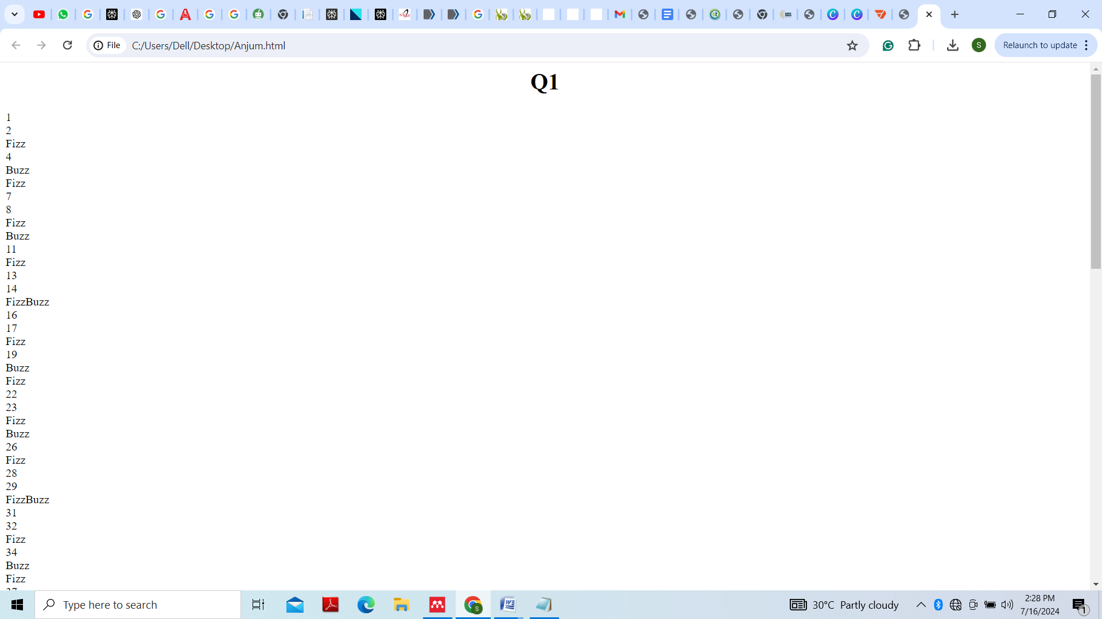

**Q2) Write a function that takes a string input representing a simple arithmetic expression (only addition and subtraction) and returns the result.**

<html>

<head>

<center><h1>Q2</h1></center>

<script src"js/script.js">

function add(num1, num2)

{return num1+num2;}

function subtract(num1, num2)

{return num1-num2;}

</script>

</head>

<body>

<script src"js/script.js">

var num1= prompt("Enter first number");

var num2= prompt("Enter second number");

var op= prompt("Enter operation");

operation=op;

let result;

if(operation == "+"){

result=add(num1, num2);

}

else if(operation == "-"){

result=subtract(num1, num2);

}

else

{result ="Invalid operation";}

document.write("The Result of this operation is : " +result);

</script>

</body>

</html>

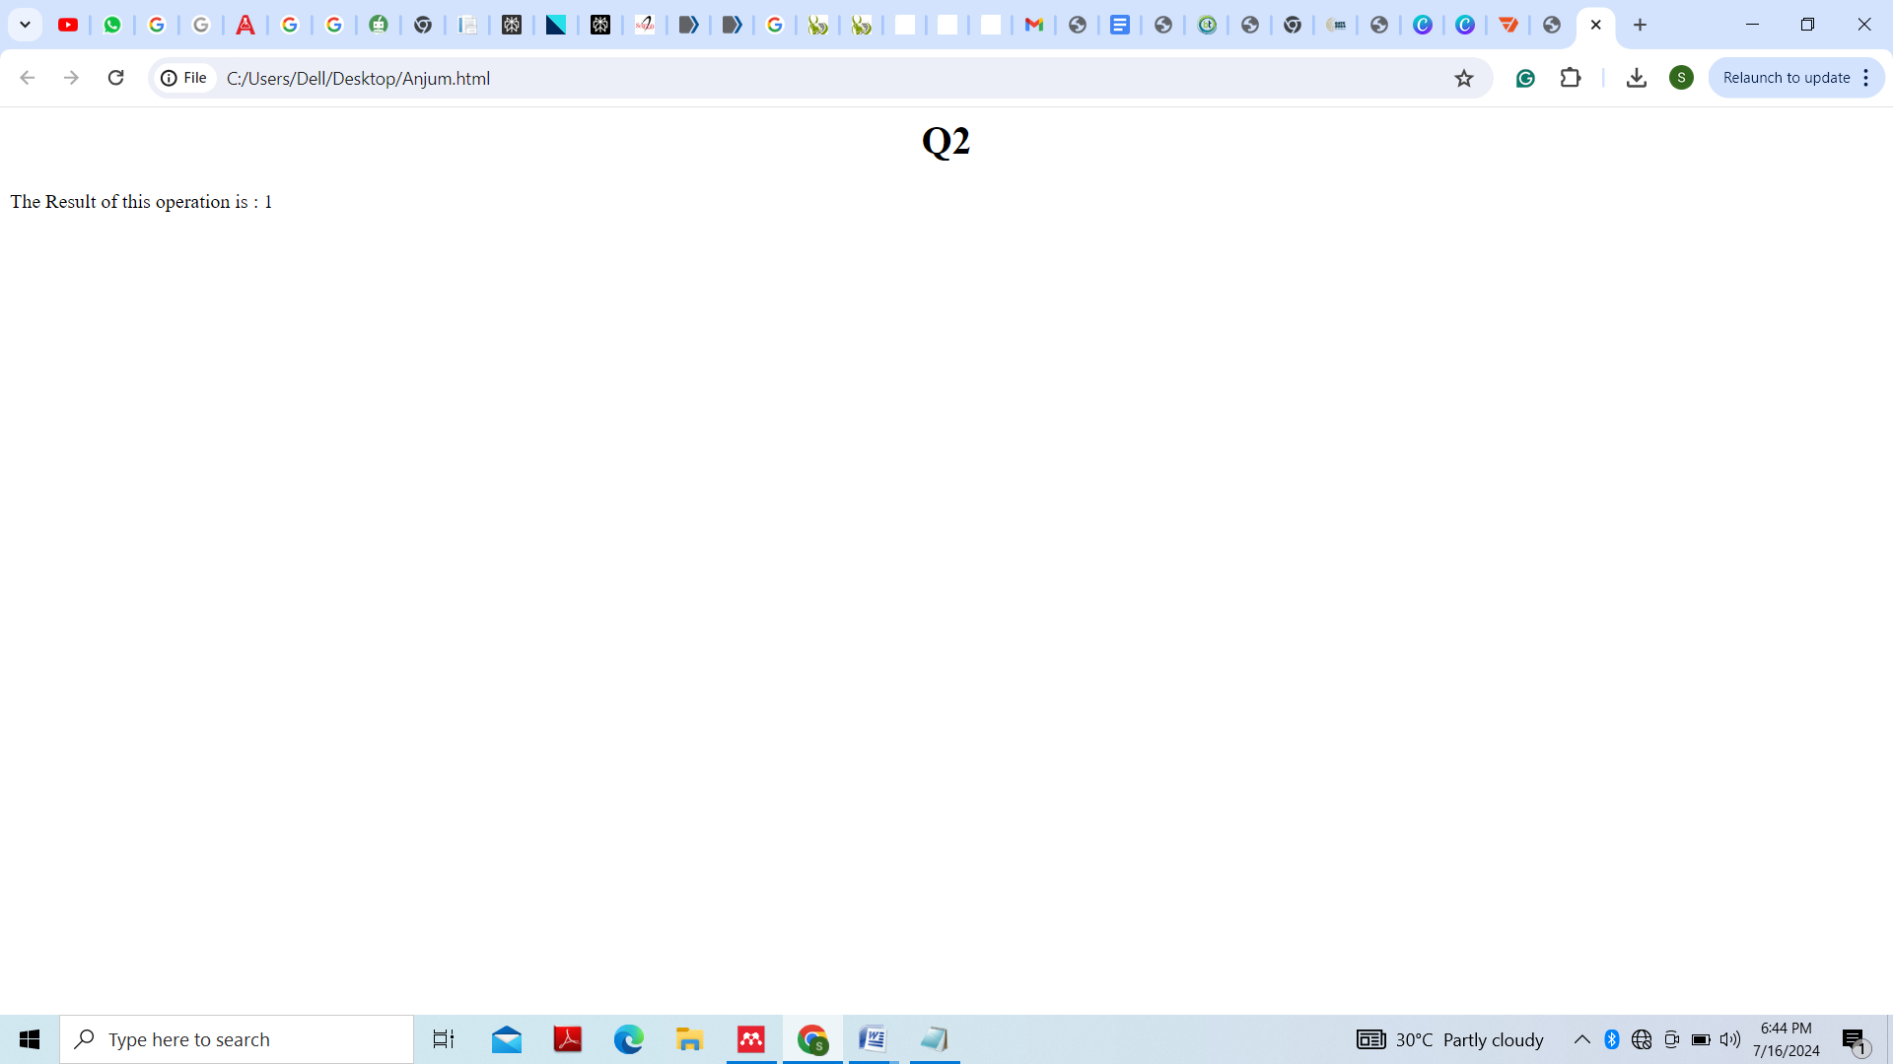

**Q3) Write a function that takes a nested array and returns a flattened array.**

<html>

<head>

<center><h1>Q3</h1></center>

</head>

<body>

<script src"js/script.js">

arr = [1,2,[3,4,5],[6,7,8,9],10]

document.write("Original Array: " ,arr)

document.write('<br>')

let flattened_arr=[].concat.apply([], arr);

document.write("Flattened Array : " +flattened_arr);

</script>

</body>

</html>

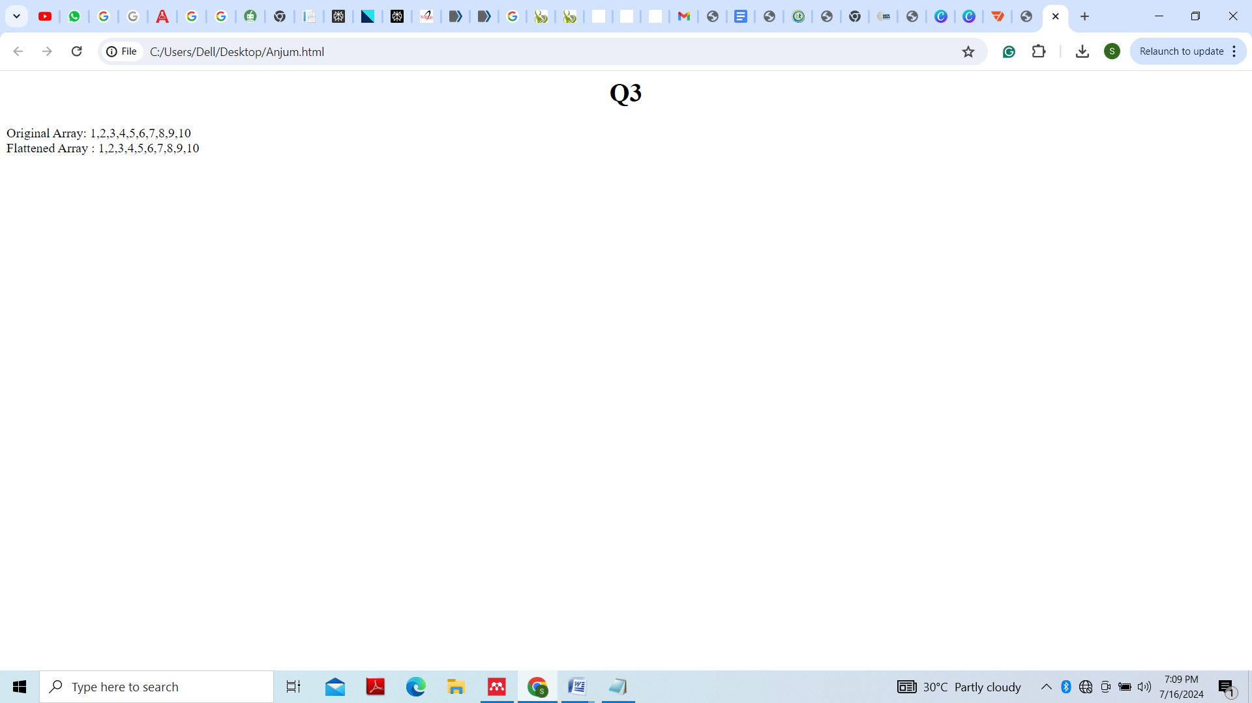

**Q4) Write a function that checks if two given strings are anagrams of each other.**

<html>

<head>

<center><h1>Q4</h1></center>

</head>

<body>

<script src"js/script.js">

function areAnagram(str1,str2)

{

let n1 = str1.length;

let n2 = str2.length;

if (n1 != n2)

return false;

str1.sort();

str2.sort()

for (let i = 0; i < n1; i++)

if (str1[i] != str2[i])

return false;

return true;

}

let str1=['t', 'e', 's', 't'];

let str2=['t', 's', 'e', 't'];

if (areAnagram(str1, str2))

document.write("The two strings are" + " anagram of each other<br>");

else

document.write("The two strings are not" + " anagram of each other<br>");

</script>

</body>

</html>

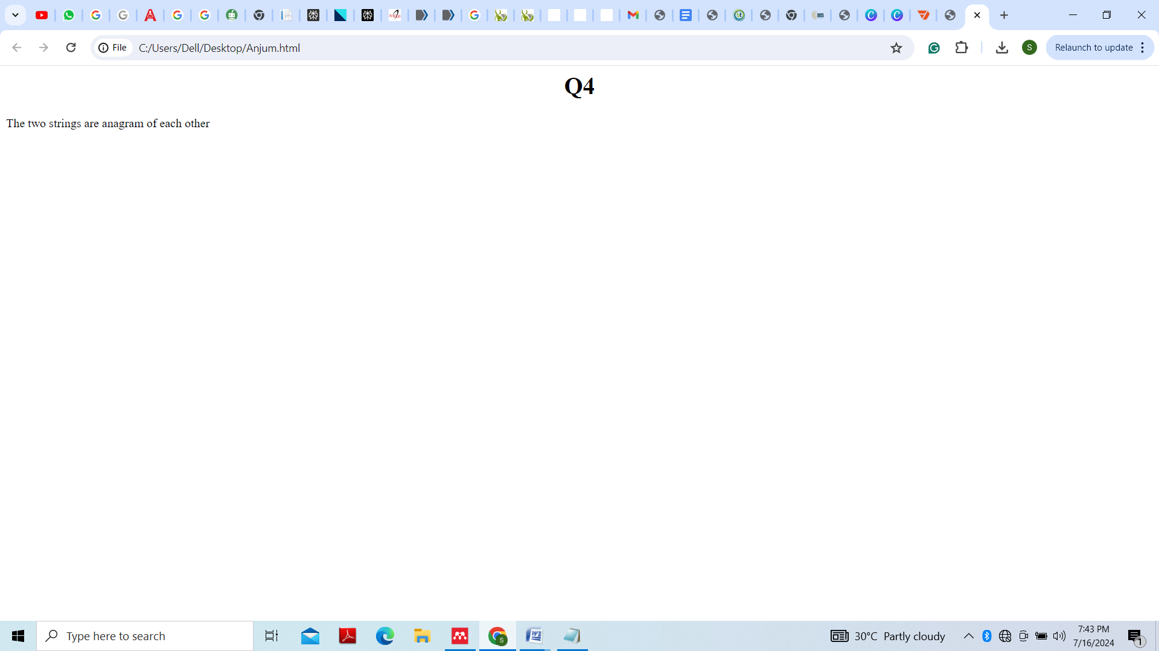

**Q5) Write a function that takes an array and returns a new array with duplicates removed.**

<html>

<head>

<center><h1>Q5</h1></center>

</head>

<body>

<script src"js/script.js">

let arr = ["apple", "mango", "apple", "orange", "mango", "mango"];

function removeDup(arr) {

return arr.filter((item,index) => arr.indexOf(item) === index);

}

document.write(removeDup(arr));

</script>

</body>

</html>

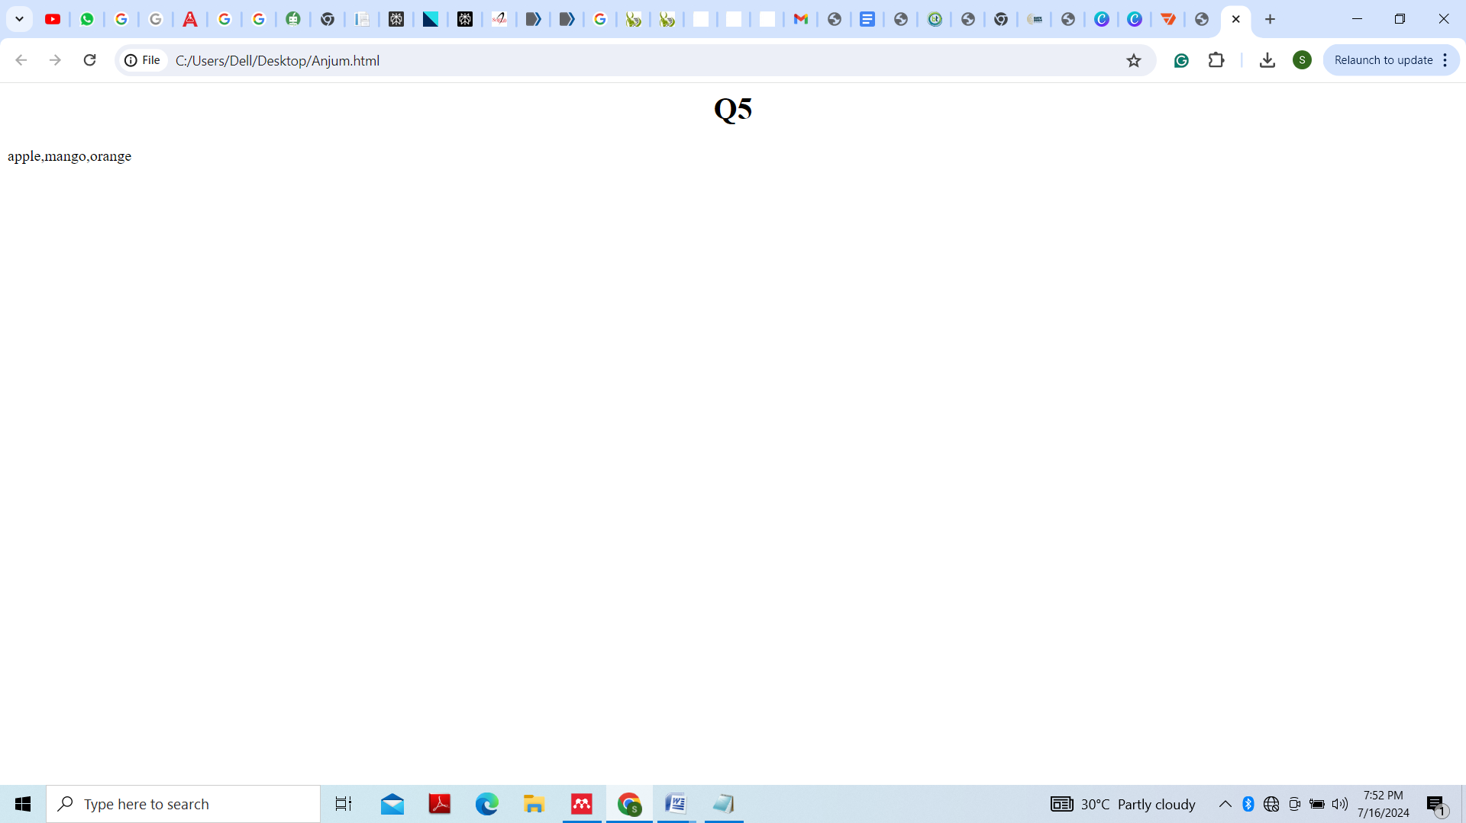

**Q6) Write a function that takes a string and capitalizes the first letter of each word in the string.**

<html>

<head>

<center><h1>Q6</h1></center>

</head>

<body>

<script src"js/script.js">

function first_letter(str)

{

str = str.split(" ");

for (var i = 0, x = str.length; i < x; i++) {

str[i] = str[i][0].toUpperCase() + str[i].substr(1);

}

return str.join(" ");

}

document.write(first_letter("Write a function that takes a string and capitalizes the first letter of each word in the string."));

</script>

</body>

</html>

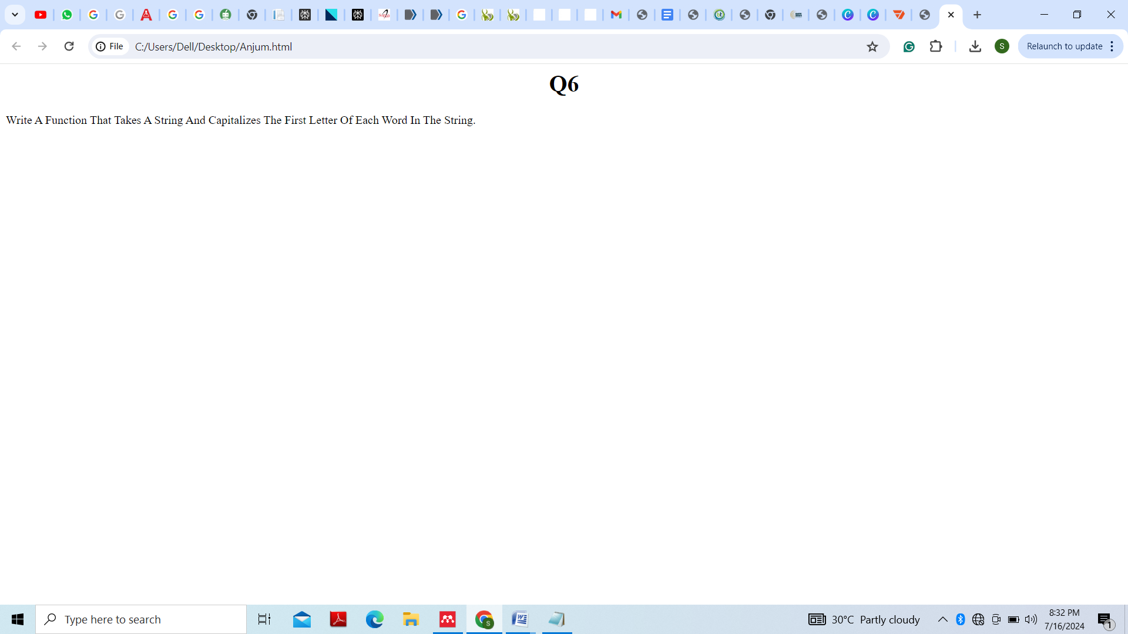

**Q7) Write a function that generates the first n numbers of the Fibonacci sequence.**

<html>

<head>

<center><h1>Q7</h1></center>

</head>

<body>

<script src"js/script.js">

var fibonacci_series = function (n) {

if (n <= 1) {

return [0, 1];

}

else {

var s = fibonacci_series(n - 1);

s.push(s[s.length - 1] + s[s.length - 2]);

return s.slice(0, n);

}

};

document.write(fibonacci_series(8));

</script>

</body>

</html>

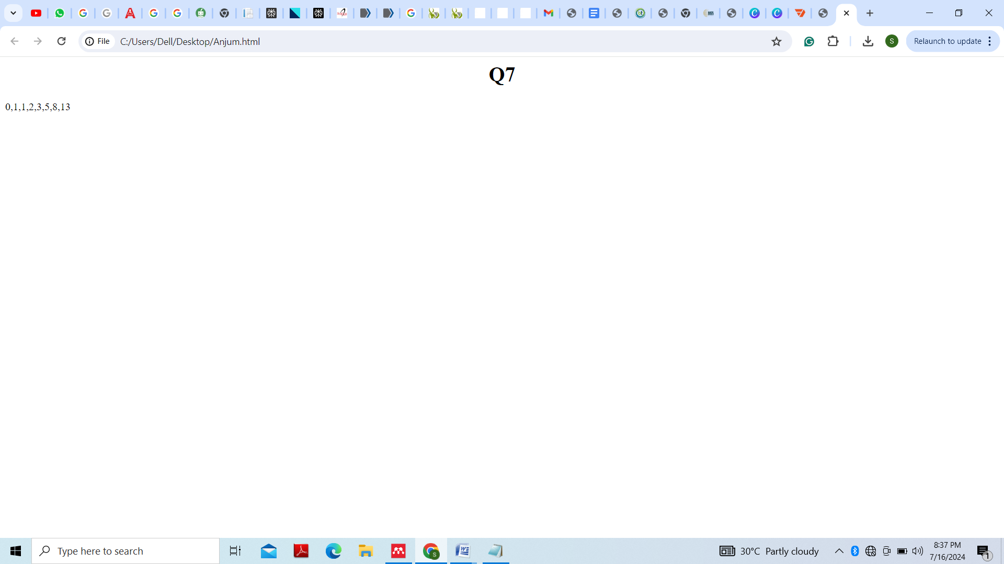

**Q8) Implement a simple HashMap class with put, get, and remove methods.**

<html>

<head>

<center><h1>Q8</h1></center>

</head>

<body>

<script src"js/script.js">

class SimpleHashMap {

constructor(capacity = 10) {

this.capacity = capacity;

this.buckets = new Array(capacity);

}

_hash(key) {

let hash = 0;

for (let i = 0; i < key.length; i++) {

hash += key.charCodeAt(i);

}

return hash % this.capacity;

}

put(key, value) {

const index = this._hash(key);

if (!this.buckets[index]) {

this.buckets[index] = [];

}

this.buckets[index].push({ key, value });

}

get(key) {

const index = this._hash(key);

if (!this.buckets[index]) return undefined;

for (const pair of this.buckets[index]) {

if (pair.key === key) {

return pair.value;

}

}

return undefined;

}

remove(key) {

const index = this._hash(key);

if (!this.buckets[index]) return undefined;

const bucket = this.buckets[index];

for (let i = 0; i < bucket.length; i++) {

if (bucket[i].key === key) {

bucket.splice(i, 1);

return true;

}

}

return undefined;

}

}

</script>

</body>

</html>

**Q9) Write a function that filters out even numbers from an array.**

<html>

<head>

<center><h1>Q9</h1></center>

</head>

<body>

<script src"js/script.js">

var arr = [2, 64, 26, 4, 0, 7, 76];

var evens = arr.filter(function(x) {

if (x % 2 == 0 || x == 0)

{

return x;

}

}

)

document.write(evens);

</script>

</body>

</html>

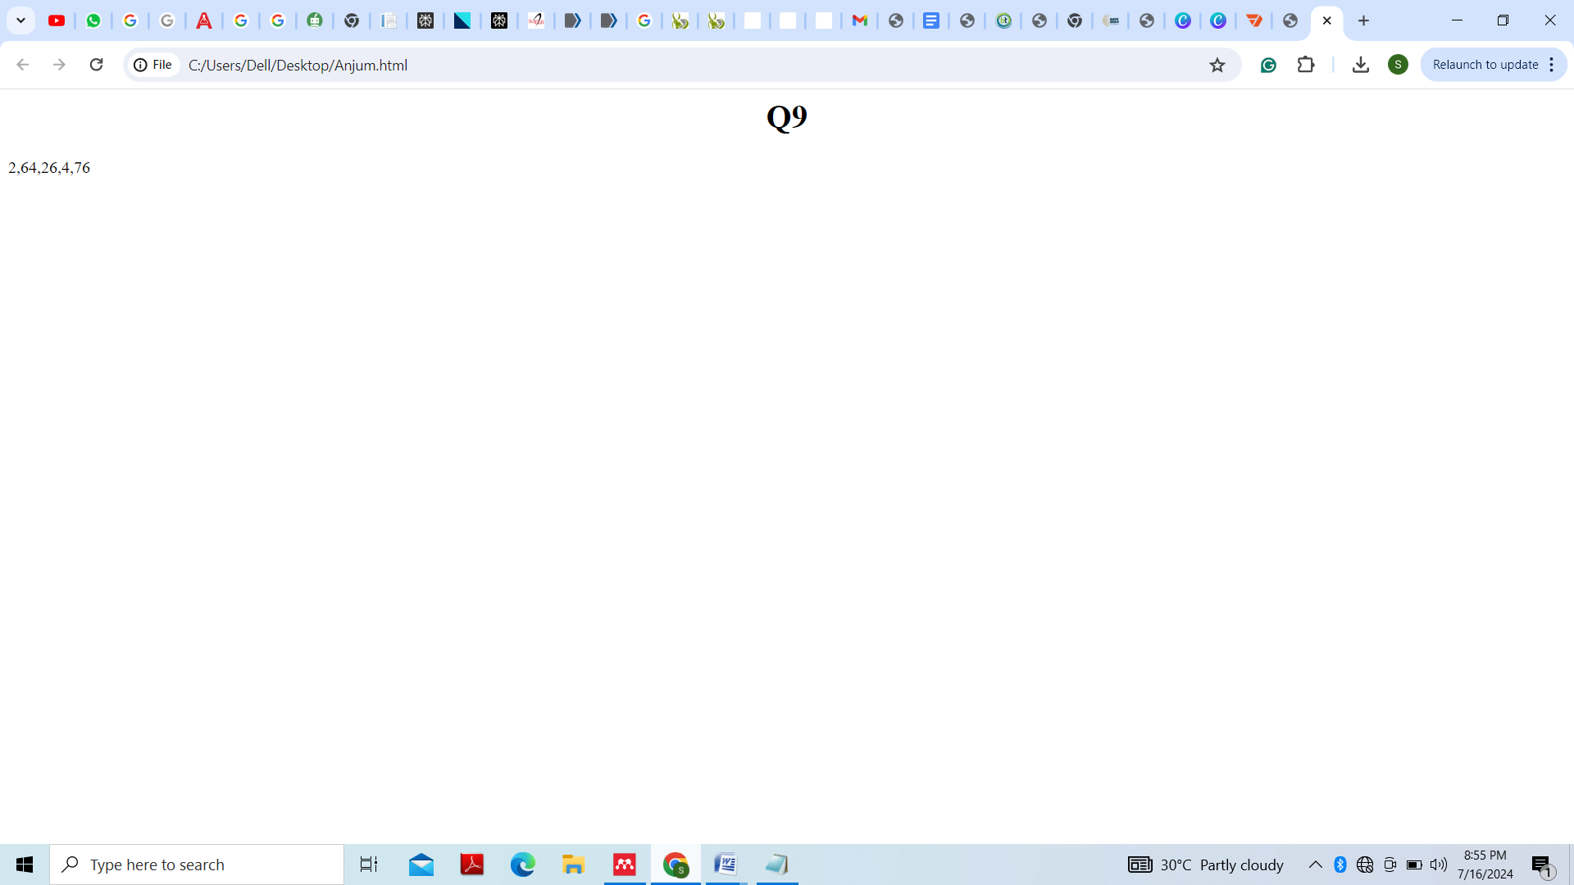

**Q10) Write a function that converts a given string to title case (capitalizing the first letter of each word).**

<html>

<head>

<center><h1>Q10</h1></center>

</head>

<body>

<script src"js/script.js">

function first_letter(str)

{

str = str.split(" ");

for (var i = 0, x = str.length; i < x; i++) {

str[i] = str[i][0].toUpperCase() + str[i].substr(1);

}

return str.join(" ");

}

document.write(first_letter("Write a function that converts a given string to title case (capitalizing the first letter of each word)."));

</script>

</body>

</html>

