User Management System

1. Project Overview
This User Management System is built using C#, Blazor Server, SQL, and NUnit. It provides administrators with a complete interface to manage users, monitor activity logs, and perform CRUD operations, along with testable backend logic. The solution is structured using clean architecture principles for maintainability and testability.

2. Tech Stack
- C# (Business logic, UI interaction)
- Blazor Server (UI framework)
- SQL Database (Planned for persistent storage)
- NUnit (Unit testing framework)
- Entity Framework Core (Data access – planned)
- Moq (Used in testing activity logs)

3. Project Features Implemented
✔ Added DateOfBirth Property to User Model
✔ Stub/Mock User Data for UI testing before DB integration
✔ Active/Inactive filter logic for users
✔ Show All users functionality
✔ Full CRUD operations (Create, Update, Delete, View)
✔ Activity Log recording for every CRUD action
✔ NUnit-based unit testing for filtering and user logic

4. Dashboard
The dashboard provides a high-level summary of system activity including total users, active users, inactive users, and new users. It also contains quick actions to navigate to user management functionality.
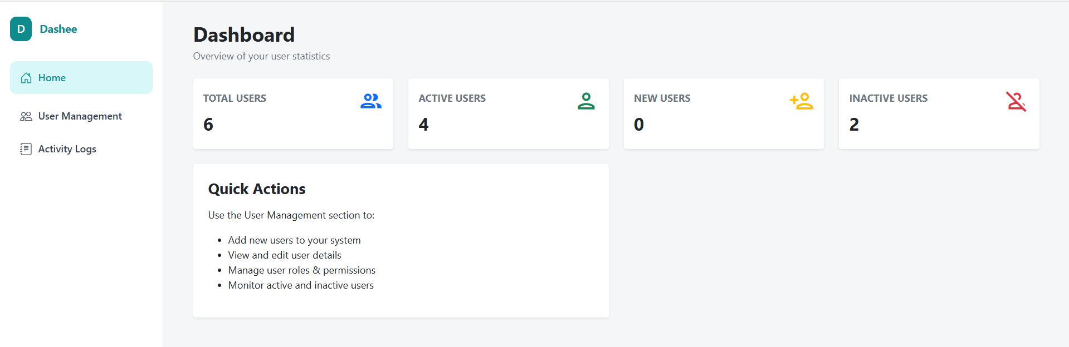

5. User Management
The User Management page allows administrators to add, view, edit, or delete users. It includes filters for:
• All Users
• Active Users
• Inactive Users
Users are displayed in a tabular format showing Forename, Surname, Email, Date of Birth, and Status.
• Search bar : To search user from the list.
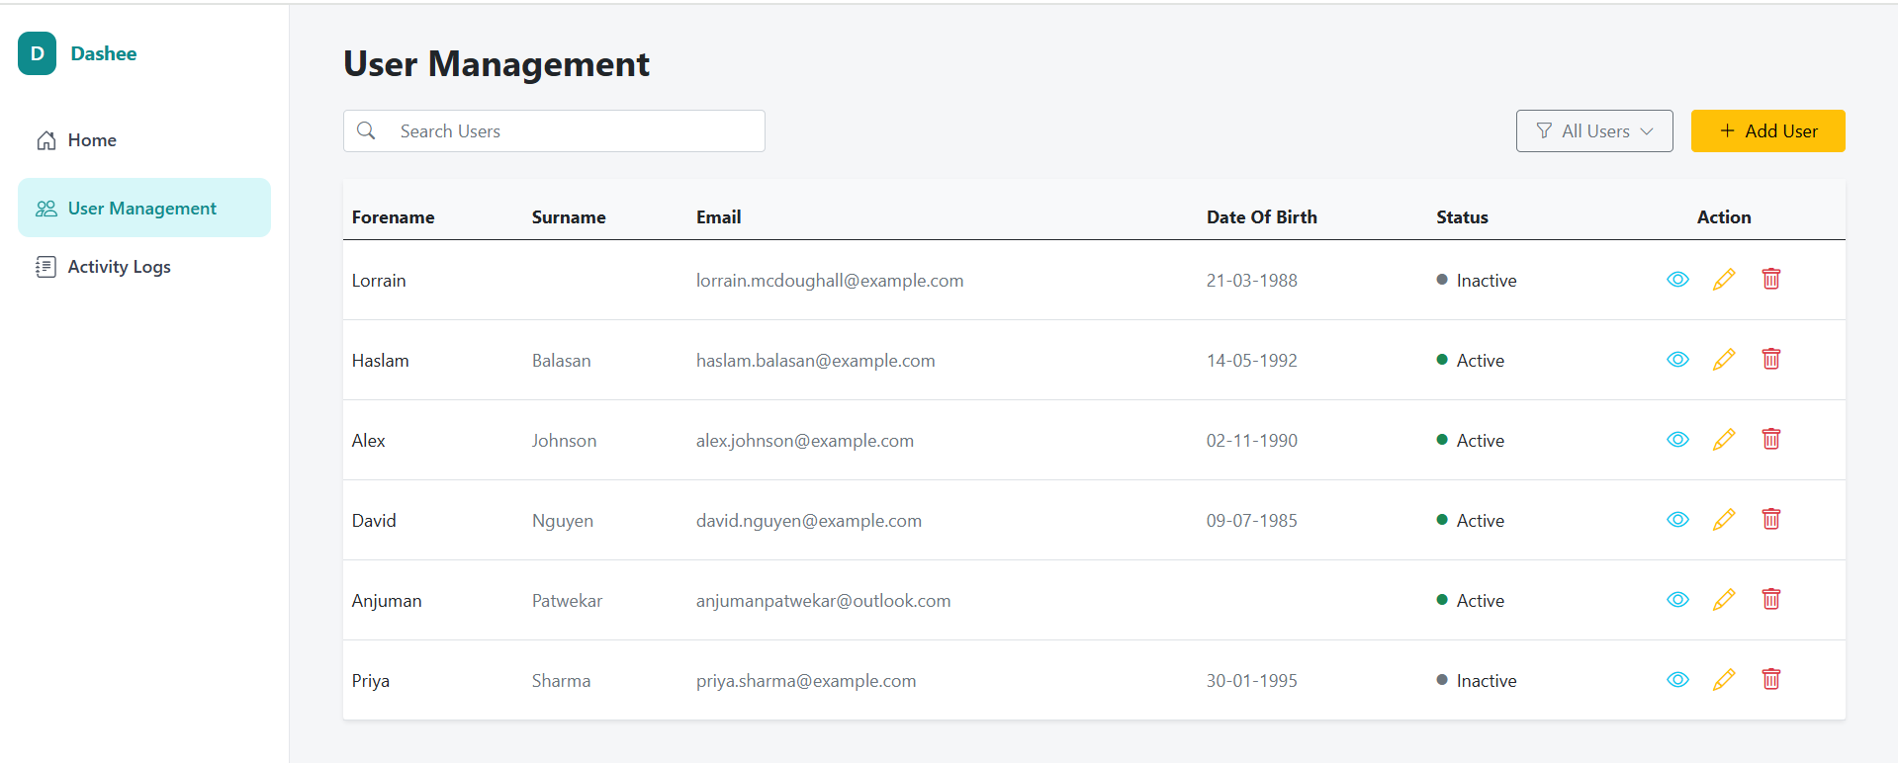

6. Activity Logs
All user actions such as creation, updates, and deletions are logged with timestamps, action performed, user affected, and detailed descriptions. The Activity Log page includes:
- Search functionality
- Date range filters
- Action-based filters
- On click on icon of action column, can see the details of the activity.
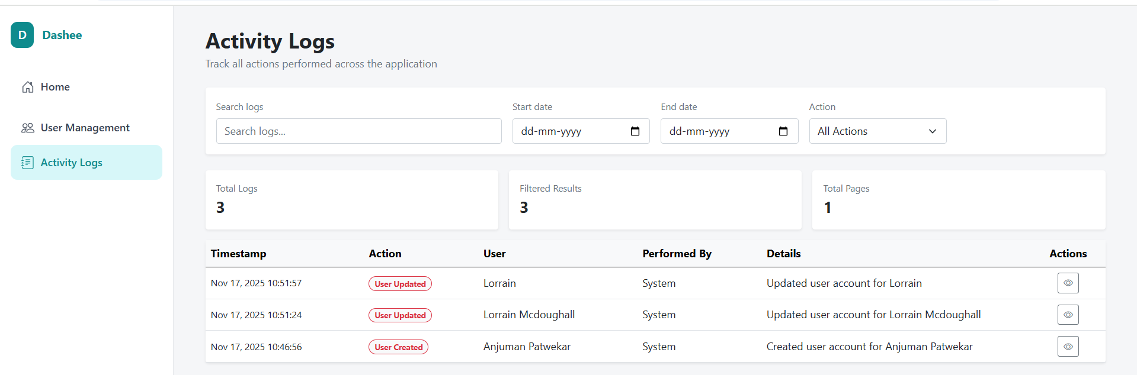

7. NUnit Testing
NUnit is used extensively for testing core business logic components. This includes verifying active/inactive user filtering, CRUD operations, and ensuring that all user-related actions trigger corresponding Activity Log entries.
Example NUnit Test Cases:
- Should_Return_Only_Active_Users
- Should_Return_Only_Inactive_Users
- Should_Log_User_Updates_and_Creations

8. DataBase:
1. User Table
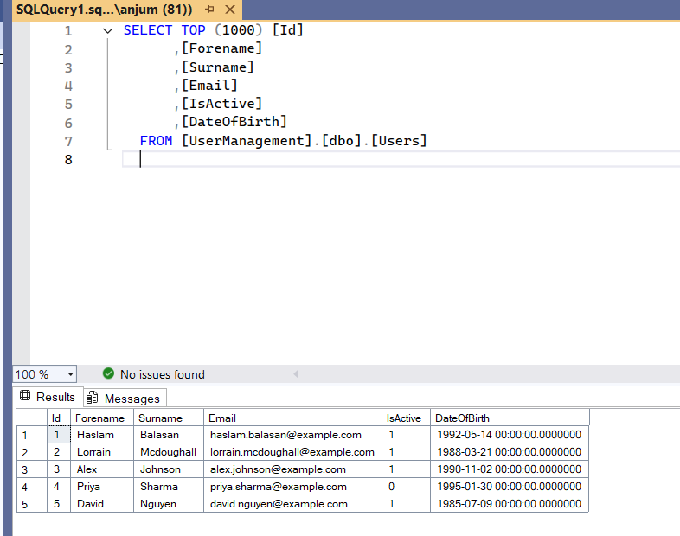
2. Activity Log table:
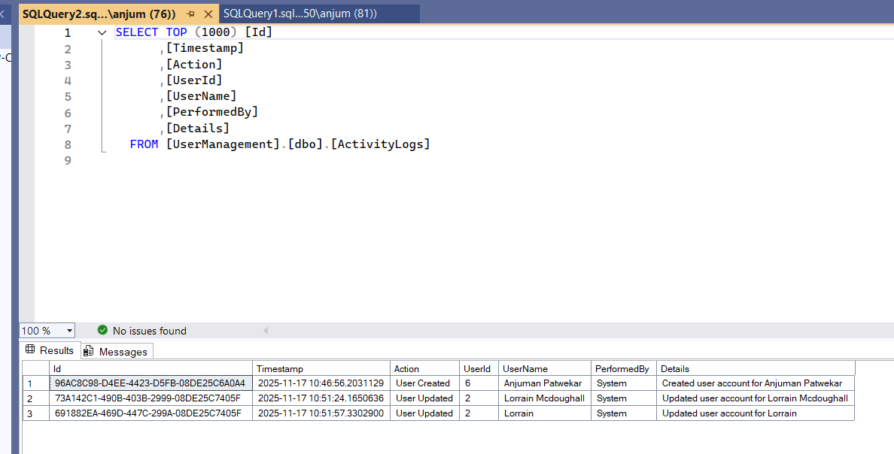

9. NuGet Packages Used
- Microsoft.EntityFrameworkCore
- Microsoft.EntityFrameworkCore.SqlServer
- Microsoft.EntityFrameworkCore.Tools
- NUnit
- NUnit3TestAdapter
- Microsoft.NET.Test.Sdk
- Moq

10. IDE
1. Visual Studio 2022
Docker & Docker Compose:
Architecture Diagram
This document provides a concise explanation of how Docker and Docker Compose work together to build and run the UserManagement application, consisting of: - webapp (.NET 9 application) - sqlserver (SQL Server 2022 container)
It also includes a flow diagram illustrating the full lifecycle from build to runtime.

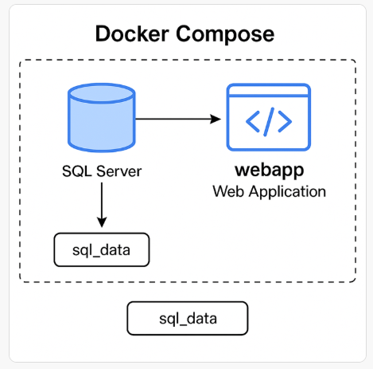

Architecture Summary
Containers
- webapp
  - Built using Dockerfile in the project root
  - Uses .NET 9 SDK to build and .NET 9 ASP.NET Runtime to run
  - Connects to SQL Server via internal Docker network
- sqlserver
  - Built using Dockerfile from ./sqlserver
  - Exposes port 1433
  - Persists database files using sql_data Docker volume
docker-compose.yml
Defines both services and orchestrates: - Build order - Dependencies (depends_on) - Environment variables - Networks – Volumes

Container Interaction Flow
- docker compose up –build is executed.
- Compose builds images:
  - webapp using .NET 9
  - sqlserver using SQL Server 2022
- Compose creates a private network for both containers.
- SQL Server container starts and initializes.
- Webapp container starts and reads the environment variable connection string:
- Webapp communicates with SQL Server via Docker DNS (sqlserver).
- Database files persist in the sql_data volume.

Commands Summary
Build and run:
docker compose up --build
Stop containers:
docker compose down
Stop and remove volumes:
docker compose down -v

GitHub Actions CI/CD Pipeline Design
Workflow Summary
The pipeline performs: 1. Source checkout 2. Azure authentication using a Service Principal 3. Docker image build using the root Docker file 4. Tagging and pushing the image to Azure Container Registry (ACR) 5. Running Entity Framework migrations against Azure SQL Database 6. Deploying the container to Azure App Service

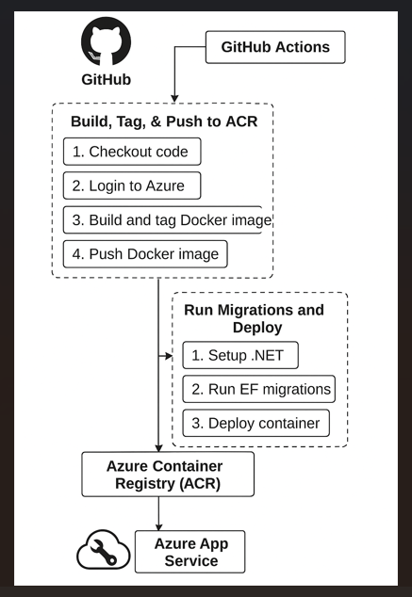

Azure Components Involved
Azure Container Registry (ACR)
- Stores built Docker images.
- The workflow logs in using the ACR name extracted from the login server.
Azure App Service
- Host environment for running the container.
- Pulls images from ACR.
Azure SQL Database
- EF Core database migrations are applied during deployment.

GitHub Secrets Required
Secret Name | Purpose
AZURE_CREDENTIALS | Service Principal JSON for Azure login
AZURE_SQL_CONNECTION_STRING | Connection string used for EF Core migrations

Job Breakdown
Job: build_and_push
- Builds the Docker image.
- Tags the image with commit SHA.
- Pushes to ACR.
- Must complete before deployment.
Job: deploy
- Runs only on push to master.
- Performs EF migrations using the ASP.NET project as startup.
- Deploys the newly pushed container to Azure App Service.

Key Workflow Benefits
- Immutable deployments using commit-based image tags.
- Separation of concerns between build and deploy jobs.
- Database migrations included ensuring schema consistency.
- Secure authentication using GitHub Secrets and Azure Service Principal.
Fully automated from commit → build → push → migrate → deploy.

