**COMP1710/COMP6780: Laboratory 2**

**MOOC Week 1-3, HTML Forms and Links**

**1. Objectives**

This lab aims to familiarise you with creating tables and forms using HTML. You will also update your files on Partch. You will repeat this process when doing your assignment 1 to 3.

Specifically, you will:

* Create HTML Forms
* Edit images using HTML and CSS
* Create a Source Log
* Create a HTML Feedback Form
* upload your assignment.html and index.html page into your public_html space of your account on Partch,

MOOC online learning for week 1-3 is open this week,

**Please be sure to complete this week’s quizlets by the end of the week!**

**2. HTML Tasks**

**2.1 Create a new Lab 2 Folder**

1. Create a folder called “COMP1710_Lab2”

**2.2 First edit of HTML content: Headings & Paragraphs**

1. Use your text editor to create a new me.html file and add the basic structure as introduced in the previous lab.
2. Put in the basic skeleton of an HTML file, and update the Heading and Paragraph to include:
   1. Open Heading tag
   2. Write “About me”
   3. Close Heading tag
   4. Open Paragraph tag
   5. Write a self-introduction within the paragraph tag
   6. Close Paragraph tag
3. Save the file and open it using your web browser.

**2.3 Second edit of HTML content: Links**

1. Open the “me.html” created in step 2.1 using your text editor.
2. Fulfill the following requirements, which include:
   1. Insert another heading tag and write “My passion”. Don’t forget to close the heading tag.
   2. Insert another paragraph tag below “My passion”, and write a description of your hobbies. Don’t forget to close the paragraph tag.
   3. Add an absolute hyperlink which goes to the anu website
   4. Create two anchor hyperlinks which go to About me and My passion heading
   5. Create a simple navigation menu using the two anchor hyperlinks
3. Save the file and open it in your web browser to view the effect of your revised HTML.

**2.4 Third edit of HTML content: Images.**

1. Open the “me.html” created in step 2.1
2. Fulfill the following requirements, which include:
   1. Create a folder in your project directory and name it as “Images”
   2. Download an image and put it insides the “Images” folder.
   3. Below the introduction of “my passion”, insert the image in the “me.html”
3. Save the file and open it in your web browser to view the effect of your revised HTML.
4. Now reopen your me.html and rescale the image so that it is 400px in width.
5. Use CSS to convert the image to grayscale (Hint: you can use “filter: grayscale(100%);” in your CSS file).
6. Save the file and open it in your web browser to view the effect of your revised HTML.

**2.5 Source Log**

* + 1. Create a new file and save it to the lab folder as “sourcelog.html”.
    2. Open the “sourcelog.html” using your text editor, and put in the basic skeleton of an HTML file, which includes:
       1. Set doctype
       2. Open HTML tag
       3. Open Head tag
       4. Insert Title
       5. Close Head tag
       6. Open Body tag
       7. Close Body tag
       8. Close HTML tag
    3. Inside the body tag, insert a heading of “Sources Log”
    4. Below the heading of “Sources Log”, create a table.
    5. Inside the table, create a header row with three columns, namely “Original”, “Type” and “How Altered or Justification”.
    6. After the header row, create two rows of empty cells.
    7. Edit the table based on the following requirements:
       1. The cell on the first row and the first column contains a link that goes to the original URL of the image (that is where you downloaded this image from).
       2. The cells on the second column contain a text that specifies the type of these images (you can use “Graphic” as their type) .
       3. The cell on the first row and the third column should contain a text describing how you altered the image (e.g. We resized it in step 2.2.5).
    8. Inside the table, create a caption that describes the content of the table.
    9. Save the file and open it in your web browser to view the effect of your revised HTML. It may look similar to the following picture.

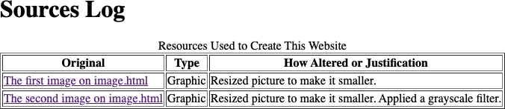

**2.6 Feedback Form**

* + 1. Create a new file and save it to the lab folder as “feedback.html”.
    2. Open the “feedback.html” using your text editor, and put in the basic skeleton of an HTML file, which includes:
       1. Set doctype
       2. Open HTML tag
       3. Set language
       4. Open Head tag
       5. Insert Title
       6. Close Head tag
       7. Open Body tag
       8. Close Body tag
       9. Close HTML tag
    3. Inside the body tag, insert a heading of “Feedback Form”.
    4. Create a form which contains:
       1. A label named “Your name” and a text box for users to fill in their names.
       2. A label named “Your email address” and a text box for users to fill in their email addresses.
       3. A label named “What is your gender?” and a radio button allowing users to select from “Male”, “Female”, “Other” and “I prefer not to say”.
       4. A label named “Please fill in your feedback” and a text area for users to fill in their feedback.
       5. A submit button named “Send it”. If you click on the button, it will prompt up an email app that shows your email address as the receiver.

**You can try adding 'method=post' to submit the fields to the email.**

* + - 1. A button named “Clear” which will clear all the filled content in the form upon a click.
    1. Save the file and open it in your web browser to view the effect of your revised HTML. It may look similar to the following picture.

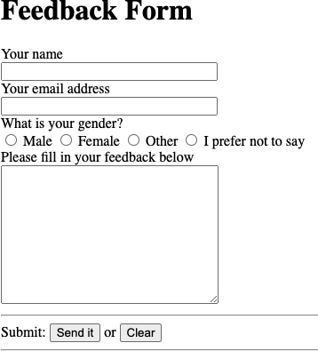

## Validate your HTML file

* + 1. Submit your file to W3C validation service and understand the errors that are returned.

# Edit your assignment.html

1. Download “assignment.html” from Wattle and save it to the lab folder. (Feel free to reuse the assignment.html you edited in lab 2)
2. Open “assignment.html” with your text editor to fulfill the following requirements:
   1. Insert a relative link in section 1.5 which goes to the sourcelog.html
   2. Insert a relative link in section 1.6 which goes to the feedback.html
   3. Put in some comments in section 1.5 and 1.6 if desired.
   4. Delete the sentences of “Replace this line with your URL link to this element in your website” in section 1.5 and 1.6.
3. Save the file and open it in your web browser to see if you can click on each link on your assignment.html file.

# Upload your website to partch

1. Follow the steps documented in COMP1710 Submission Guide 2023 to upload all the files to the public_html folder in partch, which include:
   1. sourcelog.html
   2. feedback.html
   3. assignment.html
2. Use your web browser to access the uploaded assignment.html under your Partch account (e.g. by opening [http://Stuweb.CECS.anu.edu.au/~uid/assignment.html](http://Stuweb.CECS.anu.edu.au/~uid/assignment.html%20) ) and see if all the links are clickable
3. Use your web browser to access the uploaded sourcelog.html under your Partch account (e.g. by opening [http://Stuweb.CECS.anu.edu.au/~uid/sourcelog.html](http://Stuweb.CECS.anu.edu.au/~uid/sourcelog.html%20) )
4. Use your web browser to access the uploaded feedback.html under your Partch account (e.g. by opening [http://Stuweb.CECS.anu.edu.au/~uid/feedback.html](http://Stuweb.CECS.anu.edu.au/~uid/feedback.html%20) )