User Manual:

Python 3.0 and up

\*Install fpdf module via pip install fpdf if choose to enable this function\*

-Main Page-

\* The default timer limit is 30 minutes\*

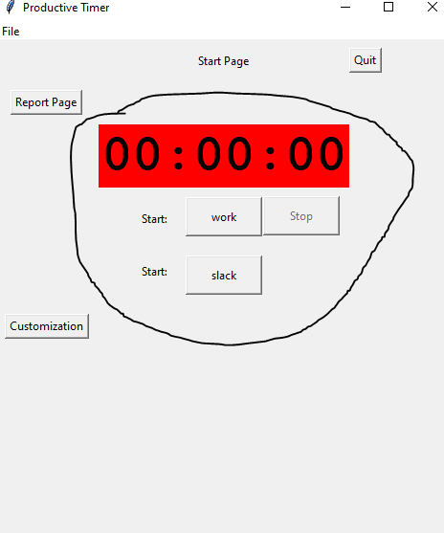

Clicking either start button will start the timer.

Click the stop button to stop it early and record that time.

Once the timer hit it timer limit it will play a sound and popup a message to warn user the time has reached.

-Customization-

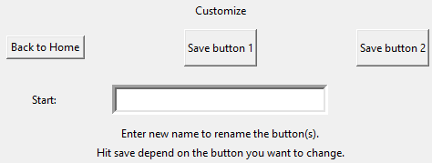

Renaming buttons (default: work and slack):

To rename a button enter a desired name in the field box and hit save according to the button that you want to change.

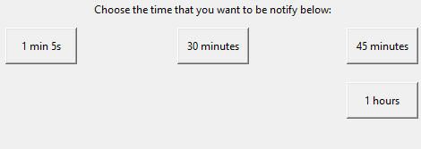

Changing the timer limit:

Clicking any of the button in that bottom line will set the timer limit to that time according to the button name.

-Report-

Sort:

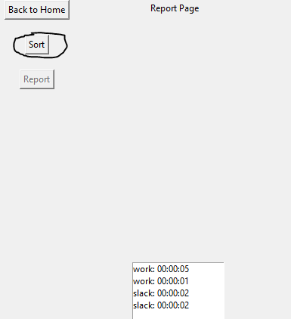

|

|

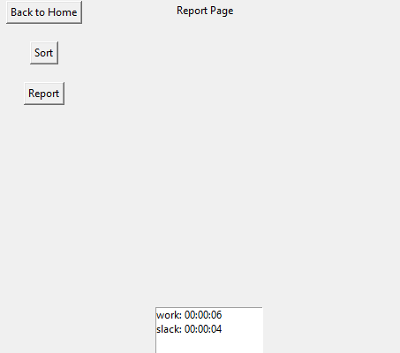

Clicking the sort will added up all the time in the list according to the button. Meaning button 1 will only added in button 1, and button 2 will only add in button 2.

Report:

Report button is unavailable when first started the program

To enable, click the sort button first

Report will save the timer list into a pdf file, and pdf file will be named as current date (ex. 2021-04-27)

The pdf is located at where you run this program.