This documents show how to create a multiple filter from ModernAD

In the table, clic on Search Builder

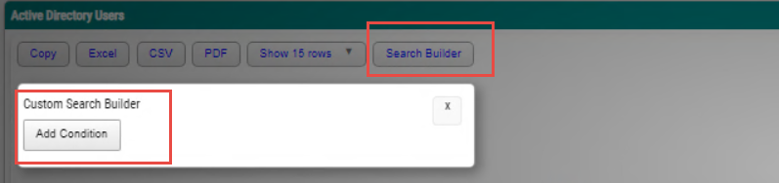

And then click to 'Add Condition'

Select your parameters and then conditions you want

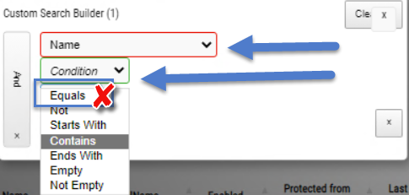

Note: Pls do not use the conditions Equals for parameters have more than two value result

You can added more condition and value, and also switch between And/OR

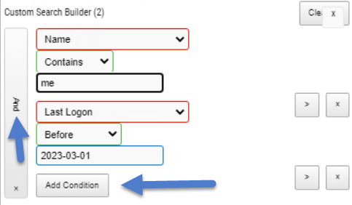

## Close Search Tab:

To close the search tab with keeping the result, pls click to the top X



Clear Search Tab Result :

To clear the current filter, plus clic on the X from all conditions you want to remove

