This documents show how to do a sample search with ModernAD

In this example we will information from table

In the tab home, chose a category:

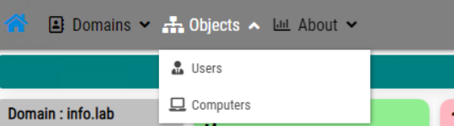

And enter in the right box a part of string to search, in our exemple I enter MEH for mehdi and the filter is immediately

