.git --> is the heart of the git process (.git is hidden file, see using ls -a)
maintains and keeps track of code changes, hash f()s etc
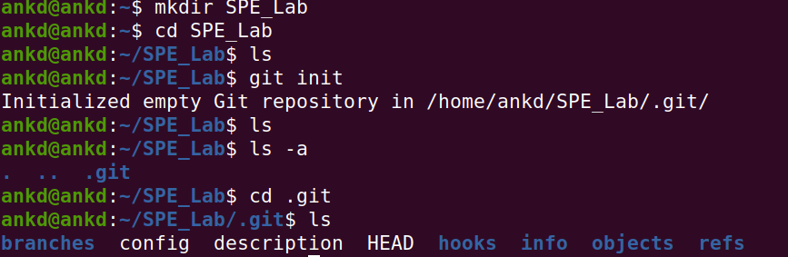

add remote repo ie cloud remote repository
1. initialize git and then add remote
or
2. create from github

git remote add origin https://github.com/AnkD165/devops-class.git
use this to set the origin cloud details ie whenever we want to push & pull
git remote -v //see the push pull link

username, pwd & ssh needed to access the cloud along with link

git status -> checks if there are files that are not added to git yet, commited yet. They are called untracked files.
Here just created a simple text and hence that file shows up as the untracked one here.
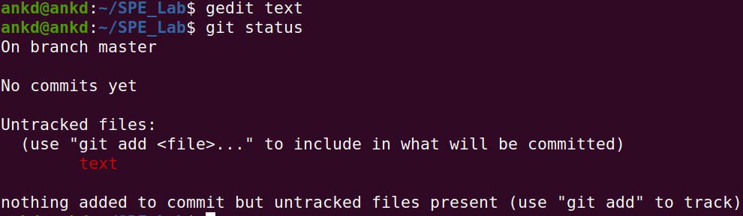

git add . //ie add all untracked files from untracked to staged state. Instead of all files we can add file names to only add those file for staging.
Now commit
git commit -m "created file: text" // -m means commit with any msg
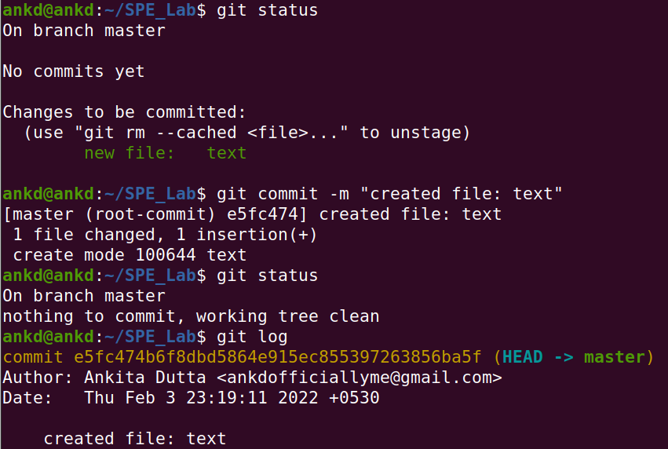
files go through stages
untracked -> staged -> unmodified
so once a file is committed and changed again, it shows up under modified. Whereas a newly created file that hasn’t been committed once shows up as untracked.
We can add and commit is as before.
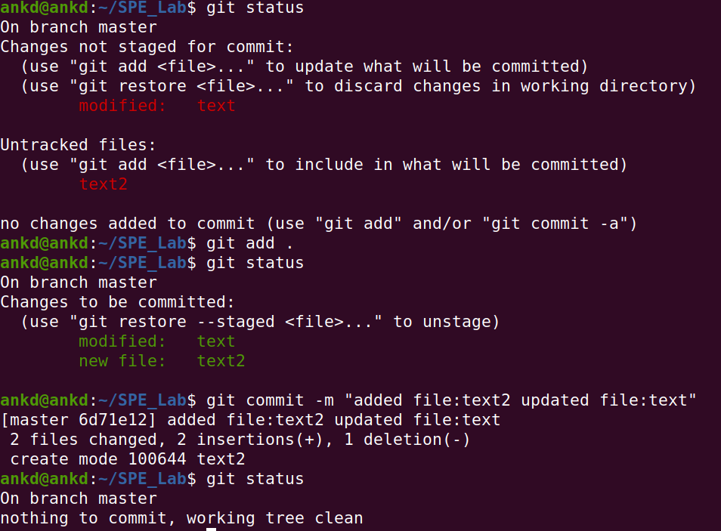
git ls-files -s //gives the hash state of the updates on files
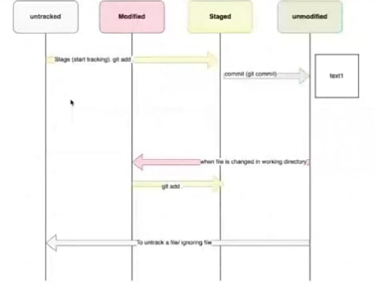

nkllllllllllllllllllllll

