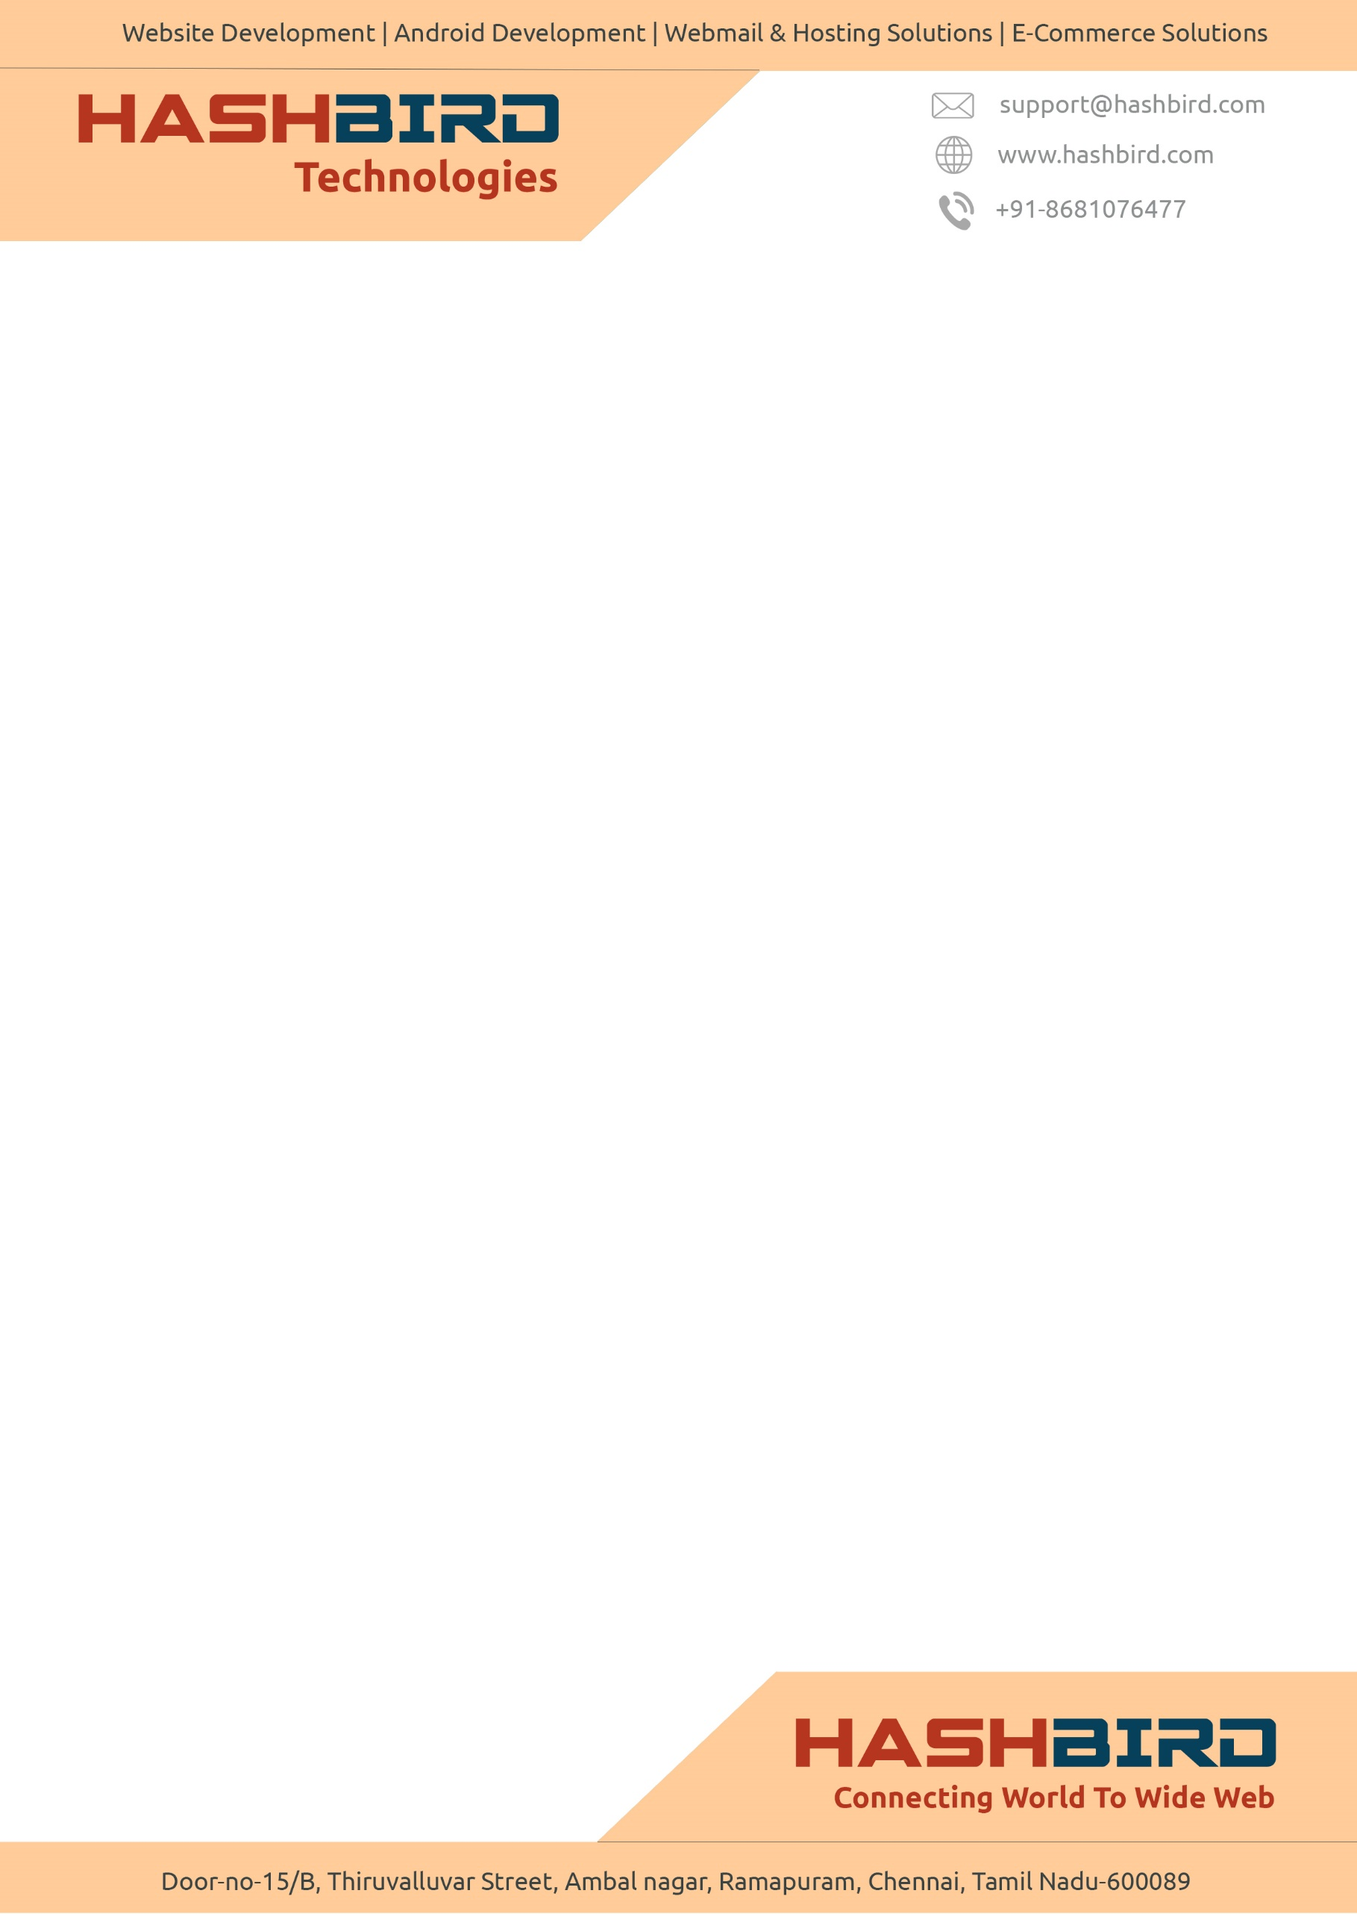**Gokulraj & Dinesh Chartered Accountant Resource Management System**

Web based application for resource management.

The Application Consists of three login panels

* Super Admin
* Admin
* Articles

**Hierarchy**

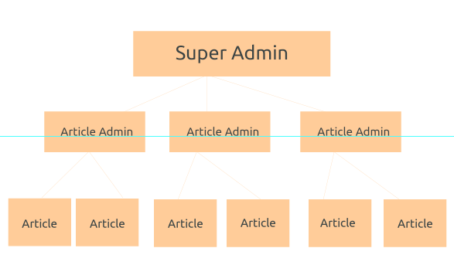

**Super Admin**

* **Add Tasks, Primary Tasks and Sub Tasks**
* **Add Clients Articles and Article Admins**
* **Assign Admin to articles**
* **Assign Clients to articles**
* **View all data of clients**
* **Send Visit Request to Article admin**
* **View data client wise, Article Wise and Date wise**
* **Can Export Excel Format Data**
* **Assign Task to Article for a client**
* **View Ranking of article**
* **Can Modify Entries, Client Details, Admin Details And Article Details**

**Article Admin**

* **Accept Or Reject Visit Request from Super Admin**
* **Can manage article details under them**

**Securities**

* Data on database will be fully encrypted and cannot be understood by the hacker hacking in to database

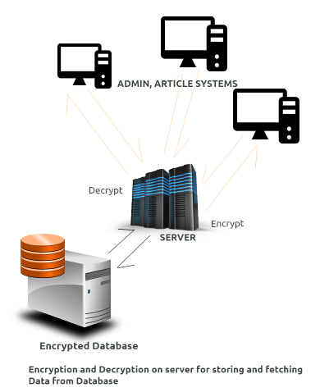

* Logs for all Events going in Article, Article Admin and Super Admin Account will be created.
* Ip Address Monitoring and storing for every login and app visit
* Logs for last login details
* Blacklisting ip Addresses, etc