VERIDEX
Distribution Operating System
Functional & Data Specification
Carrier · MGA · Agency · Insured — one distribution hierarchy, AI-first
Field | Value
Client | Southlake Insurance
Prepared by | Fynix Consulting
Prototype | Client review build — sample data only, no backend
Version | v2 — supersedes the initial onboarding-only draft
Status | Living document — updated as the clickable prototype evolves

1. Executive Summary
Veridex is the operating system for insurance distribution: it lets a carrier onboard and manage its MGAs, lets each MGA build and manage its own book of agencies, and lets each agency onboard and service its own customers — with every one of those relationships carrying its own states, lines of business, and classes of business. Every capability in the product exists on two equal paths: a manual UI form/table, and an equivalent natural-language "Ask Veridex" request that drives the same underlying action. Nothing is AI-only or manual-only.
This document specifies the platform as currently represented in the clickable prototype (Veridex_Prototype.html / veridex-app.js), covering the ownership hierarchy, every functional module (onboarding, branding, network filtering, performance analytics, executive dashboards, CRM integration, marketing/leads, broadcasts, and the insured/customer portal), the underlying data model, and the data flow through the system (Section 8).
Prototype scope note
The current build is a self-contained, client-side HTML/JS prototype with sample data and no backend, database, or authentication. It is built to demonstrate every workflow end-to-end for stakeholder review. Section 9 lists what is out of scope for this build and would be required for a production system.

2. Business Model & Ownership Hierarchy
Distribution authority flows in one direction only, and the platform enforces this structurally rather than by convention:
- A Carrier appoints and owns MGAs. A carrier never appoints or owns an agency directly.
- An MGA appoints and owns Agencies. Each MGA builds its own independent downline.
- An Agency onboards and owns Insureds/Customers. Each agency has its own book of business.
- Every relationship (carrier→MGA, MGA→agency, agency→customer) carries its own states, lines of business, and classes of business — a single agency can hold several independent relationships, each scoped differently.
Tier | Owns (downline) | Cannot directly own | Example in this build
Carrier | MGAs | Agencies, Customers | Southlake → Futuristic Underwriters, Lonestar Underwriting Group, Summit Underwriting Partners
MGA | Agencies | Customers (of another MGA), Carriers | Futuristic Underwriters → Links, Lone Star Brokerage, Gulf Coast Agency
Agency | Customers / Insureds | Agencies, MGAs, Carriers | Links → Ishant, Vela Freight Co
Insured | — | — | Views its own policies only

3. Portals & Personas
Each tier logs into its own branded, separately-configurable workspace. A single top bar lets a reviewer switch between the four demo personas.
Portal | Persona in this build | Primary job to be done
Carrier | Southlake (Dana Reyes, Administrator) | Appoint and govern MGAs; see network-wide performance and compliance
MGA | Futuristic Underwriters (Ishant P.) | Build and manage an agency downline; underwrite delegated authority
Agency | Links (Sam Okafor) | Place business with customers; the producer-facing broker workspace
Insured | Ishant | View policies, ask about renewals, refer business

4. Feature Specifications

4.1 Onboarding & Hierarchy Management
Every tier onboards exactly the level below it, never a peer or a level below that:
- Carrier portal → "Onboard an MGA" only.
- MGA portal → "Onboard an Agency" only.
- Agency portal → "Onboard a Customer" only.
Each onboarding page offers two equal paths: a manual sectioned form, or an AI-guided invite ("Ask Veridex" drawer) that gathers the same fields conversationally, reads an uploaded document (state licence / delegated authority agreement), verifies it against NIPR and the Secretary of State, and produces the same outcome — a new tenant, a live relationship edge scoped to a state/class/line, and an agreement sent for e-signature.

MGA / Agency onboarding fields
Field names below are sourced from the client’s own Southlake back-office schema (carrier-form / mga-form) so the prototype’s vocabulary matches the real system of record.
Section | Fields
MGA / Agency Information | Name, DBA Name, Code, Display Id
Licensing & Compliance | FEIN/EIN (##-#######), NPN (10 digits), Domiciled State, Licensed States (multi-select)
Address | Address, Zip (drives auto city/state lookup), City, State
Operational Settings (MGA only) | Open Item (Y/N), Op Start Date
Business Contact | Business Email, Official Phone, Mobile
Additional Contacts | Contact Type/Role, Name, Email, Phone (repeatable)
Documents required: delegated authority agreement (MGA) or state producer licence (Agency), E&O certificate, and a W-9. Verification: NIPR + Secretary of State + zip lookup. Result: new tenant created, added to the parent’s downline array, and a distribution/delegated-authority agreement sent for e-signature.

4.2 Branding & Partner Invites
Every tier — Carrier, MGA, and Agency — can configure its own portal appearance independently: display name, logo initials, tagline, accent color, background color, and light/dark/auto theme. This is deliberately per-organization, not per-role, so a carrier and its MGAs can each look distinct.
- A live preview renders the sign-in card exactly as a recipient would see it before saving.
- "Generate invite preview link" produces a shareable (simulated) URL plus an in-app preview, so a carrier/MGA/agency can show a prospective downline partner what their branded workspace will look like before they commit to onboarding.
- Southlake’s own brand (navy #0D1B4B / coral #E05470, and its concentric-arc logo mark) is wired in as the carrier’s default branding, pulled from the client’s existing Angular admin app design tokens.

4.3 Network Directory & Filters
Each tier sees only its direct downline: Carrier sees its MGAs, MGA sees its agencies, Agency sees its markets (its own MGA and that MGA’s carrier, read-only). A relationship graph visualizes the tier at the centre with its downline around it.
Filters are real, not decorative: State, Class of business, Line of business, Status (active/warning/attention), and free-text search — all recompute the table and the graph together, with a result count and a "Clear filters" action. The identical filter can be set conversationally ("filter agencies to TX and trucking with active status").
Selecting any row opens a "Partner 360" — states authorised, production YTD, lines/classes of business, and (for MGAs/agencies) a direct link into that entity’s Performance page.

4.4 Performance Analytics
One parameterized view serves three audiences:
- Carrier → MGA performance: production, growth, loss ratio per MGA, with a state × class-of-business breakdown and a read-only rollup into that MGA’s own agencies.
- MGA → Agency performance: identical shape one tier down, drilling into each agency’s own customers.
- Agency → Customer book: per-customer state, class of business, coverages, premium, and status.
The same breakdown is available conversationally ("which MGA has the best loss ratio?") and returns the matching state × class matrix inline in the Ask Veridex drawer.

4.5 Executive Dashboard
The dashboard is a dense, single-screen financial/operational view, modeled on the client’s own Executive Dashboard reference design:
- Toolbar: Period (MTD / QTD / YTD / ITD), an entity filter scoped to the tier below (MGA / Agency / Customer), State, Line of business, and Clear Filters — every KPI, chart and grid on the page reacts to this toolbar.
- Tab strip: Home/Metrics, Action Center (live count of items needing attention), and MGA/Agency/Customer Contributions (ranked share-of-production view with a link into full Performance).
- Financials view toggle: Gross / Ceded / Net, applying a cession-rate multiplier to every premium figure.
- KPI cards (carrier tier mirrors the client’s own reference figures exactly): Written Premium, Earned Premium, Unearned Premium, Claim Settlement, Loss Ratio, Expense Ratio, Combined Ratio — each with a period-over-period delta, a caption, and a status badge (e.g. STRONG / MONITOR / ON TRACK / EXCELLENT). MGA and Agency tiers get an equivalent, tier-appropriate KPI set (Bound/Placed Premium, Commission Earned, Active Agencies/Customers, Open Leads, Markets Appointed).
- Trend charts: Written Premium Trend and Claim Settlement Trend (bar), Ratio Trend — Loss/Expense/Combined (line) — rendered as native charts, not decorative bars.
- Production by state × line-of-business grid: the core cross-cut requested by the client — for a carrier this is production per MGA per state per LOB (selectable per MGA from the toolbar); for an MGA it is per agency per state per LOB; the grid respects the active State/LOB/entity filters.
- A live "AI onboarding, in one click" card demonstrates the onboarding flow inline with a real working button, so the ease of the AI path is shown, not just described.

4.6 CRM & Lead Integration
Available to Carrier, MGA, and Agency. Connect HubSpot, Salesforce, or Zoho (simulated OAuth for this build), or use a generic webhook/API key to push/pull leads from any other system. A "tracked leads" table lists every lead — manually added, CRM-synced, or platform-routed — in one place, and leads can be added manually with no CRM at all. Reachable conversationally ("connect my CRM", "add a lead").

4.7 Marketing & Leads
Each entity runs its own marketing campaigns in its own CRM (HubSpot, Salesforce, etc.); Veridex turns campaign activity into routable leads and keeps a full custody trail (which entity touched a lead, in order) without owning the marketing data itself.

4.8 Product & Appetite Broadcasts
Carriers and MGAs push new-state/line/class announcements down their network; recipients get an in-app alert, email, and CRM webhook, with delivery and addendum-acceptance tracked per recipient.

4.9 AI Assistant ("Ask Veridex")
A single natural-language entry point (top bar and a slide-in drawer) classifies free-text intent and routes it to the matching flow: onboarding (partner or customer), branding, network filtering, performance analysis, CRM/lead actions, broadcasts, lead routing, referrals, and policy questions. Every flow surfaces its source data (OCR, NIPR, Secretary of State, or user-entered) before committing an action, and every committed action is mirrored back into the manual UI (the org hierarchy, filters, and dashboards update immediately).

4.10 Insured / Customer Portal
The lightest-weight portal: My Policies (now with effective and renewal dates, days-to-renewal, and a clickable detail view per policy), an embedded on-page assistant to ask about renewals/coverage without leaving the page, Refer & Earn, and Documents.

5. Data Model Reference
The prototype represents the hierarchy as a single keyed object graph (ORGS), where every carrier, MGA, agency, and insured is one record carrying its own children array, so ownership is structural rather than conventionally implied.
Field | Present on | Purpose
type | all | CARRIER / MGA / AGENCY / INSURED
parentId | MGA, Agency, Insured | Points at the exact owning tenant — the structural enforcement of the hierarchy
mgaIds / agencyIds / customerIds | Carrier / MGA / Agency | The owned downline, read via a single childrenOf(orgId) helper
perf.grid | MGA, Agency | State → class-of-business → premium — the source for every state × LOB grid and matrix
brand | Carrier, MGA, Agency | accent, bg, logoText / logoSvg, theme, tagline — per-organization white-label config
licensedStates | Agency | States licensed, independent of where premium is currently active
status / statusL | all | Drives every alert, badge and Action Center item network-wide

6. Data Flow Diagrams
Two views of the same system: a Level 0 context diagram (the platform as one process, seen from outside), and a Level 1 diagram decomposing that process into its six functional sub-processes and their data stores.

6.1 Level 0 — Context Diagram
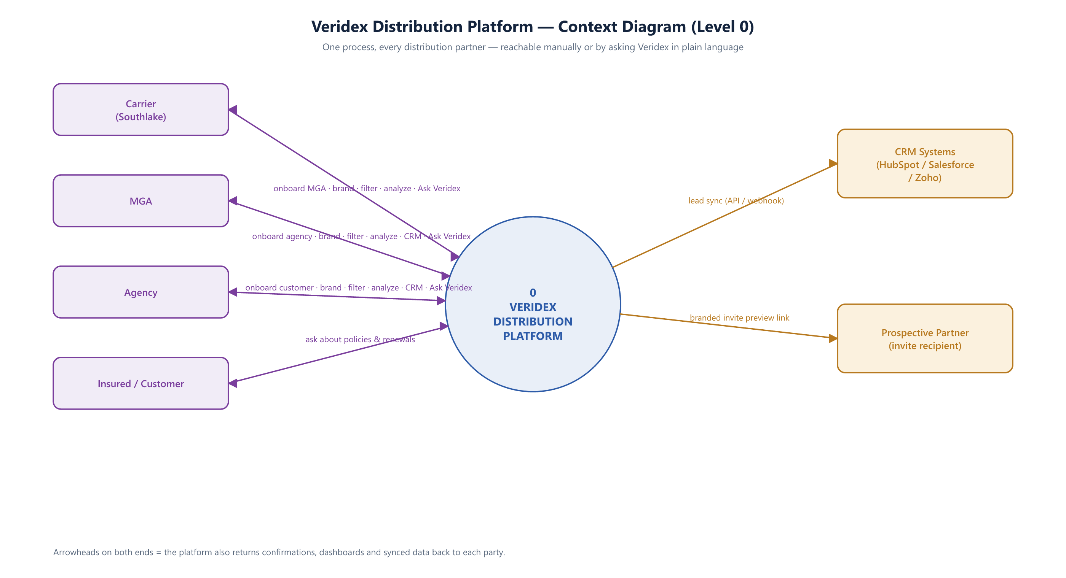
Figure 1 — every external entity and system that exchanges data with the platform, and what flows each way.
Carrier, MGA and Agency each carry the same five-fold flow into the platform (onboard the tier below, configure branding, filter their downline, analyze performance, and — for MGA/Agency — connect a CRM), all of which are reachable manually or by asking Veridex. The Insured only asks about policies and renewals. Outbound, the platform syncs leads with external CRM systems and sends branded invite-preview links to prospective partners.

6.2 Level 1 — Process Decomposition
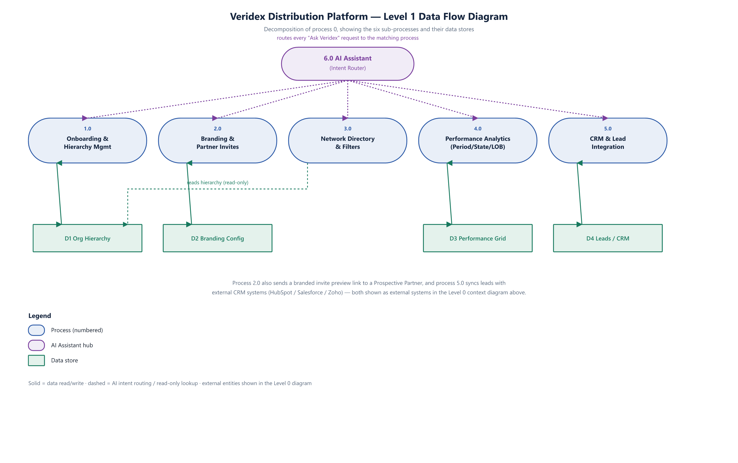
Figure 2 — the six sub-processes behind process 0, and the data stores each one owns or reads.
Process 6.0 (the AI Assistant / intent router) is the single entry point for every natural-language request and dispatches it to whichever of processes 1.0–5.0 matches; the same five processes are equally reachable directly through the manual UI. Process 3.0 (Network Directory & Filters) only reads the org hierarchy store (D1) — filtering never mutates the hierarchy. Processes 2.0 and 5.0 are the only two with an outbound edge to an external system (Prospective Partner and CRM Systems respectively, both detailed in the Level 0 diagram).

7. Design System Notes
- Southlake’s real brand tokens are wired in as the carrier default: navy #0D1B4B, coral #E05470, "Instrument Sans"-style clean sans-serif, 8px/12px corner-radius convention, and a three-tier shadow scale — sourced from the client’s own Angular admin codebase design tokens.
- Every other MGA/Agency in the network carries its own independent brand (accent, background, logo, tagline), editable on its own Branding page — nothing is hard-coded to the carrier’s palette.
- Responsive breakpoints collapse the KPI grid and chart row from 4/3-wide down to 2-wide (≤1200px) and 1-wide (≤640px); the sidebar collapses below 920px.

8. Open Items / Next Steps
Out of scope for the current client-review prototype, and required before a production build:
- A real backend, database, and authentication/authorization layer (today: static in-memory sample data, no persistence between sessions).
- Real NIPR / Secretary of State / zip-lookup integrations (today: simulated verification with mock delays).
- Real CRM OAuth (HubSpot/Salesforce/Zoho) and webhook delivery (today: simulated connect/sync).
- Real e-signature integration for distribution/delegated-authority agreements (today: a toast confirmation).
- Multi-carrier support — the hierarchy currently models a single carrier (Southlake) with three MGAs; the same Carrier-form field schema pulled from the reference repo would apply if/when a second carrier is onboarded onto the platform.

