Spring Cloud Microservices
Architecture & Implementation Notes
─────────────────────────────────────────
Bhanu Ankalam | 2026

Quick Reference — Service Ports
Service | Port | URL
service-registry | 8761 | http://localhost:8761
cloud-config-server | 9196 | http://localhost:9196
cloud-gateway | 8989 | http://localhost:8989
order-service | 9192 | http://localhost:9192
payment-service | 9191 | http://localhost:9191

1. Microservices Architecture Overview

This project implements a microservices architecture using Spring Cloud. Instead of one monolithic application, functionality is split across independent services that communicate via REST and are coordinated through a service registry, API gateway, and centralized configuration.

Microservices Architecture
🌐 Client / Postman |  | 📋 Eureka Server (Service Registry) localhost:8761
↓ All requests go through Gateway
🔀 API Gateway (localhost:8989) Circuit Breaker • Load Balancer • Routing • Fallback
↓ Routes to services via lb://
📦 Order Service localhost:9192 /order/** |  | 💳 Payment Service localhost:9191 /payment/**
↑ All services register with Eureka & fetch config from Config Server

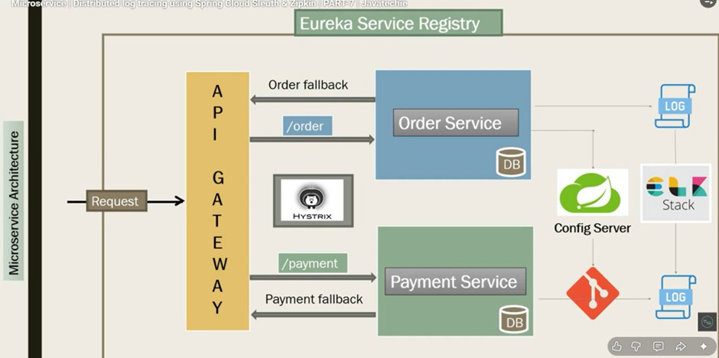
Fig 1: Microservice Architecture — Eureka Registry, API Gateway with Hystrix circuit breaker, Order Service and Payment Service with fallback handling

Startup Order
Always start services in this exact sequence to avoid registration failures:
Step | Reason
1. service-registry | Must be running first — all services register here
2. cloud-config-server | Must be up before services fetch their config
3. order-service | Registers with Eureka, fetches config
4. payment-service | Registers with Eureka, fetches config
5. cloud-gateway | Last — routes to all registered services

2. Service Registry — Eureka

Eureka acts as a phone book for all microservices. Instead of hardcoding host:port of each service, every service registers itself with Eureka on startup and discovers other services by name.

Setup
- Add @EnableEurekaServer to main class of service-registry
- Verify at: http://localhost:8761
- All other services add @EnableDiscoveryClient to register themselves

Eureka Config (in each service)
eureka:
client:
register-with-eureka: true
fetch-registry: true
service-url:
defaultZone: http://localhost:8761/eureka
instance:
prefer-ip-address: true

Key Rule — Service Naming
Always use HYPHENS in service names, never underscores.
WRONG: spring.application.name: ORDER_SERVICE
CORRECT: spring.application.name: ORDER-SERVICE

Underscores in lb://ORDER_SERVICE are invalid URI hostname characters and cause:
java.lang.IllegalStateException: Invalid host: lb://ORDER_SERVICE

3. API Gateway — Spring Cloud Gateway

The API Gateway is the single entry point for all client requests. It handles routing, load balancing, circuit breaking, and fallback responses — clients only need to know the gateway URL.

Why API Gateway?
 | Description | Example
Without Gateway | Client calls each service directly | Client → order-service:9192 Client → payment-service:9191
With Gateway | Client calls one endpoint only | Client → gateway:8989/order/** Client → gateway:8989/payment/**

Real World Analogy: Hotel Reception
Hotel Reception = API Gateway
Without gateway → Guest goes directly to kitchen, housekeeping, maintenance separately
With gateway → Guest calls reception → reception routes to right department

Gateway Request Flow
API Gateway Request Flow
Client Request POST /order/bookOrder
↓
API Gateway :8989
↓
Route Matching Path=/order/** → lb://ORDER-SERVICE
↓
Circuit Breaker Check (Resilience4j)
↓
Eureka Lookup ORDER-SERVICE → localhost:9192
↓
Forward Request → Order Service

Gateway application.yml
spring:
cloud:
gateway:
discovery:
locator:
enabled: true
routes:
- id: order-service
uri: lb://ORDER-SERVICE # lb:// = load balanced via Eureka
predicates:
- Path=/order/**
filters:
- name: CircuitBreaker
args:
name: order-service
fallbackUri: forward:/orderFallBack

Key Dependencies — Gateway pom.xml
Dependency | Purpose | Status
spring-cloud-starter-gateway | Core gateway routing | Required
spring-cloud-starter-netflix-eureka-client | Register with Eureka | Required
spring-cloud-starter-loadbalancer | Resolve lb:// URIs | Required
spring-cloud-starter-circuitbreaker-reactor-resilience4j | Circuit breaker (reactive) | Required
spring-boot-starter-actuator | Health & metrics endpoints | Recommended

4. Spring Cloud Config Server

Config Server centralizes configuration that would otherwise be duplicated across every microservice — things like Eureka registration details, endpoint URLs, and environment-specific properties. Instead of each service hardcoding this, they all pull from a single Config Server backed by a Git repository.

Config Server Flow
GitHub Repo (application.yml) | → | Config Server :9196 | → | All Services (on startup)

One config change in Git → all services pick it up without code changes

Config Server Flow Reference
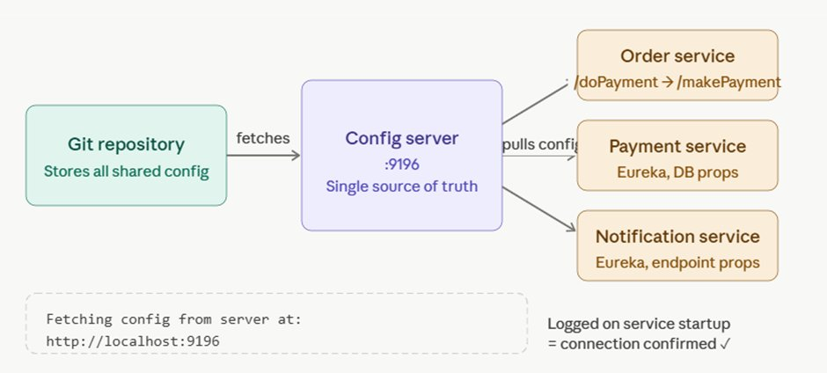
Fig 2: Config Server as single source of truth — Git repository stores shared config, Config Server at :9196 distributes to Order, Payment, and Notification services on startup

Why Git as the Backend?
- Version history — see exactly what config was active and when it changed
- Rollback — revert a bad config change instantly
- Branch-per-environment — dev/staging/prod branches with different configs
- Access control — control who can change configuration
- One change in Git → all services pick it up on restart (or instantly with @RefreshScope)

The URL Change Problem — Solved
Before Config Server
If /doPayment is renamed to /makePayment:
→ Update hardcoded URL in every service that calls it
→ Rebuild and redeploy each one
→ Risk of missing one service

After Config Server
If /doPayment is renamed to /makePayment:
→ Update ONE property in the Git repo
→ All services pick it up on restart (or instantly with /actuator/busrefresh)
→ Zero code changes, zero redeployment

What Lives in Config Server
- Eureka client settings (register-with-eureka, defaultZone, instance-id)
- Internal service URLs used between microservices
- Database connection details per environment
- Feature flags or timeout values shared across services

Config Server application.yml
spring:
application:
name: CONFIG-SERVER
cloud:
config:
server:
git:
uri: https://github.com/AnkalamBhanu/cloud-config-server
default-label: main
clone-on-start: true # clone on startup
force-pull: true # always pull latest
server:
port: 9196

Client Service bootstrap.yml
spring:
application:
name: ORDER-SERVICE # config server fetches ORDER-SERVICE.yml from git
cloud:
config:
uri: http://localhost:9196
fail-fast: false # don't crash if config server is down

Verify Config Server is Working
Hit these URLs after starting config server:
http://localhost:9196/ORDER-SERVICE/default
http://localhost:9196/PAYMENT-SERVICE/default
http://localhost:9196/GATEWAY-SERVICE/default

Each returns JSON with the properties for that service.
If you see 'Fetching config from server at: http://localhost:9196' in service logs — it's working!

5. Monitoring — Prometheus & Grafana

Prometheus scrapes metrics from each service's /actuator/prometheus endpoint. Grafana visualizes them in dashboards. Together they replace the Hystrix Dashboard.

Tool Responsibilities
Tool | Purpose | Answers
Resilience4j | Circuit breaking & fallback | Is my service failing? Should I stop calling it?
Prometheus + Grafana | Metrics & dashboards | How is my service performing? CPU, memory, error rates
ELK / Loki | Log aggregation & search | What exactly happened? Show me the ERROR logs

Docker Compose Setup
version: '3'
services:
prometheus:
image: prom/prometheus
ports:
- "9090:9090"
volumes:
- ./prometheus.yml:/etc/prometheus/prometheus.yml
grafana:
image: grafana/grafana
ports:
- "3000:3000"

Grafana Dashboard
- Import Dashboard ID 15757 for Resilience4j circuit breaker metrics
- Prometheus UI: http://localhost:9090
- Grafana UI: http://localhost:3000 (login: admin / admin)

6. Common Issues & Fixes

Error | Fix
Invalid host: lb://ORDER_SERVICE | Rename to ORDER-SERVICE (hyphen, not underscore)
IndexOutOfBoundsException: Index 0 | discoveryClient.getInstances() returning empty — wrong service name
Unable to find GatewayFilterFactory: CircuitBreaker | Add spring-cloud-starter-circuitbreaker-reactor-resilience4j
No spring.config.import defined | Add spring-cloud-starter-bootstrap dependency
src refspec main does not match | Run: git branch -m master main
Hystrix dependency not found | Hystrix is removed — use Resilience4j instead
BOM overriding explicit version | Remove explicit version tags, let BOM manage all Spring Cloud versions

7. Circuit Breaker — Resilience4j

Hystrix is dead — removed from Spring Cloud after 2020.0.x. Resilience4j is the modern replacement. It prevents cascade failures by opening the circuit when a service is failing, and serving a fallback response instead.

Hystrix → Resilience4j Migration
 | Hystrix (Old) | Resilience4j (New)
Annotation | @EnableHystrix | Nothing needed (auto-configured)
Dependency | spring-cloud-starter-netflix-hystrix | spring-cloud-starter-circuitbreaker-reactor-resilience4j
YAML key | fallbackuri (lowercase) | fallbackUri (camelCase)
Config prefix | hystrix.command.* | resilience4j.circuitbreaker.*
Dashboard | Hystrix Dashboard (dead) | Prometheus + Grafana or Actuator

Fallback Controller
@RestController
public class FallbackController {

@RequestMapping("/orderFallBack")
public Mono<String> orderServiceFallBack() {
return Mono.just("Order Service is down. Please try again later.");
}

@RequestMapping("/paymentFallback")
public Mono<String> paymentServiceFallBack() {
return Mono.just("Payment Service is down. Please try again later.");
}
}

Circuit Breaker Config
resilience4j:
circuitbreaker:
instances:
order-service:
sliding-window-size: 10
failure-rate-threshold: 50 # open circuit at 50% failure
wait-duration-in-open-state: 10s # wait before retry
timelimiter:
instances:
order-service:
timeout-duration: 3s # fallback if > 3 seconds

Monitoring Circuit Breakers
Endpoint | What it shows
/actuator/health | Circuit breaker state: OPEN / CLOSED / HALF_OPEN
/actuator/circuitbreakers | All instances and their metrics
/actuator/circuitbreakerevents | Full event history — calls, failures, fallbacks

Resilience4j — Circuit Breaker Implementation

Handling Payment Failure — 500 Error Response
When a Payment Service call fails with a 500 error, rather than stopping the user entirely, the better approach is to handle it gracefully using a Try-Catch block combined with the Circuit Breaker pattern. Since no service stays down indefinitely, the goal is to engage the user with a retry mechanism while the circuit breaker manages the downstream failure automatically.
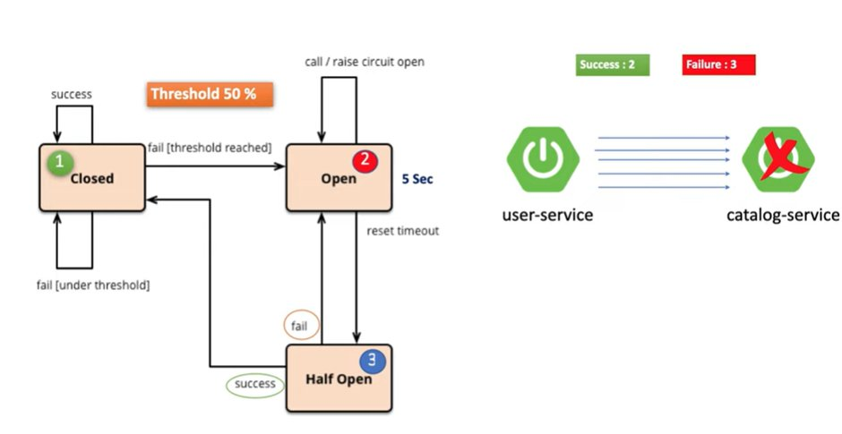
Fig 3: Circuit Breaker state transitions — Closed → Open → Half Open → Closed, with 50% failure threshold and 5-second reset timeout
Circuit Breaker State Machine (Threshold: 50%)
- CLOSED — Normal operation. All requests pass through. Individual failures that stay under the threshold loop back to CLOSED.
- OPEN — Triggered when failure rate exceeds the 50% threshold (e.g., 3 out of 5 requests fail). All calls are rejected immediately — no requests reach the downstream service. Circuit waits for 5 seconds before transitioning to HALF OPEN.
- HALF OPEN — A probe state after the 5-second wait. One test request is allowed. If it succeeds, the circuit moves back to CLOSED. If it fails, the circuit returns to OPEN.
Circuit Breaker Configuration (application.yml)
failureRateThreshold: 50
minimumNumberOfCalls: 5
automaticTransitionFromOpenToHalfOpenEnabled: true
waitDurationInOpenState: 5s
Monitoring via Actuator Health Endpoint
Use the following URL to inspect the current circuit breaker state for the payment service:
http://localhost:9192/actuator/health
When the payment service is failing, the response will show the circuit as CIRCUIT_OPEN, with a 100% failure rate (all 3 buffered calls failed), failure rate threshold of 50%, and state: “OPEN” — confirming the breaker has tripped and is protecting the system.
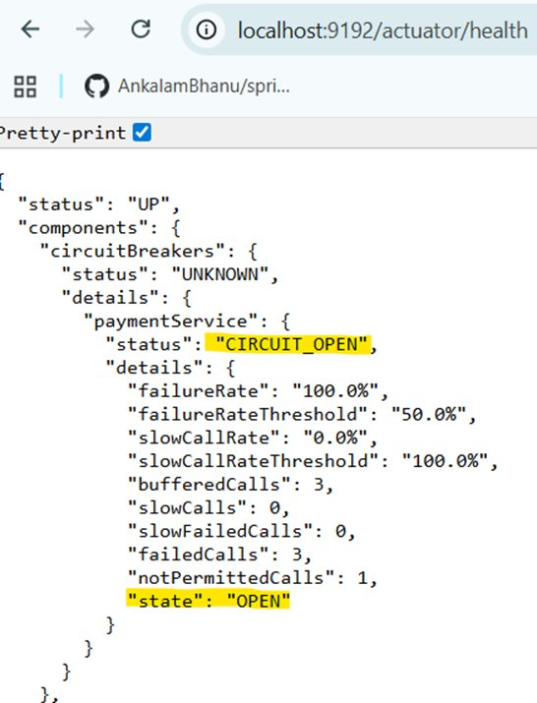
Fig 4: localhost:9192/actuator/health — paymentService circuit breaker is CIRCUIT_OPEN with failureRate 100%, failedCalls: 3, state: OPEN

Resilience4j — Full Feature Set
Resilience4j provides a comprehensive set of fault-tolerance patterns beyond just the circuit breaker. All features work independently or in combination:
Feature | Description
Circuit Breaker | Fault tolerant — prevents cascade failures by tripping open when failure rate exceeds threshold, serving fallback responses instead
Rate Limiter | Blocks too-frequent requests — caps the number of calls allowed within a time window to protect downstream services from overload
Time Limiter | Sets a time limit when calling remote applications — if the remote call does not complete within the configured duration, it is cancelled and a fallback is triggered
Retry Mechanism | Automatically retries a failed remote request — configurable with a max attempt count and back-off delay between retries
Bulkhead | Avoids too many concurrent requests — limits the number of parallel executions to a bounded pool, preventing one service from monopolising all threads
Cache | Stores results of costly remote operations — subsequent identical calls return the cached result instantly without hitting the remote service

Config Server Flow Reference

Fig 2: Config Server as single source of truth — Git repository stores shared config, Config Server at :9196 distributes to Order, Payment, and Notification services on startup

Spring Cloud Microservices Study Notes • Bhanu Ankalam • 2026

