Indian Road Accident Analysis

Executive Business Report

Prepared By

Ankan Sen
Bachelor of Technology
(B.Tech)
Computer Science & Engineering
Haldia Institute of Technology

A comprehensive data analytics project that analyzes Indian road
accident data using exploratory data analysis, business intelligence,
statistical techniques, and interactive dashboards to generate
actionable road safety insights.

Tools & Technologies:
Python • Pandas • NumPy •Matplotlib • Seaborn • Tableau

GitHub Portfolio:
https://github.com/AnkanXcoder

July 2026
Version 1.0

Table of Contents

Contents
Prepared By 1
1. Executive Summary 3
2.Project Objective 4
2.1 Background 4
2.2 Problem Statement 4
2.3 Project Objectives 4
2.4 Business Questions 4
3.Dataset Overview 5
3.1 Dataset Description 5
3.2 Dataset Summary 5
3.3 Key Features Used 5
3.4 Dataset Features 6
3.5 Data Dictionary 6
3.6 Dataset Preview 6
4. Data Cleaning & Preprocessing 7
4.1 Data Quality Assessment 7
4.2 Missing Value Analysis 4.3 Duplicate Record Analysis 7
4.4 Feature Engineering 7
5. KPI & Business Analysis 8
5.1 Introduction 8
5.2 Geographic Analysis 8
5.3 City Analysis 9
5.4 Time-Based Analysis 9
5.5 Weather Analysis 10
5.6 Road Infrastructure Analysis 10
6. Advanced Analytics 11
6.1 Introduction 11
6.2 Pareto Analysis 11
6.3 Risk Quartile Analysis 11
6.4 Risk Hotspot Analysis 12
Introduction 12
Key Findings 12
Business Interpretation 12
6.5 Fatality Rate Analysis 12
Introduction 12
Key Findings 12
Business Interpretation 12
7. Interactive Dashboard 13
7.1 Dashboard Overview 13
7.2 Dashboard Components 13
8. Business Recommendations 14
Introduction 14
Recommendation 1: Prioritize High-Risk States 14
Recommendation 2: Strengthen Traffic Enforcement During Peak Hours 14
Recommendation 3: Reduce Overspeeding 14
Recommendation 4: Enhance Emergency Response 14
9. Conclusion 15
9.1 Project Achievements 15
10. Future Scope 16
Introduction 16
10.1 Machine Learning-Based Accident Prediction 16
10.2 Real-Time Data Integration 16
10.3 Interactive Web Dashboard 16
10.4 Geographic Information System (GIS) Mapping 16
10.5 Automated Reporting System 16
Conclusion 16
11. Project Reflection 17
Introduction 17
Key Learnings 17
Challenges Faced 17
Indian Road Accident Analysis & Prediction 18
A Data Analytics & Business Intelligence Project 18
Prepared By 18
Tools & Technologies 18
Project Duration 18

Executive Summary

Road accidents are a major public safety challenge in India, leading to significant loss of life, injuries, and economic costs every year. Analyzing accident data helps identify high-risk locations, understand accident patterns, and support data-driven decisions for improving road safety.
This project analyzes 20,000 Indian road accident records using Python, Pandas, NumPy, Matplotlib, Seaborn, and Tableau. The analysis followed a structured workflow that included data cleaning, exploratory data analysis (EDA), business analysis, advanced analytics, and interactive dashboard development. The objective was to identify accident trends, evaluate risk factors, and generate practical recommendations for road safety improvement.
The analysis examined accidents from multiple perspectives, including geographical distribution, time, weather conditions, road infrastructure, accident causes, severity, and risk levels. Business intelligence techniques such as Pareto Analysis, Risk Segmentation, Risk Hotspot Score, Safety Score, and Executive Priority Score were applied to identify high-priority regions and factors contributing to severe accidents.
The findings revealed that Maharashtra recorded the highest number of accidents, while Karnataka had the highest fatality rate. Pune reported the highest number of fatal accidents, and Overspeeding emerged as the most impactful accident cause. The analysis also showed that fog created the highest weather-related accident risk, highlighting the importance of targeted interventions under adverse driving conditions.
Overall, this project demonstrates how data analytics can transform raw accident records into actionable business insights. The findings can support transportation authorities, policymakers, and urban planners in improving road safety, prioritizing infrastructure investments, and allocating resources more effectively. The project also provides a strong foundation for future predictive analytics, machine learning models, and interactive business intelligence dashboards for road safety management.

2.Project Objective

2.1 Background
Road accidents are a major concern worldwide, causing thousands of fatalities, injuries, and significant economic losses every year. In India, increasing urbanization, rapid growth in vehicle ownership, traffic congestion, and varying road conditions have made road safety an important public policy issue. Understanding accident patterns through data analysis can help identify high-risk areas, major contributing factors, and opportunities for preventive action.
By analyzing historical accident records, transportation authorities can make informed decisions regarding infrastructure improvements, traffic management, law enforcement, and emergency response planning. This project applies data analytics techniques to transform raw accident data into meaningful insights that support evidence-based road safety strategies.

2.2 Problem Statement
Road accident data contains valuable information, but the large volume of records makes it difficult to identify meaningful trends through manual analysis. Decision-makers often require clear business insights rather than raw data to support effective planning and resource allocation.
The primary challenge addressed in this project is to analyze accident data systematically, identify the factors associated with accident frequency and severity, and present the findings through meaningful visualizations, business metrics, and executive dashboards.

2.3 Project Objectives
- Analyze the distribution of road accidents across different states and cities.
- Examine accident trends based on time, weather, road type, and traffic conditions.
- Identify the leading causes contributing to severe and fatal accidents.
- Develop business KPIs to evaluate accident frequency, severity, and risk.
- Apply advanced analytical techniques such as Pareto Analysis, Risk Segmentation, and Executive Priority Scoring.
- Create an interactive Tableau dashboard for business users and decision-makers.
- Generate actionable recommendations to improve road safety and resource allocation.

2.4 Business Questions
- This project was designed to a-nswer several key business questions, including:
- Which states and cities experience the highest number of road accidents?
- Which regions have the highest accident severity and fatality rates?
- How do weather conditions affect accident frequency and severity?
- What are the most common causes of road accidents?
- Which time periods have the highest accident risk?
- Which locations should be prioritized for road safety improvements?

3.Dataset Overview

3.1 Dataset Description

This project uses a structured road accident dataset containing 20,000 accident records collected from multiple states and cities across India. Each record represents an individual road accident and contains information related to location, date and time, weather conditions, road characteristics, traffic conditions, accident severity, casualties, and calculated risk metrics.
The dataset was analyzed to identify accident patterns, evaluate road safety risks, and generate business insights. During the analysis, additional features such as Severity Index and Risk Quartile were created to improve analytical capabilities and support business decision-making.

3.2 Dataset Summary

Dataset Attribute | Value
Total Records | 20000
Total Features | 26
Geographic Features | 5
Temporal Features | 5
Road Features | 3
Environmental Features | 3
Traffic Features | 2
Accident Features | 5
Engineered Features | 2

3.3 Key Features Used

The analysis primarily focuses on geographical variables, accident timing, weather conditions, road characteristics, accident causes, severity levels, traffic conditions, and engineered risk indicators. These variables collectively provide a comprehensive understanding of accident frequency, severity, and associated risk factors.

3.4 Dataset Features
The dataset consists of variables describing accident location, time, road infrastructure, environmental conditions, traffic characteristics, accident outcomes, and engineered risk metrics. To improve understanding, the features have been grouped into logical categories based on their purpose in the analysis.

Feature Category | Variable | Purpose
Geographic | accident_id, city, state, latitude, longitude | Identify accident locations
Temporal | date, time, hour, day_of_week, is_weekend | Analyze accident timing
Road Infrastructure | road_type, lanes, traffic_signal | Evaluate road characteristics
Environment | weather, visibility, temperature | Assess environmental impact
Traffic | traffic_density, is_peak_hour | Analyze traffic conditions
Accident Details | cause, accident_severity, vehicles_involved, casualties | Measure accident outcomes
Engineered Features | risk_score, severity_index, risk_quartile | Support advanced analytics

3.5 Data Dictionary
Feature | Description
accident_id | Unique identifier for each accident
city | City where the accident occurred
state | State where the accident occurred
weather | Weather condition during the accident
road_type | Type of road where the accident occurred
accident_severity | Severity category of the accident
vehicles_involved | Number of vehicles involved
casualties | Number of casualties
risk_score | Calculated accident risk score
severity_index | Engineered metric representing accident severity
risk_quartile | Risk category created using quartile segmentation

3.6 Dataset Preview
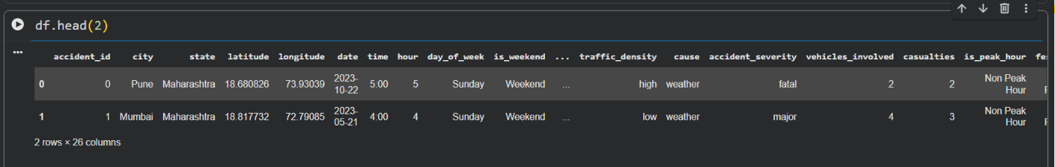
Figure 3.1: Preview of the Road Accident Dataset4. Data Cleaning & Preprocessing

4. Data Cleaning & Preprocessing

4.1 Data Quality Assessment
Before performing any analysis, the dataset was examined to evaluate its overall quality and consistency. The data quality assessment included checking the dataset structure, identifying missing values, detecting duplicate records, verifying data types, and validating the consistency of the variables. These steps ensure that the dataset is reliable and suitable for business analysis and visualization.
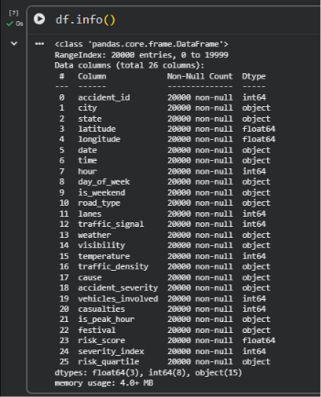
Figure 4.1: Dataset Structure and Data Types

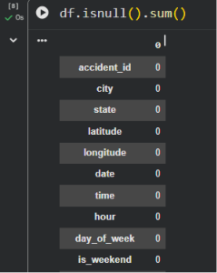
4.2 Missing Value Analysis 4.3 Duplicate Record Analysis
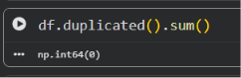
Duplicate records were examined to prevent repeated observations from influencing the analytical results. No duplicate records were identified; therefore, no duplicate removal was required.

4.4 Feature Engineering
Two additional analytical features were created during the project to improve business interpretation. The Severity Index was calculated by combining the number of vehicles involved and casualties, while Risk Quartile was generated using quartile-based segmentation of the Risk Score. These engineered features were later used in advanced analytics and executive KPI development.

5. KPI & Business Analysis

5.1 Introduction
The KPI and Business Analysis phase was conducted to evaluate road accident patterns from multiple business perspectives. The analysis focuses on geographical distribution, accident severity, risk levels, fatalities, and other operational indicators that support strategic decision-making. Key Performance Indicators (KPIs) were developed to summarize the overall performance of the dataset and identify areas requiring immediate attention.
Key Performance Indicator | Value
Total Road Accidents | 2000
Total Fatal Accidents | 2987
Overall Fatality Rate | 14.94%
Average Risk Score | 0.44
Average Severity Index | 6.32
Average Casualties | 1.72
Average Vehicles Involved | 3.00
Table 5.1: Executive KPI Summary.
The Executive KPIs provide a high-level overview of road accident characteristics across the dataset. While the total number of accidents indicates the overall accident burden, the Fatality Rate, Severity Index, and Risk Score provide deeper insights into accident impact and risk. These KPIs establish the baseline for the detailed business analysis presented in the following sections.

5.2 Geographic Analysis
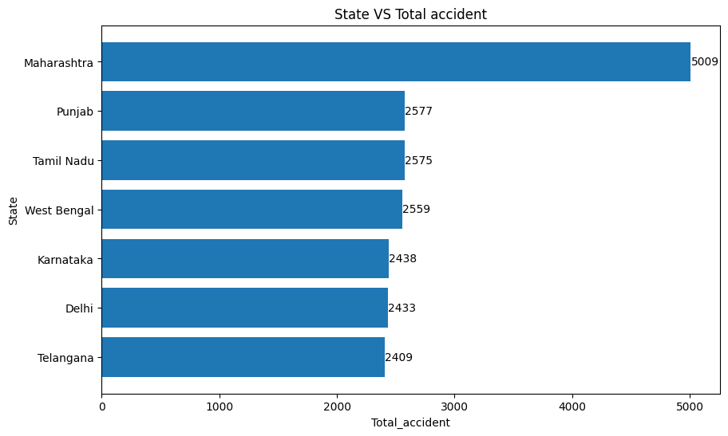
5.1: Total Road Accidents by State
The geographical analysis reveals noticeable differences in accident patterns across states. Maharashtra recorded the highest number of road accidents, indicating a substantial accident burden compared with the other states included in the dataset. However, accident frequency alone does not necessarily represent overall road safety performance, as accident severity and fatality rates vary across regions.

5.3 City Analysis
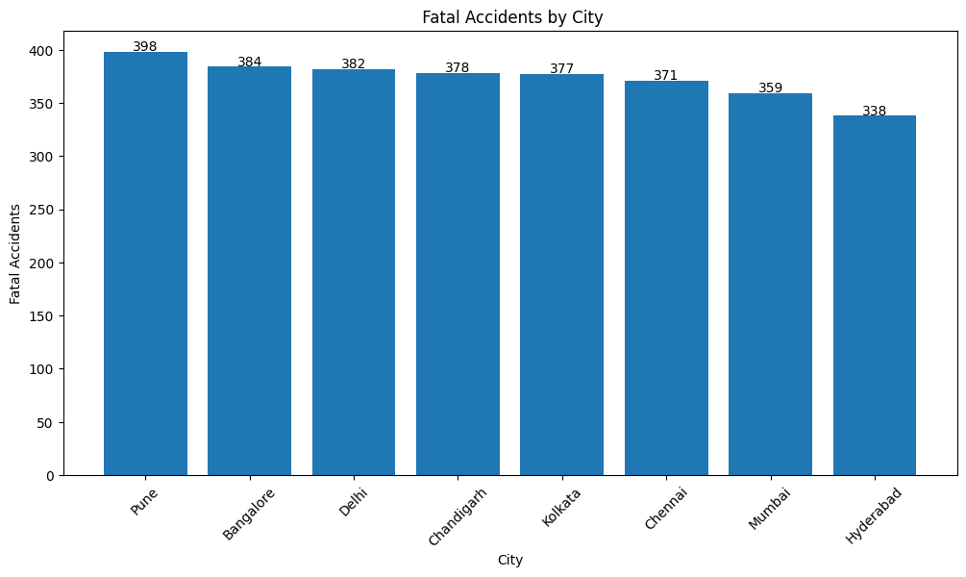
5.2: Total Road Accidents by City

The analysis shows that Chandigarh recorded the highest number of reported accidents, indicating a higher concentration of accident incidents compared with the other cities in the dataset. The variation among cities suggests that accident frequency is influenced by factors such as traffic volume, population density, road infrastructure, and driving behavior.

5.4 Time-Based Analysis
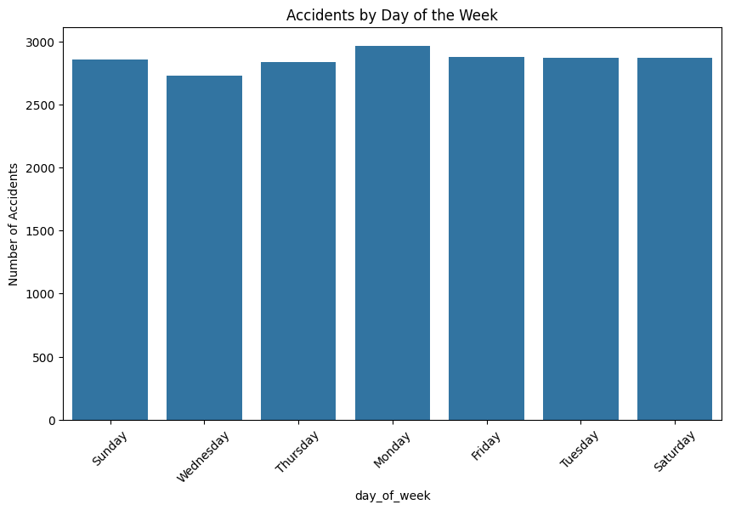
Figure 5.4: Road Accidents by Day of Week
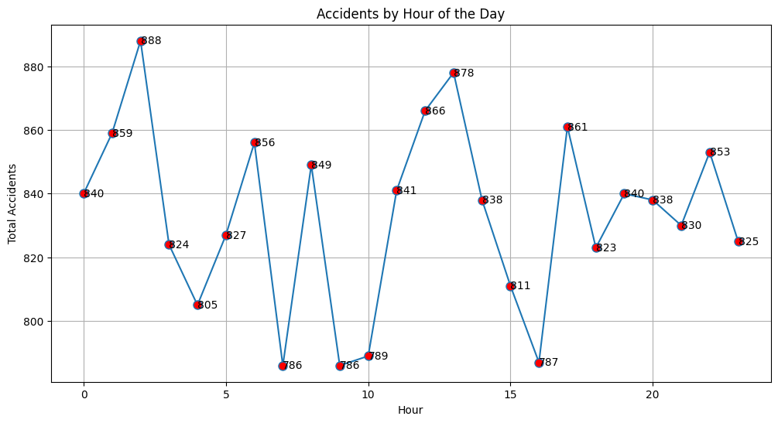 Figure 5.3: Road Accidents by Hour

The analysis indicates that accident frequency peaks during the 9:00–10:00 AM and 12:00–1:00 PM periods, which coincide with increased traffic movement. Weekdays recorded more accidents than weekends, while Monday showed the highest accident count among all days of the week. These patterns suggest that traffic congestion and commuting behavior significantly influence accident occurrence.

5.5 Weather Analysis
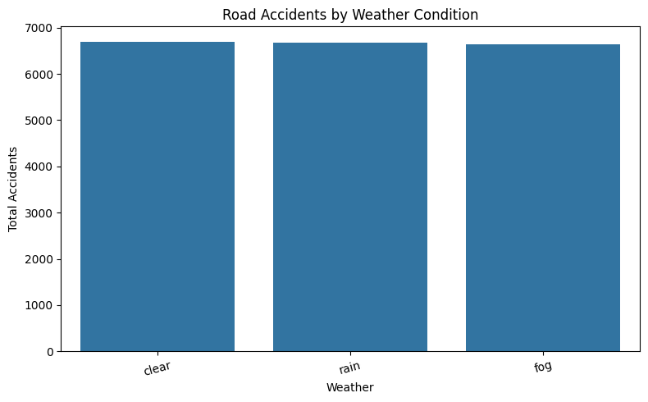
Figure 5.5: Road Accidents by Weather Condition

The analysis shows that clear weather recorded the highest number of road accidents. However, fog produced the highest Weather Risk Index, indicating that accidents occurring under foggy conditions are generally more severe. Rain also contributed to an increase in accident severity compared with normal weather conditions.

5.6 Road Infrastructure Analysis
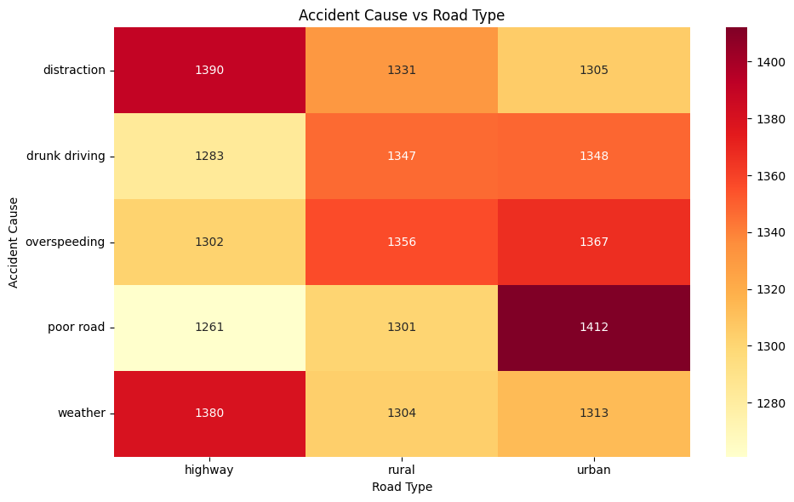
Figure 5.6: Accident Cause Distribution Across Road Types
The analysis of accident causes across different road types reveals that the dominant causes vary depending on the road environment.

6. Advanced Analytics

6.1 Introduction
The Advanced Analytics phase extends the descriptive analysis by applying business-focused analytical techniques to identify hidden patterns, prioritize high-risk regions, and support strategic decision-making. Unlike basic statistical summaries, these analyses combine multiple indicators to evaluate accident severity, risk, and operational priorities.

6.2 Pareto Analysis
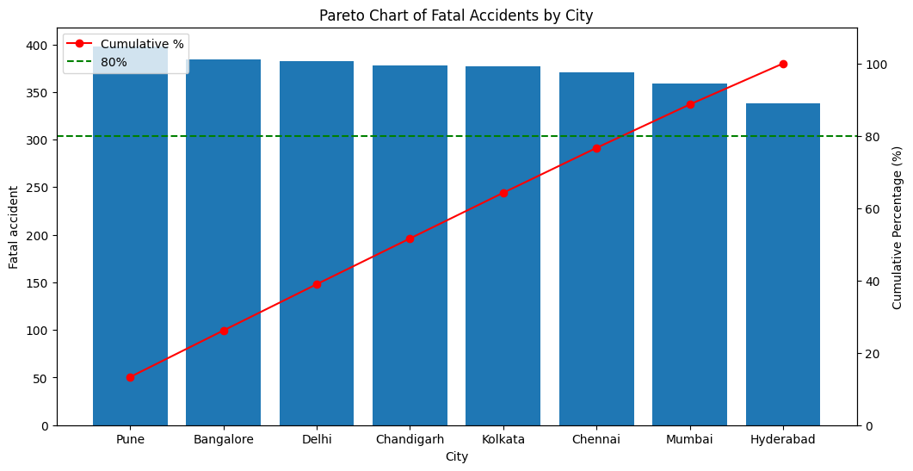
Figure 6.1: Pareto Analysis of Fatal Accidents by City
The Pareto Analysis indicates that a relatively small number of cities contribute to a large share of fatal accidents. Pune recorded the highest number of fatal accidents, followed by Bangalore, Delhi, Chandigarh, Kolkata, and Chennai. Together, these cities account for most of the cumulative fatal accident burden.

6.3 Risk Quartile Analysis
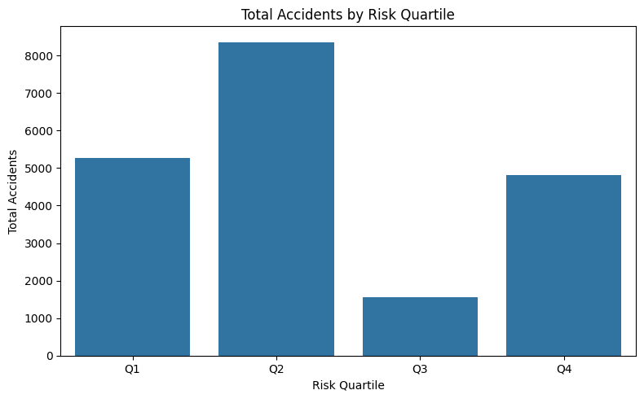
Figure 6.2: Risk Quartile Analysis of Accident Frequency

6.4 Risk Hotspot Analysis

Introduction

The Risk Hotspot Score was developed to identify states that require immediate attention based on both accident frequency and average risk score. Unlike traditional accident counts, this metric combines multiple indicators to prioritize regions where road safety interventions can have the greatest impact.

Key Findings

- Maharashtra recorded the highest Risk Hotspot Score.
- Punjab ranked second, indicating a relatively high average accident risk.
- Tamil Nadu also appeared among the highest-priority states.
- States with high hotspot scores generally experienced both frequent accidents and elevated risk levels.

Business Interpretation

The Risk Hotspot Score demonstrates that accident frequency alone is not sufficient to identify priority regions. Combining accident volume with risk level provides a more balanced assessment and helps transportation authorities allocate resources more effectively.

6.5 Fatality Rate Analysis

Introduction
Fatality Rate Analysis measures the percentage of accidents that resulted in fatalities. This metric provides deeper insight into accident outcomes and helps distinguish between accident frequency and accident severity.

Key Findings
- Karnataka recorded the highest fatality rate.
- Delhi and Maharashtra followed closely.
- States with high accident counts did not always record the highest fatality rates.

Business Interpretation
The findings indicate that reducing fatalities requires targeted improvements in emergency medical response, trauma care, road infrastructure, and traffic law enforcement rather than focusing only on reducing accident frequency.

7. Interactive Dashboard

7.1 Dashboard Overview
An interactive dashboard was developed using Tableau to present the key findings of the road accident analysis in a clear and user-friendly format. The dashboard consolidates multiple analytical views into a single interface, allowing users to monitor accident trends, identify high-risk regions, and compare accident patterns across different dimensions. By integrating key performance indicators with interactive visualizations, the dashboard supports faster decision-making and improves the accessibility of business insights.

7.2 Dashboard Components
The dashboard consists of the following analytical components:
- Top 5 States by Total Accidents
- Top 5 Cities by Total Accidents
- Accident Severity Distribution
- Road Accident Share Across Road Types
- Road Accidents by Hour of the Day
- Road Accidents by Day of the Week
- Monthly Road Accident Trend
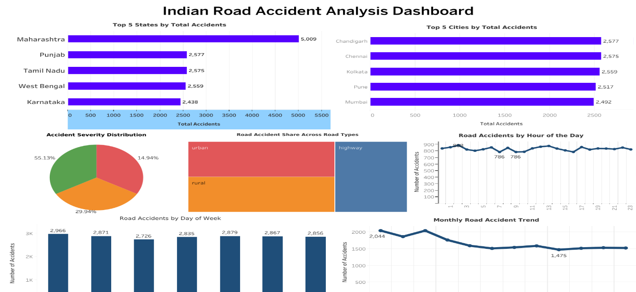
Figure 7.1: Indian Road Accident Analysis Dashboard Developed in Tableau

The dashboard highlights Maharashtra as the state with the highest number of reported accidents, while Chandigarh records the highest accident count among the analyzed cities. The accident severity distribution indicates that most accidents fall within the lower severity category, although a considerable proportion of fatal accidents is also present

8. Business Recommendations

Introduction
The recommendations presented below are based on the findings obtained from exploratory data analysis, business analysis, advanced analytics, and dashboard visualization. These recommendations aim to reduce accident frequency, improve road safety, and support evidence-based decision-making by transportation authorities and policymakers.

Recommendation 1: Prioritize High-Risk States
Recommendation
Focus road safety investments on states with the highest Executive Priority Scores and Risk Hotspot Scores.
Justification
The analysis identified Maharashtra, Punjab, and Tamil Nadu as high-priority regions requiring immediate attention due to their combination of high accident frequency and elevated risk levels.

Recommendation 2: Strengthen Traffic Enforcement During Peak Hours
Recommendation
Increase traffic police deployment and automated speed monitoring during peak commuting hours.
Justification
Peak-hour analysis showed higher accident severity and risk scores compared with non-peak periods.

Recommendation 3: Reduce Overspeeding
Recommendation
Install additional speed cameras, introduce stricter enforcement measures, and conduct public awareness campaigns targeting overspeeding.
Justification
Overspeeding recorded the highest Cause Impact Score, making it one of the most influential contributors to severe accidents.

Recommendation 4: Enhance Emergency Response
Recommendation
Improve ambulance availability and emergency response times in high-fatality regions.
Justification
States with higher fatality rates would benefit from faster medical intervention, potentially reducing accident-related deaths.
Implementing these recommendations can contribute to reducing accident frequency, minimizing fatalities, improving resource allocation, and strengthening long-term road safety planning. A combination of infrastructure improvements, enforcement strategies, public awareness, and continuous data monitoring is essential for sustainable road safety management.

9. Conclusion

This project successfully analyzed 20,000 Indian road accident records to identify patterns related to accident frequency, severity, fatalities, and overall road safety risk. A structured analytical workflow was followed, beginning with data cleaning and exploratory data analysis, followed by business analysis, advanced analytics, and interactive dashboard development.
The analysis demonstrated that road accidents are influenced by multiple interconnected factors, including geographical location, accident causes, traffic conditions, weather, and time of occurrence. Instead of relying only on accident counts, the project introduced additional analytical metrics such as Risk Hotspot Score, Safety Score, and Executive Priority Score to provide a more comprehensive evaluation of road safety across different states.
The findings revealed that Maharashtra recorded the highest number of accidents, while Karnataka reported the highest fatality rate. Pune emerged as the city with the highest number of fatal accidents, and overspeeding was identified as the most impactful accident cause. Risk-based analysis further showed that high-risk accident groups were associated with greater accident severity and higher casualty levels.
An interactive Tableau dashboard was developed to present the analytical findings through executive KPIs and dynamic visualizations. The dashboard enables users to monitor accident trends, compare regional performance, and explore road safety indicators in an intuitive manner, supporting faster and more informed decision-making.
Overall, this project demonstrates how data analytics can transform raw accident data into meaningful business intelligence. The insights generated can support transportation authorities, policymakers, and urban planners in prioritizing safety initiatives, improving infrastructure planning, and allocating resources more effectively. The project also highlights the practical application of Python, Tableau, and business intelligence techniques in solving real-world transportation challenges.

9.1 Project Achievements
- ✔ Processed and analyzed 20,000+ road accident records using Python and Pandas.
- ✔ Built 50+ business-driven analytical question and KPIs.
- ✔ Developed 6 custom analytical metrics for executive decision-making.
- ✔ Created 15+ professional visualizations using Matplotlib, Seaborn, and Tableau.
- ✔ Designed an interactive executive dashboard for road safety monitoring.
- ✔ Produced a comprehensive 18-page business report documenting methodology, insights, and recommendations.
- ✔ Delivered actionable recommendations based on data-driven analysis to support transportation planning.

10. Future Scope

Introduction
Although this project provides a comprehensive analysis of historical road accident data, there are several opportunities to enhance its capabilities through advanced analytical techniques and emerging technologies. Future improvements can increase prediction accuracy, enable real-time monitoring, and support more proactive road safety management.

10.1 Machine Learning-Based Accident Prediction
Develop supervised machine learning models such as Random Forest, XGBoost, or Gradient Boosting to predict accident severity or accident risk based on weather conditions, traffic density, road type, visibility, and other factors. Predictive models can help authorities identify high-risk situations before accidents occur.

10.2 Real-Time Data Integration
Integrate live data sources such as weather services, traffic sensors, and GPS systems to monitor accident risk in real time. Continuous data updates would allow transportation authorities to respond more quickly to changing road conditions.

10.3 Interactive Web Dashboard
Expand the Tableau dashboard into a web-based application using Streamlit, Power BI Service, or Dash. This would allow decision-makers to access reports, apply filters, and explore accident trends from any device.

10.4 Geographic Information System (GIS) Mapping
Integrate GIS tools to visualize accident hotspots on interactive maps. Geographic visualization would help identify high-risk corridors, intersections, and accident-prone zones for infrastructure planning.

10.5 Automated Reporting System
Develop an automated reporting pipeline that refreshes dashboards and generates updated reports whenever new accident data becomes available. This would reduce manual effort and support continuous monitoring.

Conclusion
Future enhancements will transform this project from a descriptive analytics solution into a predictive and decision-support platform. By integrating machine learning, GIS, real-time data, and automated reporting, the system can provide more accurate insights and help transportation authorities implement proactive road safety strategies.

11. Project Reflection

Introduction
This project provided practical experience in applying the complete data analytics lifecycle, from raw data preparation to business reporting. Beyond developing technical skills, the project emphasized the importance of understanding business problems, selecting appropriate analytical methods, and communicating insights effectively to support decision-making.

Key Learnings
During the development of this project, several important technical and analytical skills were strengthened:
- Performed end-to-end data cleaning and preprocessing using Python and Pandas.
- Applied exploratory data analysis techniques to understand data distributions, identify trends, and detect anomalies.
- Developed business-focused KPIs to measure accident frequency, severity, fatalities, and risk.
- Used aggregation, grouping, ranking, pivot tables, and statistical summaries to answer business questions.
- Created meaningful data visualizations using Matplotlib, Seaborn, and Tableau.
- Designed an interactive dashboard for presenting analytical insights to business users.
- Improved the ability to translate technical findings into actionable business recommendations.
- Strengthened documentation and reporting skills through the preparation of a structured business report.

Challenges Faced
Throughout the project, several challenges were encountered and successfully addressed:
- Cleaning and organizing a large dataset before analysis.
- Selecting the most meaningful KPIs from multiple available metrics.
- Designing advanced analytical measures such as Risk Hotspot Score and Executive Priority Score.
- Creating clear and informative visualizations that effectively communicate insights.
- Structuring a professional report that combines technical analysis with business interpretation.
This project significantly improved my understanding of the complete data analytics workflow. It demonstrated how raw data can be transformed into meaningful business insights through structured analysis, visualization, and reporting. Working on this project also strengthened my problem-solving abilities and reinforced the importance of communicating analytical findings in a clear and business-oriented manner. The knowledge and experience gained will serve as a strong foundation for future projects in data analytics, business intelligence, and machine learning.

Thank You

Indian Road Accident Analysis & Prediction

A Data Analytics & Business Intelligence Project

Prepared By

Ankan Sen
B.Tech in Computer Science & Engineering
Haldia Institute of Technology

Tools & Technologies

Python • Pandas • NumPy • Matplotlib • Seaborn • Tableau • GitHub

Project Duration

June 2026 – July 2026

"Transforming road accident data into actionable business insights through data analytics."

