ElectroMart
Technical Documentation & Software Architecture Reference
Ankani Balaji
July 2026
Table of Contents

1 ElectroMart

1.0.1 Modern Full-Stack E-Commerce Web Application
Technical Documentation & Software Architecture Reference
Developer | Ankani Balaji
Document Version | 1.0
Date | July 2026
Repository | https://github.com/Ankani-Balaji/ElectroMart
Live Demo | https://electro-mart-indol.vercel.app/
Primary Stack | React 19 · Vite · Redux Toolkit · React Router DOM · Axios · JSON Server · Razorpay
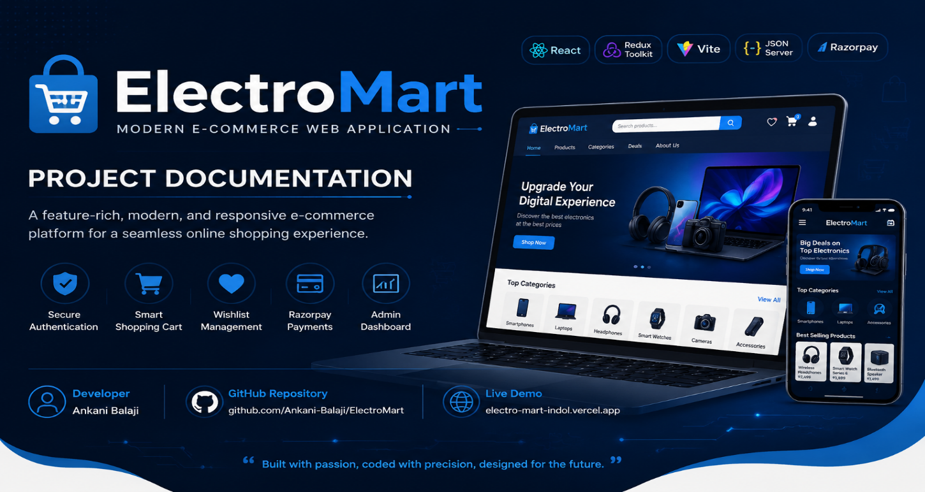

1.1 Certificate
This is to certify that the project titled “ElectroMart – A Modern Full-Stack E-Commerce Web Application” is an original work designed, developed, and documented by Ankani Balaji.
The project demonstrates the practical application of modern front-end engineering principles, state management architecture, RESTful API integration, and payment-gateway workflows, and is submitted as a portfolio-grade software engineering artifact suitable for academic evaluation, technical interviews, and professional review.
The work embodies an original implementation, follows industry-standard coding conventions, and has been independently tested against the functional requirements described in this document.

Project Title | ElectroMart
Developed By | Ankani Balaji
Document Prepared On | July 2026
Status | Actively Maintained

1.2 Acknowledgement
The development of ElectroMart has been a rewarding exercise in applying modern front-end architecture, state management, and third-party service integration to a realistic, end-to-end product scenario.
I would like to acknowledge the open-source community behind React, Redux Toolkit, Vite, React Router, Axios, and JSON Server, whose documentation and design philosophy shaped many of the architectural decisions in this project. I am also grateful to the maintainers of Razorpay’s developer documentation for providing a clear and accessible test-mode integration path, and to the Vercel platform for enabling frictionless, zero-configuration deployment of the front-end application.
This documentation itself is an attempt to bring enterprise-grade documentation discipline — the kind typically seen inside product engineering organizations — to a project built and maintained by a single developer, in the belief that clear documentation is as much a part of software craftsmanship as the code itself.

1.3 Abstract
ElectroMart is a modern, full-stack e-commerce web application that simulates the core shopping experience of a consumer electronics storefront — product discovery, cart and wishlist management, checkout, payment processing, and order tracking — alongside a complete administrative back office for catalog, order, and user management.
Purpose. The project was built to demonstrate production-quality front-end engineering: a component-driven UI, centralized and predictable state management, clean separation between presentation and data-access layers, and a checkout/payment flow modeled closely on real-world payment gateway integration (Razorpay, in test mode).
Problem. Many student and portfolio e-commerce projects stop at a static product listing with a shopping cart implemented in local component state. This does not reflect how production applications are actually built: with normalized global state, persisted sessions, protected routing, role-based access (customer vs. admin), and a payment flow that mirrors what a real checkout integration looks like.
Solution. ElectroMart addresses this gap with a React 19 single-page application built on Vite, using Redux Toolkit slices as the single source of truth for authentication, products, cart, wishlist, and orders. Data is served by a JSON Server mock REST API during development, with the application’s service layer deliberately abstracted (services/) so that the mock backend can be swapped for a production Flask + MySQL + JWT backend without touching UI code. Payments are processed through the Razorpay Test Mode checkout widget via a dedicated useRazorpay hook, and authentication/session state is persisted to localStorage and rehydrated on load.
Technologies. React 19, Vite, Redux Toolkit, React Router DOM, Axios, React Toastify, React Icons, JSON Server, Razorpay (Test Mode), pure CSS with a token-based design system, Git/GitHub for version control, and Vercel for deployment.
Expected Impact. As a portfolio and reference project, ElectroMart is intended to demonstrate to engineers, interviewers, and recruiters a working understanding of component architecture, Redux data flow, RESTful API design, authentication and route protection, third-party payment integration, and the discipline of writing software that anticipates a production backend migration rather than assuming the mock backend is permanent.

1.4 Table of Contents

2 1. Introduction

2.1 1.1 Background
E-commerce front-ends are one of the most common — and most instructive — categories of full-stack learning project, because they touch nearly every concern a real product engineering team deals with: catalog data modeling, search and filtering, cart and pricing logic, authentication, authorization, payment processing, and administrative tooling. ElectroMart was built to work through each of these concerns deliberately rather than superficially.

2.2 1.2 Existing System
Typical introductory e-commerce clones tend to share a common set of limitations:
- Product and cart data held in local component state, lost on refresh.
- No distinction between customer-facing and admin-facing routes.
- Checkout that ends at a static “Thank you” page with no persisted order record.
- No abstraction between UI components and the data-fetching layer, making a future backend swap require rewriting the UI.
- No design system — ad-hoc inline styles or a heavyweight CSS framework that obscures the developer’s own CSS ability.

2.3 1.3 Problems Identified
Problem | Consequence
Cart/wishlist state not persisted | User loses selections on refresh or navigation
No route protection | Unauthenticated users can reach checkout/admin pages
No admin/customer separation | Cannot demonstrate role-based access control
Tight coupling between UI and data fetching | Backend migration requires rewriting components
No real payment flow | Checkout doesn’t reflect how production payments work

2.4 1.4 Proposed System — ElectroMart
ElectroMart proposes a React 19 + Redux Toolkit single-page application with:
- A service layer (src/services/) that isolates all HTTP calls behind functions such as productService, authService, orderService, adminService, and userService, so the UI never calls axios directly.
- Redux Toolkit slices (authSlice, productSlice, cartSlice, wishlistSlice, orderSlice) as the single source of truth for all shared state.
- localStorage-backed persistence for the auth session, cart, and wishlist, rehydrated on application load.
- Protected routing for both customer routes (/checkout, /orders, /order-success, /profile) and the entire /admin/* route tree.
- A Razorpay Test Mode payment integration wired through a dedicated useRazorpay hook.
- A token-based CSS design system (tokens.css + global.css) rather than a third-party CSS framework, giving full control over visual identity.

2.5 1.5 Objectives
See Section 2 for the full breakdown of functional and non-functional objectives.

2.6 1.6 Scope
The current scope covers the customer-facing storefront (home, product listing, product details, search, cart, wishlist, checkout, orders, profile), the admin back office (dashboard, product management, order management, user management, categories), authentication for both roles, and a test-mode payment flow. Out of scope for the current version: a production relational database, server-side authentication (JWT), and real payment settlement — all of which are addressed in the “Future Enhancements” roadmap (Section 29) and were deliberately deferred to keep the front-end architecture the primary focus of this iteration.

2.7 1.7 Advantages
- Clear separation of concerns (UI → services → API) that makes the backend swap in the roadmap a low-risk change.
- A single, reusable ProductCard component eliminates UI duplication across Home, Products, Wishlist, and Related Products.
- Explicit distinction between “Buy Now” (single-item, cart-independent checkout) and “cart checkout” (multi-item, cart-clearing checkout), a subtlety many clone projects get wrong.
- A persisted session model that survives page refreshes without requiring a real backend session store.

3 2. Problem Statement
Design and implement a full-stack e-commerce web application that provides a realistic customer shopping journey (browse, search, cart, wishlist, checkout, pay, track orders) and a realistic administrative back office (manage products, orders, users, categories), while keeping the front-end architecture decoupled enough from the current mock backend (JSON Server) that migrating to a production backend (Flask, MySQL, JWT) requires changes only to the service layer, not to UI components or Redux slices.

4 3. Objectives

4.1 3.1 Functional Objectives
- Allow customers to browse, search, and filter a product catalog.
- Allow customers to view detailed product pages with related products.
- Allow customers to add/remove items from a cart and a wishlist that persist across sessions.
- Allow customers to check out via cart items or a single “Buy Now” item.
- Integrate a test-mode payment gateway (Razorpay) with a Cash on Delivery fallback.
- Allow customers to view their order history and order confirmation details.
- Allow customers to register, log in, and manage a profile.
- Allow admins to log in separately and manage products, categories, orders, and users through a dashboard.
- Protect customer-only and admin-only routes from unauthorized access.

4.2 3.2 Non-Functional Objectives
- Maintainability: isolate data access behind a service layer; keep Redux slices focused and predictable.
- Usability: consistent, token-driven visual design; toast notifications for user feedback; loading and empty states for all data-driven views.
- Performance: minimize unnecessary re-renders, keep bundle size lean via Vite’s native ES module dev server and production bundling.
- Portability: design the data layer so the mock backend (JSON Server) can be replaced with a production backend without UI-layer changes.
- Security (forward-looking): document a clear path from localStorage-based authentication to JWT-based authentication with bcrypt password hashing (Section 18, Section 23).

5 4. Literature Survey
To ground ElectroMart’s design decisions, it is useful to compare its approach — at a high, non-proprietary level — with how established e-commerce platforms structure their front-ends.
Aspect | Amazon | Flipkart | Best Buy | ElectroMart
Catalog scale | Hundreds of millions of SKUs, multiple sellers | Tens of millions of SKUs, marketplace model | Curated first-party electronics catalog | Small curated demo catalog (db.json)
State management | Highly distributed, micro-frontend architecture | Redux-family patterns at large scale | Component-driven with server-rendered pages | Redux Toolkit, single SPA
Authentication | Multi-factor, federated identity | OTP + password, session tokens | Account + guest checkout | LocalStorage session (roadmap: JWT)
Payments | Dozens of payment methods, in-house gateway | Multiple gateways, wallet integration | Multiple gateways, financing options | Razorpay Test Mode + Cash on Delivery
Admin tooling | Internal seller/ops consoles (not public) | Seller dashboard (not public) | Internal inventory systems (not public) | Public-facing /admin dashboard for demonstration
Similarities. All four systems separate the customer-facing storefront from an administrative/seller back office, rely on a persisted cart/session, and route checkout through a dedicated payment step distinct from product browsing.
Differences. ElectroMart is deliberately scoped down: a single JSON data source instead of a distributed product catalog service, a single Redux store instead of a federated state architecture, and a single payment gateway in test mode rather than a multi-provider payment orchestration layer. These simplifications are intentional — the goal is to demonstrate the architectural patterns used by production e-commerce systems (service-layer abstraction, protected routing, role-based dashboards, persisted client state) at a scale appropriate for a single-developer project, not to replicate their scale or proprietary implementation details.

6 5. System Requirements

6.1 5.1 Hardware Requirements
Component | Minimum | Recommended
Processor | Dual-core 1.6 GHz | Quad-core 2.0 GHz+
RAM | 4 GB | 8 GB+
Storage | 500 MB free | 1 GB+ free
Display | 1280×720 | 1920×1080

6.2 5.2 Software Requirements
Component | Requirement
Operating System | Windows 10+, macOS 11+, or any modern Linux distribution
Node.js | v18 LTS or later
Package Manager | npm (bundled with Node.js)
Code Editor | VS Code (recommended)
Version Control | Git 2.30+

6.3 5.3 Browser Support
Browser | Supported Versions
Google Chrome | Last 2 major versions
Mozilla Firefox | Last 2 major versions
Microsoft Edge | Last 2 major versions
Safari | Last 2 major versions
Note: ElectroMart uses modern ES2020+ JavaScript and CSS Grid/Flexbox; Internet Explorer is not supported.

6.4 5.4 Node Version
The project targets Node.js 18 LTS or later, consistent with Vite 5’s minimum engine requirement.

6.5 5.5 Key Dependencies
Package | Purpose
react, react-dom | UI library (v19)
vite | Dev server & build tool
@reduxjs/toolkit, react-redux | State management
react-router-dom | Client-side routing
axios | HTTP client
react-toastify | Toast notifications
react-icons | Icon library
json-server | Mock REST API (dev only)

7 6. Technology Stack

7.1 6.1 Overview
Layer | Technology | Role
UI Library | React 19 | Component-driven rendering
Build Tool | Vite | Dev server, HMR, production bundling
State Management | Redux Toolkit | Global, predictable state
Routing | React Router DOM | Client-side navigation & route protection
HTTP Client | Axios | REST API communication
Mock Backend | JSON Server | Development-only REST API over db.json
Notifications | React Toastify | User feedback (success/error toasts)
Icons | React Icons | Iconography
Styling | Pure CSS (tokens + global) | Design system without a CSS framework
Payments | Razorpay (Test Mode) | Checkout widget integration
Auth (current) | localStorage | Client-side session persistence
Auth (future) | JWT | Server-issued, verifiable session tokens
Future Backend | Flask + MySQL | Production REST API and relational storage
Deployment | Vercel | Static hosting for the Vite build output
Version Control | Git + GitHub | Source control and collaboration

7.2 6.2 Why Each Technology Was Selected
React 19. Component-driven architecture is the industry standard for building maintainable, testable UIs. React’s declarative model and mature ecosystem (React Router, React Toastify, React Icons) made it the natural choice, and version 19 provides improved rendering performance and simplified data-handling patterns over earlier releases.
Vite. Vite was chosen over Create React App (which is no longer actively maintained) for its near-instant dev server startup, native ES module-based hot module replacement, and significantly faster production builds via Rollup under the hood.
Redux Toolkit. Rather than hand-rolling Context-based state management or using legacy Redux boilerplate, Redux Toolkit’s createSlice API provides reducers, action creators, and immutable update logic (via Immer) with a fraction of the code, while remaining fully compatible with Redux DevTools for debugging.
React Router DOM. Chosen for declarative, nested routing and its first-class support for route guarding patterns (ProtectedRoute, AdminProtectedRoute), which are essential for separating customer and admin experiences.
Axios. Selected over the native fetch API for its interceptor support, automatic JSON parsing, and more ergonomic error handling — all of which are used inside the services/ layer.
JSON Server. Provides a zero-backend-code REST API over a single db.json file, allowing full-stack-shaped development (real HTTP requests, real status codes, real async loading states) without needing to stand up Flask/MySQL before the front-end architecture is proven out.
Razorpay (Test Mode). A widely used Indian payment gateway with a well-documented test-mode checkout widget, allowing a realistic payment UX (card entry, OTP step, success/failure callbacks) without handling real financial transactions during development.
Pure CSS with a token system. Rather than adopting Bootstrap or Tailwind, ElectroMart defines its own design tokens (tokens.css) and global reset/utilities (global.css), demonstrating CSS fundamentals (Flexbox, Grid, custom properties, animations) without hiding behind a framework’s opinionated defaults.
Vercel. Chosen for its zero-configuration deployment of Vite-based SPAs, automatic preview deployments per Git branch, and generous free tier — ideal for a portfolio project.
Git & GitHub. Industry-standard version control and the de facto platform for open-source and portfolio project hosting, code review, and issue tracking.

8 7. Software Architecture

8.1 7.1 High-Level Architecture
ElectroMart follows a classic layered SPA architecture: presentation (React components) → state (Redux) → data access (service layer) → transport (Axios) → API (JSON Server today, Flask tomorrow) → storage (db.json today, MySQL tomorrow).
flowchart TD
U[User / Browser] --> RC[React Components]
RC --> RD[Redux Store - Slices]
RD --> SV[Service Layer - services/*.js]
SV --> AX[Axios HTTP Client]
AX --> API[JSON Server REST API]
API --> DB[(db.json)]
RC -.persist/rehydrate.-> LS[(localStorage)]
RD -.persist/rehydrate.-> LS
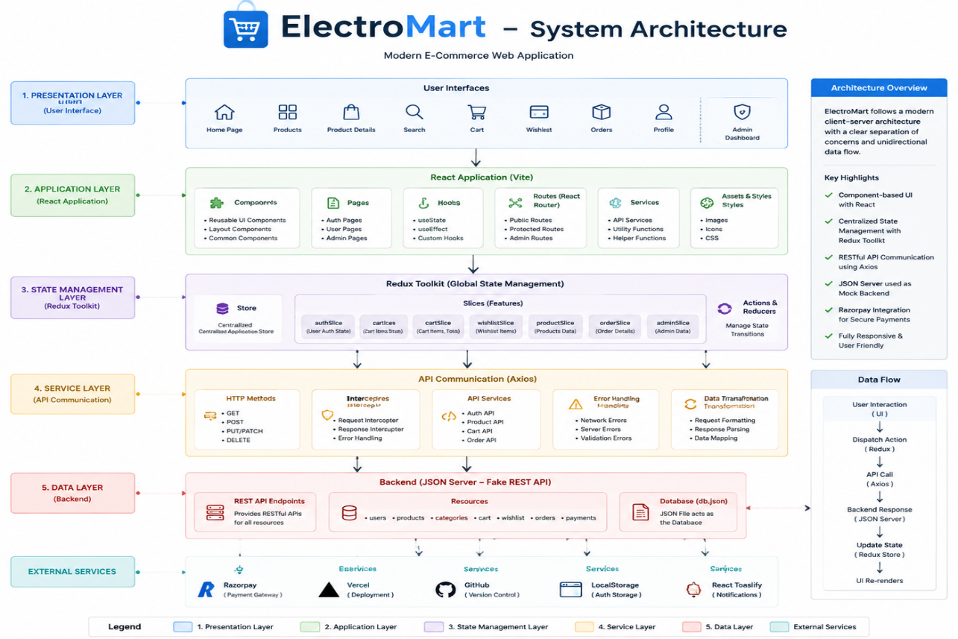

8.2 7.2 Layer Responsibilities
Layer | Responsibility | Location
Presentation | Renders UI, captures user input, dispatches Redux actions | src/pages/, src/components/, src/admin/
State | Holds normalized application state, exposes selectors | src/redux/store.js, src/redux/slices/
Service | Wraps all HTTP calls; the only layer allowed to import Axios | src/services/
Transport | Executes HTTP requests, handles base URL & headers | src/services/api.js
API | Exposes REST endpoints over the catalog/users/orders data | JSON Server (dev) → Flask (production roadmap)
Storage | Persists data | db.json (dev) → MySQL (production roadmap)

8.3 7.3 Design Principle: One-Way Dependency
Components never call Axios directly, and services never import React or Redux. This one-way dependency (components → redux → services → axios) is what makes the “swap JSON Server for Flask” migration in the roadmap a service-layer-only change.
Best Practice: If a new page needs data that isn’t already exposed by an existing service function, add the function to the relevant service file — never call axios.get(...) inline in a component.

8.4 7.4 Client-State Persistence Model
sequenceDiagram
participant App as App Root
participant LS as localStorage
participant Store as Redux Store
App->>LS: Read persisted auth/cart/wishlist on load
LS-->>App: Return stored JSON (or null)
App->>Store: Hydrate initial state
Store-->>App: Provide state to components
Note over Store,LS: On every relevant state change,<br/>middleware/effect writes back to localStorage

9 8. Project Folder Structure

9.1 8.1 Complete Folder Tree
ElectroMart/
├── public/ # Static assets served as-is
├── src/
│ ├── admin/ # Admin panel pages
│ │ ├── Dashboard.jsx
│ │ ├── Products.jsx
│ │ ├── Orders.jsx
│ │ ├── Users.jsx
│ │ ├── Categories.jsx
│ │ ├── Profile.jsx
│ │ ├── Login.jsx
│ │ └── Register.jsx
│ ├── components/
│ │ ├── auth/
│ │ │ ├── ProtectedRoute.jsx
│ │ │ └── AdminProtectedRoute.jsx
│ │ ├── common/
│ │ │ ├── Button.jsx
│ │ │ ├── Input.jsx
│ │ │ ├── Modal.jsx
│ │ │ ├── Loader.jsx
│ │ │ ├── EmptyState.jsx
│ │ │ └── SearchBar.jsx
│ │ ├── home/
│ │ │ ├── Hero.jsx
│ │ │ ├── Categories.jsx
│ │ │ ├── FlashDeals.jsx
│ │ │ └── Brands.jsx
│ │ ├── product/
│ │ │ ├── ProductCard.jsx # Single source of truth
│ │ │ ├── ProductGrid.jsx
│ │ │ └── ProductBadge.jsx
│ │ ├── layout/
│ │ │ ├── Navbar.jsx
│ │ │ ├── Footer.jsx
│ │ │ └── MainLayout.jsx
│ │ └── admin/
│ │ ├── AdminSidebar.jsx
│ │ ├── AdminTopbar.jsx
│ │ ├── AdminLayout.jsx
│ │ ├── StatCard.jsx
│ │ ├── RevenueChart.jsx
│ │ └── AdminTable.css
│ ├── pages/
│ │ ├── Home.jsx
│ │ ├── Products.jsx
│ │ ├── ProductDetails.jsx
│ │ ├── Cart.jsx
│ │ ├── Wishlist.jsx
│ │ ├── Checkout.jsx
│ │ ├── Orders.jsx
│ │ ├── OrderSuccess.jsx
│ │ ├── Login.jsx
│ │ ├── Register.jsx
│ │ ├── Contact.jsx
│ │ ├── Profile.jsx
│ │ └── NotFound.jsx
│ ├── redux/
│ │ ├── store.js
│ │ └── slices/
│ │ ├── authSlice.js
│ │ ├── productSlice.js
│ │ ├── cartSlice.js
│ │ ├── wishlistSlice.js
│ │ └── orderSlice.js
│ ├── services/
│ │ ├── api.js # Axios instance & base config
│ │ ├── authService.js
│ │ ├── productService.js
│ │ ├── adminService.js
│ │ ├── orderService.js
│ │ └── userService.js
│ ├── utils/
│ │ ├── formatters.js
│ │ └── constants.js
│ ├── hooks/
│ │ └── useRazorpay.js
│ └── styles/
│ ├── tokens.css # Design system (colors, spacing, typography)
│ └── global.css # Reset + utility classes
├── db.json # JSON Server database
├── index.html
├── vite.config.js
├── package.json
└── package-lock.json
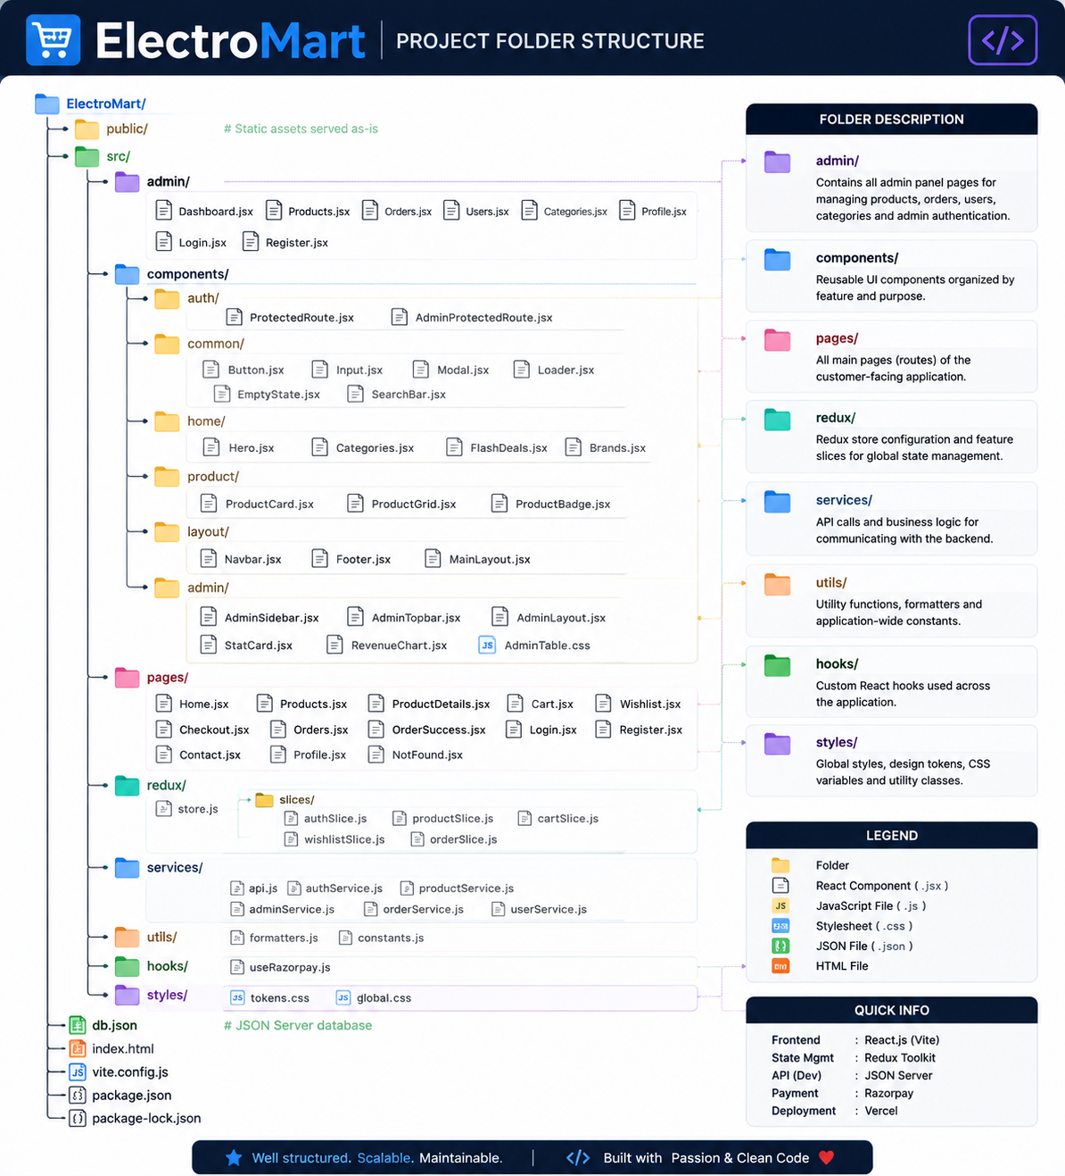

9.2 8.2 Folder-by-Folder Explanation
Folder | Purpose
src/admin/ | Full admin back office: dashboard KPIs, product/order/user/category management, and a dedicated admin login/register flow, isolated from customer pages.
src/components/auth/ | Route guards. ProtectedRoute gates customer-only pages; AdminProtectedRoute gates the entire /admin/* tree.
src/components/common/ | Reusable, presentation-only UI primitives (buttons, inputs, modals, loaders, empty states, the search bar) shared across customer and admin surfaces.
src/components/home/ | Landing-page-specific sections (hero banner, category tiles, flash deals, brand strip) that only ever appear on Home.jsx.
src/components/product/ | Product presentation components, most importantly the single, reused ProductCard.
src/components/layout/ | App shell: navigation bar, footer, and the MainLayout wrapper that composes them around routed page content.
src/components/admin/ | Admin-only chrome: sidebar navigation, top bar, layout wrapper, dashboard stat cards, and the revenue chart.
src/pages/ | Route-level components — one file per customer-facing route.
src/redux/ | The Redux store and its five feature slices.
src/services/ | The data-access layer; the only place Axios is imported.
src/utils/ | Pure helper functions (currency/date formatting) and shared constants (API base URL, route paths, etc.).
src/hooks/ | Custom React hooks; currently useRazorpay for payment widget orchestration.
src/styles/ | The CSS design system: tokens (custom properties) and global reset/utility classes.
db.json | The JSON Server database file: products, categories, users, admins, orders.

10 9. Application Workflow

10.1 9.1 Overall User Journey
flowchart LR
A[Land on Home] --> B{Browse or Search?}
B -->|Browse| C[Category / Products Page]
B -->|Search| D[Search Results]
C --> E[Product Details]
D --> E
E --> F{Buy Now or Add to Cart?}
F -->|Buy Now| G[Checkout - single item]
F -->|Add to Cart| H[Cart]
H --> I[Checkout - cart items]
G --> J[Payment]
I --> J
J --> K[Order Success]
K --> L[Order History]

10.2 9.2 Registration Flow
flowchart TD
Start([Visit /register]) --> Form[Fill registration form]
Form --> Validate{Client-side validation passes?}
Validate -->|No| Error[Show inline field errors]
Error --> Form
Validate -->|Yes| Submit[authService.register]
Submit --> API[POST /users]
API --> Success{User created?}
Success -->|Yes| Store[Persist session to localStorage + Redux]
Store --> Toast[Toast: Registration successful]
Toast --> Redirect[Redirect to Home]
Success -->|No - email exists| Fail[Toast: Email already registered]
Fail --> Form

10.3 9.3 Login Flow
sequenceDiagram
actor User
participant LoginPage
participant authSlice
participant authService
participant API as JSON Server
User->>LoginPage: Enter email + password
LoginPage->>authService: login(credentials)
authService->>API: GET /users?email=...
API-->>authService: Matching user record (or empty)
authService-->>LoginPage: Resolve/reject based on password match
LoginPage->>authSlice: dispatch(loginSuccess(user))
authSlice->>authSlice: Persist session to localStorage
authSlice-->>LoginPage: Updated auth state
LoginPage-->>User: Redirect to intended page
Note: Because JSON Server has no server-side hashing or verification, password comparison happens client-side against the fetched record. Section 18 and Section 23 describe the production-ready JWT + bcrypt alternative.

10.4 9.4 Product Browsing & Search Flow
flowchart TD
P[Products Page mounts] --> Fetch[productService.getAll]
Fetch --> API[GET /products]
API --> Store[productSlice stores list]
Store --> Filter{User applies filter/search/sort?}
Filter -->|Yes| Derive[Selector derives filtered list]
Filter -->|No| Render[Render full ProductGrid]
Derive --> Render
Render --> Card[ProductCard per item]

10.5 9.5 Add to Cart / Wishlist Flow
flowchart LR
Card[ProductCard] -->|Click Add to Cart| Dispatch1[dispatch cartSlice.addItem]
Card -->|Click Wishlist icon| Dispatch2[dispatch wishlistSlice.toggleItem]
Dispatch1 --> Persist1[Write cart to localStorage]
Dispatch2 --> Persist2[Write wishlist to localStorage]
Persist1 --> Toast1[Toast: Added to cart]
Persist2 --> Toast2[Toast: Added/Removed from wishlist]

10.6 9.6 Checkout & Payment Flow
flowchart TD
Entry{Entry point} -->|Buy Now| SingleItem[Navigate to /checkout with router state]
Entry -->|From Cart| CartItems[Navigate to /checkout with cart items]
SingleItem --> Form[Shipping details form]
CartItems --> Form
Form --> Method{Payment method}
Method -->|Razorpay| Razorpay[useRazorpay opens checkout widget]
Method -->|Cash on Delivery| COD[Skip payment step]
Razorpay --> Result{Payment result}
Result -->|Success| CreateOrder[orderService.create]
Result -->|Failure/Cancelled| Retry[Show retry option]
COD --> CreateOrder
CreateOrder --> ClearCart{Was this a cart checkout?}
ClearCart -->|Yes| Clear[dispatch cartSlice.clear]
ClearCart -->|No - Buy Now| Skip[Cart untouched]
Clear --> Success[Navigate to /order-success]
Skip --> Success

10.7 9.7 Order Confirmation Flow
sequenceDiagram
participant Checkout
participant orderService
participant API as JSON Server
participant orderSlice
participant OrderSuccess as OrderSuccess Page
Checkout->>orderService: createOrder(payload)
orderService->>API: POST /orders
API-->>orderService: Created order (with id, timestamp)
orderService-->>Checkout: Resolved order
Checkout->>orderSlice: dispatch(addOrder(order))
Checkout->>OrderSuccess: navigate('/order-success', { state: order })
OrderSuccess-->>Checkout: Render confirmation summary

11 10. Database Design

11.1 10.1 Current Structure — db.json (JSON Server)
JSON Server exposes each top-level key in db.json as a REST resource. ElectroMart’s db.json contains the following collections:
Collection | Description
products | Product catalog: id, name, brand, category, price, discount, images, stock, specifications, rating
categories | Product category metadata: id, name, slug, icon
users | Registered customer accounts: id, name, email, password, address, phone
admins | Administrator accounts: id, name, email, password, role
orders | Placed orders: id, userId, items[], shippingAddress, paymentMethod, paymentStatus, orderStatus, total, createdAt

11.1.1 Example — products record
{
"id": "p101",
"name": "Wireless Noise-Cancelling Headphones",
"brand": "SoundWave",
"category": "audio",
"price": 8999,
"discountPercent": 15,
"stock": 42,
"rating": 4.5,
"images": ["/assets/products/p101-1.jpg"],
"specifications": {
"batteryLife": "30 hours",
"connectivity": "Bluetooth 5.2"
}
}

11.1.2 Example — orders record
{
"id": "ord-2031",
"userId": "u12",
"items": [
{ "productId": "p101", "quantity": 1, "price": 8999 }
],
"shippingAddress": { "line1": "...", "city": "...", "pincode": "..." },
"paymentMethod": "razorpay",
"paymentStatus": "paid",
"orderStatus": "confirmed",
"total": 8999,
"createdAt": "2026-07-10T09:22:00Z"
}

11.2 10.2 Entity Relationship Diagram (Current)
erDiagram
USERS ||--o{ ORDERS : places
PRODUCTS ||--o{ ORDER_ITEMS : "included in"
ORDERS ||--|{ ORDER_ITEMS : contains
CATEGORIES ||--o{ PRODUCTS : classifies
ADMINS ||--o{ PRODUCTS : manages
USERS {
string id PK
string name
string email
string password
string phone
}
PRODUCTS {
string id PK
string name
string category FK
number price
number stock
number rating
}
CATEGORIES {
string id PK
string name
string slug
}
ORDERS {
string id PK
string userId FK
string paymentStatus
string orderStatus
number total
}
ORDER_ITEMS {
string productId FK
string orderId FK
number quantity
number price
}
ADMINS {
string id PK
string name
string email
string role
}

11.3 10.3 Future Schema — MySQL (Production Roadmap)
The production migration (Section 29) replaces db.json with a normalized MySQL schema:
CREATE TABLE users (
id INT PRIMARY KEY AUTO_INCREMENT,
name VARCHAR(120) NOT NULL,
email VARCHAR(160) UNIQUE NOT NULL,
password_hash VARCHAR(255) NOT NULL,
phone VARCHAR(20),
created_at TIMESTAMP DEFAULT CURRENT_TIMESTAMP
);
CREATE TABLE admins (
id INT PRIMARY KEY AUTO_INCREMENT,
name VARCHAR(120) NOT NULL,
email VARCHAR(160) UNIQUE NOT NULL,
password_hash VARCHAR(255) NOT NULL,
role VARCHAR(40) DEFAULT 'admin'
);
CREATE TABLE categories (
id INT PRIMARY KEY AUTO_INCREMENT,
name VARCHAR(80) NOT NULL,
slug VARCHAR(80) UNIQUE NOT NULL
);
CREATE TABLE products (
id INT PRIMARY KEY AUTO_INCREMENT,
name VARCHAR(200) NOT NULL,
brand VARCHAR(80),
category_id INT,
price DECIMAL(10,2) NOT NULL,
discount_percent DECIMAL(5,2) DEFAULT 0,
stock INT DEFAULT 0,
rating DECIMAL(2,1) DEFAULT 0,
FOREIGN KEY (category_id) REFERENCES categories(id)
);
CREATE TABLE orders (
id INT PRIMARY KEY AUTO_INCREMENT,
user_id INT NOT NULL,
payment_method VARCHAR(30),
payment_status VARCHAR(30) DEFAULT 'pending',
order_status VARCHAR(30) DEFAULT 'placed',
total DECIMAL(10,2) NOT NULL,
created_at TIMESTAMP DEFAULT CURRENT_TIMESTAMP,
FOREIGN KEY (user_id) REFERENCES users(id)
);
CREATE TABLE order_items (
id INT PRIMARY KEY AUTO_INCREMENT,
order_id INT NOT NULL,
product_id INT NOT NULL,
quantity INT NOT NULL,
price DECIMAL(10,2) NOT NULL,
FOREIGN KEY (order_id) REFERENCES orders(id),
FOREIGN KEY (product_id) REFERENCES products(id)
);

11.4 10.4 Relationship Explanation
- A user can place many orders (1:N).
- An order contains many order_items, and each order_item references exactly one product — this junction table resolves the many-to-many relationship between orders and products while carrying order-specific data (quantity, price-at-time-of-purchase).
- A category classifies many products (1:N).
- An admin manages products, orders, and categories through the admin panel, but is stored in a table separate from users to keep customer and administrative identity cleanly separated — a pattern that also makes future role-based-access-control rules simpler to reason about.
Warning: In the current JSON Server implementation, password fields are stored and compared in plain text. This is acceptable for a local development mock API but must never be used in a production deployment — see Section 23 (Security) for the JWT + bcrypt migration plan.

12 11. Redux Architecture

12.1 11.1 Store Composition
src/redux/store.js composes five feature slices into a single store using Redux Toolkit’s configureStore:
import { configureStore } from '@reduxjs/toolkit';
import authReducer from './slices/authSlice';
import productReducer from './slices/productSlice';
import cartReducer from './slices/cartSlice';
import wishlistReducer from './slices/wishlistSlice';
import orderReducer from './slices/orderSlice';
export const store = configureStore({
reducer: {
auth: authReducer,
products: productReducer,
cart: cartReducer,
wishlist: wishlistReducer,
orders: orderReducer,
},
});

12.2 11.2 Slice Responsibilities
Slice | State Shape (simplified) | Responsibilities
authSlice | { user, isAuthenticated, role, status, error } | Login/logout/register, session persistence, role (customer | admin)
productSlice | { items, filters, status, error } | Product list, category/search/sort filters, loading state
cartSlice | { items, status } | Add/remove/update-quantity, cart totals, clear on order success
wishlistSlice | { items } | Toggle product in/out of wishlist
orderSlice | { orders, currentOrder, status } | Order history, most recent order for the confirmation page

12.3 11.3 Example Slice — cartSlice.js
import { createSlice } from '@reduxjs/toolkit';
const persisted = JSON.parse(localStorage.getItem('cart')) || [];
const cartSlice = createSlice({
name: 'cart',
initialState: { items: persisted },
reducers: {
addItem(state, action) {
const existing = state.items.find(i => i.productId === action.payload.productId);
if (existing) {
existing.quantity += action.payload.quantity ?? 1;
} else {
state.items.push({ ...action.payload, quantity: action.payload.quantity ?? 1 });
}
localStorage.setItem('cart', JSON.stringify(state.items));
},
removeItem(state, action) {
state.items = state.items.filter(i => i.productId !== action.payload);
localStorage.setItem('cart', JSON.stringify(state.items));
},
updateQuantity(state, action) {
const item = state.items.find(i => i.productId === action.payload.productId);
if (item) item.quantity = action.payload.quantity;
localStorage.setItem('cart', JSON.stringify(state.items));
},
clearCart(state) {
state.items = [];
localStorage.removeItem('cart');
},
},
});
export const { addItem, removeItem, updateQuantity, clearCart } = cartSlice.actions;
export default cartSlice.reducer;
Tip: Because Redux Toolkit uses Immer internally, reducers can mutate state directly (as above) while Redux still receives an immutable update behind the scenes.

12.4 11.4 Actions, Reducers, Dispatch, Selectors
Concept | Role in ElectroMart
Action | A plain object describing an intent, e.g. { type: 'cart/addItem', payload: {...} }, created automatically by createSlice
Reducer | The function inside each slice that computes the next state for a given action
Dispatch | Components call dispatch(addItem(product)) (via useDispatch) to trigger a state change
Selector | Components call useSelector(state => state.cart.items) to read state, keeping components decoupled from the store’s internal shape

12.5 11.5 Redux Data Flow Diagram
flowchart LR
Component -->|dispatch action| Reducer[Slice Reducer]
Reducer -->|new state| Store[(Redux Store)]
Store -->|useSelector| Component
Reducer -.side effect.-> LS[(localStorage)]
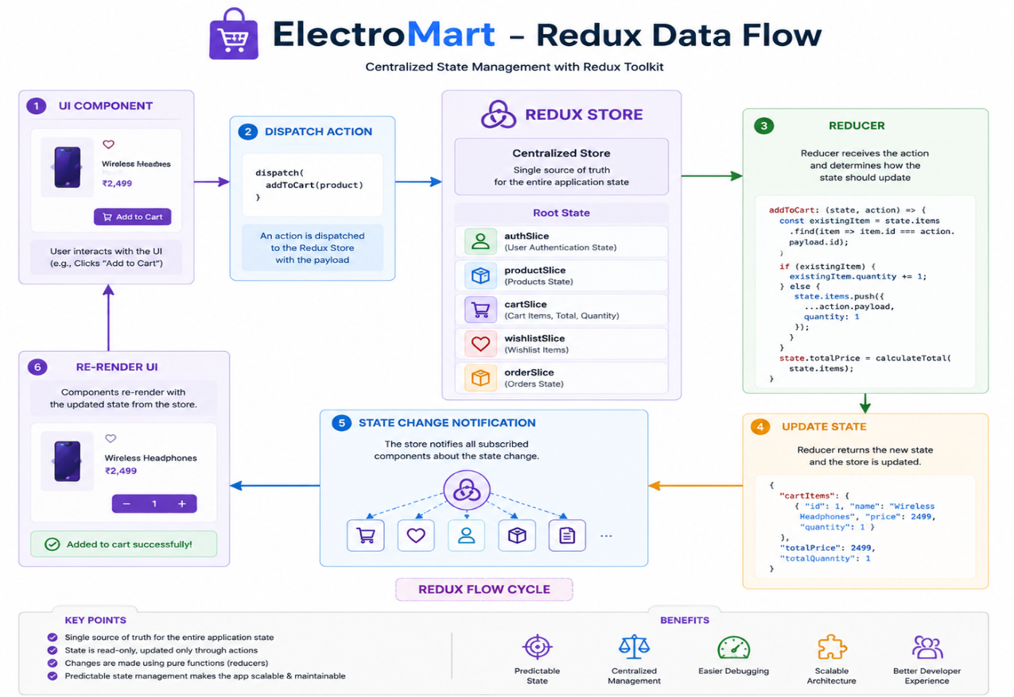

12.6 11.6 Why Redux Toolkit Over Context API
Concern | React Context | Redux Toolkit
Boilerplate | Low, but scales poorly with multiple domains | Low, via createSlice, and scales cleanly
DevTools | None built-in | Full time-travel debugging via Redux DevTools
Re-render granularity | Coarse (any consumer re-renders on any change) | Fine-grained via useSelector
Async handling | Manual | createAsyncThunk (roadmap) or service-layer promises (current)
ElectroMart uses five independent domains (auth, products, cart, wishlist, orders) that are read from many unrelated components; Redux Toolkit’s selector-based subscription model avoids the re-render fan-out that a single large Context would cause.

13 12. Routing

13.1 12.1 Route Table
Path | Page Component | Access | Layout
/ | Home | Public | MainLayout
/products | Products | Public | MainLayout
/products/:id | ProductDetails | Public | MainLayout
/cart | Cart | Public | MainLayout
/wishlist | Wishlist | Public | MainLayout
/checkout | Checkout | Protected (customer) | MainLayout
/orders | Orders | Protected (customer) | MainLayout
/order-success | OrderSuccess | Protected (customer) | MainLayout
/profile | Profile | Protected (customer) | MainLayout
/login | Login | Public | MainLayout
/register | Register | Public | MainLayout
/contact | Contact | Public | MainLayout
/admin/login | admin/Login | Public | —
/admin/register | admin/Register | Public | —
/admin/dashboard | admin/Dashboard | Protected (admin) | AdminLayout
/admin/products | admin/Products | Protected (admin) | AdminLayout
/admin/orders | admin/Orders | Protected (admin) | AdminLayout
/admin/users | admin/Users | Protected (admin) | AdminLayout
/admin/categories | admin/Categories | Protected (admin) | AdminLayout
/admin/profile | admin/Profile | Protected (admin) | AdminLayout
* | NotFound | Public | MainLayout

13.2 12.2 Route Protection Components
// components/auth/ProtectedRoute.jsx
function ProtectedRoute({ children }) {
const { isAuthenticated } = useSelector(state => state.auth);
const location = useLocation();
if (!isAuthenticated) {
return <Navigate to="/login" state={{ from: location }} replace />;
}
return children;
}
// components/auth/AdminProtectedRoute.jsx
function AdminProtectedRoute({ children }) {
const { isAuthenticated, role } = useSelector(state => state.auth);
if (!isAuthenticated || role !== 'admin') {
return <Navigate to="/admin/login" replace />;
}
return children;
}
Note: Both guards read directly from authSlice, which is itself rehydrated from localStorage before the router renders — so a page refresh on a protected route does not incorrectly redirect an already-authenticated user.

13.3 12.3 Public vs. Protected Route Diagram
flowchart TD
Nav[Navigation attempt] --> Check{Route type?}
Check -->|Public| Render[Render page]
Check -->|Customer-protected| AuthCheck{isAuthenticated?}
Check -->|Admin-protected| RoleCheck{isAuthenticated AND role == admin?}
AuthCheck -->|Yes| Render
AuthCheck -->|No| RedirectLogin[Redirect to /login]
RoleCheck -->|Yes| Render
RoleCheck -->|No| RedirectAdmin[Redirect to /admin/login]

14 13. Authentication

14.1 13.1 Current Implementation — localStorage-based Sessions
On successful login or registration, authService resolves a user object which authSlice stores in Redux and writes to localStorage under a dedicated key. On application bootstrap, the root component reads this key and dispatches a rehydration action before the router renders, so refreshing the page does not log the user out.
// services/authService.js (simplified)
export async function login({ email, password }) {
const { data } = await api.get(`/users?email=${email}`);
const user = data[0];
if (!user || user.password !== password) {
throw new Error('Invalid email or password');
}
const { password: _omit, ...safeUser } = user;
return safeUser;
}
Warning: This approach compares plaintext passwords fetched over an unauthenticated GET request — acceptable only because JSON Server is a local development mock. It must not be treated as a security model; see Section 13.2 and Section 23.

14.2 13.2 Production-Ready Alternative — JWT Authentication
The documented migration path replaces this with a stateless, server-verified token model:
- Client sends credentials to POST /api/auth/login.
- Server (Flask) verifies the password against a bcrypt hash stored in MySQL.
- Server issues a signed JWT (short-lived access token, optionally a longer-lived refresh token).
- Client stores the access token in memory (or an httpOnly cookie for stronger XSS resistance) and attaches it as Authorization: Bearer <token> on subsequent requests.
- Server middleware verifies the token’s signature and expiry on every protected endpoint, rather than trusting client-reported state.

14.3 13.3 Authentication Sequence Diagram — Future (JWT)
sequenceDiagram
actor User
participant Client as React App
participant API as Flask API
participant DB as MySQL
User->>Client: Submit login form
Client->>API: POST /api/auth/login {email, password}
API->>DB: SELECT user WHERE email = ?
DB-->>API: User row (password_hash)
API->>API: bcrypt.compare(password, password_hash)
alt Valid credentials
API->>API: Sign JWT (access + refresh)
API-->>Client: 200 { accessToken, refreshToken, user }
Client->>Client: Store accessToken, update authSlice
else Invalid credentials
API-->>Client: 401 Unauthorized
end

14.4 13.4 Current vs. Future Authentication Comparison
Aspect | Current (localStorage) | Future (JWT)
Password storage | Plain text in db.json | bcrypt hash in MySQL
Session verification | Client trusts its own stored state | Server verifies signed token on every request
Token expiry | None | Access token expiry + refresh flow
Vulnerable to | Any script with localStorage access can read the “session” | Mitigated via httpOnly cookies + short-lived tokens
Suitable for | Local development / demo | Production deployment

15 14. API Documentation

15.1 14.1 Base Configuration
// services/api.js
import axios from 'axios';
const api = axios.create({
baseURL: import.meta.env.VITE_API_URL || 'http://localhost:4000',
headers: { 'Content-Type': 'application/json' },
});
export default api;
All endpoints below are relative to this base URL and are served by JSON Server reading/writing db.json.

15.2 14.2 Products
Method | URL | Description | Status Codes
GET | /products | List all products (supports ?category=, ?q= search, ?_sort=, ?_order=) | 200
GET | /products/:id | Get a single product by id | 200, 404
POST | /products | Create a product (admin) | 201
PUT | /products/:id | Replace a product (admin) | 200, 404
PATCH | /products/:id | Partially update a product, e.g. stock (admin) | 200, 404
DELETE | /products/:id | Remove a product (admin) | 200, 404
Example Request
GET /products?category=audio&_sort=price&_order=asc HTTP/1.1
Host: localhost:4000
Example Response
[
{ "id": "p101", "name": "Wireless Headphones", "category": "audio", "price": 8999, "stock": 42 }
]

15.3 14.3 Categories
Method | URL | Description | Status Codes
GET | /categories | List all categories | 200
POST | /categories | Create a category (admin) | 201
PUT | /categories/:id | Update a category (admin) | 200, 404
DELETE | /categories/:id | Delete a category (admin) | 200, 404

15.4 14.4 Users & Authentication
Method | URL | Description | Status Codes
GET | /users?email=:email | Look up a user by email (used during login) | 200
POST | /users | Register a new customer | 201, 409
GET | /users/:id | Get a user’s profile | 200, 404
PATCH | /users/:id | Update a user’s profile | 200, 404
Example Request — Register
POST /users HTTP/1.1
Content-Type: application/json
{ "name": "Asha Rao", "email": "asha@example.com", "password": "password123" }
Example Response
{ "id": "u12", "name": "Asha Rao", "email": "asha@example.com" }

15.5 14.5 Admins
Method | URL | Description | Status Codes
GET | /admins?email=:email | Look up an admin by email (admin login) | 200
POST | /admins | Register a new admin | 201, 409

15.6 14.6 Orders
Method | URL | Description | Status Codes
GET | /orders?userId=:id | List orders for a specific customer | 200
GET | /orders | List all orders (admin) | 200
GET | /orders/:id | Get a single order | 200, 404
POST | /orders | Create an order (checkout) | 201
PATCH | /orders/:id | Update order status (admin) | 200, 404
Example Request — Create Order
POST /orders HTTP/1.1
Content-Type: application/json
{
"userId": "u12",
"items": [{ "productId": "p101", "quantity": 1, "price": 8999 }],
"paymentMethod": "razorpay",
"paymentStatus": "paid",
"total": 8999
}
Example Response
{
"id": "ord-2031",
"userId": "u12",
"orderStatus": "confirmed",
"total": 8999,
"createdAt": "2026-07-10T09:22:00Z"
}

15.7 14.7 Error Response Convention
JSON Server returns a bare 404 with no body for missing resources; the service layer normalizes this into a consistent error shape before it reaches components:
{ "message": "Product not found", "status": 404 }
Best Practice: Every function in src/services/ wraps its Axios call in a try/catch and re-throws a normalized { message, status } object, so components and Redux thunks never need to inspect raw Axios error internals.

16 15. Feature Documentation
This section documents each major feature of ElectroMart individually, covering its purpose, user flow, business logic, implementation components, Redux state touched, API calls made, error handling, and planned improvements.

16.1 15.1 Home
Description. The landing page that introduces the storefront: a hero banner, category shortcuts, a flash-deals rail, and a brand strip.
User Flow. User lands on / → scrolls through Hero → Categories → FlashDeals → Brands → clicks through to Products or a specific category.
Business Logic. Flash deals are derived from products with an active discountPercent above a configured threshold, sorted by discount descending.
Components Used. Hero, Categories, FlashDeals, Brands, ProductCard (within FlashDeals), MainLayout.
Redux State. Reads products.items (for FlashDeals) via useSelector; no dedicated home slice.
API Calls. productService.getAll() on mount (via productSlice thunk/effect) if products aren’t already cached in the store.
Error Handling. Loader shown while products.status === 'loading'; EmptyState shown if the flash-deals derivation yields zero items.
Future Improvements. Server-driven “featured” curation instead of a client-side discount threshold; personalized recommendations.
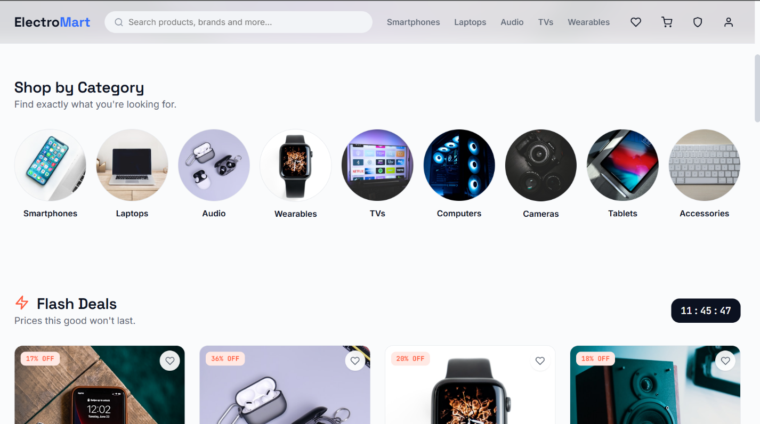

16.2 15.2 Products (Listing)
Description. The full catalog view with filtering, sorting, and pagination.
User Flow. User navigates to /products (optionally with a ?category= query) → applies filters (category, price range, brand) and sort order → browses the resulting ProductGrid.
Business Logic. Filtering and sorting are computed client-side over the already-fetched products.items array via memoized selectors, avoiding redundant network requests when only the filter changes.
Components Used. ProductGrid, ProductCard, SearchBar, filter controls, Loader, EmptyState.
Redux State. products.items, products.filters, products.status.
API Calls. productService.getAll() (once per session unless explicitly refreshed).
Error Handling. Network failure shows a toast and an EmptyState with a retry action.
Future Improvements. Server-side pagination and filtering once the catalog grows beyond a size comfortable for client-side filtering.
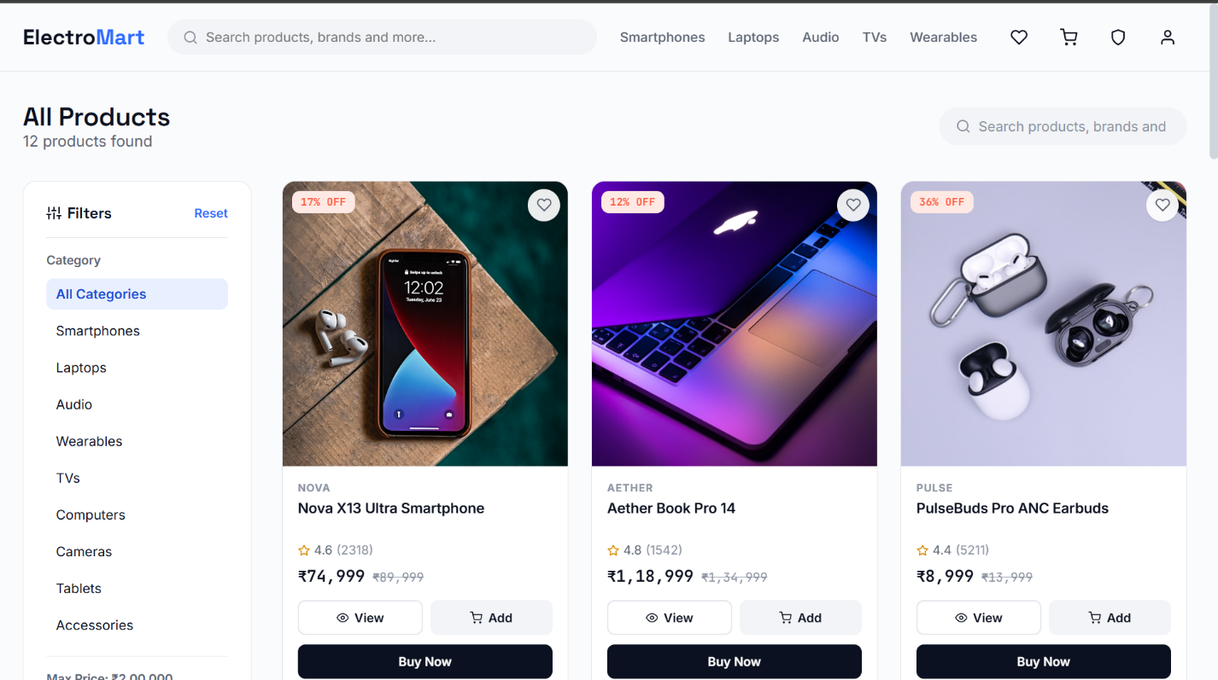

16.3 15.3 Search
Description. A global search bar (in the navbar) that filters products by name/brand as the user types.
User Flow. User types a query in SearchBar → debounced update narrows the visible product list → clicking a result navigates to ProductDetails.
Business Logic. Search is a case-insensitive substring match against name and brand, debounced (roadmap: 300ms) to avoid filtering on every keystroke.
Components Used. SearchBar, ProductGrid.
Redux State. products.filters.query.
API Calls. None additional — search operates over already-fetched products.items.
Error Handling. No results renders EmptyState with a “clear search” action.
Future Improvements. Server-side full-text search (e.g., MySQL FULLTEXT index or a dedicated search service) once catalog size makes client-side filtering impractical.
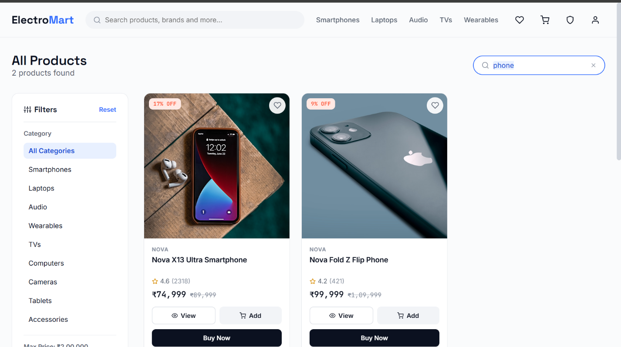

16.4 15.4 Product Details
Description. A detailed single-product view: images, price, specifications, stock, rating, and related products.
User Flow. User arrives via a ProductCard click → views full details → chooses quantity → clicks Add to Cart, the wishlist icon, or Buy Now.
Business Logic. “Buy Now” bypasses the cart entirely, passing the single product and chosen quantity via React Router’s navigation state directly to /checkout. “Add to Cart” dispatches cartSlice.addItem and stays on the page.
Components Used. ProductBadge, ProductGrid (for “Related Products”), Button, Loader.
Redux State. Reads a single product from products.items by :id; may dispatch to cartSlice or wishlistSlice.
API Calls. productService.getById(id) if not already present in the cached list.
Error Handling. Invalid/removed product id resolves to the NotFound page rather than a broken details view.
Future Improvements. Customer reviews and star-rating submission (Section 29).
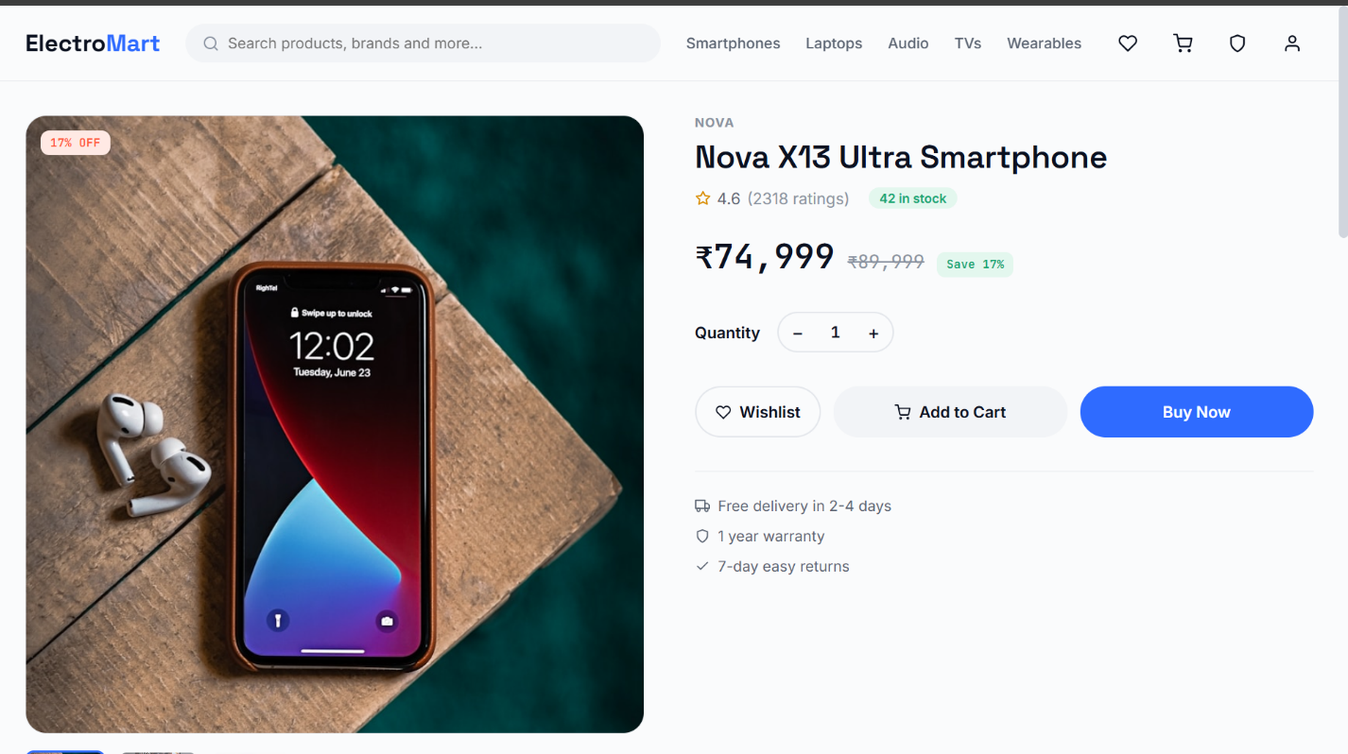

16.5 15.5 Cart
Description. The shopping cart: line items, quantity controls, subtotal, and a checkout entry point.
User Flow. User reviews items added from ProductCard/ProductDetails → adjusts quantities or removes items → clicks Proceed to Checkout.
Business Logic. Cart totals (subtotal, item count) are computed via a memoized selector over cart.items, never stored redundantly in state.
Components Used. ProductCard-derived line-item rows, Button, EmptyState (empty cart).
Redux State. cart.items (read and mutated via addItem, removeItem, updateQuantity).
API Calls. None — the cart is a purely client-side concept until checkout.
Error Handling. Removing the last item shows the EmptyState “Your cart is empty” view with a link back to /products.
Future Improvements. Server-persisted carts for logged-in users across devices.
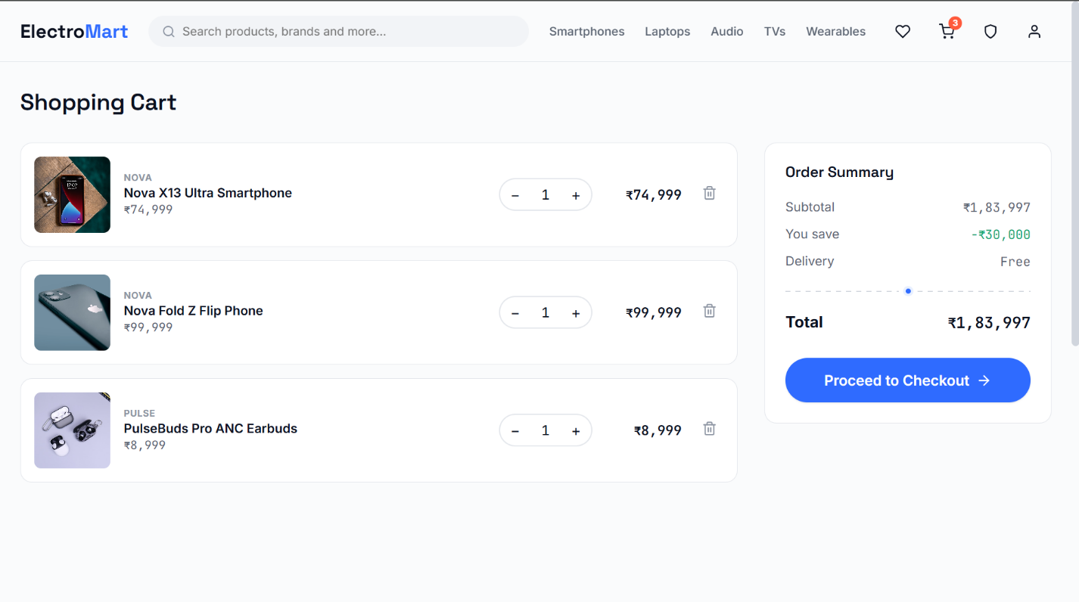

16.6 15.6 Wishlist
Description. A saved-for-later list, independent of the cart.
User Flow. User toggles the heart/wishlist icon on any ProductCard → item appears on /wishlist → user can move it to the cart or remove it.
Business Logic. Wishlist membership is a simple toggle (isInWishlist(productId) selector), not a quantity-bearing collection.
Components Used. ProductGrid, ProductCard, EmptyState.
Redux State. wishlist.items.
API Calls. None in the current implementation (purely localStorage-persisted).
Error Handling. Empty wishlist renders EmptyState with a call-to-action back to /products.
Future Improvements. Server-persisted wishlist tied to the user account rather than the browser.
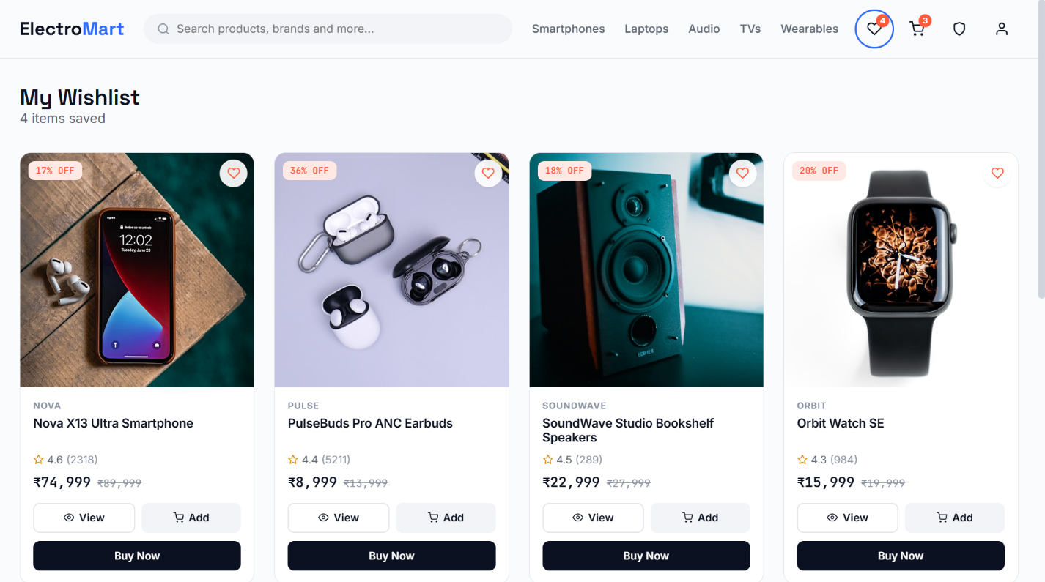

16.7 15.7 Checkout
Description. Collects shipping details and payment method, then creates the order.
User Flow. User arrives from either “Buy Now” (single item, via router state) or “Proceed to Checkout” (full cart) → fills shipping address → selects Razorpay or Cash on Delivery → confirms.
Business Logic. This is the one page in the application that must distinguish its two entry points: a Buy Now checkout never touches cart.items, while a cart checkout clears the cart only after the order is successfully created — never before, so a failed payment does not silently lose the user’s cart contents.
Components Used. Input (address form), Button, useRazorpay hook.
Redux State. Reads cart.items or router-state product (Buy Now); dispatches orderSlice.addOrder and, for cart checkout, cartSlice.clearCart on success.
API Calls. orderService.createOrder(payload).
Error Handling. Payment failure/cancellation keeps the user on the checkout page with a retry option and does not create an order record; network failure on order creation shows a toast and preserves form input.
Future Improvements. Address book (save multiple addresses), shipping-cost calculation, coupon codes (Section 29).
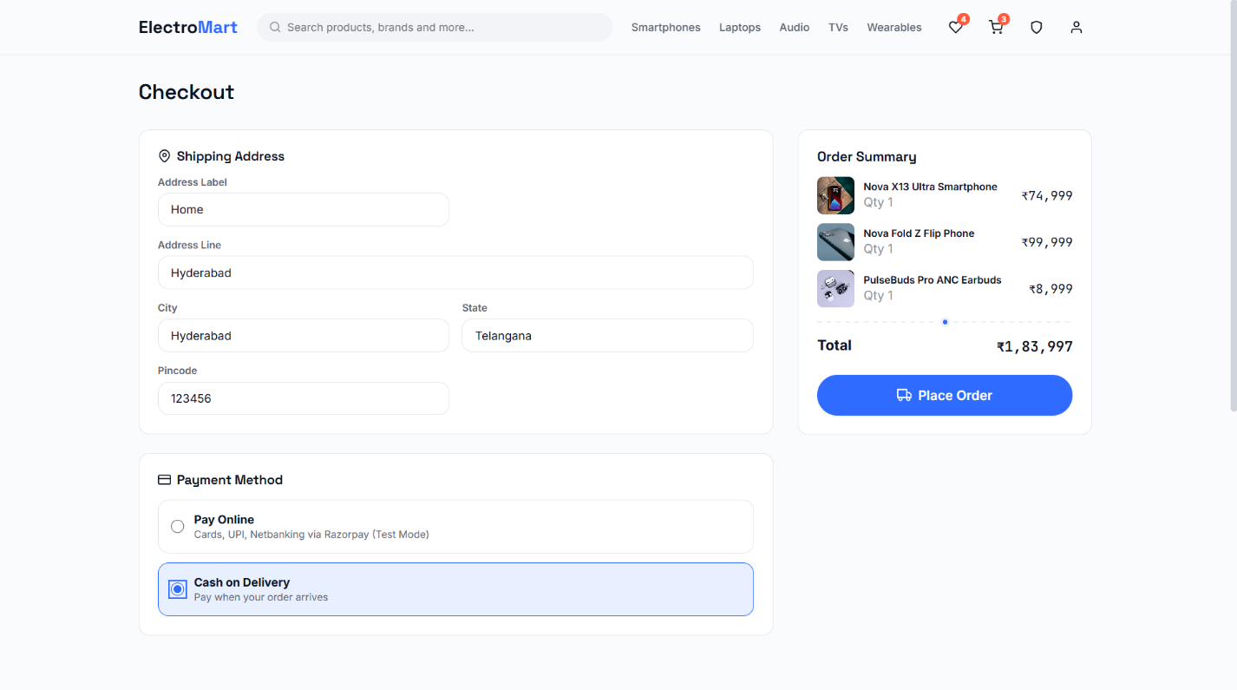

16.8 15.8 Payment
Description. The Razorpay Test Mode checkout widget, orchestrated through the useRazorpay hook, plus a Cash on Delivery fallback that skips this step entirely.
See Section 17 for the full payment integration walkthrough.

16.9 15.9 Orders (History)
Description. A customer’s past orders, each showing items, status, and total.
User Flow. User navigates to /orders (protected route) → sees a reverse-chronological list of their orders → can expand an order for item-level detail.
Business Logic. Orders are filtered server-side (GET /orders?userId=:id) rather than fetching all orders and filtering client-side, keeping the customer’s request scoped to their own data.
Components Used. Order list/row components, Loader, EmptyState.
Redux State. orders.orders.
API Calls. orderService.getByUser(userId).
Error Handling. No orders yet renders EmptyState with a link to /products.
Future Improvements. Order status timeline/tracking view, downloadable invoices.
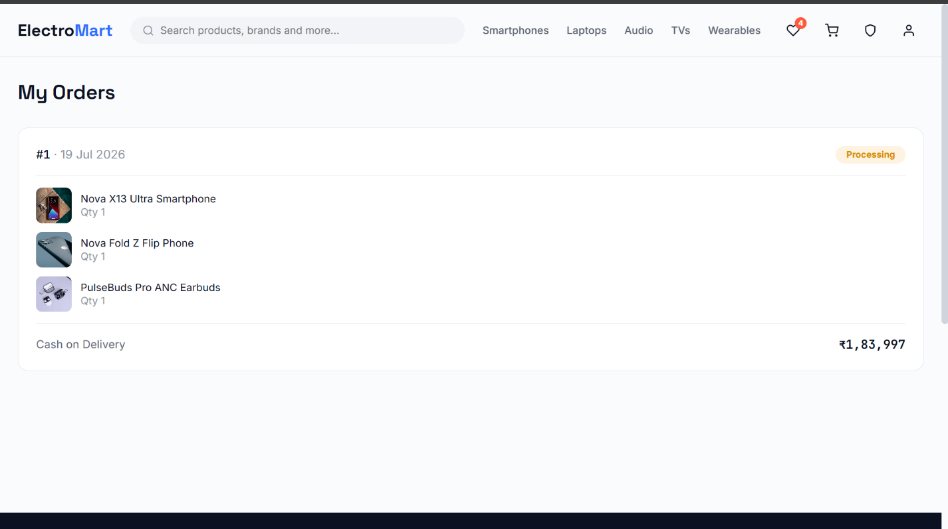

16.10 15.10 Order Success / Confirmation
Description. The confirmation screen shown immediately after a successful checkout.
User Flow. Redirected here from Checkout with the newly created order passed via router state → user sees an order summary and a link to /orders.
Business Logic. Reads the order from router state rather than re-fetching, so the confirmation renders instantly; falls back to the most recent entry in orders.currentOrder if the page is reloaded.
Components Used. Order summary card, Button.
Redux State. orders.currentOrder.
API Calls. None (data already available from the checkout response).
Error Handling. Direct navigation to /order-success without a preceding checkout redirects to /orders.
Future Improvements. Email/SMS order confirmation (Section 29).
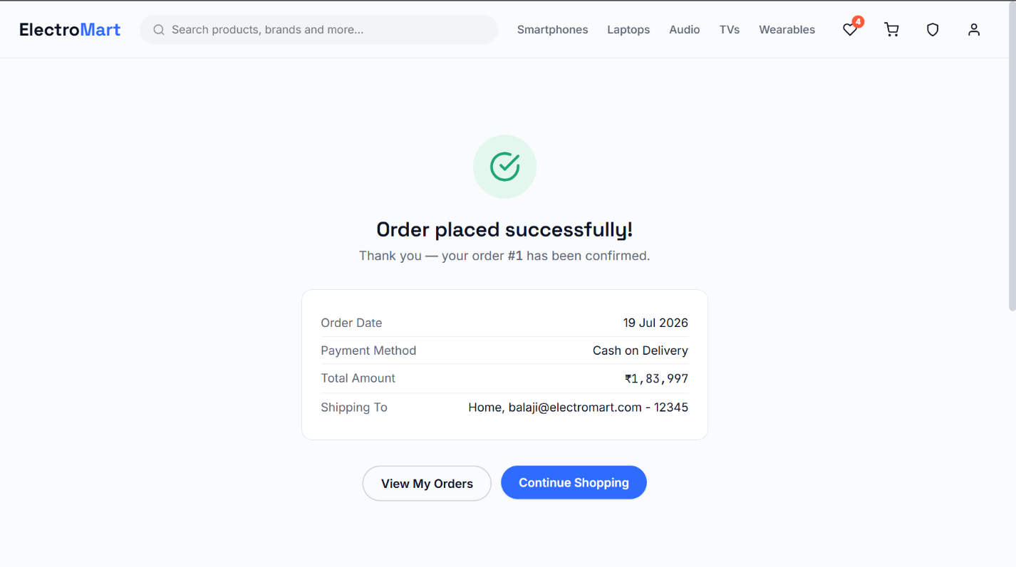

16.11 15.11 Profile
Description. Customer account details: name, email, phone, address.
User Flow. User navigates to /profile (protected) → views/edits account details → saves changes.
Business Logic. Profile updates are a PATCH against the user’s own id only — the UI never exposes another user’s id as editable.
Components Used. Input, Button.
Redux State. auth.user.
API Calls. userService.updateProfile(id, changes).
Error Handling. Validation errors shown inline; failed save shows a toast and leaves the form editable with the user’s attempted changes intact.
Future Improvements. Password change flow, order-linked address book.
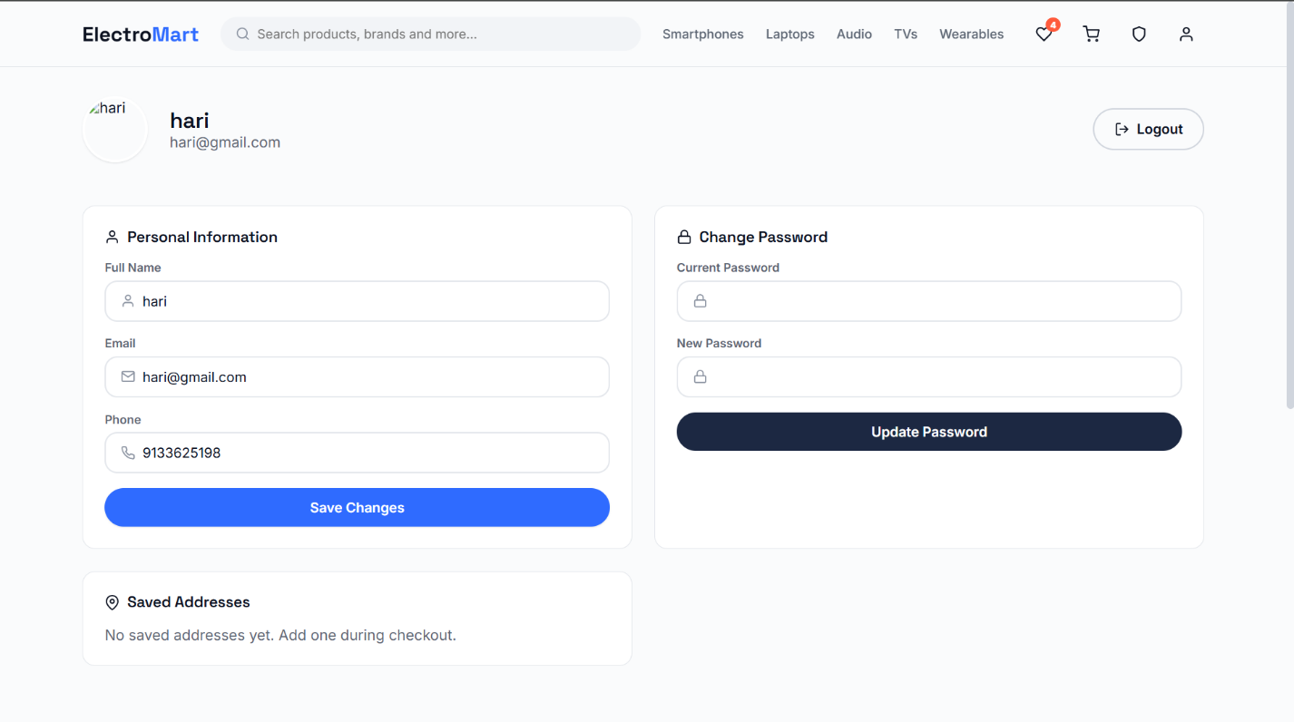

16.12 15.12 Admin Dashboard
Description. The admin landing page: key metrics (total revenue, order count, product count, low-stock alerts) and a revenue trend chart.
User Flow. Admin logs in at /admin/login → lands on /admin/dashboard → reviews StatCards and RevenueChart.
Business Logic. Dashboard metrics are derived client-side from orders and products slices (sums, counts) rather than requiring dedicated aggregation endpoints — acceptable at demo scale, called out explicitly as a scaling limitation.
Components Used. StatCard, RevenueChart, AdminLayout, AdminSidebar, AdminTopbar.
Redux State. orders.orders, products.items.
API Calls. orderService.getAll(), productService.getAll().
Error Handling. Partial data failures degrade individual StatCards to a loading/error state rather than blocking the whole dashboard.
Future Improvements. Server-side aggregation endpoints for dashboard metrics as order volume grows.
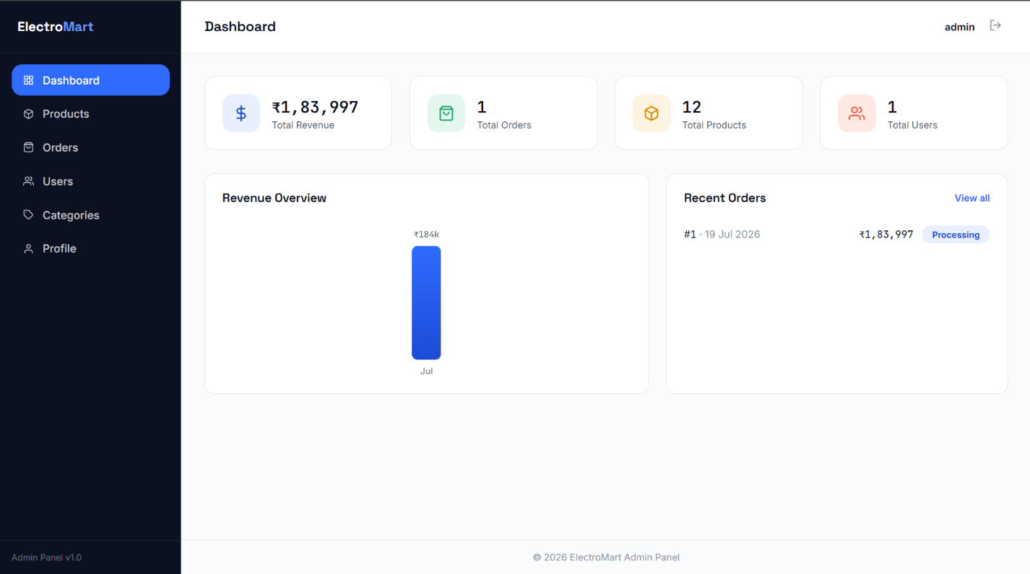

16.13 15.13 Admin Product Management
Description. CRUD interface for the product catalog.
User Flow. Admin navigates to /admin/products → views a searchable/sortable table → creates, edits, or deletes products via a Modal form.
Business Logic. Deleting a product does not retroactively alter historical order_items (which store price at time of purchase), preserving order history integrity even after a product is removed from the catalog.
Components Used. AdminTable, Modal, Input, Button.
Redux State. products.items, refreshed after each mutation.
API Calls. adminService.createProduct, updateProduct, deleteProduct.
Error Handling. Optimistic UI update rolled back with a toast if the API call fails.
Future Improvements. Bulk import/export (CSV), image upload to cloud storage instead of static asset paths.
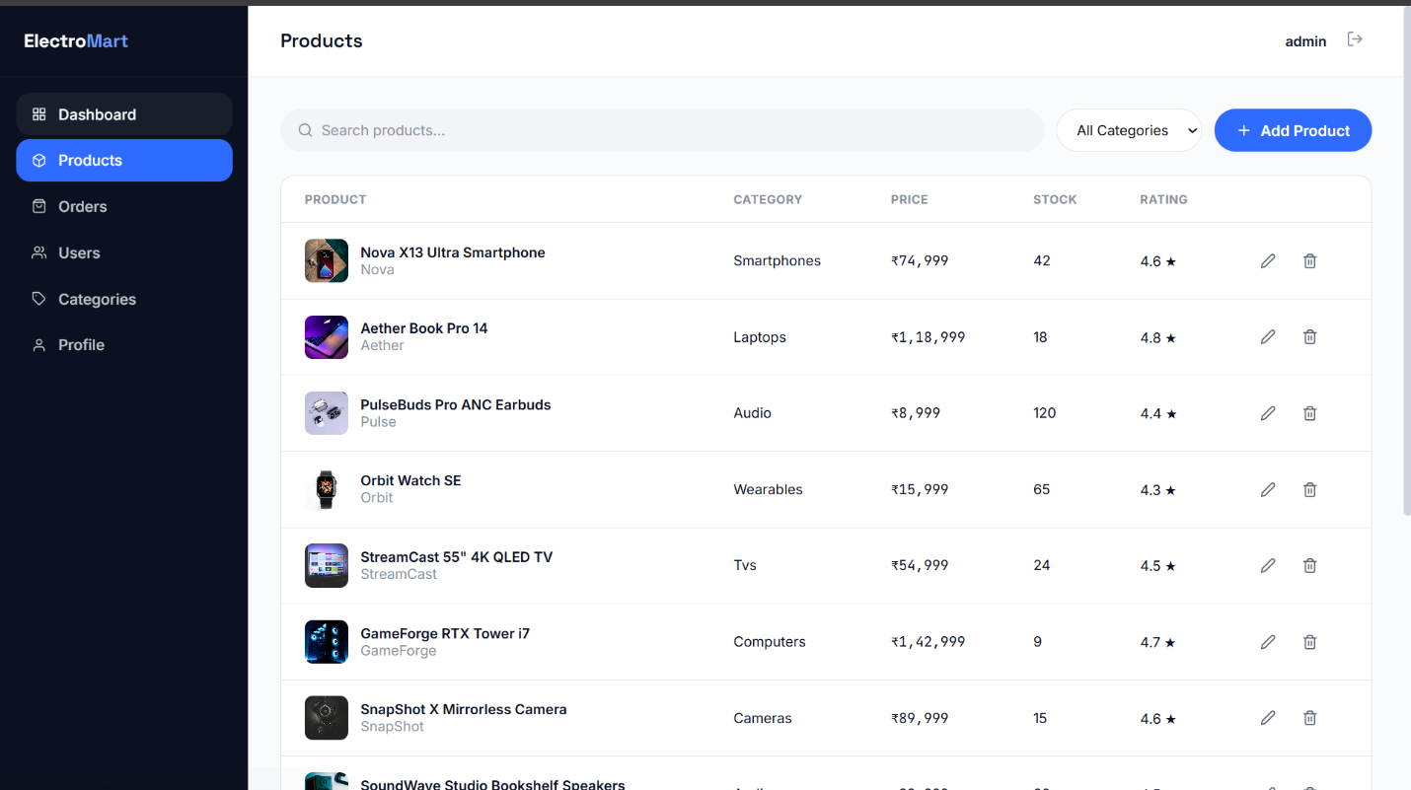

16.14 15.14 Admin Order Management
Description. View and update order status (e.g., placed → confirmed → shipped → delivered) across all customers.
User Flow. Admin navigates to /admin/orders → filters by status → updates an order’s status from a detail view.
Business Logic. Status transitions are validated against an allowed-transitions map (e.g., a delivered order cannot be moved back to placed) at the UI layer, with the same rule intended to be enforced server-side in the production backend.
Components Used. AdminTable, status badge components.
Redux State. orders.orders.
API Calls. adminService.getAllOrders, adminService.updateOrderStatus.
Error Handling. Failed status update reverts the table row and shows a toast.
Future Improvements. Shipment tracking number field, automated status webhooks from a courier partner API.
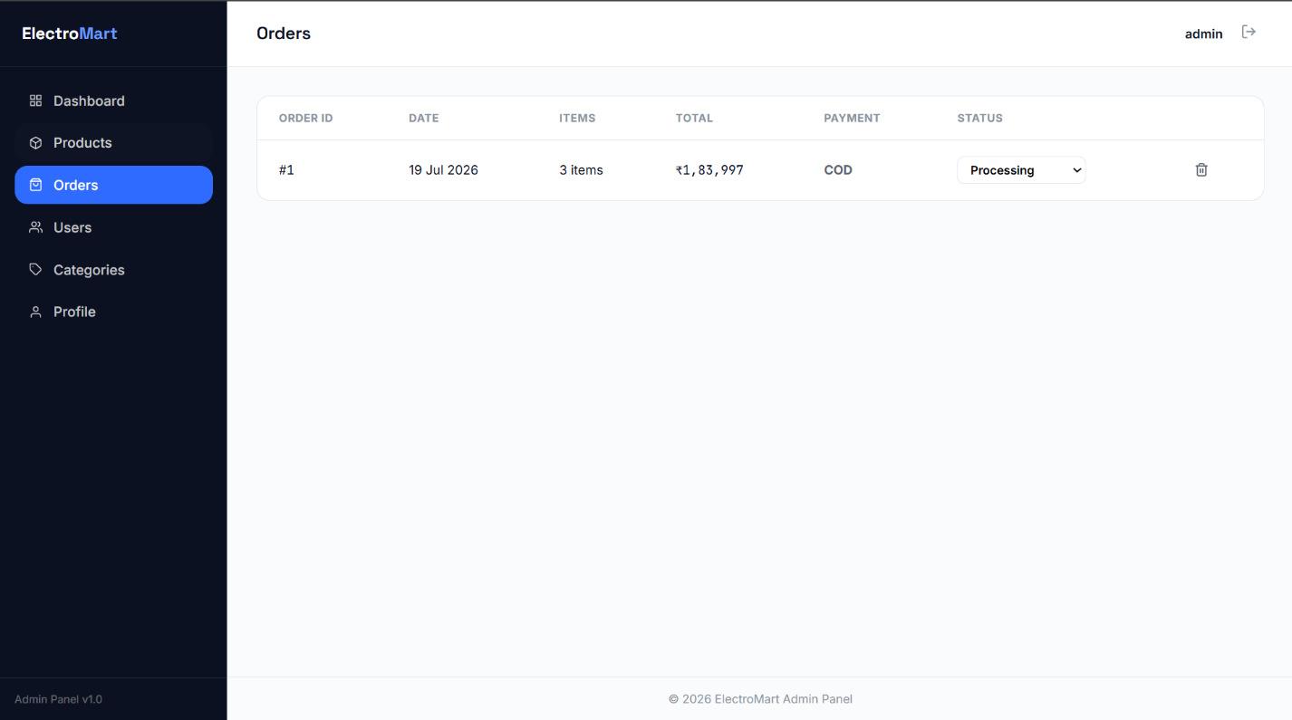

16.15 15.15 Admin User & Category Management
Description. View registered customers and manage the category taxonomy used across the catalog.
User Flow. Admin navigates to /admin/users to view customer accounts (read-focused), or /admin/categories to create/edit/delete categories used by the product form.
Business Logic. Deleting a category that still has associated products is blocked at the UI layer with a warning, preventing orphaned category references on existing products.
Components Used. AdminTable, Modal, Input.
Redux State. No dedicated slice for users/categories in the current version — fetched and held in local component state within the admin pages.
API Calls. adminService.getUsers, adminService.createCategory, updateCategory, deleteCategory.
Error Handling. Delete-blocked case shows an explanatory toast rather than a silent no-op.
Future Improvements. Promote category state into a Redux slice if category management grows in complexity; add customer account suspension.

16.16 15.16 Authentication (Feature Summary)
Covered in full in Section 13. In summary: customer and admin authentication are deliberately separate flows against separate db.json collections (users vs. admins), each with its own login/register pages and its own route guard component, so that a customer session can never accidentally satisfy an admin-protected route.

17 16. UI Documentation
This section briefly describes each major screen. Screenshots are marked as placeholders pending capture from the live deployment.
Screen | Key Elements
Home | Hero banner, category tiles, flash deals rail, brand strip, navbar, footer
Products | Filter sidebar, sort dropdown, search bar, responsive product grid, pagination controls
Product Details | Image gallery, price/discount, stock badge, quantity selector, Add to Cart / Buy Now / Wishlist actions, specifications table, related products
Cart | Line-item rows with quantity steppers, subtotal panel, proceed-to-checkout button, empty state
Wishlist | Reused ProductGrid, empty state
Checkout | Shipping address form, order summary panel, payment method selector (Razorpay / COD)
Payment | Razorpay Test Mode modal widget (card, UPI, wallet tabs)
Orders | Reverse-chronological order cards, expandable item details, status badges
Order Success | Confirmation message, order id, summary, link to Orders
Login / Register | Centered form card, inline validation messages
Profile | Editable account details form
Admin Dashboard | KPI stat cards, revenue line/bar chart, recent orders table
Admin Products / Orders / Users / Categories | Sidebar navigation, top bar, searchable/sortable data tables, modal forms

17.1 16.1 Design System
src/styles/tokens.css defines CSS custom properties for color, spacing, typography scale, radii, and shadows; src/styles/global.css applies a modern CSS reset and shared utility classes (flex/grid helpers, spacing utilities, visually-hidden text for accessibility).
:root {
--color-primary: #1a56db;
--color-primary-hover: #1e40af;
--color-accent: #f97316;
--color-bg: #ffffff;
--color-surface: #f8fafc;
--color-text: #0f172a;
--color-text-muted: #64748b;
--radius-sm: 6px;
--radius-md: 10px;
--space-1: 4px;
--space-2: 8px;
--space-4: 16px;
--space-8: 32px;
--font-sans: 'Inter', system-ui, sans-serif;
}
Best Practice: All component-level CSS references these tokens rather than hard-coded hex values or pixel counts, so a future theme change (e.g., dark mode, Section 29) touches tokens.css alone.

17.2 16.2 Responsive Behavior
The layout uses CSS Grid for the product grid (auto-fill/minmax columns) and Flexbox for navigation and form layouts, with breakpoints at approximately 640px (mobile), 1024px (tablet), and 1280px (desktop).

18 17. Payment Integration

18.1 17.1 Overview
ElectroMart integrates Razorpay’s Test Mode checkout widget, orchestrated by a custom useRazorpay hook, giving customers a realistic card/UPI/wallet payment UX without any real money movement. A Cash on Delivery option is available as an alternative that bypasses the payment widget entirely.

18.2 17.2 Test Credentials (Documented for Reviewers)
Field | Value
Card Number | 4111 1111 1111 1111
Expiry | Any future date
CVV | Any 3 digits
OTP | 1111 (or blank if not prompted)
Note: No real financial transaction occurs. These are Razorpay’s published test-mode values, used with the standard Razorpay test public key.

18.3 17.3 useRazorpay Hook
// hooks/useRazorpay.js
export function useRazorpay() {
const loadScript = () => new Promise((resolve) => {
if (window.Razorpay) return resolve(true);
const script = document.createElement('script');
script.src = 'https://checkout.razorpay.com/v1/checkout.js';
script.onload = () => resolve(true);
script.onerror = () => resolve(false);
document.body.appendChild(script);
});
const openCheckout = async ({ amount, name, onSuccess, onFailure }) => {
const loaded = await loadScript();
if (!loaded) return onFailure('Razorpay SDK failed to load');
const options = {
key: import.meta.env.VITE_RAZORPAY_KEY,
amount: amount * 100, // paise
currency: 'INR',
name: 'ElectroMart',
description: `Order for ${name}`,
handler: (response) => onSuccess(response),
modal: { ondismiss: () => onFailure('Payment cancelled') },
theme: { color: '#1a56db' },
};
const rzp = new window.Razorpay(options);
rzp.open();
};
return { openCheckout };
}

18.4 17.4 Payment Sequence Diagram
sequenceDiagram
actor Customer
participant Checkout
participant useRazorpay
participant RazorpaySDK as Razorpay Checkout Widget
participant orderService
participant API as JSON Server
Customer->>Checkout: Click "Pay Now"
Checkout->>useRazorpay: openCheckout({amount, ...})
useRazorpay->>RazorpaySDK: Load script + init widget
RazorpaySDK-->>Customer: Show card/UPI/wallet form
Customer->>RazorpaySDK: Enter test card details
alt Payment succeeds
RazorpaySDK-->>useRazorpay: handler(response)
useRazorpay-->>Checkout: onSuccess(response)
Checkout->>orderService: createOrder({..., paymentStatus:'paid'})
orderService->>API: POST /orders
API-->>Checkout: Order created
Checkout-->>Customer: Redirect to /order-success
else Payment cancelled/fails
RazorpaySDK-->>useRazorpay: ondismiss()
useRazorpay-->>Checkout: onFailure(reason)
Checkout-->>Customer: Show retry option, no order created
end

18.5 17.5 Production Considerations
In a production deployment, the flow described above must be extended with server-side payment verification:
- The backend creates a Razorpay Order (orders.create) before the widget opens, rather than the client controlling the amount directly.
- After payment, the backend verifies the returned razorpay_signature using HMAC-SHA256 against the Razorpay key secret (never exposed to the client) before marking the order as paid.
- Webhook handling for asynchronous payment events (e.g., delayed UPI confirmation) rather than relying solely on the client-side handler callback.
Warning: In the current client-only implementation, payment success is trusted based on the widget’s client-side callback. This is appropriate for a test-mode demo but is not a secure pattern for real payments — server-side signature verification is a hard requirement before processing live transactions.

19 18. Security

19.1 18.1 Current Implementation
Area | Current State
Password storage | Plain text in db.json
Session model | localStorage-persisted user object, trusted by the client
Transport | HTTP to localhost:4000 in development; HTTPS provided by Vercel for the static front-end in production
Authorization | Client-side route guards only (ProtectedRoute, AdminProtectedRoute)
Payment verification | Client-side callback only

19.2 18.2 Limitations
- Any user with browser DevTools access can inspect or forge the localStorage session object.
- JSON Server has no authentication or authorization middleware of its own — any client can call any endpoint.
- There is no CSRF protection, since there is no server-side session/cookie model in the current architecture.
- No rate limiting or input sanitization at the API layer.

19.3 18.3 Future Implementation (Production Roadmap)
Control | Description
JWT | Signed, expiring tokens issued by the Flask backend and verified on every protected endpoint
bcrypt | Salted password hashing, replacing plain-text storage
HTTPS | Enforced end-to-end, including the API layer (already provided for the static front-end by Vercel)
CSRF protection | httpOnly, SameSite cookies if session cookies are introduced, plus CSRF tokens on state-changing requests
Input validation | Server-side schema validation (e.g., marshmallow or pydantic) on every Flask endpoint, not just client-side form checks
Secure headers | Content-Security-Policy, X-Frame-Options, X-Content-Type-Options via Flask-Talisman or an equivalent
Role-based access | Server-side enforcement of customer vs. admin roles on every endpoint, not just client-side route guards
Warning: Client-side route guards (as implemented today) prevent navigation to protected pages but do not prevent a determined user from calling the underlying API directly. Server-side authorization is a prerequisite for any production deployment.

20 19. Performance Optimization

20.1 19.1 Current Practices
Technique | Application in ElectroMart
Component reusability | A single ProductCard renders across Home, Products, Wishlist, and Related Products, reducing bundle size and rendering inconsistency
Efficient rendering | Presentational components (common/) are kept prop-driven and free of internal data fetching, minimizing unnecessary re-renders
Redux selector granularity | Components select only the state slice they need (e.g., state.cart.items) rather than the entire store
Vite build optimization | Rollup-based production builds with automatic code minification and tree-shaking

20.2 19.2 Recommended Next Steps
Technique | Where It Applies
Memoization | Wrap ProductCard in React.memo; memoize derived selectors (filtered/sorted product lists) with reselect
Lazy loading | React.lazy + Suspense for the entire /admin/* route tree, which customer-facing users never load
Code splitting | Route-based splitting via Vite’s dynamic import() for Checkout, Orders, and admin pages
Image optimization | Serve responsive image sizes / modern formats (WebP) for product images, currently served as static assets
Pagination | Server-side pagination for /products once catalog size grows beyond a few hundred items
Caching | HTTP caching headers on the future Flask API; client-side cache of productService.getAll() results with a short TTL
flowchart LR
A[Route requested] --> B{Route is admin-only?}
B -->|Yes| C[React.lazy dynamic import]
B -->|No| D[Already in main bundle]
C --> E[Suspense fallback: Loader]
E --> F[Chunk loaded, page renders]

21 20. Error Handling

21.1 20.1 Strategy
ElectroMart handles errors at three layers:
- Service layer — every function in src/services/ wraps its Axios call in try/catch and normalizes the error into { message, status } before it propagates further (Section 14.7).
- Redux layer — slice reducers/thunks set a status: 'failed' and error: message field rather than throwing, so components can render error state declaratively.
- Component layer — pages render Loader while status === 'loading', EmptyState or an inline error message while status === 'failed', and use react-toastify for transient, action-triggered feedback (e.g., “Added to cart”, “Payment failed”).

21.2 20.2 Example — Component-Level Handling
function Products() {
const { items, status, error } = useSelector(s => s.products);
if (status === 'loading') return <Loader />;
if (status === 'failed') return <EmptyState message={error} onRetry={refetch} />;
if (items.length === 0) return <EmptyState message="No products found" />;
return <ProductGrid products={items} />;
}

21.3 20.3 Toast Notification Conventions
Event | Toast Type
Add to cart / wishlist | Success
Login / registration success | Success
Login / registration failure | Error
Payment failure or cancellation | Error/Warning
Order placed successfully | Success
Network/API failure | Error
Admin CRUD success | Success
Admin CRUD failure | Error
Tip: Centralizing toast copy in utils/constants.js keeps user-facing messaging consistent across customer and admin surfaces, and makes future localization (Section 29) simpler.

22 21. Deployment

22.1 21.1 Current Deployment — Vercel
ElectroMart’s front-end is deployed on Vercel as a static Vite build. Vercel builds the project with npm run build and serves the resulting dist/ output from its global CDN, with automatic preview deployments generated for every pushed branch/PR.
flowchart LR
Dev[git push to GitHub] --> Hook[Vercel Git Integration Webhook]
Hook --> Build[npm install and npm run build]
Build --> Dist[dist/ static output]
Dist --> CDN[Vercel Edge CDN]
CDN --> User[Browser]
Note: json-server is a development-only mock backend and is intentionally not part of the Vercel deployment — the deployed build points at whichever API base URL is configured via environment variables, which in the current demo deployment still requires a running JSON Server instance reachable by the client.

22.2 21.2 Local Development
npm install
# Terminal 1 — JSON Server API on http://localhost:4000
npm run server
# Terminal 2 — Vite dev server on http://localhost:5173
npm run dev

22.3 21.3 Production Build
npm run build
npm run preview

22.4 21.4 Future Deployment Architecture
The production roadmap (Flask + MySQL) introduces a proper multi-tier deployment:
flowchart TD
Client[React SPA on Vercel CDN] -->|HTTPS| LB[Nginx Reverse Proxy]
LB --> App[Flask App via Gunicorn]
App --> DB[(MySQL)]
App --> Cache[(Redis - optional cache/session store)]
subgraph Container Host / Docker
LB
App
end
Component | Role
Nginx | Reverse proxy, TLS termination, static file caching, request buffering
Gunicorn | WSGI application server running the Flask app with multiple worker processes
Docker | Containerizes the Flask + Gunicorn + Nginx stack for reproducible deployment
MySQL | Primary relational data store, replacing db.json
Best Practice: Even after migrating to Flask/MySQL, the React front-end continues to be deployed independently on Vercel — decoupling front-end and back-end deployment cadence is a deliberate architectural choice carried over from the current design.

23 22. Challenges Faced
# | Problem | Cause | Solution | Lesson Learned
1 | Cart state was lost on every page refresh during early development | State lived only in a component useState, not in Redux or localStorage | Moved cart state into cartSlice and added localStorage read/write on every mutation | Global, persisted state should be designed in from the start for anything the user expects to survive navigation
2 | “Buy Now” was initially implemented by silently adding the item to the cart and redirecting to checkout | Reusing the cart-checkout code path seemed simpler | Split into a dedicated Buy Now path that passes the product via router state and never touches cart.items | Reusing a code path that has different business semantics (single-item vs. cart-clearing checkout) causes subtle bugs; explicit is better than implicit
3 | Duplicate product-card markup and styling drifted across Home, Products, and Wishlist pages | Each page initially had its own inline card markup | Extracted a single ProductCard component used everywhere | A shared presentational component prevents visual and behavioral drift, and is far easier to test once
4 | Protected routes briefly flashed a redirect to /login on page refresh even for already-authenticated users | The router rendered before the localStorage-persisted auth state had been read into Redux | Rehydrated authSlice from localStorage synchronously before the router’s first render | Session rehydration must complete before route guards evaluate, or guards will race against state initialization
5 | Razorpay’s checkout script occasionally failed to load on slow connections, breaking the payment button silently | No handling for <script> load failure | Added an explicit loadScript() promise with an onerror branch inside useRazorpay, surfaced via a toast | Third-party script loading is a network request like any other and needs the same failure handling as an API call
6 | Admin and customer sessions could overwrite one another when both were tested in the same browser tab | Both roles initially shared a single localStorage key | Namespaced auth persistence and the role field so authSlice unambiguously distinguishes a customer session from an admin session | Multi-role authentication needs a role-aware storage/session design from day one, not as a later patch

24 23. Testing Strategy

24.1 23.1 Testing Layers
Layer | Tooling (Recommended) | Scope
Unit Testing | Vitest + React Testing Library | Individual components (ProductCard, Button, formatters in utils/), Redux slice reducers in isolation
Integration Testing | React Testing Library + mocked service layer | Page-level flows (e.g., adding a product to cart updates the cart badge)
End-to-End Testing | Cypress or Playwright | Full user journeys against a running JSON Server instance (register → browse → checkout → order confirmation)
Manual Testing | Structured checklist (below) | Cross-browser, responsive layout, and payment widget verification
Note: As of this document’s writing, ElectroMart’s automated test suite is part of the future roadmap (Section 29); the manual testing checklist below reflects the verification process currently used before each release.

24.2 23.2 Manual Testing Checklist
- ☐ Register a new customer account; verify redirect and persisted session after refresh.
- ☐ Log in with the demo customer account (asha@example.com / password123).
- ☐ Log in with the demo admin account (admin@electromart.com / admin123).
- ☐ Browse Products, apply category filter, apply search, apply sort — verify grid updates correctly.
- ☐ Add a product to the cart; refresh the page; verify the item persists.
- ☐ Add/remove a product from the wishlist; verify persistence across refresh.
- ☐ Use “Buy Now” on a product; verify the cart is unaffected and checkout shows only that item.
- ☐ Checkout from the cart with multiple items; verify the cart is cleared only after order success.
- ☐ Complete a Razorpay Test Mode payment using the documented test card; verify order appears in Order History.
- ☐ Cancel a Razorpay payment mid-flow; verify no order is created and a retry option is shown.
- ☐ Choose Cash on Delivery at checkout; verify the payment step is skipped and the order is still created.
- ☐ Attempt to access /checkout while logged out; verify redirect to /login.
- ☐ Attempt to access /admin/dashboard as a logged-in customer (not admin); verify redirect to /admin/login.
- ☐ In the admin panel, create, edit, and delete a product; verify changes reflect on the customer-facing catalog.
- ☐ In the admin panel, update an order’s status; verify it reflects for the customer in Order History.
- ☐ Attempt to delete a category that has associated products; verify the delete is blocked with a warning.
- ☐ Resize the browser to mobile, tablet, and desktop widths; verify responsive layout on Home, Products, and Checkout.

24.3 23.3 Example Test Cases
Test Case ID | Description | Steps | Expected Result
TC-01 | Cart persistence across refresh | Add item to cart → refresh page | Item remains in cart
TC-02 | Buy Now isolation from cart | Add item A to cart → Buy Now item B → complete checkout | Cart still contains only item A
TC-03 | Protected route redirect | Log out → navigate directly to /orders | Redirected to /login
TC-04 | Admin route isolation | Log in as customer → navigate to /admin/dashboard | Redirected to /admin/login, dashboard not rendered
TC-05 | Payment cancellation | Start Razorpay checkout → dismiss modal | No order created; retry option shown
TC-06 | Category delete guard | Attempt to delete a category with existing products | Deletion blocked; warning toast shown

25 24. Future Enhancements
Enhancement | Description
JWT Authentication | Replace localStorage-trusted sessions with server-issued, verifiable tokens (Section 13.2, Section 23)
Flask Backend | Production REST API replacing JSON Server, with real request validation and business-rule enforcement
MySQL | Normalized relational storage replacing db.json (Section 10.3)
Redis | Caching layer for frequently-read data (product catalog, dashboard aggregates) and/or session storage
Docker | Containerized Flask + Gunicorn + Nginx stack for reproducible deployment (Section 21.4)
Kubernetes | Orchestrated deployment and horizontal scaling once traffic justifies it
Cloud Storage | Product images moved from static assets to S3-compatible object storage with a CDN
Email Notifications | Order confirmation and status-change emails (e.g., via SendGrid or SES)
SMS Notifications | Delivery/OTP notifications via a provider such as Twilio
Reviews & Ratings | Customer-submitted product reviews feeding into the existing rating field
Coupons | Discount code support at checkout, with admin-managed coupon rules
AI Recommendations | “You may also like” recommendations based on browsing/purchase history
Analytics Dashboard | Expanded admin analytics: conversion funnel, cart abandonment, top categories
Dark Mode | Enabled by the existing tokens.css design-token system with minimal component changes
Multi-language Support | i18n framework (e.g., react-i18next) layered over existing string constants in utils/constants.js

26 25. Lessons Learned
Technical Skills. Building ElectroMart reinforced practical fluency in component-driven UI design, Redux Toolkit’s slice pattern, RESTful API consumption via a dedicated service layer, client-side session persistence, protected routing, and third-party payment widget integration.
Soft Skills. Scoping a project of this breadth as a single developer required disciplined prioritization — deciding, for example, that a production backend was out of scope for this iteration while still designing the front-end so that decision wouldn’t become technical debt.
Problem-Solving. The “Buy Now vs. cart checkout” and “cart-clears-only-after-order-success” edge cases (Section 22) are the kind of subtle business-logic bugs that only surface through deliberate manual testing, reinforcing the value of a written test checklist even without full automation.
Architecture. Separating components, Redux, and the service layer into strict one-way dependencies (Section 7.3) proved its value directly: documenting the Flask/MySQL migration path (Sections 10.3, 13.2, 21.4) required no changes to any React component.
Debugging. The route-guard “flash of redirect” issue (Section 22, #4) was a useful lesson in initialization ordering — state rehydration and route evaluation are two async-adjacent concerns that must be sequenced deliberately, not assumed to happen in the “obvious” order.
Deployment. Deploying a Vite SPA to Vercel highlighted the difference between a self-contained static front-end and a full-stack application — and made explicit why the mock backend (JSON Server) cannot simply “come along for the ride” in a serverless static hosting model.
Git Workflow. Maintaining a clean commit history and a descriptive README.md (mirrored and expanded in this document) reinforced that documentation is a deliverable in its own right, not an afterthought.

27 26. Resume Impact
ElectroMart demonstrates a range of skills directly relevant to front-end and full-stack engineering interviews:
Skill Demonstrated | Where It Shows Up
Component architecture & reuse | Single ProductCard used across four pages
State management at scale | Five-slice Redux Toolkit store with persisted state
RESTful API design & consumption | Full CRUD across products, orders, users, categories
Authentication & authorization patterns | Dual-role (customer/admin) auth with route guards
Third-party integration | Razorpay payment widget via a custom hook
API abstraction for portability | Service layer isolating the UI from JSON Server, enabling a documented backend migration
Design systems | Token-based CSS architecture without a framework
Technical documentation | This document itself — a demonstrable communication artifact
Why it matters for interviews. Beyond “I built an e-commerce site,” ElectroMart lets a candidate speak concretely about why specific architectural boundaries exist (Section 7.3), what tradeoffs were made and why (Section 1.6 Scope), and what a realistic production migration looks like (Sections 10.3, 13.2, 18.3, 21.4) — the kind of systems-thinking discussion that distinguishes a portfolio project from a tutorial clone.

28 27. Conclusion
ElectroMart demonstrates that a disciplined, production-minded architecture — a clean service layer, predictable Redux state, persisted sessions, protected routing, and a realistic payment integration — can be built with a front-end-only stack (React, Vite, Redux Toolkit, JSON Server) without sacrificing the ability to migrate to a real backend later. The one-way dependency between components, state, and services is the single architectural decision that makes every item in the “Future Enhancements” roadmap (Section 24) a scoped, additive change rather than a rewrite.
As a portfolio artifact, the project — together with this documentation — is intended to demonstrate not just working code, but the engineering judgment behind it: what was deliberately deferred, what tradeoffs were made under a single-developer scope, and what the path to production actually looks like.

29 28. References
- React — Official Documentation. https://react.dev
- Redux Toolkit — Official Documentation. https://redux-toolkit.js.org
- Vite — Official Documentation. https://vitejs.dev
- Axios — Official Documentation. https://axios-http.com
- React Router — Official Documentation. https://reactrouter.com
- Razorpay — Developer Documentation. https://razorpay.com/docs
- JSON Server — Project Documentation. https://github.com/typicode/json-server
- Vercel — Official Documentation. https://vercel.com/docs
- JavaScript (MDN Web Docs). https://developer.mozilla.org/en-US/docs/Web/JavaScript

30 29. Appendix

30.1 29.1 Glossary
Term | Definition
SPA | Single-Page Application — a web app that loads once and updates the DOM dynamically rather than reloading pages
Slice | A Redux Toolkit module bundling a piece of state with its reducers and actions
Selector | A function that reads a specific piece of data from the Redux store
Thunk | A function used for asynchronous Redux logic
Route Guard | A component that conditionally allows or redirects navigation based on auth state
Mock API | A backend that simulates real API behavior without a persistent production database

30.2 29.2 Acronyms
Acronym | Meaning
API | Application Programming Interface
REST | Representational State Transfer
JWT | JSON Web Token
CRUD | Create, Read, Update, Delete
CSRF | Cross-Site Request Forgery
CDN | Content Delivery Network
HMR | Hot Module Replacement
SDK | Software Development Kit
KPI | Key Performance Indicator

30.3 29.3 Folder Tree
See Section 8.1 for the complete, annotated folder tree.

30.4 29.4 Environment Variables
Variable | Purpose | Example
VITE_API_URL | Base URL for the JSON Server / future Flask API | http://localhost:4000
VITE_RAZORPAY_KEY | Razorpay public test key used by the checkout widget | rzp_test_xxxxxxxxxxxx

30.5 29.5 Useful Commands
npm install # Install dependencies
npm run dev # Start Vite dev server (http://localhost:5173)
npm run server # Start JSON Server API (http://localhost:4000)
npm run build # Production build to dist/
npm run preview # Preview the production build locally

30.6 29.6 Installation Guide
- Clone the repository: git clone https://github.com/Ankani-Balaji/ElectroMart.git
- Install dependencies: npm install
- Start the mock API in one terminal: npm run server
- Start the dev server in a second terminal: npm run dev
- Open http://localhost:5173 in a browser.
- Log in with a demo account (Section 29.7) or register a new one.

30.7 29.7 Demo Accounts
Role | Email | Password
Customer | asha@example.com | password123
Admin | admin@electromart.com | admin123

30.8 29.8 Troubleshooting
Symptom | Likely Cause | Fix
Products page shows nothing | JSON Server not running | Run npm run server in a separate terminal
“Network Error” toast on any data fetch | VITE_API_URL misconfigured or API port blocked | Verify JSON Server is on http://localhost:4000 and matches VITE_API_URL
Razorpay widget doesn’t open | Script blocked by an ad blocker/extension, or VITE_RAZORPAY_KEY missing | Disable blocking extensions for localhost; verify the env variable is set
Logged-in state lost immediately after login | Browser blocking localStorage (private/incognito mode with strict settings) | Allow site data/storage for localhost
Admin pages redirect to /admin/login even when logged in as admin | Logged in as a customer account, not an admin account | Log in with an account from the admins collection, e.g. the demo admin account

30.9 29.9 Frequently Asked Questions
Is this connected to a real payment processor? No. Razorpay is integrated in Test Mode only; no real transactions occur, and Cash on Delivery is available to skip payment entirely.
Can I deploy this as-is for a real store? No — the current backend (JSON Server) and authentication model (localStorage) are explicitly development-only. See Section 18 (Security) and Section 24 (Future Enhancements) for the production migration path.
Why isn’t cart state stored on the server? The current architecture is intentionally front-end-focused; server-persisted carts are part of the future roadmap (Section 15.5).
Why are customer and admin logins separate? To keep authorization boundaries unambiguous and to make the eventual server-side role enforcement (Section 18.3) a straightforward extension of an already-separated data model (users vs. admins).

