Accident prevention system

Contents:

1. Introduction ---------------------------------------------------------------------------------------2
2. Problem statement----------------------------------------------------------------------2
3. Solution----------------------------------------------------------------------------------2
4. Abstract---------------------------------------------------------------------------------2
5. 5W’s and 1H---------------------------------------------------------------------------3
6. SWOT analysis-------------------------------------------------------------------------3
7. Feature----------------------------------------------------------------------------------4
8. Requirements---------------------------------------------------------------------------------------4
9. High level requirements----------------------------------------------------------------4
10. Low level requirements---------------------------------------------------------------4
11. Diagrams
12. Structural diagram-----------------------------------------------------------------------5
13. Behavioral diagram---------------------------------------------------------------------6
14. Description of components-----------------------------------------------------------------------7
15. Test Plan
16. Future scope

**Introduction**

**Problem Statement**

**-** Sudden appearance of obstacle while driving is a major reason for vehicle accidents.

- The response time varies from person to person in this situation.

- At that point of time, controlling the vehicle becomes a difficult task.

**Solution**

In this proposed system I am trying to lower the number of accidence by giving the alert to the driver and decrease the speed of the vehicle.

**Abstract**

The proposed system helps the drier to avoid the accidents by controlling the car on time. The accident prevention system includes ultrasonic wave emitter installed in front of the car producing and emitting the ultrasonic waves. It will also receive ultrasonic waves and gives the distance between the obstacle and car.

The micro-controller is used to operate in such a way that it can controls the speed of car based on the information detected.

In this system include ultrasonic sensors and buzzer is used as an input. These are used to receive the signals if any obstacle comes under the range and will give the alert signal to the driver so that driver can take necessary actions to avoid accidents.

This system also includes motor driver and potentiometer to control the speed of the car.

**5W’s and 1H**

What?

- Accident prevention system

Where?

- In any vehicle like car, bike, truck, etc

When?

- When any obstacle appears while driving

Who?

- People who wants to have a safe drive

Why?

- To avoid accidents

How?

- With the help of ultrasonic sensors and micro-controller

**SWOT Analysis**

This represents the S.W.O.T analysis done by me.

**Strength:**

- Alert the driver

- Controls the speed automatically

- Safety of vehicle and driver

**Weakness:**

- Unable to apply brakes directly

- Doesn’t have system that communicates between vehicles

**Opportunities:**

- The scope of this system is huge in the automobile industry

- Components can be easily replaceable

- Minimum cost

**Threats:**

- Person need to apply breaks manually as of now.

**Feature:**

Vehicle can be controlled by detecting the object and lowering the speed of vehicle.

**Requirements:**

**High level requirements:**

1. It shall have detect the obstacle
2. It shall have give alert signal to driver
3. It shall control the speed according to the voltage.

**Low level requirements:**

1. Ultrasonic sensor shall detect the object under the range of 5m
2. As the distance decrease the buzzer shall have beep more
3. Buzzer shall start buzzing as the object detected under 5m
4. As the distance of the obstacle decrease at 2.5 m the intensity of the buzzer shall increase
5. Potentiometer shall detect the correct voltage
6. Speed of the motor shall decrease according to the information

**Diagrams:**

Structural diagram:

* UML

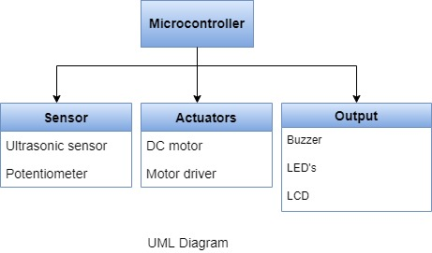

* Block Diagram:

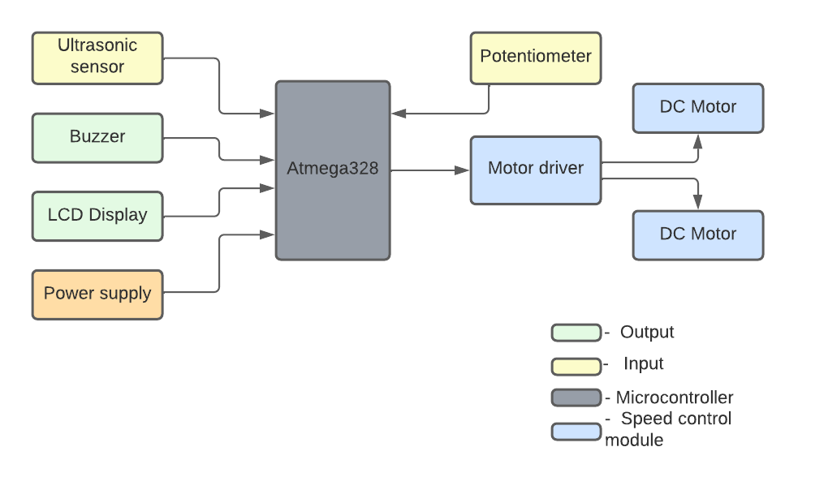

1. Behavioural Diagram:

* Workflow Diagram:

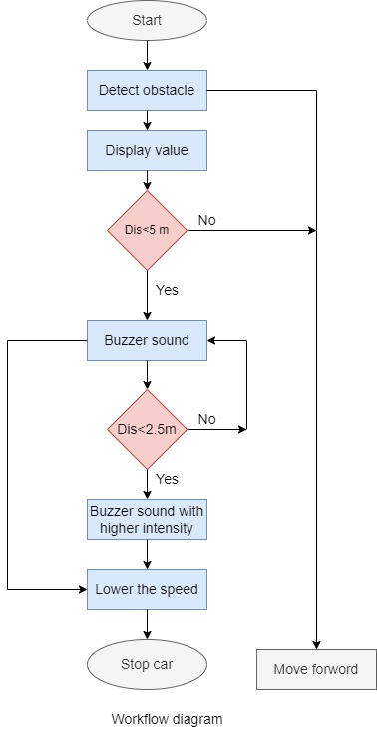

**Complonents**

**Microcontroller**

This is the brain of the system

* Atmega328

- Here we used Atmega328, it supports 8-bit data processing. Atmega328 has 32KB internal flash memory and 1KB electrically

- Erasable programmable read-only memory : If the electric supply supplied to the microcontroller is removed, even then it can store the data and can provides results after providing it with the electric supply.

**Sensor**

* Ultrasonic sensor

- It sends an ultrasonic pulse out at 40KHz which travels through the air and if there is an obstacle or object, it will bounce back to the sensor.

- By calculating the travel time and speed of sound, the distance can be calculated.

- Ultrasonic sensors are a great solution for the detection of the clear objects.

* Potentiometer

- Potentiometer can also be used to control motor speed.

- When used to vary voltage, a potentiometer can be connected to a motor through motor driver and vary the voltage and therefore power delivered to motor which will control its speed.

**Actuator**

* DC Motor

- An electric motor is an electrical machine that converts electrical energy into mechanical energy.

- Most electric motors operate through the interaction between the motor's magnetic field and electric current in a wire winding to generate force in the form of torque applied on the motor's shaft.

* Motor driver

- Motor drivers acts as an interface between the motors and the control circuits.

- Motor require high amount of current whereas the controller circuit works on low current signals.

- So the function of motor drivers is to take a low-current control signal and then turn it into a higher-current signal that can drive a motor.

**Output**

* Buzzer

- The buzzer is a sounding device that can convert audio signals into sound signals. It is usually powered by DC voltage.

- It is widely used in alarms, computers, printers and other electronic products as sound devices.

* LCD Display

- LCD display is used to see the distance between the vehicle and obstacle