**DSM – 410**

**Computer Vision Project**

**Pneumonia detection using chest scans using computer vision techniques.**

|  |  |  |
| --- | --- | --- |
| **Name** | **Roll. No.** | **Email** |
| Ankeet Singh | 2304107010 | msdsm2304107010@iiti.ac.in |
| Kanishk Kaushik | 2304107037 | msdsm2304107037@iiti.ac.in |

**Introduction**

Pneumonia is a lung infection caused by bacteria, viruses, or fungi, leading to inflammation and fluid buildup in the lungs. It accounts for over 15% of deaths in children under five, especially in areas with overcrowding, pollution, and poor sanitation. Early diagnosis is crucial to prevent complications, and chest X-rays are a common, cost-effective diagnostic tool. However, X-ray interpretation can vary among radiologists, leading to potential errors, highlighting the need for an automated system to assist in pneumonia detection.

This study aims to develop a computer-aided diagnosis (CAD) system for the accurate classification of pneumonia from chest X-ray images using Convolutional Neural Networks (CNNs), a widely adopted deep learning technique. CNNs have proven to be highly effective in image recognition tasks, and their ability to capture intricate visual patterns makes them ideal for medical image analysis. Given the difficulty of obtaining large, labeled biomedical datasets, we will employ transfer learning, leveraging pre-trained CNN models to enhance performance on the relatively small chest X-ray datasets available for pneumonia detection.

**Methodology**

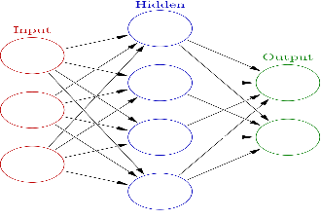

Dataset

Image Enhancement

Feature Extraction

Pre-Processing

Decision making

Classifier Model

Neural Network

1. **Data Collection and Preprocessing:**

We will use publicly available CXR datasets, such as NIH or RSNA, containing both pneumonia and healthy images. All images will be resized, normalized, and augmented with techniques like rotation and flipping to improve model robustness.

1. **CNN Model Architecture:**

We will apply transfer learning with pre-trained CNN models (ResNet-18, DenseNet-121, GoogLeNet) fine-tuned for pneumonia detection. The last layers will be replaced with a custom classifier to fit the binary classification task (pneumonia vs. healthy).

1. **Training and Optimization:**

The model will be trained using binary cross-entropy loss and the Adam optimizer, with early stopping and learning rate scheduling to prevent overfitting. An 80-20 split for training and validation will ensure the model generalizes well.

1. **Ensemble Learning:**

Outputs from ResNet, DenseNet, and GoogLeNet will be combined using weighted averaging to improve classification accuracy. Weights will be assigned based on performance metrics like precision, recall, and AUC.

1. **Model Evaluation:**

Accuracy, precision, recall, F1-score, and AUC will assess the model’s performance. A confusion matrix will further evaluate true and false classifications.

1. **Testing and Validation:**

The final model will be tested on an unseen dataset to evaluate generalization, with k-fold cross-validation applied to ensure robustness.

**Database Description**

The dataset used for this project comprises 5,863 chest X-ray images (JPEG format) of pediatric patients between the ages of one and five, obtained from Guangzhou Women and Children’s Medical Center. These images are divided into three folders—train, test, and validation sets—with subfolders for each category (Pneumonia/Normal). The dataset captures anterior-posterior chest radiographs, with a total size of approximately 6.5 GB.

The images have been curated for quality control, where low-quality or unreadable scans were discarded. The labeling process involved two expert physicians, with a third expert validating the evaluation set to ensure diagnostic accuracy. The dataset reflects a diverse set of pneumonia cases, including bacterial and viral variants, and serves as the foundation for developing a Convolutional Neural Network (CNN)-based classifier.

**Results and Discussion**

**Model Performance**

|  |  |  |
| --- | --- | --- |
| **Model** | **Accuracy** | **Loss** |
| **ResNet-18** | 73.24% | 0.6160 |
| **DenseNet-121** | 86.38% | 0.7666 |
| **GoogLeNet** | 79.49% | 1.0142 |

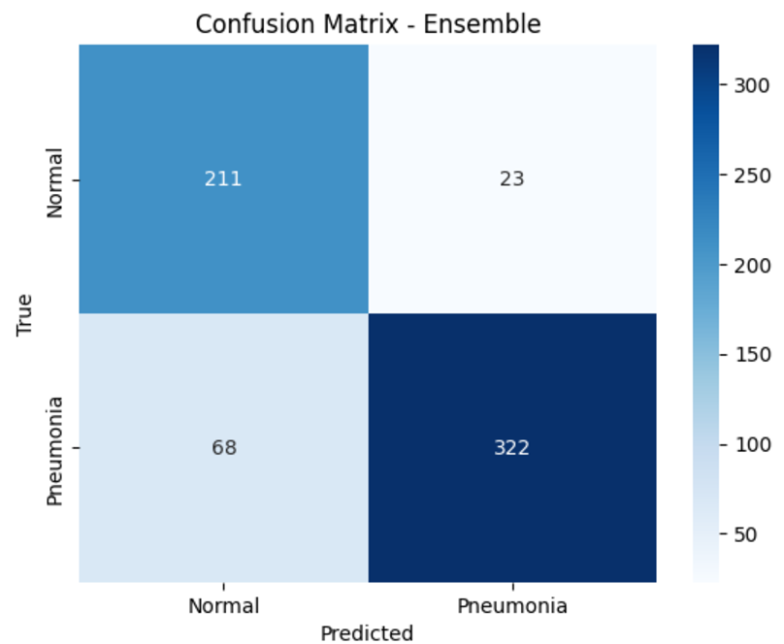

**Ensemble Model Results**

The ensemble model achieved an accuracy of **85.42%**.

**Classification Report**

|  |  |  |  |  |
| --- | --- | --- | --- | --- |
| **Class** | **Precision** | **Recall** | **F1-score** | **Support** |
| **Normal** | 0.76 | 0.90 | 0.82 | 234 |
| **Pneumonia** | 0.93 | 0.83 | 0.88 | 390 |

**Overall Accuracy**: 85%

**Weighted Avg. F1-score**: 86%

The results demonstrate that DenseNet-121 achieved the highest individual accuracy, while the ensemble model provided better overall performance, reducing false negatives and improving diagnostic reliability.

**Conclusion**

The study successfully developed a robust CAD (Computer-Aided Diagnosis) system for pneumonia detection using chest X-rays, achieving an impressive accuracy of 85.42%. The system leverages pre-trained CNN models (ResNet-18, DenseNet-121, and GoogLeNet), fine-tuned for this task, with an ensemble approach that enhanced performance. The high recall for pneumonia cases indicates the model's reliability in identifying affected patients, which is crucial for diagnostic purposes.

Given its strong performance, this model can indeed be used for prediction in real-world scenarios. It shows promise as a diagnostic aid for radiologists, potentially improving efficiency and reducing the risk of misdiagnosis. No further work is immediately necessary for the system to be deployed, but future improvements could include expanding datasets and experimenting with advanced architectures to ensure robustness across diverse clinical settings.

**References**

1. Kermany, D. S., Goldbaum, M., Cai, W., et al. (2018). Identifying medical diagnoses and treatable diseases by image-based deep learning. *Cell*, 172(5), 1122-1131.
2. He, K., Zhang, X., Ren, S., & Sun, J. (2016). Deep residual learning for image recognition. *Proceedings of the IEEE Conference on Computer Vision and Pattern Recognition (CVPR)*.
3. Huang, G., Liu, Z., Van Der Maaten, L., & Weinberger, K. Q. (2017). Densely connected convolutional networks. *Proceedings of the IEEE Conference on Computer Vision and Pattern Recognition (CVPR)*.
4. Szegedy, C., Liu, W., Jia, Y., et al. (2015). Going deeper with convolutions. *Proceedings of the IEEE Conference on Computer Vision and Pattern Recognition (CVPR)*.