[1]

Spatial and Frequency Domain Filters for Restoring Noisy Images

Paras Jain1, Vipin Tyagi2

Research Scholar, Department of Computer Science & Engineering, Jaypee University of Engineering & Technology, Guna, MP, India e-mail: parasbe05@ gmail.com,

2. Associate Prof., Department of Computer Science & Engineering, Jaypee University of Engineering & Technology, Guna, MP, India e-mail: dr.vipin.tyagi@gmail.com,

**ABSTRACT**

Image restoration is the operation of taking a degraded image and estimating the clean original image. Degradation in an image occurs primarily due to blur and noise. Restoration attempts to reconstruct or recover an image that has been degraded by using a priori knowledge of the degradation phenomenon. Thus restoration techniques are oriented toward modeling the degradation and applying the inverse process in order to recover the original image. This paper starts with basic model of image degradation/restoration process and proceeds towards enlisting commonly occurring blurs and noises. Thereafter, it reviews some spatial and frequency domain filters for restoration of only noisy images.

*Keywords:*

Degradation function, Frequency domain filtering, Image restoration, Spatial filtering.

# **INTRODUCTION**

Images captured by various digital devices may be corrupted due to several reasons, e.g. motion blur, noise. Blurring often arises from the optical aberrations and motions between the object and the camera, and noise is caused by malfunctioning pixels in camera sensors, faulty memory locations in hardware, or transmission in a noisy channel. Blurring and noise hamper any computer vision algorithms aimed at the automatic recognition and identification of these images. Therefore, image restoration is a very important problem and is always an active research area [1][2].

Image restoration is a process of reconstructing or recovering an image that has been degraded by using a priori knowledge of the degradation phenomenon.It usually involves formulating a criterion of goodness that will yield an optimal estimate of the desired result.

Image restoration is applicable in many areas like astronomical imaging as explained earlier. In the area of medical imaging, image restoration has certainly played a very important role. Restoration has been used for filtering Poison distributed film grain noise in chest X-rays, mammograms, and digital angiographic images, and for the removal of additive noise in Magnetic Resonance Imaging (MRI) [3]. Another emerging application of image restoration in medicine is in the area of quantitative autoradiography (QAR). In this field images are obtained by exposing X-ray sensitive film to a radioactive specimen.

Digital image restoration is being used in many other applications as well. Just to name a few, restoration has been used to restore blurry X-ray images of aircraft wings to improve the federal aviation inspection procedures [4]. It is used for restoring the motion induced effects present in still composite frames (produced by the superposition of two temporally fields of a video image [5]), and, more generally, for restoring uniformly blurred television pictures [6]. Printing application often require the use of restoration to ensure that halftone reproductions of continuous images are of high quality. In addition, restoration can improve the quality of continuous images generated from halftone images [7].

All in all, it is clear that there is a very real and important place for image restoration technology today. Our task at hand now is to evaluate what type of applications may arise in the future and demand further innovations in this field.

The rest of this paper is organized as follows. In section 2, the basic model for image degradation/restoration process is illustrated. In section 3, various types of blurs and noises are summarized. Various types of spatial domain filters along with their demonstrations are illustrated in section 4 for restoring images that are degraded only due to noise. In Section V, various types of frequency domain filters are demonstrated for the same purpose. Conclusions are reached in section 6.

# **basic model for digital image restoration**

## As Fig. 1 shows, the degradation process is modeled as degradation function that, together with an additive noise term η(x, y), operates on an input image f(x, y) to produce a degraded image g(x, y). Digital image restoration may be viewed as the process of obtaining an approximation to f(x, y), given g(x, y) and a knowledge of the degradation in the form of operator H [8][9][19]. We assume that knowledge of η(x, y) is limited to information of a statistical nature.



Figure 1: A model of image degradation process

The input-output relationship in Fig. 1 can be expressed as follows:

 (1)



If *H* is a linear, position-invariant process, then the degraded image is given in the *spatial domain* by

 (2)

or

 (3)

where *h(x, y)* is the spatial representation of the degradation function and symbol “*” indicates 2-D convolution.

Above Equation is the *spatial domain* representation of degradation process shown in Fig. 1. As we know that convolution in the spatial domain is equivalent to multiplication in the frequency domain, so we may write the model in Eq. (3) in a *frequency domain* representation:

 (4)

where the terms in capital letters are the Fourier transforms of the corresponding terms in Eq. (3).

# **3. primary causes for image degradation**

There are two main causes for degradation in an image, viz, blur and noise. This section is devoted for understanding these primary causes.

**3.1 Image Blur**

Blurringis a phenomenon due to which we face difficulty in viewing image contents clearly. There are following commonly known blurs:

*3.1.1 Motion Blur*

It represents 1-D uniform local averaging of neighboring pixels, a common result of camera panning or fast object motion, shown here for horizontal motion

1/*L*, if *–L/*2≤ *i* ≤ *L/*2

*h(i) =*  (5)

0, otherwise

*3.1.2 Atmospheric Turbulence Blur*

Common in image sensing and aerial imaging, the blur due to long-term exposure through the atmosphere can be modeled by a Gaussian PSF

*h(i, j)* = *Kexp*[(*i*2 +*j*2)/2*σ*2] (6)

where *K* is a normalizing constant ensuring that blur is of unit volume and σ2  is the variance that determines the severity of the blur.

*3.1.3 Uniform Out-of-Focus Blur*

It models the simple defocusing found in a variety of imaging systems as a uniform intensity distribution within a circular disk,

1/π*R*2 if (*i*2 +*j*2)1/2 ≤ *R*



*h(i, j)* *=* (7)

0, otherwise

*3.1.4 Uniform 2-D Blur*

This is a more severe form of degradation that approximates an out-of-focus blur, and is used in many research simulations.

1/(*L*)2, if –*L*/2 ≤ *i, j* ≤ *L*/2

*h(i, j)* *=* (8)



0, otherwise

where *L* is assumed to be a odd integer.

**3.2 Image noise**

Image noise is random (not present in the object imaged) variation of *brightness* or *color information* in images, and is usually an aspect of electronic noise. The principal sources of noise in digital images arise during image acquisition (digitization) and/or transmission. Image noises can be broadly classified in two categories viz. spatially independent noise and spatially dependent noise[10][11].

*3.2.1 Spatially independent noise*

This kind of noise is independent of spatial coordinates, and that is uncorrelated with respect to the image itself (that is, there is no correlation between pixel values and the values of noise components). These assumptions are at least partially invalid in some applications (quantum-limited imaging, such as in *X*-ray and nuclear-medicine imaging, is a good example). Restoration of images from noises of this category can be significantly done with the help of spatial domain filters illustrated in section 4. Some of the frequently occurring spatially independent noises are enlisted below:

**Gaussian** noise is typical in sensors, especially in low lighting conditions

**Rayleigh** noise arises in range images.

**Uniform noise** is caused by quantizing the pixels of a sensed image to a number of discrete levels.

**Gamma** and **Exponential** noise is present in laser imaging.

**Impulse** (salt-and-pepper) noise comes from disturbed switching devices

*3.2.2 Spatially dependent noise*

This kind of noise is dependent on spatial coordinates, and that is correlated with respect to the image itself (that is, there is some correlation between pixel values and the values of noise components). Most popular noise in this category is *periodic noise*.

Periodic noise in an image arises typically from electrical or electromechanical interferences during image acquisition. Restoration of images from periodic noises can be significantly done with the help of frequency domain filters illustrated in section 5.

**4. SPATIAL DOMAIN FILTERING FOR RESTORING NOISY IMAGES**

Filters in this category can be broadly classified into the following filter families: mean filters, order-statistic filters, and adaptive filters

**4.1 Mean filters**

The mean filters [12][13][18] function by finding some form of an average within the window *W* of size *m x n*, centered at point *(x, y)*, using the sliding window concept to process the entire image. The restored value of degraded image at point *(x, y)* will be the mean value obtained from mean operation defined by the underlying mean filter on the pixels within the filter window *W.*  Commonly used mean filters are defined below:

*4.1.1 Arithmetic mean filter*

This is the simplest form of the mean filters. It computes the average value of the corrupted image *g(x, y)* in the area defined by *W*. In other words,

(9)



The arithmetic meanfilters smooth out local variations within an image, so it essentially a lowpass filter. This type of filter will tend to blur an image while mitigating the noise effects and works best with Gaussian noise [Fig. 2(c)].

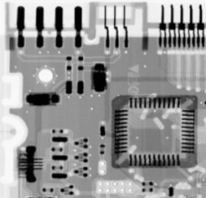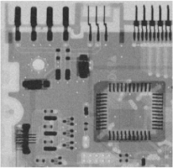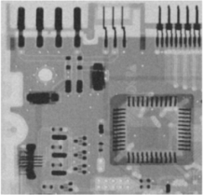

**(a) (b) (c)**

**Figure 2: (a) X-ray image. (b) Image corrupted by additive Gaussian noise of mean 0 and variance 400. (c) Result of filtering (b) with an arithmetic mean filter of size 3 × 3.**

*4.1.2 Contraharmonic mean filter*

The contraharmonic mean filter yields a restored image based on the expression

(10)



where *Q* is called the *order* of the filter. This filter is well suited for reducing or virtually eliminating the effects of salt-and-pepper noise. For positive values of *Q*, the filter eliminates pepper noise [Fig. 3(c)]. Foe negative values of *Q* it eliminates salt noise [Fig. 3(d)]. It cannot do both simultaneously.

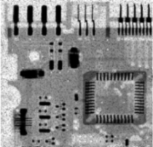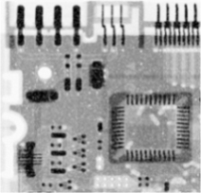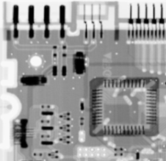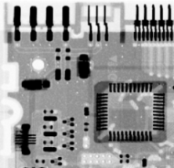

**(a) (b) (c) (d)**

**Figure 3: (a) Image corrupted by pepper noise with a probability of 0.1. (b) Image corrupted by salt noise with a probability of 0.1. (c) Result of filtering (a) with a 3 × 3 contraharmonic mean filter of order 1.5. (d) Result of filtering (b) with a 3 × 3 contraharmonic mean filter of order -1.5.**

**4.2 Order-Statistic filters**

Order-statistic filters [15][18] are spatial filters whose response is based on ordering (ranking) the values of the pixels contained in the image area encompassed by the filter. The ranking result determines the response of the filter. The restored value of degraded image at point *(x, y)* will be the response obtained from operation defined by the underlying order-statistic filter on the pixels within the filter window *W.* Note that same conventions are used for window *W* as were used in mean filters. Most frequently used order-statistic filters are defined below:

*4.2.1 Median filter*

The best-known order-statistic filter is the median filter, as its name implies, replaces the value of a pixel by the median of the intensity levels in the neighborhood of that pixel:

(11)



The value of the pixel at *(x, y)* is included in the computation of the median. Median filters are quite popular because, for certain types of random noise they provide excellent noise-reduction capabilities, with considerably less blurring than linear smoothing filters of similar size. Median filters are particularly effective in the presence of both bipolar and unipolar impulse noise. Fig. 4 shows successive applications of median filter. Salt-and-pepper noise present in image is removed in multiple passes rather than single application of median filter.

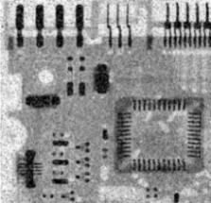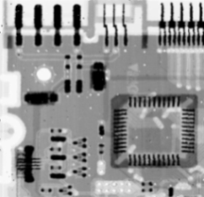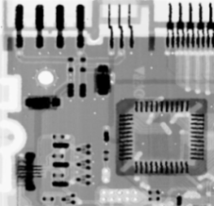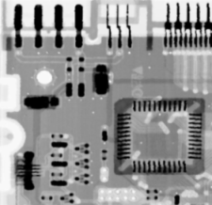

**(a) (b)** **(c) (d)**

**Figure 4: Image corrupted by salt-and-pepper noise with probabilities Pa = Pb = 0.05. (b) Result of one pass with a median filter of size 3 × 3. (c) Result of processing (b) with this filter. (d) Result of processing (c) with the same filter.**

*4.2.2 Alpha-trimmed mean filter*

Suppose that we delete the *d*/2 lowest and the *d*/2 highest intensity values of *g(s, t)* in the neighborhood *W*. Let *gr(s, t)* represent the remaining *mn – d* pixels. A filter formed by averaging these remaining pixels is called an *alpha-trimmed mean* filter:

(12)



where the value of *d* can range from 0 to *mn –* 1*.* When *d* = 0, the alpha-trimmed filter reduces to the arithmetic mean filter. If we choose *d* = *mn –* 1, the filter becomes a median filter. For the other values of d, the alpha-trimmed filter is useful in situations involving multiple types of noise, such as a combination of salt-and-pepper and Gaussian noise.

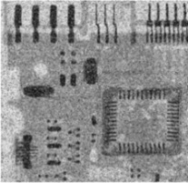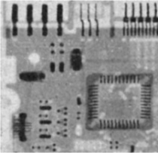

**(a) (b)**

**Figure 5: (a) Image corrupted by additive uniform noise and salt-and-pepper noise. (b) Result of filtering by Alpha-trimmed mean filter of size 5 × 5 with *d* = 10.**

**4.3 Adaptive filters**

Once selected, the filters discussed thus far are applied to an image without regard how image characteristics vary from one point to another. Here we take a look at two simple adaptive filters whose behavior changes based on statistical characteristics of the image inside the filter region defined by the *m* × *n*rectangular window *W*. Adaptive filters alter its basic behavior as the image is processed; it may act like a mean filter on some parts of the image and a median filter on other parts of the image. Adaptive filters are capable of performance superior to that of the filters discussed thus far. The price paid for improved filtering power is an increase in filter complexity. Commonly known filters of this family are presented below:

*4.3.1 Minimum mean-square error (MMSE) filter*

The minimum mean-square error (MMSE) **(**oradaptive, local noise reduction**)** filter is a good example of an adaptive filter [17][18], which exhibits varying behavior based on local image statistics. The MMSE filter works best with Gaussian or uniform noise. This filter is to operate on a local region, *W*. The response of the filter at any point *(x, y)* on which the region *W* is centered is to be based on four quantities:

**(a)** *g(x, y)*, the value of noisy image at *(x, y)*;

**(b)** *σn2*, the variance of the noise corrupting *f(x, y)* to form *g(x, y)*;

**(c)** *mL*, the local mean of the pixels in *W*;

**(d)** *σL2*, the local variance of the pixels in *W*;

The MMSE filter can be defined as follows:

(13)



This MMSE represents the restored value of from degraded image *g(x, y)* at point *(x, y)*. MMSE filter adapts itself to the local image statistic, preserving image details while removing noise. Above adaptive expression is based on the following assumptions:

1. If *σn2*is zero, the filter should return simply the value of *g(x, y)*. This is the trivial zero-noise case in which *g(x, y)* is equal to *f(x, y)*.
2. If *σL2* is high relative to *σn2*, the filter should return a value close to *g(x, y)*. A high local variance typically is associated with edges, and these should be preserved.
3. If *σL2* is equal to *σn2*, the filter will return arithmetic mean value of pixels in *W*. This condition occurs when the local area has the same properties as the overall image, and the local noise is to be reduced simply by averaging.

In above adaptive expression, the only quantity that needs to be known or estimated is the variance of the overall noise, *σn2*. The other parameters are computed from the pixels in *W* at each location *(x, y)* on which the filter window is centered.

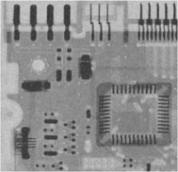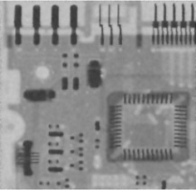

**(a) (b)**

**Figure 6: (a) Image corrupted by additive Gaussian noise with mean 0 and variance 1000. (b) Result of filtering by MMSE filter of size 7 × 7.**

*4.3.2 Adaptive median filter*

The median filter discussed in section 4.1.2 performs well as long as the spatial density of the impulse noise is not large (as a rule of thumb, *Pa* and *Pb* less than 0.2). It is shown in this section that adaptive median filtering [14][16][18] can handle impulse noise with probabilities even larger than these. An additional benefit of adaptive median filter is that it seeks to preserve detail while smoothing nonimpulse noise, something that the “traditional” median filter does not do.

As in all the filters discussed in the preceding sections, the adaptive median filter also works in a rectangular window area *W*. Unlike those filters, however, the adaptive median filter changes (increases) the size of *W* during filter operation, depending on certain conditions listed in this section.

Consider the following notations:

*zmin* = minimum gray level value in *W*.

*zmax* = maximum gray level value in *W*.

*zmed* = median of gray levels in *W*.

*zxy* = gray level at coordinates *(x, y)*.

*Wmax*= maximum allowed size of *W*.

The adaptive median filtering works in two levels, denoted level A and level B, as follows:

Level A: A1 = *zmed* - *zmin*

A2 = *zmed* - *zmax*

If A1 > 0 AND A2 < 0, Go to level B

Else increase the window size.

If window size ≤ *Wmax* repeat level A

Else output *zxy.*

Level B: B1 = *zxy* - *zmin*

B2 = *zxy* - *zmax*

If B1 > 0 AND B2 < 0, output *zxy*

Else output *zmed.*

The key to understanding the mechanics of this algorithm is to keep in mind that it has three main purposes:

1. to remove salt-and-pepper (impulse) noise;
2. to provide smoothing of other noise that may not be impulsive; and
3. to reduce the distortion, such as excessive thinning or thickening of object boundaries.

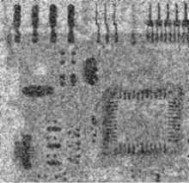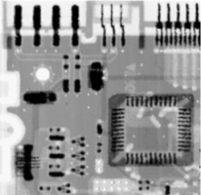

**(a) (b)**

**Figure 7: (a) Image corrupted by salt-and-pepper noise with probabilities *Pa* = *Pb* = 0.25. (b) Result of filtering by Adaptive median filter with *Wmax* = 7.**

**5. FREQUENCY DOMAIN FILTERING FOR RESTORING NOISY IMAGES**

This section review some frequency domain filters (usually referred as *frequency selective filters*) that are used for removal of periodic noise. These filters can be classified into following filter families: bandreject filters, bandpass filters, and notch filters.

**5.1 Bandreject filters**

A bandreject filter [18] removes or attenuates a band of frequencies about the origin of the Fourier transform. These filters can be classified as: ideal, Butterworth, and Gaussian bandreject filters.

* + 1. *Ideal bandreject filter*

An ideal bandreject filter is given by the expression

*H(u, v) =* (14)



1 otherwise

* + 1. *Butterworth bandreject filter*

A Butterworth bandreject filter of order *n* is given by the expression

(15)



* + 1. *Gaussian bandreject filter*

A Gaussian bandreject filter is given by the expression

(16)



where *D(u, v)*, *D0*, and *W* in above three bandreject filters has the following semantics:

*D(u, v)*:The distance of a given frequency from the origin of the centered frequency rectangle, as defined below,

(17)



*D0*: The radial center of the band, and

*W* : The width of the band.

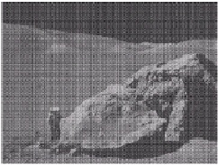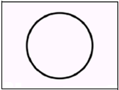

**(a) (b) (c)**

**Figure 8: (a) Image corrupted by sinusoidal noise. (b) Butterworth bandreject filter (white represents 1). (c) Result of filtering of (a).**

**5.2 Bandpass filters**

A bandpass filter [18] performs the opposite operation of a bandreject filter. The transfer function *HBP(u, v)* of a bandpass filter is obtained from corresponding bandreject filter with transfer function *HBR(u, v)* by using the expression

(18)



Similar to bandreject filters, bandpass filter are also categorized into ideal, Butterworth, and Gaussian bandpass filters. We can derive the expressions for transfer functions for these filters by using Eq. (18).

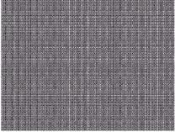

**Figure 9: Noise pattern of the image in Fig. 8(a) obtained by bandpass filtering.**

**5.3 Notch filters**

Notch filters [18] are most useful of the frequency selective filters. A notch filter rejects (or passes) frequencies in a predefined neighborhood about the origin of the centered frequency rectangle. As we know that a notch filter is a zero-phase-shift filter (filters that affect the real and imaginary parts equally, and thus have no effect on the phase, are appropriately

called *zero-phase-shift* filters), which must be symmetric about the origin, so a notch with center at *(u0, v0)* must have a corresponding notch at the location *(-u0, -v0)*. Notch filters can further be classified as: notch reject filters and notch pass filters

* + 1. *Notch reject filters*

A notch reject filter, containing *Q* notch pairs, are constructed as the products of highpass filters whose centers have been translated to the centers of the notches. The general form is:

(19)



where *Hk(u, v)* and *H-k(u, v)* are highpass filters whose centers are at *(uk, vk)* and *(-uk, -vk)*, respectively. These centers are specified with respect to the center of the frequency rectangle, *(M/2, N/2)*. The distance computations for each filter are thus carried out using the expressions



(20)

and



(21)

Similar to bandreject filters, notch reject filters also have same three types, i. e, ideal, Butterworth, and Gaussian notch reject filters.

* + - 1. *Ideal notch reject filter*

As declared in general form of a notch reject filter, an *ideal notch reject* *filter*, containing *Q* notch pairs, can be defined as the product of ideal highpass filters as follows:

(22)



where *HINR(u, v)*, denotes ideal notch reject filter and *HIk(u, v)*, *HI-k(u, v)* are ideal highpass filters whose centers are at *(uk, vk)*

and *(-uk, -vk)*, respectively. *HIk(u, v)* and *HI-k(u, v)* are defined as follows:

0 if *Dk(u, v)* ≤ *D0k*

*HIk(u, v)* = 1 if *Dk(u, v)* ≤ *D0k* (23)



and

0 if *D-k(u, v)* ≤ *D0k*

*HI-k(u, v)* = (24)

1 if *D-k(u, v)* ≤ *D0k*

* + - 1. *Butterworth notch reject filter*

A Butterworth notch reject filter of order *n*, containing *Q* notch pairs, can be defined as the product of Butterworth highpass filters of order *n* as follows:

(25)



where *HBNR(u, v)*, denotes Butterworth notch reject filter and *HBk(u, v)*, *HB-k(u, v)* are Butterworth highpass filters of order *n* whose centers are at *(uk, vk)* and *(-uk, -vk)*, respectively. *HBk(u, v)* and *HB-k(u, v)* are defined as follows:

, (26)



and

(27)



* + - 1. *Gaussian notch reject filter*

A Gaussian notch reject filter, containing *Q* notch pairs, can be defined as the product of Gaussian highpass filters as follows:

(28)



where *HGNR(u, v)*, denotes Gaussian notch reject filter and *HGk(u, v)*, *HG-k(u, v)* are Gaussian highpass filters whose centers are at *(uk, vk)* and *(-uk, -vk)*, respectively. *HGk(u, v)* and *HG-k(u, v)* are defined as follows:

(29)



and

(30)



The constant *D0k* (cutoff frequency) in all above notch reject filters is the same for each pair of notches, but it can be different for different pairs. *Dk(u, v)* and *D-k(u, v)* are given by Eqs. (20) and (21).

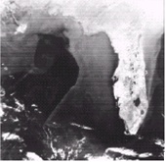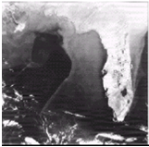

**(a)**  **(b)**

**Figure 10: (a) Satellite image of Florida and Gulf of Mexico (note horizontal sensor scan lines). (b) Result of notch reject filtering.**

* + 1. *Notch pass filters:*

A notch pass filter[18] performs the opposite operation of a notch reject filter. The transfer function *HNP(u, v)* of a notch pass filter is obtained from corresponding notch reject filter with transfer function *HNR(u, v)* by using the expression

(31)



Similar to bandpass filters, notch pass filters also have same three types, i.e., ideal, Butterworth, and Gaussian notch pass filters. We can derive the expressions for transfer functions for these filters by using Eq. (31).

**6. Conclusion**

Basic definition, needs and some key applications of digital image restoration were included in section 1, i.e., introduction. A basic linear model of degradation was presented in section 2. Some prime causes for degradation in an image were enlisted in section 3. In section 4, some basic spatial domain filters were reviewed that were aimed to restoration of images in which degradation was taken place due to spatially independent noise. In section 5 some basic frequency domain filters were reviewed that were aimed to restoration of images in which degradation was taken place due to spatially dependent noise. All in all, this paper is capable of giving good understanding about various aspects of digital image restoration.

References

1. M. Banham and A. Katsaggelos, “Digital image restoration,” *IEEE Signal Process. Mag.*, vol. 14, no. 2, pp. 24–41, March. 1997.
2. T. F. Chan and J. Shen, “Theory and computation of variational image

deblurring,” 2006, IMS Lecture Notes.

1. M. R. Banham and A. K. Katsaggelos, “Digital Image Restoration,” *IEEE Signal Proc. Magazine*, March 1997.



1. T. J. Kostas, L. Mugnier, A. K. Kastaggelos, and A. V. Sahakian, “A Super-Exponential Method for blur Identification and Image Restoration,” *SPIE* *conference* *Visual Commun. And Image Processing*, Chicago, IL, pp. 921-929, October 1994.
2. R. Manduchi and G. M. Cortelazzo, “Spectral Characteristics and Motion –Compensated Restoration of Composite Frames,” *IEEE Trans. Image Processing*, vol. 4. pp. 95-99, January 1995.
3. Z. K. Liu and J Y. Xiao, “ Restoration of blurred TV Pictures Caused by Uniform Linear Motion,” *Comput. Vision, Graphics, Image Proc*., vol. 44, pp 30-34, 1988.
4. S. Hien and A. Zakhor, “Halftone to Continuous-Tone Conversion of Error-Diffusion Coded Images.” *IEEE Trans. Image Processing*, vol. 4. pp. 208-216, February 1995.
5. K. R. Castleman, “Digital Image Processing,” 2nd ed. *Prentice Hall*, *Upper Saddle River, NJ.*, 1996.
6. W. K. Pratt, “Digital Image Processing,” 3rd ed., *John Wiley & Sons*, *New York*, 2001.
7. P. Z. Peebles, ”Probability, Random Variables, and Random Signal Principles,” 3rd ed., *McGraw-Hill ,New York*, 1993.
8. A. Papoulis, “Probability, Random Variables, and Stochastic Processes,” 3rd ed., *Mc-Graw Hill, New York*, 1991.
9. S. E. Umbaugh, “Computer Imaging: Digital Image Analysis and Processing,” *CRC Press, Boca Raton*, FL, 205.
10. R. A. Boie and I. J. Cox, “An analysis of Camera Noise,” *IEEE Trans. Pattern Anal. Machine Intell*., vol. 1091, pp. 2-18, 1992.
11. H. Hwang and R. A. Hadded, ”Adaptive Median Filters: New Algorithms and Results,” *IEEE Trans. Image Processing*, vol. 4., no. 4, pp. 499-502, 1995.
12. J. B. Wilburn, “ Developments in Generalized Ranked-Order Filters,” *J. Opt. Soc. Aer.-A.Optics, Image Science, and Vision* , vol. 15, no. 5, pp. 1084-1099,1998.
13. H. -L. Eng and K. -K. Ma, “A Switching Median Filter With Boundary Discriminative Noise Detection for Extremely Corrupted Images,” *IEEE Trans. Image Processing*, vol. 15., no. 6, pp. 1506-1516, 2006.
14. S. Haykin, “ Adaptive Filter Theory,” *Prentice Hall, Upper Saddle River, N. J.*, 1996.
15. R. C. Gonzalez and R. E. Woods, “Digital Image Processing,” 3rd ed., *Prentice Hall, Upper Saddle River, N. J.*, 2008.
16. A. Rosenfeld and A. C. Kak, “Digital Picture Processing,” vols. 1 and 2, 2nd ed. *Academic Press, New York*, 1982.

**Paras Jain** received the M.E. degree in Computer Engineering from Shri Govindram Seksaria Institute of Technology and Science, Indore, India, affiliated with Rajiv Gandhi Technical University Bhopal, India in 2010.

PP Size Photo



**S.B. Author**

He is currently pursuing his Ph. D. degree from

Jaypee University of Engineering and Technology,

Guna, India in Computer Science and Engineering

since July 2012.

**Dr. VIPIN TYAGI**is faculty in Computer Science and Engineering at Jaypee University of Engg and Technology, Raghogarh, Guna (MP) India. He has about 20 years of teaching and research experience.

He was President of Engineering Sciences Section of the Indian Science Congress Association for the term 2010-11, and recorder for the term 2008 - 2010.

He is a Life Fellow of the Institution of Electronics and Telecommunication Engineers. He is a senior life member of Computer Society of India. He is actively associated with such professional societies. He is member of Academic-Research and Consultancy committee of Computer Society of India. He is head of CSI Special Interest Group on Cyber Forensics. He is a Fellow of Institution of Electronics and Telecommunication Engineers, life member of CSI, Indian Remote Sensing Society, CSTA, ISCA and IEEE, International Association of Engineers.

He was nominated to visit Czech Republic from INSA, New Delhi for two weeks in May 2012. He has published more than 50 papers in various journals, advanced research series and has attended several national and international conferences in India and abroad. He is Principal Investigator of research projects funded by DRDO, MP Council of Science and Technology and CSI.

1.