Software Requirement Specification (SRS) – RUDRA

1. Introduction

1.1 Purpose
This document specifies the software requirements for RUDRA, an AI-based voice assistant.
The SRS serves as a reference for development, testing, and future enhancements using an Agile Incremental SDLC model.

1.2 Scope
RUDRA is an offline-first, multi-platform AI voice assistant capable of:
- Voice and text interaction
- Wake-word detection
- Natural language understanding
- Memory management
- Machine-learning-based intent recognition
- System control and multi-device support
The system is designed to evolve incrementally across development iterations.

1.3 Definitions, Acronyms, Abbreviations
- NLP – Natural Language Processing
- STT – Speech to Text
- ML – Machine Learning
- GUI – Graphical User Interface
- SDLC – Software Development Life Cycle

1.4 References
- IEEE 830 / IEEE 29148 SRS Standard
- Agile Development Principles

2. Overall Description

2.1 Product Perspective
RUDRA is a standalone AI assistant system developed incrementally.
Each iteration adds or improves features without affecting existing stable components.

2.2 Product Functions (High-Level)
- Accept voice/text input
- Detect wake word (“rudra”)
- Convert speech to text
- Process intent using NLP and ML
- Execute system commands
- Store and retrieve memory
- Respond via text and voice

2.3 User Characteristics
- Basic computer knowledge
- No technical background required for usage
- Developer-level access for configuration and extension

2.4 Operating Environment
- Linux (primary)
- Windows
- Android
- Raspberry Pi
- Python 3.x
- Local MySQL database

2.5 Constraints
- Google Speech Recognition only
- Offline-first design
- Modular architecture
- Limited hardware resources on Raspberry Pi

2.6 Assumptions and Dependencies
- Microphone availability
- Internet access required only for online features
- OS-level permissions granted

3. System Features (Incremental)
⚠️ Important (Agile Rule):
Features are added increment by increment, not all at once.

3.1 Wake Word Detection
Description:
The system listens passively and activates only when the wake word “rudra” is detected.
Functional Requirements
- FR-1: System shall continuously listen for wake word.
- FR-2: System shall activate command mode after detection.

3.2 Voice Input Processing
- FR-3: Convert speech to text.
- FR-4: Reject weak or noisy inputs.

3.3 Intent Recognition
- FR-5: Identify user intent using NLP.
- FR-6: Use ML-based intent matching.

3.4 Memory Management
- FR-7: Store short-term memory.
- FR-8: Store long-term memory in database.
- FR-9: Recall memory on request.

3.5 System Control
- FR-10: Execute OS-level commands.
- FR-11: Provide confirmation responses.

4. External Interface Requirements

4.1 User Interface
- Command-line interface
- GUI (future increment)
- Voice output

4.2 Hardware Interface
- Microphone
- Speaker
- Keyboard (optional)

4.3 Software Interface
- MySQL database
- Operating system APIs
- Python libraries

5. Non-Functional Requirements

5.1 Performance
- Response time < 2 seconds for local commands
- Wake-word latency < 1 second

5.2 Reliability
- System should recover from invalid input
- No crash on unknown commands

5.3 Security
- Local data storage only
- No unauthorized data access

5.4 Maintainability
- Modular codebase
- Easy feature addition per increment

5.5 Portability
- Works across Linux, Windows, Android, Raspberry Pi

6. Agile-Specific SRS Section (VERY IMPORTANT)

6.1 Incremental Development Note
This SRS is a living document.
Requirements may be:
- Added
- Refined
- Reprioritized
at the end of each iteration based on feedback.

6.2 Iteration Mapping (Example)
Iteration | Features
Increment 1 | Core loop, text input
Increment 2 | Wake word
Increment 3 | Memory
Increment 4 | ML intent engine
Increment 5 | Multi-device

7. Future Enhancements
- Multi-language support
- Emotion detection
- Advanced ML models
- Cloud sync (optional)

8. Appendix
- Sample commands
- Logs format
- Folder structure

PART – 2 : SYSTEM DESIGN (RUDRA)
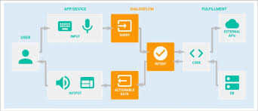
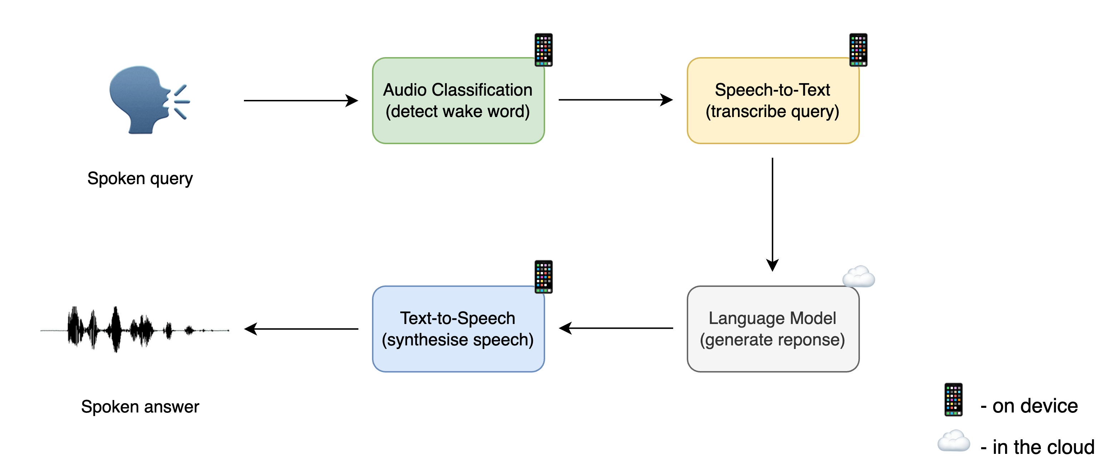
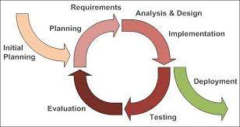

2.1 Design Overview
RUDRA follows a modular, layered architecture designed to support incremental feature addition and continuous refinement.
Each module is independent, loosely coupled, and testable in isolation, which aligns with the Agile Incremental SDLC model.

2.2 System Architecture
The system architecture is divided into logical layers:
User
↓
Input Layer (Voice / Text)
↓
Speech-to-Text Layer
↓
NLP & Intent Processing Layer
↓
Decision & Action Engine
↓
Execution Layer
↓
Response Layer (Text / Voice)
↓
Memory & Database Layer

2.3 Module Design

2.3.1 Input Module
Responsibilities
- Accept voice input via microphone
- Accept text input via terminal/GUI
- Handle wake-word activation
Design Characteristics
- Event-driven
- Non-blocking listening
- Platform-independent

2.3.2 Speech Processing Module
Responsibilities
- Convert speech to text
- Filter weak/noisy input
- Normalize text for NLP
Design Characteristics
- API-based STT
- Fail-safe fallback to text input
- Stateless processing

2.3.3 NLP & Intent Recognition Module
Responsibilities
- Tokenization
- Keyword extraction
- Intent classification
- ML-based intent matching
Design Characteristics
- Rule-based + ML hybrid
- Incrementally trainable
- Extensible intent dictionary

2.3.4 Decision Engine
Responsibilities
- Map intent to action
- Validate command safety
- Route execution flow
Design Characteristics
- Central controller
- Deterministic logic
- Handles unknown intents gracefully

2.3.5 Action / Execution Module
Responsibilities
- Execute system commands
- Control applications
- Perform assistant tasks
Design Characteristics
- OS-abstraction layer
- Permission-aware
- Modular command handlers

2.3.6 Memory Management Module
Responsibilities
- Store short-term memory
- Persist long-term memory
- Retrieve contextual data
Design Characteristics
- Database-backed
- Indexed retrieval
- Incremental memory growth

2.3.7 Response Generation Module
Responsibilities
- Generate textual responses
- Convert text to speech
- Provide confirmations and feedback
Design Characteristics
- Context-aware
- Low-latency output
- Multi-platform compatible

2.4 Data Flow Design
Voice/Text Input
↓
Speech to Text
↓
NLP Processing
↓
Intent Detection
↓
Decision Engine
↓
Action Execution
↓
Memory Update
↓
Response Output

2.5 Incremental Design Strategy (Agile Alignment)
Increment | Design Focus
Increment 1 | Core loop + text input
Increment 2 | Wake word + voice input
Increment 3 | Memory system
Increment 4 | ML intent engine
Increment 5 | Multi-device & platforms
Each increment reuses existing design and extends modules without breaking stability.

2.6 Design Constraints
- Offline-first architecture
- Limited hardware resources (Raspberry Pi)
- Modular design mandatory
- Cross-platform compatibility required

2.7 Design Advantages
- Easy refactoring
- Feature isolation
- High maintainability
- Scalable across devices
- Ideal for AI/ML uncertainty

RUDRA – Labeled System Architecture Diagram
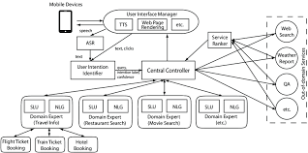
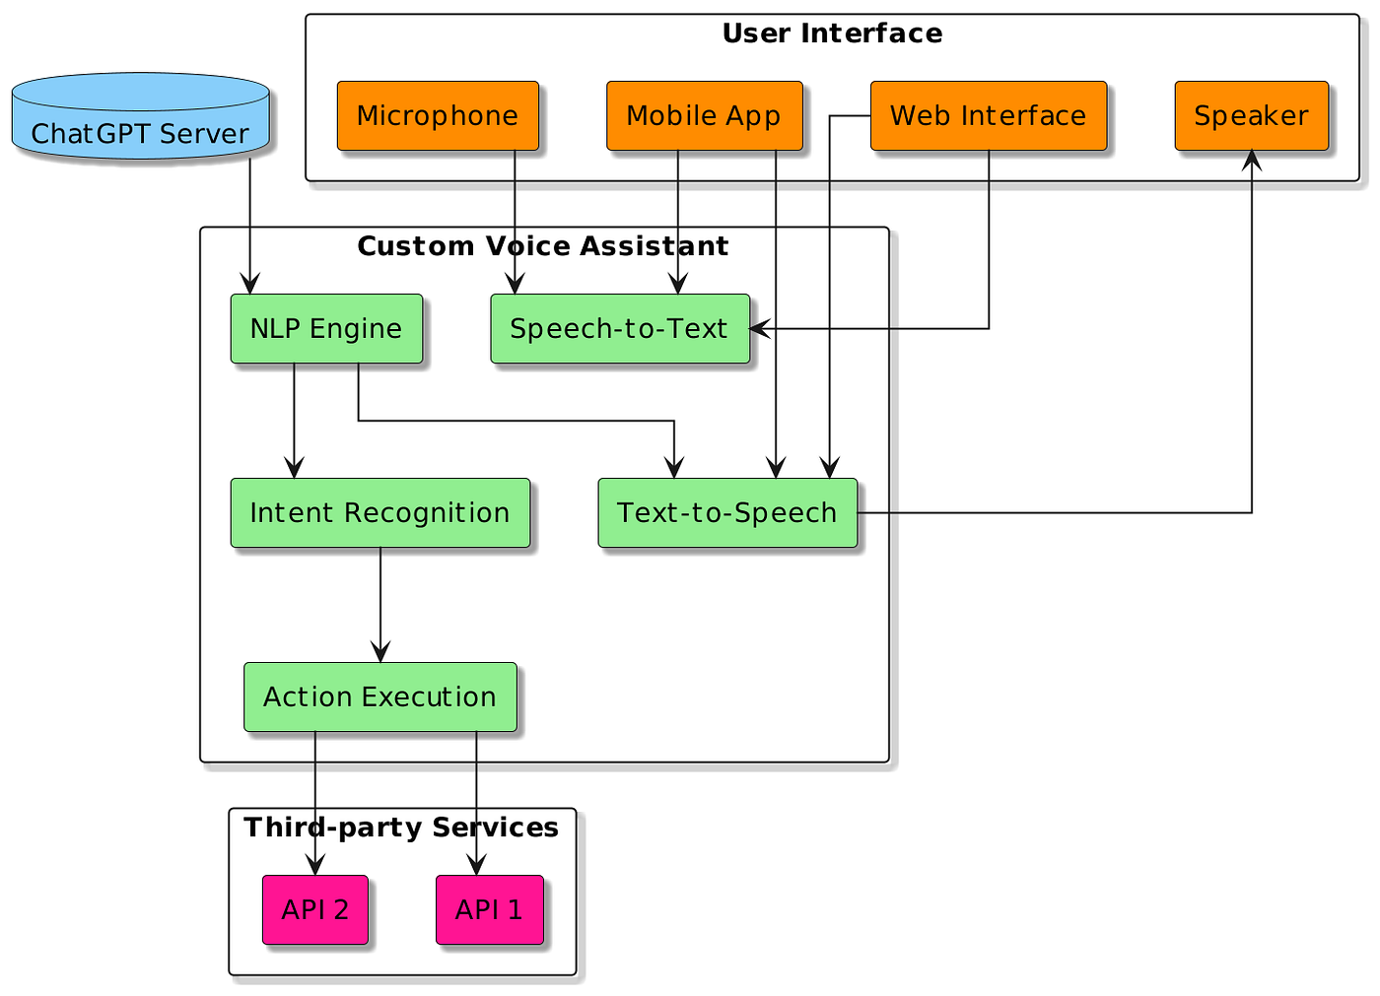

RUDRA Architecture (Labeled – Text Representation)
(Use this along with the diagram for reports & viva)
┌───────────────────────┐
│ USER │
│ (Voice / Text Input) │
└───────────┬───────────┘
↓
┌───────────────────────┐
│ INPUT LAYER │
│ • Microphone │
│ • Keyboard / GUI │
│ • Wake Word Listener │
└───────────┬───────────┘
↓
┌───────────────────────┐
│ SPEECH PROCESSING │
│ • Speech-to-Text │
│ • Noise Filtering │
│ • Text Normalization │
└───────────┬───────────┘
↓
┌───────────────────────┐
│ NLP & INTENT LAYER │
│ • Tokenization │
│ • Keyword Extraction │
│ • ML Intent Engine │
└───────────┬───────────┘
↓
┌───────────────────────┐
│ DECISION ENGINE │
│ • Intent Validation │
│ • Logic Routing │
│ • Safety Checks │
└───────────┬───────────┘
↓
┌───────────────────────┐
│ ACTION / EXECUTION │
│ • System Commands │
│ • App Control │
│ • Assistant Tasks │
└───────────┬───────────┘
↓
┌───────────────────────┐
│ RESPONSE GENERATION │
│ • Text Response │
│ • Text-to-Speech │
│ • Feedback Output │
└───────────┬───────────┘
↓
┌───────────────────────┐
│ MEMORY MANAGEMENT │
│ • Short-term Memory │
│ • Long-term Memory │
│ • Database (MySQL) │
└───────────────────────┘

Layer-wise Explanation (Labeled)

1. User Layer
- Interacts using voice or text
- No technical knowledge required

2. Input Layer
- Captures raw input
- Wake-word activates the assistant
- Prevents unnecessary processing

3. Speech Processing Layer
- Converts speech → text
- Handles noise and weak input
- Provides clean text to NLP layer

4. NLP & Intent Layer
- Understands user commands
- Identifies intent using rules + ML
- Core intelligence layer

5. Decision Engine
- Central control unit
- Maps intent → correct action
- Handles unknown or unsafe commands

6. Action / Execution Layer
- Executes system-level operations
- Controls applications and services
- Platform-dependent logic isolated here

7. Response Generation Layer
- Generates assistant reply
- Converts text → voice
- Confirms task completion

8. Memory Management Layer
- Stores conversation context
- Saves notes and preferences
- Enables learning and personalization

Why This Architecture is Correct for Agile + Incremental
- Each layer is independent
- New features add new modules, not rewrites
- Easy to debug, refactor, and extend
- Supports multi-platform deployment

