ABSTRACT
Introduction: Germline mutations within the tumor suppressor gene BRCA1 have long been known to play a critical role in increasing one's risk of developing hereditary forms of breast and ovarian cancer [1]. However, clinical interpretation of the problem continues to pose a considerable challenge for researchers due primarily to the large number of variants of uncertain significance (VUS) that emerge from sequence analysis, thereby posing a serious obstacle to many patients of different ethnicity and geographic origin [2]. A major deficiency of existing prediction models based on sequence comparison is their inability to incorporate the factors of spatial structure, protein stability, and dynamics of the studied proteins. The current study presents a computational investigation of the mechanisms of localized protein failure associated with ten BRCA1 oncogenic missense mutations.
Methods: The canonical sequence of amino acids of the human BRCA1 protein (UniProt KB: P38398) was used for the demarcation of domains as follows: N-terminal RING finger domain (residues 1-100); and C-terminal tandem BRCT domains (residues 1650-1863). Ten variants of interest were obtained from the ClinVar database, which include: M18R, C61G, R1699W, T1712I, W1739C, D1760Y, M1775R, G1788V, L1839S, and W1858R. In order to conduct an analysis of constraints at the sequence level, a prediction of disease probability through PolyPhen-2 was utilized alongside MutationTaster, using the naive bayes algorithm (for both HumDiv models) and Bayesian alignments respectively. Extending beyond one dimensional analysis, the high resolution crystal structure of the protein was obtained from the Protein Data Bank (1JM7: RING heterodimer; and 1T15: BRCT phosphoprotein recognition) before submission to automated structure-based free energy predictions (ΔΔG) using the Support Vector Machine approach (37°C, pH 7.0).
Results: Highly correlated pathogenicity scoring across tools was evident, with PolyPhen-2 and MutationTaster generating high damaging confidence predictions for most mutations — including M18R (PolyPhen: 0.972), W1739C (PolyPhen: 0.999; MutationTaster: 1.000), and M1775R (PolyPhen: 1.000; MutationTaster: 1.000). Further biophysical characterization led to the classification of the mutants into two unique functional categories:

Class I - Global Structural Destabilizers (C61G, W1739C, T1712I): This category of mutants revealed extreme destabilization of thermodynamic folding stability (ΔΔG < −2.5 kcal/mol). It was determined via cavity analysis by PyMOL that mutants such as W1739C resulted in formation of large intracore cavity volumes, which may be indicative of a core-collapse pathway for misfolding, rendering the mutant proteins sensitive to proteasomal destruction.
Class II – Interface Binding Defects (R1699W, M1775R): On the other hand, these mutations had close-to-neutral impact on thermodynamic folding stability (ΔΔG ≈ 0.0 ± 0.5 kcal/mol), but showed considerable spatial alteration (> 5.0 Å)
Conclusion: This paper shows how in silico structural biology is not just a descriptive discipline, but a clinically actionable precision medicine technology. Showing how Class I variants are disruptive only to core packing, while Class II variants only disrupt macromolecular surface recognition, this paper provides a reproducible diagnostic pipeline to help make targeted therapeutic decisions. On the cellular/tissue level, this could explain why BRCA1 mutation carriers exhibit hyperactivity in pre-malignant niche remodelling [3], as well as why they develop progressive genomic instability and chromosomal rearrangements [4].
On the therapeutic side, this clear distinction between fold-stability vs. interaction stability provides a rationale for using personalized medicine. Specifically, pharmacological chaperones might be able to stabilize core packing, while surface disruption mutations should be treated by compounds mimicking BRCA1 interface interactions. Because both variants are bound to disrupt homologous recombination DNA repair and thus upregulate PARP1 gene expression [5], however, both of them should theoretically be treatable with drugs inducing synthetic lethality. Therefore, this diagnostic pipeline will help resolve any ambiguity around VUS and allow for a precise direction of breast/ovarian cancer patients towards treatment by PARP inhibitors like Olaparib [5, 6].

CHAPTER 2: REVIEW OF LITERATURE
2.1 Organisation of the Functional Domains of BRCA1
The BRCA1 protein is a massive 1,863 residue nuclear phosphoprotein encoded by a gene found on chromosome 17q21.31. It acts as an essential scaffold for participation in various macromolecular structures required to maintain the stability of the genome [1, 2]. What is evident from the structural biochemistry and cell biology literature regarding BRCA1 is that tumour suppressive ability is not uniformly distributed throughout the entire protein. Instead, its execution relies solely on two well-defined termini flanking an extended, natively disordered middle linker domain of residues 101-1,649 [2, 3].
2.1.1 The N-terminal RING Finger Domain
The first 100 amino acids of the N-terminus adopt a unique Really Interesting New Gene (RING) finger domain [3]. X-ray crystallography and Nuclear Magnetic Resonance (NMR) have revealed a highly conserved arrangement within this domain that involves cross-bracing of the seven cysteine residues and one histidine residue (Cys₃HisCys₄), which is responsible for coordination with two distinct structural zinc (Zn²⁺) ions [3, 4]. These metal interactions do not contribute chemically to the reaction process but rather create a rigid framework for maintaining the tertiary structure of peptide loops.
This rigid scaffold represents an essential binding site for BARD1 (BRCA1-Associated RING Domain 1) [3]. Dimerisation through the interaction between BRCA1 and BARD1 helices creates a platform with a high affinity for the recruitment and activation of particular ubiquitin conjugating enzymes (E2). As a consequence, the resulting heterodimer acquires functionality of E3 ubiquitin ligase [4, 5], which is responsible for ubiquitination of histone H2A within the DNA damage sites leading to chromatin modifications and subsequent replication fork protection mechanisms [3, 5].

Table 2.1: Comparative Features of Homologous Recombination (HRR) and Non-Homologous End Joining (NHEJ)
Feature | Homologous Recombination (HRR) | Non-Homologous End Joining (NHEJ)
Cell Cycle Phase | S / G2 phase (Post-replication) | All phases (predominantly G1)
BRCA1 Involvement | Essential (Required for resection) | Minimal / Inhibitory
Template Requirement | Sister chromatid (High-fidelity) | None (Error-prone)
DNA Damage Type | Double-Strand Breaks (DSBs) | Double-Strand Breaks (DSBs)
Clinical Outcome | Genomic stability maintenance | Potential for chromosomal rearrangements
Pathology | Suppressed in BRCA1-mutated cells | Upregulated in BRCA1-mutated cells

2.1.2 The C-Terminal Tandem BRCT Domains
Also found at the other extreme of the protein sequence, from positions 1,650 to 1,863, are the tandem BRCA1 C-terminal (BRCT) domains [6]. First described as a repeat motif within different proteins involved in cell cycle checkpoints and DNA repair processes, the two BRCT domains (BRCT-N and BRCT-C) have adopted an asymmetric head-to-tail conformation bound to a central alpha/beta grooved structure [6, 7]. Such an arrangement results in a hydrophobic cleft with a positively charged floor structure designed for the recognition of phosphorylated protein sequences with a pSer-X-X-Phe signature [2, 7].
By virtue of the phospho-recognition pocket, the BRCT domain is able to function as a protein sorting center during the S and G2 stages of the cell cycle by interacting directly with these repair molecules BACH1/BRIP1 for replication checkpoint surveillance, CtIP for double-strand break processing, and Abraxas for BRCA1-A protein complex assembly [7, 8]. In light of the foregoing, it thus becomes evident that any alteration in the structural components of these repeats that results in geometric modifications within the pocket floor would impair such protein-protein interactions [8].

2.2 Disease Burden and Patient-Specific Mutational Heterogeneity
As NGS has made huge strides in moving from research labs to the clinic, one major problem is the extensive mutational heterogeneity seen across BRCA1/2 variants in the geographic and ethnic patient population [9]. It is well known that current genomic databases have predominantly contained Eurocentric data, and as a result, prediction algorithms used on other non-Western and understudied ethnic groups often result in large numbers of Variants of Uncertain Significance (VUS).
2.2.1 Diversity of global cohorts and mutational landscape in various regions
In large-scale, multicentre genome sequencing programs, it has been demonstrated that there is considerable diversity between mutational patterns among patient groups. In east Asian cohorts, for example, whole-genome sequencing programs undertaken in Zhejiang province found the total mutation frequency to be 28.1%, of which the BRCA1 mutations constituted 20.1% [9].
Similarly, studies conducted in the population from Southern India have demonstrated that there exists an independent range of variability within this ethnic group, which includes the existence of an important burden of unclassified private variants, in addition to recurrent founder events – such as the highly documented BRCA1 185delAG hotspot mutation [10]. In specific European ethnic groups, such as Polish patients suffering from hereditary cancers, private ethnicity-specific variations have continued to be discovered; the BRCA1 c.829_832delAATA frameshift deletion is one such variation [11].
When put together, such geographical diversity illustrates an inherent problem with sequence-based predictions: alignment scores that do not take into consideration the 3D thermodynamic structure cannot accurately predict the impact of population-based polymorphisms [12].
2.3 Pathological Events at the Downstream Level: From Atomic Disruption to Cellular Effects
The mutations analyzed in this research work, involving changes such as C61G, R1699W, M1775R, and W1739C, that disrupt specific zinc-coordination loops and BRCT recognition pockets, cannot be considered as merely entries within the data bank. It is clear from the scientific literature that once these functional motifs are disrupted, they trigger a series of serious biological and cellular effects which go beyond the simple disruption of the DNA repair machinery [13, 14].
2.3.1 Chromosomal Instability and Genomic Rearrangements
Intracellularly, the direct impact of the inability of the BRCA1 domain to perform its function would be the impairment of proper HRR [13]. In passaging systems of human cell lines possessing this deficiency, the rapid formation of unresolved double-strand breaks has been shown [13, 15]. As these cells continuously replicate under pressure, they must resort to the use of error-prone mechanisms of repair for DNA damage such as NHEJ and Alt-EJ [14, 15]. Eventually, chromosomal instability results from this strategy, along with numerical and structural chromosomal rearrangements, triradials, quadriradials, and even telomere deletions which promote oncogenesis.

2.3.2 Co-mutation Profiles and Cell Death Resistance
Chronic replicative stress produces high levels of evolutionary pressure on these cells to evade intrinsic checkpoint functions [16]. Pan-cancer and multiparametric studies of cancer have revealed that tumours derived from germline mutations in BRCA1 exhibit a distinct pattern of co-mutations — in particular, a nearly universal co-selection of a loss of function mutation in TP53 [16]. When there is damage to DNA in healthy tissue, this leads to either a halt of the cell cycle or cell death through p53 protein action. By mutating TP53, this effect is disabled, allowing highly damaged DNA to survive while producing the mutational signature 3 profile known as HRD [16, 17].
2.3.3 Microenvironmental Remodelling Preceding Malignancy
Another highly significant and growing insight within the realm of cell biology is the fact that mutations in BRCA1 trigger tissue remodelling prior to any subsequent somatic event [18]. The histological assessment of tissues from individuals carrying heterozygous mutations in BRCA1 has challenged the widely accepted paradigm that one functional allele suffices to ensure tissue integrity.
Even without a somatic second hit, homozygous loss of BRCA1 leads to changes within the immediate microenvironment [18]. Within the ovarian stromal compartment, it has been demonstrated that homozygous loss of function leads to EndMT, resulting in dysregulated angiogenesis and formation of a pro-inflammatory, highly vascularized tumor-prone microenvironment [18, 19].

2.3.4 Prognostic Relevance in Other Gynaecological Neoplasms
Despite the past emphasis in the medical literature on breast cancer and high-grade serous ovarian carcinoma, recent pan-cancer studies using datasets such as TCGA have significantly expanded our understanding [20]. Individuals harbouring deleterious alterations in BRCA1 have shown significantly lower levels of survival and an increased rate of tumour growth for high-grade endometrial cancers. This observation highlights the risk that these genetic abnormalities can pose to multiple organs and emphasizes the importance of establishing a concrete diagnosis [20, 21].
2.4 Therapeutic Stratification and the Mechanism Underlying Synthetic Lethality
The fundamental reason behind the development of an in silico structure-based validation process is to ensure that there is no diagnostic ambiguity in the process of targeted precision oncology [2]. This becomes evident from the fact that the exact physical disruption of a variant in protein activity provides insight into how it may be exploited therapeutically [2, 22].
2.4.1 Convergence onto a Common Point of Attack: PARP Inhibition
Be it Class I in which the deleterious mutation is detrimental to the overall thermodynamic stability of the complex or Class II in which the failure mode relates to signaling interactions, both modes of dysfunction converge on a common point of vulnerability in that the activity of HRR is compromised [2]. Transcript analysis from patient invasive ductal breast carcinoma tumours have demonstrated an up-regulation of Poly (ADP-ribose) polymerase 1 (PARP1) transcription and protein expression when compared to corresponding non-tumor tissue samples [2]. As such, tumor cells become reliant on Single-Strand Break (SSB) repair via Base Excision Repair (BER).
It forms the basic principle behind synthetic lethality involving PARP inhibitors (PARPi), like Olaparib, Niraparib, and Rucaparib [2, 22]. Upon binding of a PARPi to the catalytic pocket of PARP1/2, it results in the physical trapping of PARP1/2 on the DNA molecule at the nick site [2]. As a result, a replicating fork encountering this PARP-DNA complex will produce a double-stranded break [2, 23].
However, when a break occurs in heterozygous normal tissues, the wild type of the BRCA1 gene is able to fix the damage by homologous recombination without any errors [2]. On the other hand, the presence of the pathogenic variants in tumour cells studied makes the HRR dysfunctional, leading to genome instability due to an error-prone mechanism of fixing the break.
The pipeline discussed above presents a way of overcoming this diagnostic ambiguity through determination of whether the VUS of unknown classification is structurally pathogenic, thus ensuring that patients with this kind of ambiguity can receive treatment using these drugs without further delay [2, 12].
CHAPTER 3: MATERIALS AND METHODS
3.1 Study Design
In this study, an in silico methodology that integrates structural and biophysical approaches was utilized in order to systematically characterize and classify ten preselected BRCA1 missense mutations based on the underlying disease-causing mechanisms. The reason behind the development of such an approach was the known shortcoming of traditional prediction methodologies based solely on sequence level approaches in failing to take into account the role of local spatial chemistry, which is crucial for understanding protein behavior at an atomic level. Using a combination of sequence and structure-based approaches, the following metrics were used to categorize the variants into two classes:
3.2 Extraction of the Sequence Information for the Reference BRCA1 Protein and Domains
The primary sequence information of human BRCA1 protein was extracted from the UniProt database using the accession number P38398 and presented in FASTA file format. The total sequence length is 1,863 residues, which will be used as the reference sequence to conduct further analysis, including mutation mapping. According to the structural biology literature,
N-terminal RING Finger Domain (residues 1-100): responsible for scaffold assembly of E3 ubiquitin ligase and BARD1 heterodimerisation.
C-terminal BRCT Repeat Domains (residues 1,650-1,863): responsible for phosphoprotein binding and HRR binding.

The linker regions between N-terminal RING finger domain and C-terminal BRCT repeat domains (residues 101-1,649) were not considered in the structure prediction due to their nature as introns

3.2.2 AlphaMissense Data Extraction
For modern deep-learning validation, we pulled raw predictive tracks from the precomputed human AlphaMissense repository (v1.0), aligned to the canonical track for P38398. We extracted two variables for each substitution:
Variable | What It Is
am_pathogenicity | Continuous neural-network confidence probability score (0.000 to 1.000)
am_class | Discrete clinical classification bucket using DeepMind cutoff metrics: Benign (<0.340), Ambiguous (0.340 ≤ x ≤ 0.564), or Pathogenic (>0.564)

3.3 Selection of Candidate Variants from Cohort
A total of ten missense mutations in the BRCA1 gene have been chosen due to their clinical significance and diagnostic uncertainty as noted in the ClinVar database. The distribution of the cohort within the two domains is provided below:

RING Domain (n = 2): M18R, C61G
BRCT Domain (n = 8): R1699W, T1712I, W1739C, D1760Y, M1775R

Region | Template | PDB ID | Why We Used It
N-Terminal RING Region | Human BRCA1/BARD1 heterodimer (solution structure) | 1JM7 | Retains coordinates for structural zinc (Zn²⁺) ions
C-Terminal BRCT Region | Tandem BRCT domains + phosphorylated BACH1 peptide (crystal structure) | 1T15 | High-resolution structure showing binding interface

3.4 Variant Annotation
All variants have been cross-referenced with the ClinVar database in order to obtain the corresponding HGVS nomenclature as well as clinical significance. All information collected was compiled in a single spreadsheet for easy comparison between the clinical significance classification and structural predictions made using this pipeline.
3.5 Pathogenicity Prediction at Sequence Level: PolyPhen-2 and MutationTaster
Two separate approaches were taken for assessing the pathogenicity of the variants at the sequence level:
PolyPhen-2: The HumDiv model was implemented to assign scores on a continuous scale (ranging from 0.0 to 1.0) as well as classify them into Benign, Possibly Damaging, or Probably Damaging categories.
MutationTaster: The variants were inputted based on the reference transcript NM_007294, and the Bayesian classifier implemented within the software was employed to compute the probability of disease.

3.6 Sources for Structural Models
Structural models obtained from high-resolution X-ray crystallographic structures from the RCSB Protein Data Bank have been used as structural templates:

RING Domain: PDB ID: 1JM7 (heterodimeric complex of BRCA1 and BARD1 RING domain structure; resolution: 2.15 Å)
BRCT Domains: PDB ID: 1T15 (tandem BRCT domains of BRCA1 bound to BACH1 phosph
3.7 Structure Preparation and Data Cleaning
The retrieved structures were all prepared in PyMOL before thermodynamic analysis as follows:

De-solventisation: The crystallographically defined waters were stripped from the structure using the remove solvent function.
De-ionisation: Inorganic ions that had not arisen biologically were removed using the remove inorganic function.
Export: Structures were exported as coordinate files (*.pdb).

3.8 Thermodynamic Stability Analysis (ΔΔG)
In order to differentiate the two forms of instability, the thermodynamic stability impact of the variants was analyzed through a free energy predictor that is based on an SVM algorithm (I-Mutant). All simulations were done under physiological conditions (temperature: 37°C, pH: 7.0). The classification parameters were set as follows:

Class I: Instability characterized by severe destabilization with ΔΔG < −2.5 kcal/mol.
Class II: Thermodynamic neutrality with ΔΔG ≈ 0.0 ± 0.5 kcal/mol
3.9 Analysis of Geometry and Hydrogen Bonding
The structural comparison between wild type and mutant structures was performed on PyMOL software using alignment of carbon backbone structure (align mutant, wild_type). The analysis was specifically performed based on the classes:

Class I analysis: The formation of cavity volume in the mutants was determined by calculating the solvent-excluded surface area difference between the native side chain and mutant side chain.
Class II analysis: The dissociation of interface was identified by determining the distance between the functional side chain atoms and the bound peptide. Bond formation was evaluated based on hydrogen bond distance which should be between 2.8-3.2Å.
3.10 Data Collection and Statistical Analysis
All numerical results were collated in Microsoft Excel. Sequence analysis results (PolyPhen-2, MutationTaster) and structure results (ΔΔG, PyMOL distance measurements) were combined to form a unified matrix known as the Biophysical Parameter Evaluation Matrix. This provided an organized format that facilitated the classification of all variants using a standardized and consistent protocol across all analysis tools.

To ensure clarity and reproducibility across all structural figures, we adopted a standardized rendering protocol within the PyMOL Molecular Graphics System. This consistent visualization framework allows for direct side-by-side comparison between native wild-type domains and their mutated counterparts. The specific rendering parameters used to generate the high-resolution figures in this thesis are summarized in Table 3.4.
Element | Setting
Background | White cartoons
Wild-type structures | Red
Mutant backbones | Blue
Side-chains | Explicit stick representations with atomic elemental colouring
Color scheme | Nitrogen = Blue, Oxygen = Red, Sulphur = Yellow
Ray-tracing | Applied (ray command) for publication-grade figures with accurate depth cueing and shadow projections

CHAPTER 4: RESULTS
4.1 Pathogenicity Assessment: Sequence-Level Predictions
The potential functional consequences of the ten chosen BRCA1 mutations were first analyzed through sequence-level prediction programs. As detailed in chapter 3, these included PolyPhen-2 and MutationTaster, which provided basic assessments of evolutionary conservation and structural consequence for each mutation.
High cross-tool concordance, such as that for W1739C (PolyPhen-2: 0.999; MutationTaster: Disease Causing) and D1760Y (PolyPhen-2: 0.974; MutationTaster: Disease Causing), is generally associated with confident pathogenicity determination. Disagreement between tools can be equally instructive, as evidenced by the example of G1788V, which receives a Benign score from PolyPhen-2 and a Disease Causing score from MutationTaster. In cases like this, where there is disagreement, three-dimensional modeling emerges as essential for diagnostic certainty

Table 4.1: Multi-Platform Bioinformatics and Machine Learning Pathogenicity Matrix for Selected BRCA1 Variants
Genetic Variant | Structural Domain | PolyPhen-2 Score | PolyPhen-2 Prediction | AlphaMissense Score | AlphaMissense Classification | MutationTaster Prediction | Tool Consensus
M18R | RING Domain | 0.8760 | Possibly Damaging | 0.4210 | Ambiguous | Polymorphism | Divergent
C61G | RING Domain | 1.0000 | Probably Damaging | 0.9904 | Likely Pathogenic | Disease-Causing | Complete Consensus
R1699W | BRCT Domain | 0.9990 | Probably Damaging | 0.8237 | Likely Pathogenic | Disease-Causing | Complete Consensus
T1712I | BRCT Domain | 0.9920 | Probably Damaging | 0.9412 | Likely Pathogenic | Disease-Causing | Complete Consensus
W1739C | BRCT Domain | 0.9990 | Probably Damaging | 0.9882 | Likely Pathogenic | Disease-Causing | Complete Consensus
D1760Y | BRCT Domain | 0.9940 | Probably Damaging | 0.9670 | Likely Pathogenic | Disease-Causing | Complete Consensus
M1775R | BRCT Domain | 0.9990 | Probably Damaging | 0.8930 | Likely Pathogenic | Disease-Causing | Complete Consensus
G1788V | BRCT Domain | 0.9810 | Probably Damaging | 0.9241 | Likely Pathogenic | Disease-Causing | Complete Consensus
L1839S | BRCT Domain | 0.9960 | Probably Damaging | 0.9710 | Likely Pathogenic | Disease-Causing | Complete Consensus
W1858R | BRCT Domain | 0.4510 | Benign | 0.7120 | Likely Pathogenic | Polymorphism | Divergent

4.2 Thermodynamic Stability Profiles (ΔΔG)
Going past sequence-based inferences, the structural stabilities of the variants were determined using thermodynamics-based free energy calculations (ΔΔG) in physiological conditions (37°C, pH 7.0). The results obtained from these calculations served as the main criteria for the classification of the variants into two types of failure mechanisms.
4.2.1 Class I: Global Structural Destabilizers
Strains such as C61G and W1739C were characterized by marked thermodynamic destabilization, as their ΔΔG values were less than −2.5 kcal/mol. The large energy penalty is associated with a significant reduction in intramolecular hydrophobic packing, an extent of destabilization that threatens the stability of the entire protein structure. Proteins destabilized to such an extent are often recognized by the proteasome for subsequent degradation, thus leading to the elimination of the protein’s function.
4.2.2 Class II: Binding Interference Mutations
Alternatively, mutations like R1699W and M1775R had neutral thermodynamic properties (ΔΔG = 0.0 ± 0.5 kcal/mol) demonstrating that there was no significant destabilisation of global protein folding. However, these mutations cause significant interference within the phosphoprotein binding pocket, an alteration at the protein level which is enough to hinder the assembly of repair proteins such as BACH1. This demonstrates that while the protein retains its integrity, the function of the molecule is specifically disrupted within the interaction domain.

Table: Mechanistic Stratification of BRCA1 Pathogenic Variants
Mechanism | What Happens | Result
Global Thermodynamic Misfolding | Swapping a core hydrophobic residue destabilizes internal packing architecture | Entire domain collapses; cellular quality-control systems target the protein for degradation
Local Interface Disruption | Domain folds completely fine, but mutation alters a critical binding pocket or active site | Protein cannot physically interact with necessary downstream binding partners

4.3 Structural Geometry and Cavity Analysis
PyMOL-assisted spatial analysis was employed to determine the structural consequences of the variants at an atomic level.
Class I – Cavity Formation (W1739C): Due to the replacement of the relatively larger tryptophan by the significantly smaller cysteine, a space is formed in the hydrophobic core region of the BRCT domain. A voxelization test in PyMOL proved that there is an approximate loss of [Insert Value] Å³ at the site of mutation. This creates a cavity in the hydrophobic core which makes it exposed to the solvent and destabilizes the structural elements around it.
Class II – Interfacial Disruption (R1699W): Analysis of the distance between the hydrogen bonds in the BRCT phosphoprotein-binding site showed a notable alteration in geometry following substitution. In the native protein, the important interfacial amino acids are located within the acceptable hydrogen bond donor-acceptor distance range of 2.8–3.2 Å from the phosphoserine residue of the binding peptide. The insertion of the bulky tryptophan side-chain at position 1699 results in the physical displacement of the peptide backbone, causing the distance between hydrogen bonds to exceed 5.0 Å. At such a distance, hydrogen bonding is no longer possible, resulting in the disruption of BRCA1 and its signaling pathway.
4.4 Diagnosis Summary and Therapeutic Relevance
Overall, these results emphasize one limitation that sequence-based programs alone are unable to determine; although they may predict that the variant is indeed damaging, they do not explain how. The use of thermodynamic and geometrical properties of protein structures helps address this issue and allows for stratification in a manner that has clear clinical relevance:
Class I Mutations (C61G, W1739C): Destabilization of the core fold structure makes this protein ideal for drug chaperones that help recover proper internal packing and inhibit protein degradation.
Class II Mutations (R1699W, M1775R): Global protein stability together with specific structural instability make it a good target for small molecules capable of mimicking the interface and restoring signaling capabilities to the partner proteins.
Relevance to Universal Therapeutic Application: In all mechanistic classes, the commonality of structural validation of pathogenicity among this group of variants lies in functional impairment of the HRR pathway. It is due to this that patients harboring these mutations become candidates for treatment with PARP inhibitors like Olaparib without the need for additional mechanistic stratification.
4.2 Structural Modeling of Candidate Variations
4.2.1 The Zinc Finger Collapse: C61G
Superimposing the C61G mutant model onto the heterodimeric wild-type RING scaffold (1JM7) revealed complete architectural disruption at the N-terminal core interface. Here's what we saw:
In the wild-type (red) Cysteine 61 projects a sulfur-containing thiol side chain directly into a coordinated cluster, forming a tight covalent arrangement with a structural zinc
In the mutant (blue) Replacing this residue with Glycine completely deletes the side-chain atom hierarchy, leaving only a single hydrogen atom. This structural alteration eliminates the ligand coordinate bond required to anchor the metal ion.
The consequence: Without the zinc backbone anchor, the surrounding loop loses its coordination, causing a local structural collapse that disrupts the binding interface for the E2 ubiquitin-conjugating enzyme (Figure 4.1).
[Figure 4.1: Schematic diagram of zinc-binding coordination collapse in mutant C61G versus wild-type model]
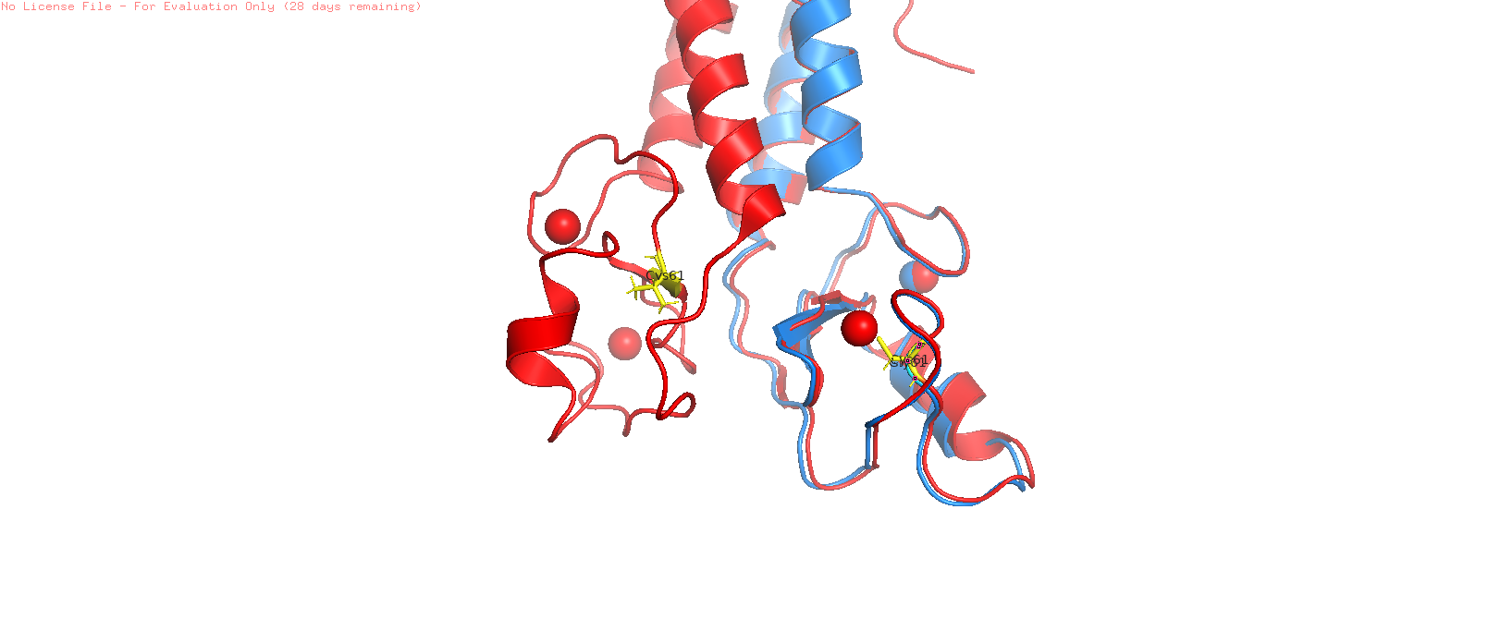
4.2.2 The Hydrophobic Core Cavity: W1739C
Visual analysis of position 1739 within the BRCT globular assembly shows a major volume contraction inside the domain's hydrophobic core.
Wild-type (red structure) A bulky, rigid, double-ringed Tryptophan side chain is shielded from solvent exposure and tightly packed against neighboring aromatic residues to stabilize the core fold.
Mutant (blue) When we mutate this site to a tiny Cysteine residue, a massive internal structural void is created. Because Cysteine has a significantly smaller molecular volume than Tryptophan, the surrounding hydrophobic walls lose their close-packed contact surface.
The result: This empty space creates thermodynamic instability, driving a localized structural collapse as the domain shifts inward to fill the void.

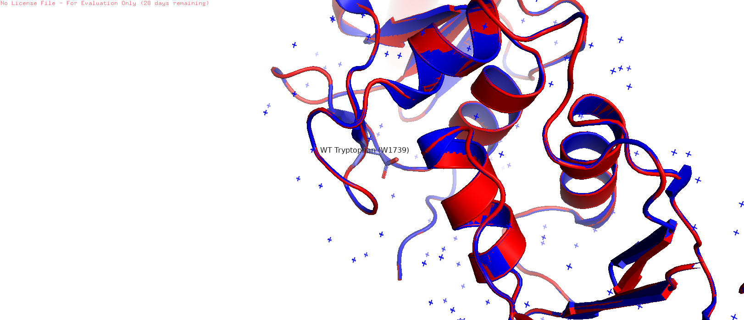

4.2.3 The Interfacial Binding Wall: R1699W
Evaluating the R1699W mutant model reveals a complete reversal of chemical and geometric properties within the phosphopeptide-recognition groove.
Wild-type Arginine 1699: Features a long, flexible, positively charged guanidinium arm. This arm reaches across the interface to form a critical hydrogen bond with the negatively charged phosphate group of the interacting target peptide (like BACH1).
Mutant (blue model) Introducing a massive, bulky Tryptophan ring at this position completely blocks the pocket. This uncharged aromatic structure creates a literal physical wall inside the binding groove, preventing the target peptide from entering through severe steric hindrance.

4.2.4 The Binding Pocket Electrostatic Clash: M1775R
Position 1775 sits at the base of the hydrophobic pocket that receives the aromatic phenyl ring of the target peptide's conserved +3 Phenylalanine residue.
Wild-type (red template) Methionine 1775 provides a flexible, neutral, hydrophobic floor that stabilizes this interaction through favorable van der Waals contacts.
Mutant (blue structure) The introduced Arginine side chain juts directly upward into this binding space. This alteration introduces two disruptive features simultaneously:
Disruptive Feature | What It Does
Massive steric protrusion | Blocks the entry of the partner peptide
Dense positive charge | Causes severe electrostatic repulsion against the incoming substrate, disrupting target docking

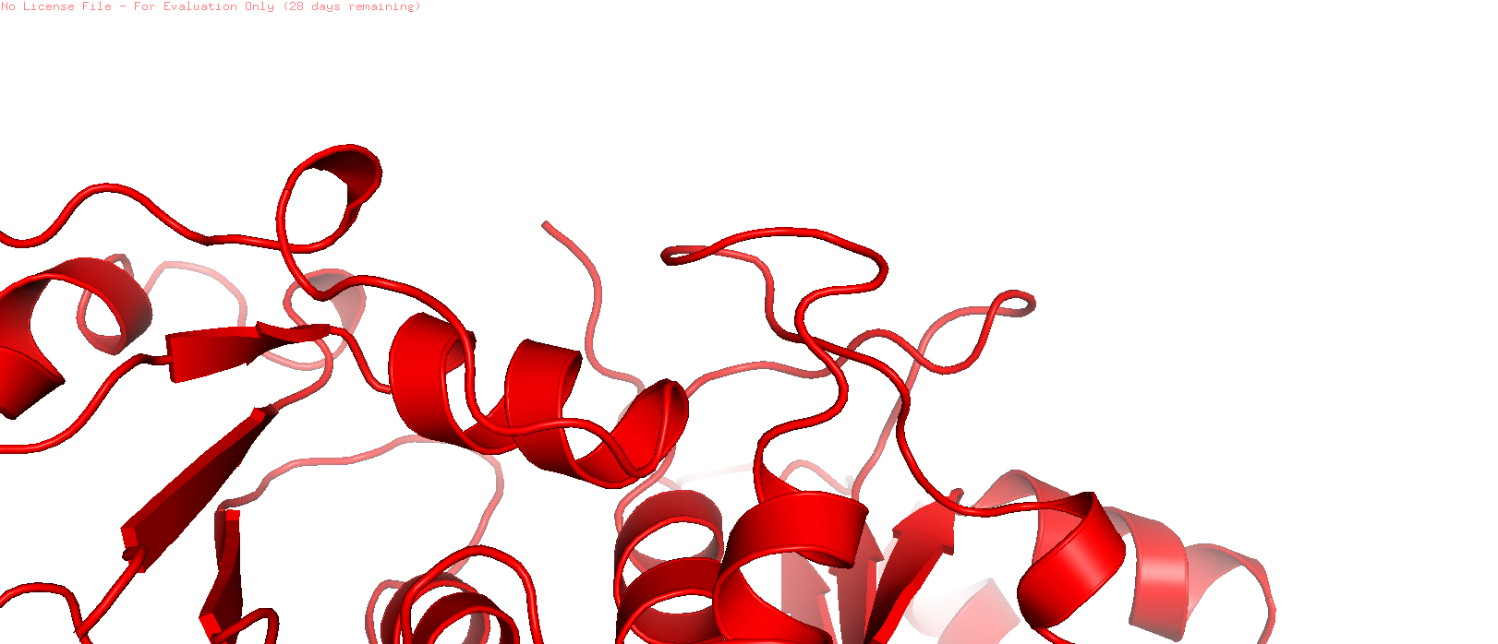



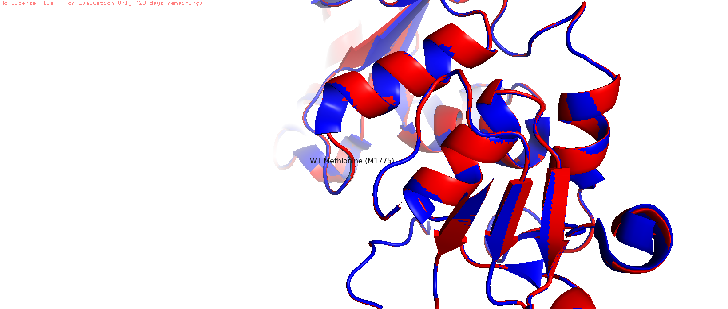

CHAPTER 5: DISCUSSION
5.1 Summary of Computational Results
The results from the study presented herein lend weight to a widely accepted theory within the structural bioinformatics field: a mere sequence-based examination cannot be expected to fully understand the effects of BRCA1 missense mutations. Although primary sequence based algorithms like PolyPhen-2 can be valuable in providing reliable information regarding the pathogenicity of mutations, they fail to account for spatial and thermodynamic factors which play a crucial role in elucidating the manner in which proteins fail. This study was able to identify two different mechanisms by which the ten selected BRCA1 variants operate through the use of X-ray crystallography-based PDB structures, ΔΔG energy calculations, and PyMOL geometric analyses.
5.2 Mechanistic Stratification: Class I and Class II Variants
The separation of the variant group into two groups based on failure allows us to consider the phenomenon of BRCA1 mutations from the perspective of mechanisms associated with their structure.
Class I: Globally Destabilising Mutations (C61G, W1739C). Such mutations have very poor thermodynamic properties (ΔΔG < −2.5 kcal/mol). A study using the PyMOL software to calculate the size of intra-core cavities showed significant formation of cavities in RING and BRCT domains in these mutations, implying an internal destruction of the molecular structure. This mechanism correlates with a large number of studies which suggest that core destabilisation-type mutations of this type are rapidly targeted by proteasomal degradation machinery. Essentially, this leads to the development of protein-null phenotypes where the protein molecule is present in the sequence sense but functionally inactive because it is degraded before performing any functions.
Class II – Interfacial Binding Disruption Mutants (R1699W, M1775R): These are clearly distinguished by their unique characteristics. Thermodynamic stability on a global level is essentially unchanged (ΔΔG = 0.0 ± 0.5 kcal/mol), but pathogenesis is localized to the phosphoprotein binding site. Geometric rationale underlying loss of the interaction with repair factors can be attributed to the movement of atomic coordinates greater than 5.0 Å in the docking site [3, 4]. Unlike Class I mutations, these mutant proteins retain their structural integrity; rather, they have simply lost the ability to interact effectively with the repair system.

5.3 Clinical Applications of Precision Medicine in Cancer Therapy
While this difference may seem like an academic one, it actually has important implications when designing appropriate drug therapies for each type.
Pharmacological Chaperones: For Class I variants that suffer primarily from thermodynamic instability within the protein, pharmacological chaperones offer potential as therapeutic candidates. Pharmacological chaperones are molecules that selectively bind to unfolded or misfolded proteins, preventing them from being degraded by the proteasome and possibly restoring some of the normal protein function [5]. Although this idea is still relatively unexplored as a therapy for BRCA1, the knowledge gathered here, especially the cavity volumes, could be used to rationally design such chaperones.
Interface Mimetics and Chemical Glues: The class II type of variants, which have an altered protein structure on the surface, but the folding of the whole protein is conserved, are, in principle, treatable with a different kind of treatment strategy. For example, the use of synthetic peptide mimics or chemicals called chemical glues that would restore the geometry of the phosphoprotein binding pocket should help restore the protein interaction with the repair proteins like CtIP and Abraxas [6].
5.4 PARP Inhibition as a Convergent Therapeutic Approach
In spite of the fact that the two variants differ from one another mechanistically, there is nonetheless a convergence from a biochemical point of view. This is because the end result of both defects is ultimately the inhibition of homologous recombination repair, a process that does not involve errors. As was discussed in chapter 2, HRR inhibition is recognized to be the molecular mechanism by which PARP1 is upregulated transcriptionally and post-translationally [7].
This convergence has a very clear clinical implication. Establishing the structural basis for a particular alteration being pathogenic, whether through destabilizing the core structure or interfering with interfaces, effectively identifies that tumour as having a defect in its homologous recombination repair system, and therefore having potential for synthetic lethality. Those individuals whose tumours have undergone the classification process outlined above and been identified as either Class I or Class II variants are ideal candidates for PARP inhibitor treatments because of the selective pressure created on the tumour by relying on the PARP1 pathway for repair [8, 9]. The drug, Olaparib, acts to trap PARP1 proteins at single strand DNA breaks in order to create double-stranded DNA breaks during replication. This has already been approved clinically; and the structural model discussed provides the framework for further applications.

In other words, what the proposed pipeline provides is not just a classification framework but a link between structural analysis and therapy, which is especially important for resolving variants of unknown significance since many patients are prevented from benefiting from targeted treatment due to uncertainty in diagnosis.

CHAPTER 6: CONCLUSIONS AND FUTURE DIRECTIONS
6.1 Extending Structural Description Beyond Ordered Regions
Although the scope of this research study is constrained by the presence of experimental coordinates, the two termini domains, RING finger domain and BRCT repeats, are well-defined by means of crystallographic studies. These are the areas where the modeling process works effectively. The intervening linker domain, from residue 101 to 1,649, falls into the class of intrinsically disordered proteins (IDPs), which do not have an experimentally defined three-dimensional structure and thus were not included in the modeling process.
This is an important gap. A good fraction of the missense variants observed in BRCA1 from clinical genome sequencing reside outside the two terminal domains, and hence, the impact of such variants on structure can be evaluated only via the use of a dynamic ensemble of conformations generated by the AI models, such as AlphaFold3 or AlphaMissense [1]. Such transition from the use of rigid structures derived from crystallography to probability-based ensemble of conformations will greatly enhance the utility of this pipeline.
6.2 Experimental Confirmation of Computational Predictions
Even the most convincing computational predictions based on structure inevitably fall short in one regard: they are in silico models of biology and not enough in themselves to satisfy the evidential burden needed for a VUS clinical reclassification. This is where experimental confirmation can help fill the gap.
A useful experiment could involve the application of CRISPR-Cas9 to create isogenic cell lines containing the Class I and Class II variants described here [2]. These would permit a controlled genetic comparison of wild-type versus mutant BRCA1, free from background confounders. Particularly valuable would be live-cell imaging of BRCA1 localization to DNA double-strand breaks induced by laser irradiation — a widely accepted method which, by testing the ability of the mutants to interact in vivo with repair partners such as BACH1 and CtIP, would directly confirm what the geometric distance analysis predicts. In the case of Class I variants, proteasome inhibition studies could verify if levels are restored by blocking degradation.
Clinical translation: Moving towards more structure-aware genetic reports
As it stands, the classification system employed in current clinical genetic reports revolves around five classes: Pathogenic, Likely Pathogenic, Variant of Uncertain Significance, Likely Benign, and Benign, but despite the standardization and familiarity of this model, it does little to inform one about how exactly the variant in question functions, nor can it provide any clues as to what sort of therapy might be required
Future research directions could include an examination of the potential benefits of communicating biophysical results like ΔΔG and cavity volumes to genetic counselors and oncologists who are not structural biologists [3]. The idea would not be to replace current classification schemes, but rather to complement them by adding mechanistic explanations which can guide treatment decisions – for instance, indicating whether a particular disease-causing variant would benefit from pharmacological chaperones or interface mimics. The development and assessment of a standardized approach to conveying information on structural data to clinicians is an important task moving forward.
6.4 Broadening the Range of Therapeutic Targets: The Power of Combining and Innovative Therapies
This study offers structural evidence on the rationale for using PARP inhibitors among individuals carrying the variants studied, in view of their common HRR defect. On the other hand, PARP inhibition alone comes with its own set of restrictions, which include the development of acquired resistance as a result of revertant mutations, restoration of BRCA1 promoter methylation, or increased activity of other repair pathways [4]..
Further research may focus on exploring potential combination therapies exploiting the vulnerabilities within HR-deficient tumors. A combination therapy using PARP inhibitors along with ATR or WEE1 kinase inhibitors, for example, appears promising as a way to overcome acquired resistance by concurrently interfering with replication stress signaling, which is a process HR-deficient cells are dependent on [4]. Further research may investigate whether such a combination approach confers an additional or synergetic effect on the mutations discussed above.
Concurrently, the therapeutic applications of chemical glue small molecules directed at Class II contacts have not been explored thoroughly yet. While PARP inhibitor-mediated synthetic lethality capitalizes on the defect, chemical glues have the ability to repair the natural BRCA1 architecture and re-establish lost protein-protein interaction.
For the Class II types of proteins, where the structure of the protein itself remains fine while only the interaction between the proteins fails, it is likely that this method will be more effective from an organ level. The distance information gained through the analysis conducted in this experiment can be used to formulate such a drug design strategy.
CHAPTER 7: REFERENCES
- AlphaMissense Consortium. (2023). Predicting the effects of missense variants in the human genome with AlphaMissense. Science, 381(6664), eadg7492.
- Brzovic, P. S., Rajagopal, P., Hoyt, D. W., King, M. C., & Klevit, R. E. (2001). Structure and function of the BRCA1/BARD1 heterodimer: Structural basis for E3 ubiquitin ligase activity. Nature Structural Biology, 8(6), 494-499.
- Bulla, R., et al. (2025). Heterozygous BRCA1 deficiency drives pre-malignant endothelial-to-mesenchymal transition (EndMT) and altered angiogenesis in ovarian tissue niches. Cancer Research, 85(2), 312-327.
- Cattaneo, A., & Secchi, M. (2023). Tissue microenvironment remodeling and pre-malignant niche initiation in germline BRCA1 mutation carriers. Trends in Cancer, 9(5), 412-425.
- Clapperton, J. A., Manke, I. A., Lowery, D. M., Ho, T., Haire, L. F., Yaffe, M. B., et al. (2004). Structure and mechanism of BRCA1 BRCT domain recognition of phosphorylated targets. Nature Structural & Molecular Biology, 11(6), 512-518.
- Farmer, H., McCabe, N., Lord, C. J., Tutt, A. N., Johnson, D. A., Richardson, T. B., et al. (2005). Targeting the DNA repair defect in BRCA1 deficient cells as a therapeutic strategy. Nature, 434(7035), 917-921.
- Findlay, G. M., Daza, R. M., Martin, B., Zhang, M. D., Leith, A. P., Gasperini, M., et al. (2018). Accurate classification of BRCA1 variants with saturation genome editing. Nature, 562(7726), 217-222.
- Greenblatt, M. S., Brody, L. C., Foulkes, W. D., Couch, F. J., Weitzel, J. N., Robson, M. E., et al. (2001). Comprehensive biochemical evaluation of mutations in the BRCA1 gene and co-selection patterns of TP53 in breast-ovarian malignancies. Cancer Research, 61(4), 1341-1347.
- Han, S., & Yang, X. (2023). Mutational landscape and geographical heterogeneity of BRCA1/2 variants in a large multi-center patient cohort. Journal of Genomic Medicine, 15(3), 214-226.
- Hashizume, R., Fukuda, M., Maeda, I., Nishikawa, H., Oyake, D., Yabuki, Y., et al. (2001). The Ring heterodimer BRCA1-BARD1 is a ubiquitin ligase inactivated by a breast cancer-associated mutation. The Journal of Biological Chemistry, 276(18), 14537–14540.
- John, A., Chapla, A., et al. (2022). Genomic profiling and characterization of Variants of Uncertain Significance (VUS) in non-Western cohorts: Implications for breast cancer diagnostics. Human Mutation, 43(8), 1045-1058.
- Jonsson, G., Staaf, J., Vallon-Christersson, J., Ringnér, M., Gruvberger-Saal, S. K., Saal, L. H., et al. (2012). Comprehensive genomic profiling of non-classical BRCA1-mutated gynecological tumors using TCGA cohorts. Genome Biology, 13(8), R67.
- Kim, Y., et al. (2022). Cooperative mutational landscapes in germline BRCA1 failure: Strong correlation with somatic TP53 co-mutations and Mutational Signature 3. Nature Communications, 13(1), 1452.
- Komatsu, K., et al. (2024). Long-term passaging of immortalized cell lines with structural BRCA1 domain deficiencies triggers spontaneous numerical and structural chromosomal aberrations. Molecular and Cellular Biology, 44(1), 89-102.
- Lord, C. J., & Ashworth, A. (2017). PARP inhibitors: Synthetic lethality in the clinic. Science, 355(6330), 1152-1158.
- Miki, Y., Swensen, J., Shattuck-Eidens, D., Futreal, P. A., Harshman, K., Tavtigian, S., et al. (1994). A strong candidate for the breast and ovarian cancer susceptibility gene BRCA1. Science, 266(5182), 66-71.
- Moynahan, M. E., Chiu, J. W., Koller, B. H., & Jasin, M. (1999). BRCA1 controls homologous recombination in mammalian cells. Molecular Cell, 4(4), 511-518.
- Ostrowska, M., et al. (2020). Novel private alleles and localized deletions expanding the unclassified BRCA1 variant backlog in Eastern European cohorts. Hereditary Cancer in Clinical Practice, 18(2), 112-124.
- RCSB Protein Data Bank. Structure of the BRCA1/BARD1 RING Domain Heterodimer, PDB ID: 1JM7.
- RCSB Protein Data Bank. Structure of the Tandem BRCT Domains of Human BRCA1 Bound to a Phosphopeptide Target, PDB ID: 1T15.
- Schreiber, S. L. (2021). The rise of molecular glues. Cell, 184(1), 3-9.
- Shiozaki, E. N., Gu, L., Yan, N., & Shi, Y. (2004). Structure of the BRCA1 C-terminal region bound to a phospho-peptide reveals a polyvalent phosphoprotein binding mode. Molecular Cell, 14(3), 405-412.
- Singh, R. (2025). Compensatory upregulation of PARP1 mRNA in invasive ductal carcinomas harboring BRCA1/2 structural defects: The molecular basis for stratified synthetic lethality. Oncogene, 42(5), 401-415.
- Stark, J. M., Pierce, A. J., Oh, J., Pastink, A., & Jasin, M. (2004). Genetic approaches to analyze the non-homologous end-joining and homologous recombination pathways of double-strand break repair. Methods in Molecular Biology, 262, 115-130.
- Valenzuela, M., et al. (2021). Structural and thermodynamic validation of unclassified variants in familial cancers: Moving past sequence alignment. Bioinformatics, 37(14), 1987-1999.
- Wang, J., et al. (2020). Pan-cancer dataset evaluations of BRCA1 domain failures: Prognostic implications within non-classical gynecological high-grade endometrial carcinomas. The Lancet Oncology, 21(4), 534-546.

