**SELF-PUBLISHING: PUBLISHING ISSUE AND RESOLUTION**

**Ankesh Yadav1 , Bhanshu Chaudhary2 , Mohammed Faheem3**

*1Department of Computer Science and Engineering, Lovely Professional University, India*

*ankeshyadav0007@gmail.com*

*2Department of Computer Science and Engineering, Lovely Professional University, India*

*bhanshu.messi1@gmail.com*

*3Department of Computer Science and Engineering, Lovely Professional University, India*

*Faheemfarooq3@gmail.com*

***Abstract***

***The project is about the online self publishing website, which will help the new talents to showcase their talents in the market.***

***The key aim of the project is to help the new writers who are unable to publish their write-ups due to lack of funds. They big publishing house wants to work only with the big names as they don’t want to take risks with the newborns.***

***As of now our main target audience is the new talents who are unable to showcase their talent to the world due to lack of funds. They can come up to our website and write from their hearts and show the world their talents which no one has recognized and can establish their names at zero initial cost.***

***Keyword:***

***Book Publishing, e-books, Reading, Writing, , etc***

**1. Introduction**

Now a days we have seen new talents are emerging in writing but due to lack of funds they are unable to showcase their talent to the world. As a self-publishing author, you need to produce the final draft and supply the funds required for marketing and distribution of your book. The authors must also decide how many copies will be printed and pay for each one. To minimize time and cost, more and more authors are turning away from print and are looking towards the e-book publishing platforms. Now a days demand for these types of e-books has been drastically increasing and this shows the potential growth of our website in the near future. Publishing your work on the online portal like ours in e-book format eliminates the costs associated with printing and distributing rights for selling the physical copies of the books and chances to reach a bigger audience will also increase.[1]

Readers around the world can simply find a copy online rather than going in person to the shop to buy it or to order it online and pay the extra shipping costs.

Traditionally publishers can offer editorial guidance, marketing muscle, and access to well-established channels of distribution, which requires lots of time, expenses and investments.[2] If the author doesn't have the money, time, or inclination to do all of those things for their book and to pay the costs of production, a publisher's experience and knowledge can make up for that gap. The costs of online publishing are fairly low in comparison to the traditional methods which we are using for years.[3] Earlier research studies based on self-publishing synthesize online mode of publishing over traditional publishing.

**2. Motivation & Scope**

Nowadays, everyone have seen that every sector is facing drastic changes in the formal way of functioning like education sector, automobile and much more.

The main purpose of our project is to overcome the problem of high publishing prices that are being charged by the book publishing farms. This problem encourages us develop a website that will come up as a silver lining for the new talents.

**3. Problem Statement**

Our aim is to develop a website for the new and emerging writers who are lacking to showcase their talent to the world due to lack of funds or any other means. Our website will give all the means which help the writer to overcome the obstacles they face and publish their book at ease. Our website also gives a chance to the readers to reach more books and follow their favorite writers , easily access their e-books through our website from anywhere around the world.

**4. TRADITIONAL WAYS**

There is a good reason that traditional publishing takes so long: many experts collaborate to design a high-quality product. Once the manuscript is published, the author's work is done and its up to the publishing house to design, prepare, print, and promote your book but that requires lots of time, cost and effort.[4] As a new writer it is hard to invest or bear the high cost of publishing initially and the tasks not end up their just simply by investing the money, launching a new book in the market also requires a lot of marketing efforts to reach their targeting audience. The authors have less creativity control while promoting their books, they need a dedicated marketing team for the same. New authors in particular are likely to be rejected many times before they manage make a good deal with a reputed publishing house, in addition to that traditional ways impose high charges for editing, design, printing, and marketing costs for print books. On that, royalty rates will usually range between 7% and 25%, with the latter on the unusually generous end.[5][12]

The traditional publishing ways are costly and time consuming, on an average it took 24 months from edited manuscript to showing up in bookstores. If we compare the same period of time, an indie author could have written, published, and promoted three titles.[6]

**5. Result**

An online self-publishing is much more beneficial in terms of getting exposure and target audience as compared to the traditional self-publishing. The online self publishing have many advantages like rapid publishing without waiting for a long period of time, with high visibility, international audience, an unlimited space for figures, extensive data and even video footage.[11] Authors are able to publish his/her book at much low cost and can promote their books by publishing Articles on websites, by email alerts, etc and much more. In addition to that the writers can also generate good revenue by reaching much wider audience online and can also get reviews from the readers that can be used as reference to improve his/her writing skill.[5][7]

Marketing and distribution might be a lot cheaper for an online publication than the traditional ways because online desktop publishing is a fairly new field, there are no set standards deemed a quality layout format.[8] We can see this as an advantage, where we have a bigger room for experimentation. In self-publishing mode the author can decide the prices and can possibly change it at any point of time, but this seems to be impossible in case of traditional publishing.[9][10]

**6. METHODOLOGY**

**6.1 Authentication**

Initially, a user will register with his email in this application and then enter his/her username and password for registration and afterwards, all this information will be stored in the application’s database. The validation information contained in the database shall authenticate the account with the Sign-in user, if the user's details are correct the user is given permission to access the resources available to him at the website, if the user's details are not valid the user is denied to access the resource (as seen in Fig.1).

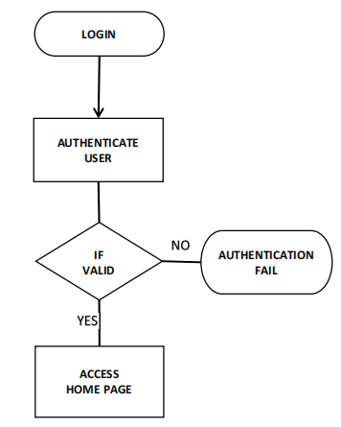

Fig.1. Flow chart

**6.2 UPLOAD AND SEARCH**

In this website the user play two roles he might be a reader or writer. Reader can search for the items which are available in the database, If the item is present in the database then he can access it from database and redirected to the payment page. Writer can register themselves as a writer and have option for uploading the items like papers, magazines and e-books. We can see the data flow diagram of this website in Fig (2, 3, 4).

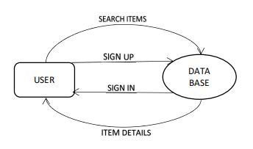Fig.2. Data Flow Diagram Level 0

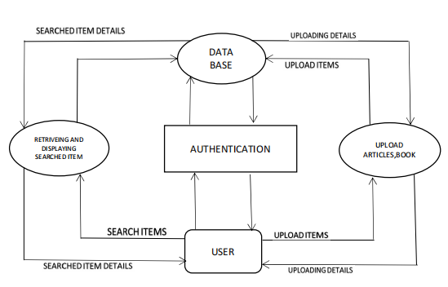

Fig.3. Data Flow Diagram Level 1

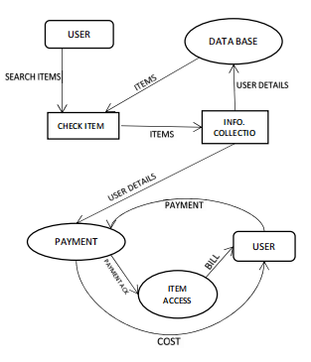

Fig.4. Data Flow Diagram Level 2

**7. Future Scope**

According to us, we feel that right now this website is the one of its kinds in our country and we believe that this will have a huge market potential in the near future. Right now , we believe there is no competition to our website as it is one of its kind and for revenue purpose as we all know Google pays to website as per there ranks in the search engine results page so right now, for revenue we are sticking to this option. For the future prospective we can think to built a mobile application for our website which will help our website to reach more people. In addition to that we can build audio books for children and physically disabled person. Apart from it , in the future we can also charge for books. Ex: The writers who have gained huge popularity through our website, then we will charge the readers for the books of those writers.

**8. Conclusion**

Online self-publication provides authors with a wide range of freedom and open hands in creativity. The authors can publish books, magazines, research papers and articles at a much lower cost with a large number of audience all over the world. Authors get open hands, more control and unlimited space to upload his/ her work and this helps them to generate good revenue. The tasks like Marketing or we can say promotion and distribution is much cheaper as compared to the traditional publication ways and this takes very less time to publish, the readers can access there work from anywhere in the world. Digital publishing and print on demand have significantly reduced the cost of publishing a book. The phenomenal growth of internet, mobile phones and tablets has expanded the market for e-books. The writers who self-publish the books are more likely to more control over the rights of the books, e.g., they set their books on sale and keep a larger proportion of the sales. Self-published books have a much higher royalty rate than traditional publishers because you get up to 50-70% of your book's profits, while if we look at the traditional publishing ways, the end up with 10%, hardly 12% after years of proving yourself as an author.[4][12]

**9. References**

[1] Jennifer Alsever, Fortune magazine, 30 December 2016, [The Kindle Effect](http://fortune.com/2016/12/30/amazon-kindle-digital-self-publishing/), Retrieved 9 November 2017, "...has become a $1 billion industry..."

[2] LYNN NEARY (19 December 2012). ["Self-Publishing: No Longer Just A Vanity Project"](https://www.npr.org/2012/12/19/167448748/self-publishing-no-longer-just-a-vanity-project). NPR. Retrieved 20 October 2017. ...They used to call it the "vanity press," and the phrase itself spoke volumes….

[3] Alan Finder (15 August 2012). ["The Joys and Hazards of Self-Publishing on the Web"](https://www.nytimes.com/2012/08/16/technology/personaltech/ins-and-outs-of-publishing-your-book-via-the-web.html). The New York Times. Retrieved 20 October2017. ... "The biggest thing you have against you in trying to sell your book is that people don't know about it," he said….

[7] ALEXANDRA ALTER (30 January 2016). ["Meredith Wild, a Self-Publisher Making an Imprint"](https://www.nytimes.com/2016/01/31/business/media/meredith-wild-a-self-publisher-making-an-imprint.html). NYT. Retrieved 20 October 2017. ...the ones who are very successful at it are making a lot of money, which … can be hard to match with the traditional publishing royalty structure…

[8] LESLIE KAUFMAN (16 April 2013). ["New Publisher Authors Trust: Themselves"](https://www.nytimes.com/2013/04/17/business/media/david-mamet-and-other-big-authors-choose-to-self-publish.html). NYT. Retrieved 20 October 2017. ...nobody ever does the marketing they promise.…

[9] ["7 Benefits Of Self Publishing A Book » Inside Brain"](https://insidebrain.in/benefits-of-self-publishing-a-book/). Inside Brain. Retrieved 18 October 2020.

[10] NEAL POLLACK (20 May 2011). ["The Case for Self-Publishing"](https://www.nytimes.com/2011/05/22/books/review/the-case-for-self-publishing.html). NYT. Retrieved 20 October 2017. ... midcareer, midlist, middle-aged, more or less middlebrow, and somewhat Internet savvy – self-publishing seems to make a lot of sense … why not start appealing directly to those readers?…

[12] Lynn Neary (19 September 2015). ["When It Comes To Book Sales, What Counts As Success Might Surprise You"](https://www.npr.org/2015/09/19/441459103/when-it-comes-to-book-sales-what-counts-as-success-might-surprise-you). NPR. Retrieved 20 October 2017. "...You used to be able to make an absolutely living wage as a writer. … it didn't usually mean you would be rich, but it had meant in the past that you could support yourself….

[14] Lea Franczak (2 December 2014). ["Interview: Sarah Grimm, author of 'Midnight Heat'"](http://happyeverafter.usatoday.com/2014/12/02/sarah-grimm-interview-midnight-heat/). USA Today. Retrieved 20 October 2017. .....tried-and-true formatters, cover artists and editors who don't cost a small fortune…

[15] Valerie Bonk of Howard Magazine (6 April 2016). ["Howard County authors make the leap into self-publishing"](http://www.baltimoresun.com/news/maryland/howard/howard-magazine/ph-mg-ho-self-published-authors-20160406-story.html). Baltimore Sun. Retrieved 20 October 2017. ...Bowman is among a growing number of authors choosing the self-publishing route…

[16] Science Fiction and Fantasy Writers of America, [Self publishing](http://www.sfwa.org/other-resources/for-authors/writer-beware/pod/), Retrieved 5 November 2017

[17] Alex Daniel (20 January 2017). ["Self-Publishing in 2017: The Year in Preview: New opportunities and challenges await self-publishing in the coming year"](https://www.publishersweekly.com/pw/by-topic/authors/pw-select/article/72560-self-publishing-in-2017-the-year-in-preview.html). Publishers Weekly. Retrieved 20 October 2017. ...Self-publishing continues to expand, with ISBN registrations jumping 21% from 2014 to 2015 …