Target Business Case Study

Exploratory Data Analysis

1) Structure & characteristics of the dataset:

A) Data type of all columns in the “customers” table

query --->

SELECT
column_name,
data_type,
is_nullable
FROM
`ecommerce-476314.target.INFORMATION_SCHEMA.COLUMNS`
WHERE
table_name = 'customers';

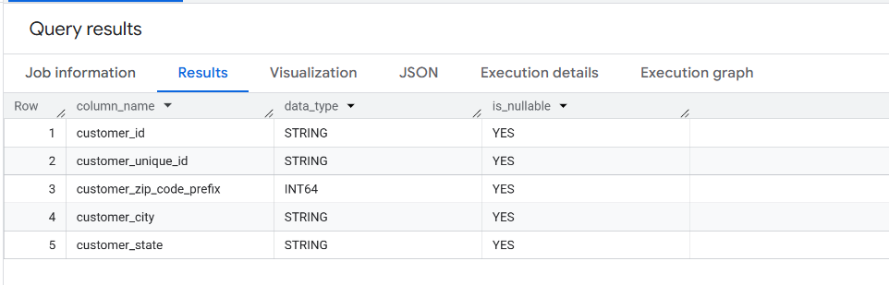

B) Get the time range between which the orders were placed.

We can get this from the order table .

Query --->

Select min(order_purchase_timestamp) as earliest_purchase,max(order_purchase_timestamp) as latest_purchase from target.orders;

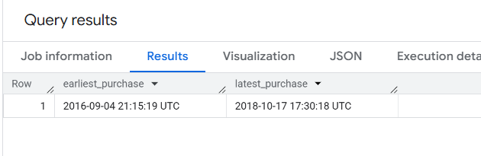

C) Count the Cities & States of customers who ordered during the given period.

query---

Select count(distinct customer_city) as total_city,
count(distinct customer_state) as total_state
from target.customers c join target.orders o on c.customer_id=o.customer_id ;

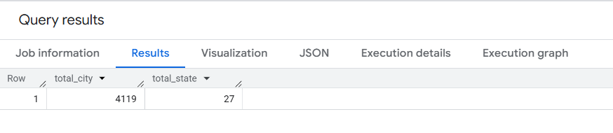

2) In-Depth Exploration--
A) Is there a growing trend in the no. of orders placed over the past years?
query—
with cte1 as
(Select Extract(year from order_purchase_timestamp) as year,Extract(month from order_purchase_timestamp) as month,FORMAT_DATE('%B', order_purchase_timestamp) AS month_name,count(order_id) as current_month_total_order from target.orders group by year,month,month_name order by year,month),
cte2 as (
Select *,Coalesce(lag(current_month_total_order,1) over (order by year,month),0) as prev_month_order,
(current_month_total_order - Coalesce(lag(current_month_total_order,1) over (order by year,month),0)) as order_gain_or_drop from cte1
)
Select *, from cte2;

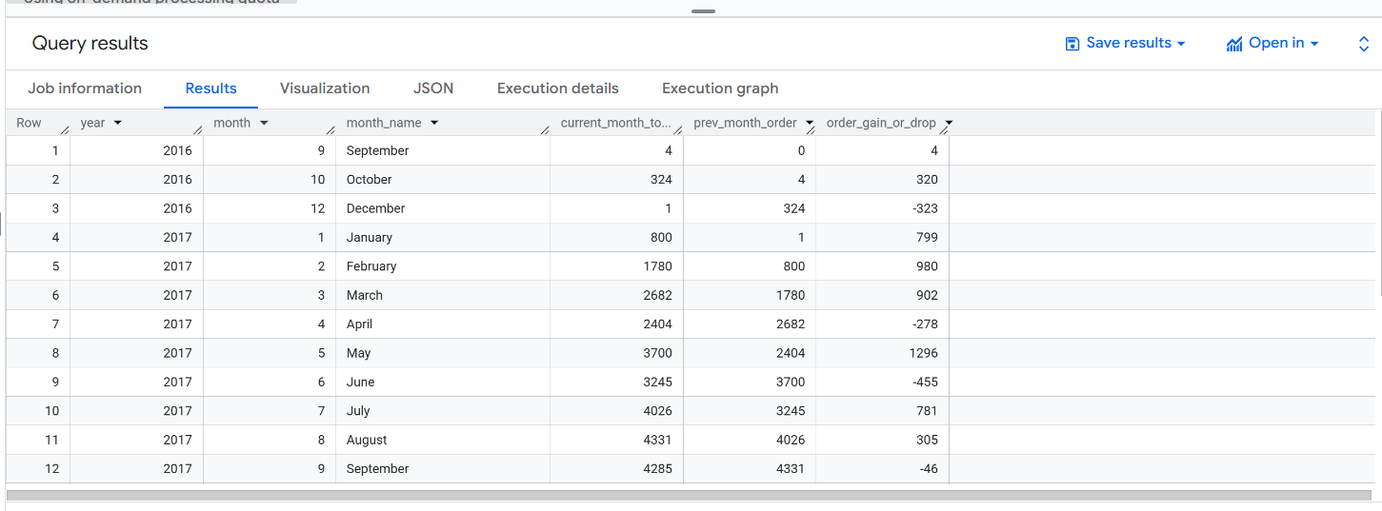
#how to handle 2016 – 11

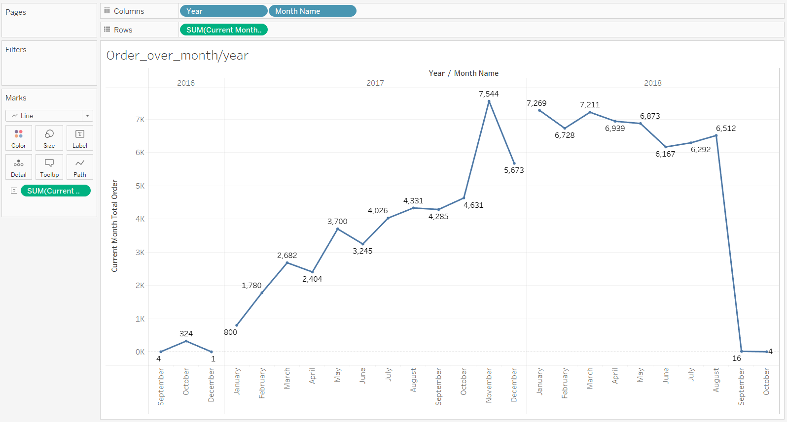

C. During what time of the day, do the Brazilian customers mostly place their
orders? (Dawn, Morning, Afternoon or Night)
● 0-6 hrs : Dawn
● 7-12 hrs : Mornings
● 13-18 hrs : Afternoon
● 19-23 hrs : Night

Select
case
when t.order_hour between 0 and 6
then "Dawn"
when t.order_hour between 7 and 12
then "Mornings"
when t.order_hour between 13 and 18
then "Afternoon"
when t.order_hour between 18 and 23
then "Night"
end as day_time,count(order_id) as total_order
from (
Select order_id,order_purchase_timestamp,Extract(hour from order_purchase_timestamp) as order_hour from target.orders
)t group by day_time order by total_order desc;

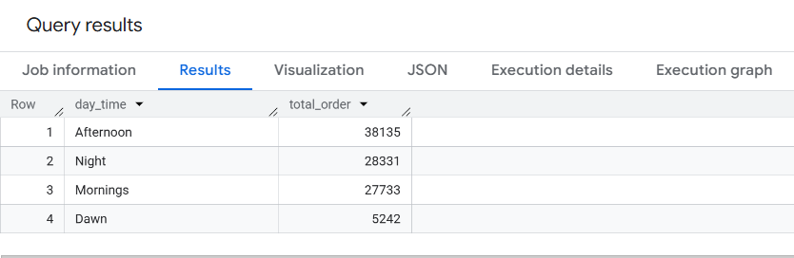

Insights:

3) Evolution of E-commerce orders in the Brazil region:
A) Get the month on month no. of orders placed in each state.

Select ct.order_year,ct.order_month,ct.customer_state,count(ct.order_id) as total_order from(
Select *,Format_Date("%Y",t.order_purchase_timestamp) as order_year,Format_Date("%B",t.order_purchase_timestamp) as order_month,Extract(month from t.order_purchase_timestamp) as month_num
from target.orders t join target.customers c on t.customer_id=c.customer_id
)ct group by ct.order_year,ct.order_month,ct.month_num,ct.customer_state order by ct.order_year,ct.month_num;
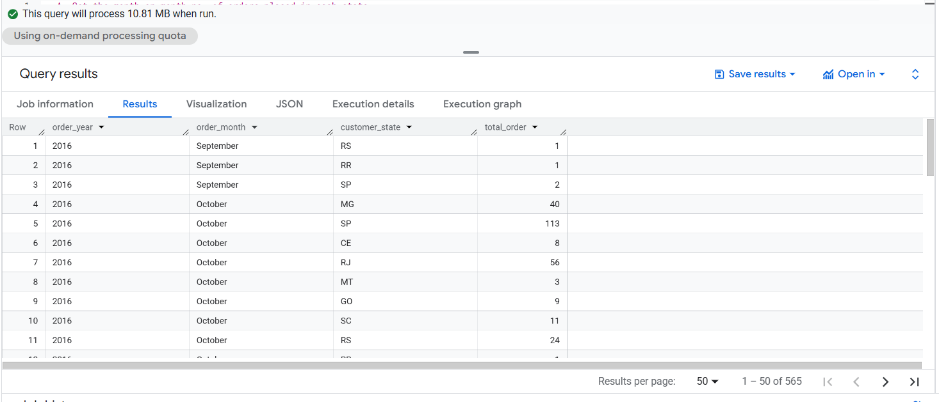
B. How are the customers distributed across all the states?

Query--
Select customer_state,count(customer_id) as total_customer from target.customers group by customer_state order by total_customer desc;

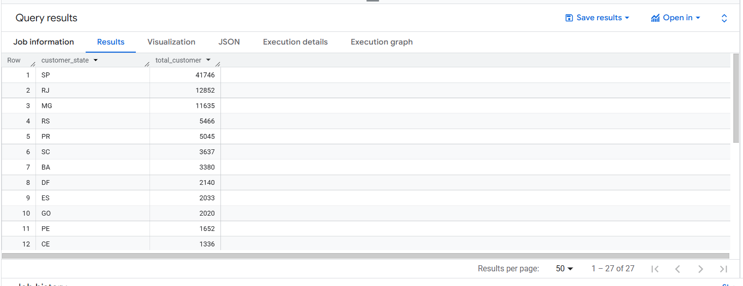

4) Impact on Economy: Analyze the money movement by e-commerce by looking at order prices, freight and others.
A) Get the % increase in the cost of orders from year 2017 to 2018 (include months between Jan to Aug only).
can use the “payment_value” column in the payments table to get the cost of orders.

Query --->

with cte1 as (
Select Extract(year from o.order_purchase_timestamp) as year,Extract(month from o.order_purchase_timestamp) as month,Format_date("%B",order_purchase_timestamp) as month_name,round(sum(p.payment_value),2) as total_payment from target.orders o left join target.payments p on o.order_id=p.order_id where p.order_id is not null group by year,month,month_name order by year,month
),
cte2 as (
Select cte1.year , cte1.month, cte1.month_name, cte1.total_payment ,coalesce(lag(cte1.total_payment,1) over (partition by cte1.year order by cte1.year,cte1.month),0) as prev_month_tot_payment,round(((cte1.total_payment - coalesce(lag(cte1.total_payment,1) over (partition by cte1.year order by cte1.year,cte1.month),0))/lag(cte1.total_payment,1) over (partition by cte1.year order by cte1.year,cte1.month))*100,2) as percent_increase from cte1 where cte1.year in (2017,2018) and cte1.month in (1,2,3,4,5,6,7,8)
)
Select * from cte2;

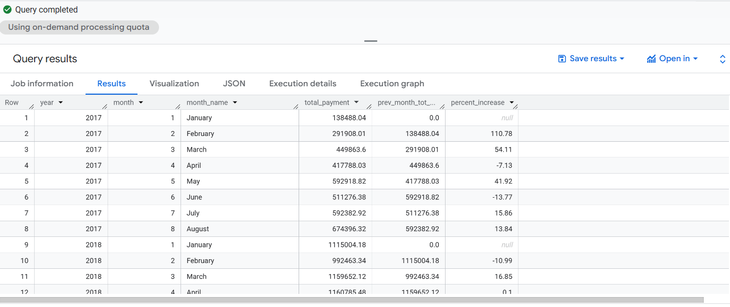

- Calculate the Total & Average value of order price for each state.
- Calculate the Total & Average value of order freight for each state.

