Target
Business Case
Scaler

Topic: SQL
Duration: 1 week

Context
- Target is a globally renowned brand and a prominent retailer in the United States. Target makes itself a preferred shopping destination by offering outstanding value, inspiration, innovation and an exceptional guest experience that no other retailer can deliver.
- This particular business case focuses on the operations of Target in Brazil and provides insightful information about 100,000 orders placed between 2016 and 2018. The dataset offers a comprehensive view of various dimensions including the order status, price, payment and freight performance, customer location, product attributes, and customer reviews.
- By analyzing this extensive dataset, it becomes possible to gain valuable insights into Target's operations in Brazil. The information can shed light on various aspects of the business, such as order processing, pricing strategies, payment and shipping efficiency, customer demographics, product characteristics, and customer satisfaction levels.

Dataset: https://drive.google.com/drive/folders/1TGEc66YKbD443nslRi1bWgVd238gJCnb?usp=sharing

The data is available in 8 different csv files:
- customers.csv
- geolocation.csv
- order_items.csv
- payments.csv
- reviews.csv
- orders.csv
- products.csv
- sellers.csv

The column description for these csv files is given below.

The customers.csv contain following features:
Features | Description
customer_id | ID of the consumer who made the purchase
customer_unique_id | Unique ID of the consumer
customer_zip_code_prefix | Zip Code of consumer’s location
customer_city | Name of the City from where order is made
customer_state | State Code from where order is made (Eg. são paulo - SP)

The orders.csv contain following features:
Features | Description
order_id | A Unique ID of order made by the consumers
customer_id | ID of the consumer who made the purchase
order_status | Status of the order made i.e. delivered, shipped, etc.
order_purchase_timestamp | Timestamp of the purchase
order_delivered_carrier_date | Delivery date at which carrier made the delivery
order_delivered_customer_date | Date at which customer got the product
order_estimated_delivery_date | Estimated delivery date of the products

The order_items.csv contain following features:
Features | Description
order_id | A Unique ID of order made by the consumers
order_item_id | A Unique ID given to each item ordered in the order
product_id | A Unique ID given to each product available on the site
seller_id | Unique ID of the seller registered in Target
shipping_limit_date | The date before which the ordered product must be shipped
price | Actual price of the products ordered
freight_value | Price rate at which a product is delivered from one point to another

The payments.csv contain following features:
Features | Description
order_id | A Unique ID of order made by the consumers
payment_sequential | Sequences of the payments made in case of EMI
payment_type | Mode of payment used (Eg. Credit Card)
payment_installments | Number of installments in case of EMI purchase
payment_value | Total amount paid for the purchase order

The geolocations.csv contain following features:
Features | Description
geolocation_zip_code_prefix | First 5 digits of Zip Code
geolocation_lat | Latitude
geolocation_lng | Longitude
geolocation_city | City
geolocation_state | State

The sellers.csv contains following features:
Features | Description
seller_id | Unique ID of the seller registered
seller_zip_code_prefix | Zip Code of the seller’s location
seller_city | Name of the City of the seller
seller_state | State Code (Eg. são paulo - SP)

The reviews.csv contain following features:
Features | Description
review_id | ID of the review given on the product ordered by the order id
order_id | A Unique ID of order made by the consumers
review_score | Review score given by the customer for each order on a scale of 1-5
review_comment_title | Title of the review
review_comment_message | Review comments posted by the consumer for each order
review_creation_date | Timestamp of the review when it is created
review_answer_timestamp | Timestamp of the review answered

The products.csv contain following features:
Features | Description
product_id | A Unique identifier for the proposed project.
product_category_name | Name of the product category
product_name_lenght | Length of the string which specifies the name given to the products ordered
product_description_lenght | Length of the description written for each product ordered on the site
product_photos_qty | Number of photos of each product ordered available on the shopping portal
product_weight_g | Weight of the products ordered in grams
product_length_cm | Length of the products ordered in centimeters
product_height_cm | Height of the products ordered in centimeters
product_width_cm | Width of the product ordered in centimeters

Dataset schema:
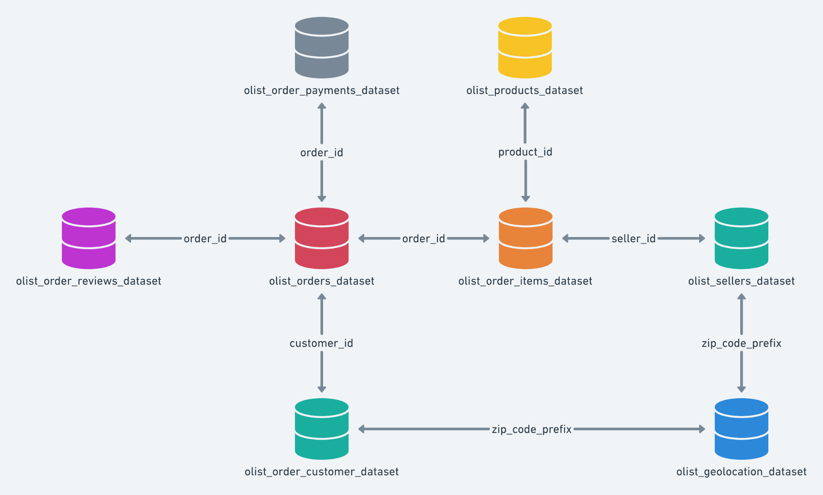

Problem Statement:
Assuming you are a data analyst/ scientist at Target, you have been assigned the task of analyzing the given dataset to extract valuable insights and provide actionable recommendations.

What does ‘good’ look like?
- Import the dataset and do usual exploratory analysis steps like checking the structure & characteristics of the dataset:
  - Data type of all columns in the “customers” table.
  - Get the time range between which the orders were placed.
  - Count the Cities & States of customers who ordered during the given period.

- In-depth Exploration:
  - Is there a growing trend in the no. of orders placed over the past years?
  - Can we see some kind of monthly seasonality in terms of the no. of orders being placed?
  - During what time of the day, do the Brazilian customers mostly place their orders? (Dawn, Morning, Afternoon or Night)
- 0-6 hrs : Dawn
- 7-12 hrs : Mornings
- 13-18 hrs : Afternoon
- 19-23 hrs : Night

- Evolution of E-commerce orders in the Brazil region:
  - Get the month on month no. of orders placed in each state.
  - How are the customers distributed across all the states?

- Impact on Economy: Analyze the money movement by e-commerce by looking at order prices, freight and others.
  - Get the % increase in the cost of orders from year 2017 to 2018 (include months between Jan to Aug only).
You can use the “payment_value” column in the payments table to get the cost of orders.
  - Calculate the Total & Average value of order price for each state.
  - Calculate the Total & Average value of order freight for each state.

- Analysis based on sales, freight and delivery time.
  - Find the no. of days taken to deliver each order from the order’s purchase date as delivery time.
Also, calculate the difference (in days) between the estimated & actual delivery date of an order.
Do this in a single query.
You can calculate the delivery time and the difference between the estimated & actual delivery date using the given formula:
- time_to_deliver = order_delivered_customer_date - order_purchase_timestamp
- diff_estimated_delivery = order_estimated_delivery_date - order_delivered_customer_date
  - Find out the top 5 states with the highest & lowest average freight value.
  - Find out the top 5 states with the highest & lowest average delivery time.
  - Find out the top 5 states where the order delivery is really fast as compared to the estimated date of delivery.
You can use the difference between the averages of actual & estimated delivery date to figure out how fast the delivery was for each state.

- Analysis based on the payments:
  - Find the month on month no. of orders placed using different payment types.
  - Find the no. of orders placed on the basis of the payment installments that have been paid.

Evaluation Criteria (100 points)
- Initial exploration like checking the structure & characteristics of the data (15 points)
- In-depth Exploration (15 points)
- Evolution of E-commerce orders in the Brazil region (10 points)
- Impact on Economy (20 points)
- Analysis on sales, freight and delivery time (20 points)
- Analysis based on the payments (10 points)
- Actionable Insights & Recommendations (10 points)

Submission Process
Once you’re done with the case study...
- Use a Word document to paste your SQL queries along with a screenshot of the first 10 rows from the output.
- List down any valuable insights that you find during the analysis and provide some action items from the company’s perspective in order to improve the current situation.
- Convert your solutions doc into a PDF, and upload the same on the platform.
- Please note that after submitting once, you will not be allowed to edit your submission.

