**Assignment - 1**

**Student Name:** Ankesh **UID:** 22BDO10014

**Branch:** CSE (DevOps) **Section/Group**- 22BCD-1/A

**Semester:** 4th **Date of Submission:** 26/02/2024

**Subject Name**: Git and hub **Subject Code:** 22CSH-293

**Task 1: Create a project on GitHub and add collaborators.**

**Steps are following:**

1. Create repository over GitHub.

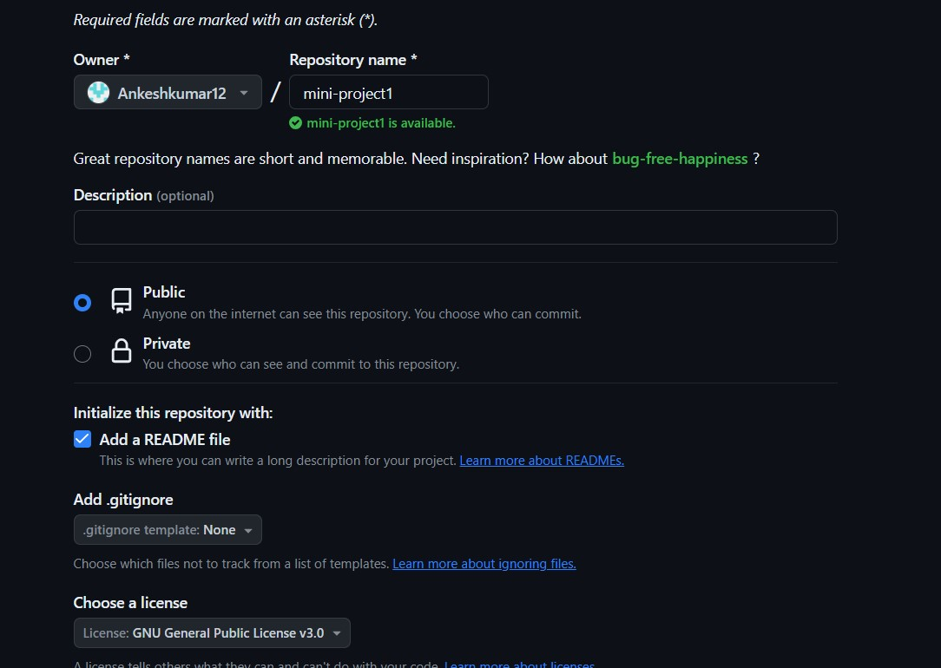

1. Upload the files of Mini-Project over to this repository using the Git Bash.

Force Push:

After push:

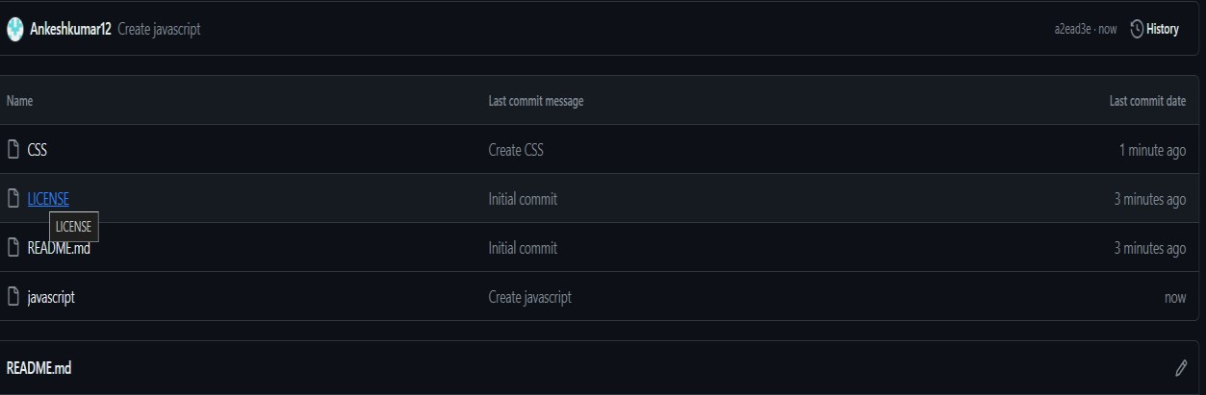

1. We have taken the file named index.html,script.js and style .css.

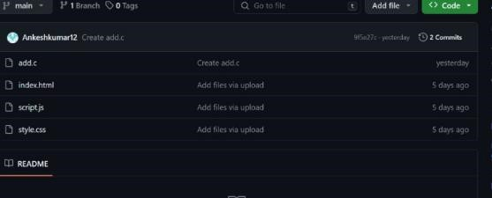

1. Let’s head over to Projects section to create project for this repository.



1. There are two options whether you wanna create a new project or link a existing project.

Click on New Project.

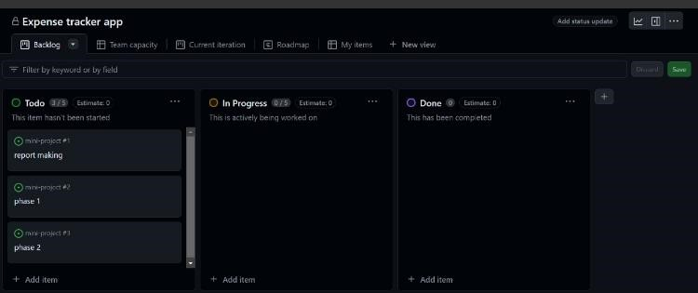

1. We are inviting to collboartors.

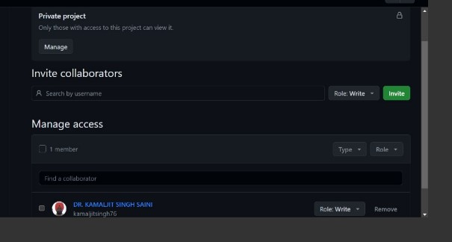

1. Now we are linking a project to create a project.

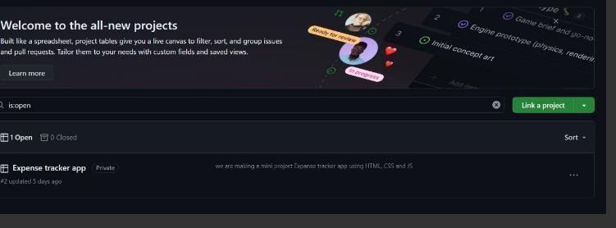

**TASK 2: Create two remote repositories, then make two files with same name but different content then merge them on local machine and push the merged version over to both remote repositories.**

Steps:

1. Go to GitHub and create 2 repositories, let’s take assignment-1 and assign2.

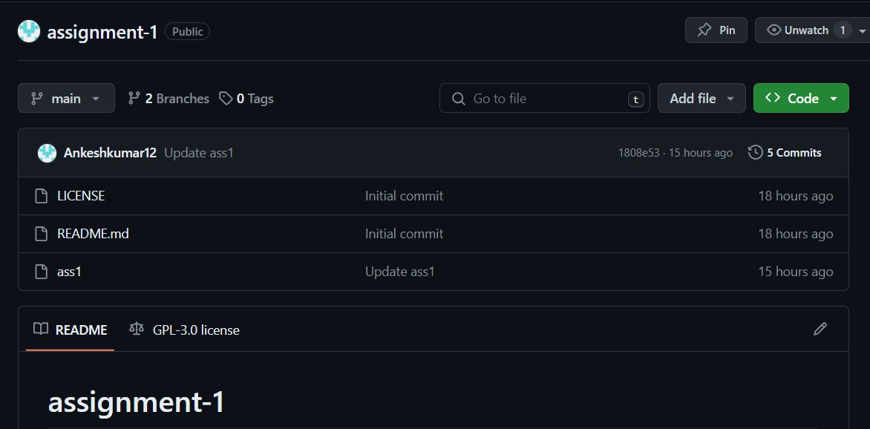

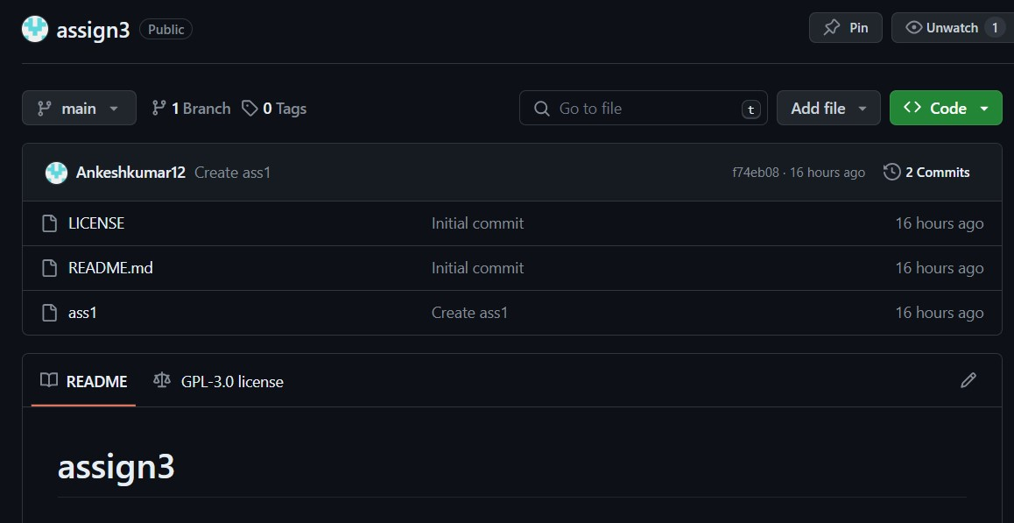

1. Create file in each repo, index.html with different content.

1. 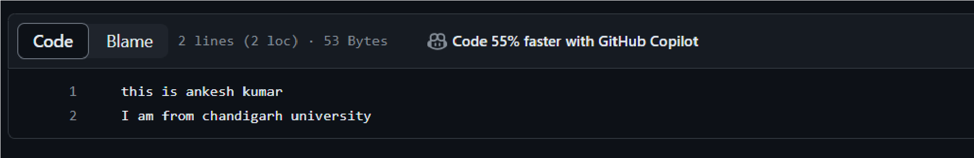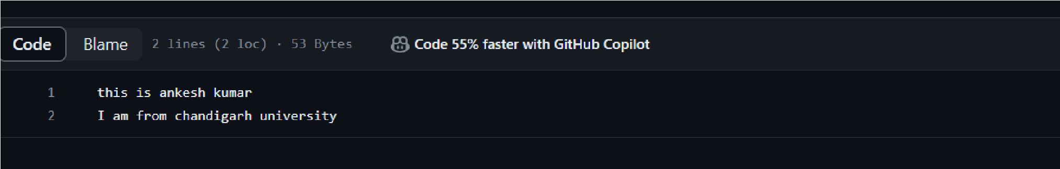Open Git Bash and create a local repository using mkdir and cd to change directrory, then initialize the git in it.

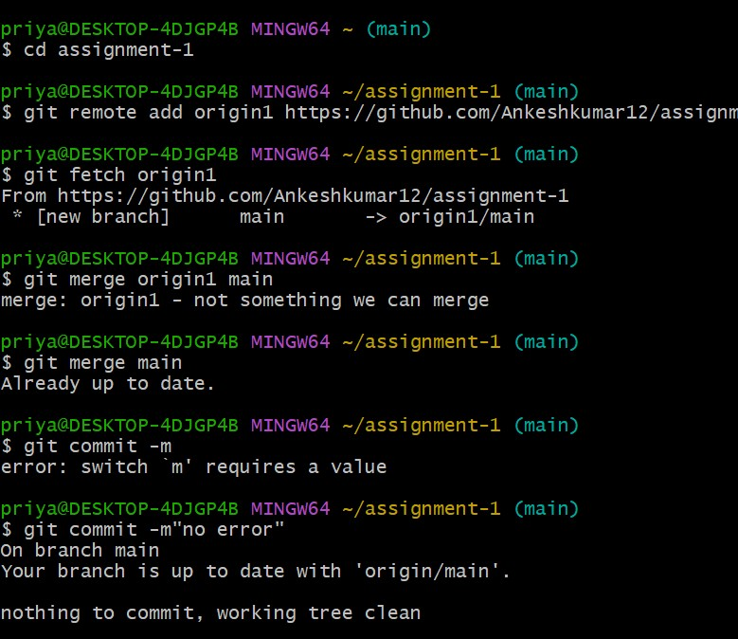

1. Then add remote of “assign1” remote repository. (also changed the branch name using:  *branch -m)*



1. Push the changes of assign1 and display file.

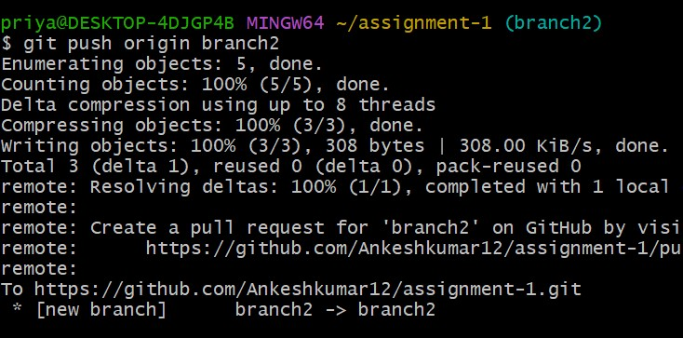

1. Fetch the changes of assign2 repository

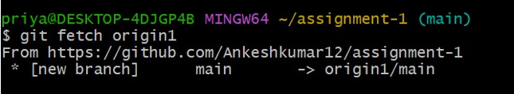

1. If we merge simply both the ass1.c it will show the following error.

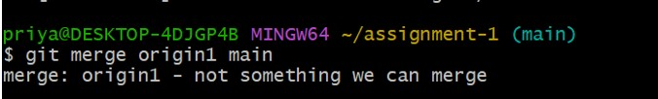

1. Use the following command to fix this error because both repo don’t have a common ancestor.

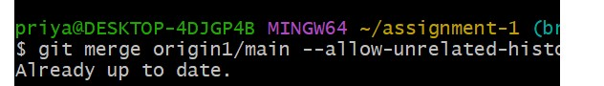

1. Delete first both remote names and keep the content you want to keep.1. Index.html

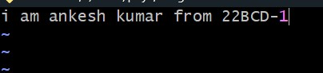

1. Now, add the changes and commit them.

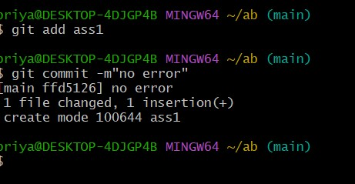

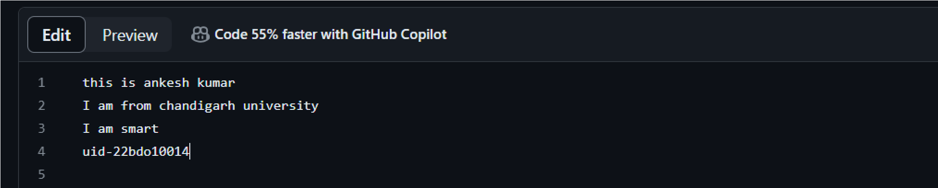

1. Pull the changes of repositories.

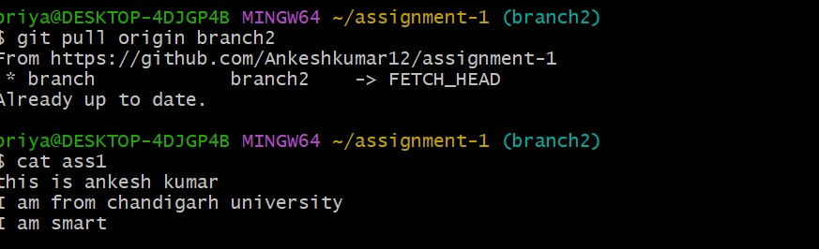

1. Go to GitHub and refresh the page, we can see both are same now.
2. Task Done.