**Experiment -1.1**

Install Git and creating repository.

**Student Name:** Shivam singh **UID:** 22BDO10005

**Branch:** CSE(DEVOPS) **Section/Group:** 22BCD-1/A

**Semester:** 4th **Date of Performance:** 17/1/24

**Subject Name:** Git and GitHub **Subject Code:** 22CSH-293

**1. Aim/Overview of the practical:** Install Git and creating repository.

**2. Task to be done:** Download git for windows, and to make repository.

**3.Steps for experiment:** **Visit the Git for Windows Website:**

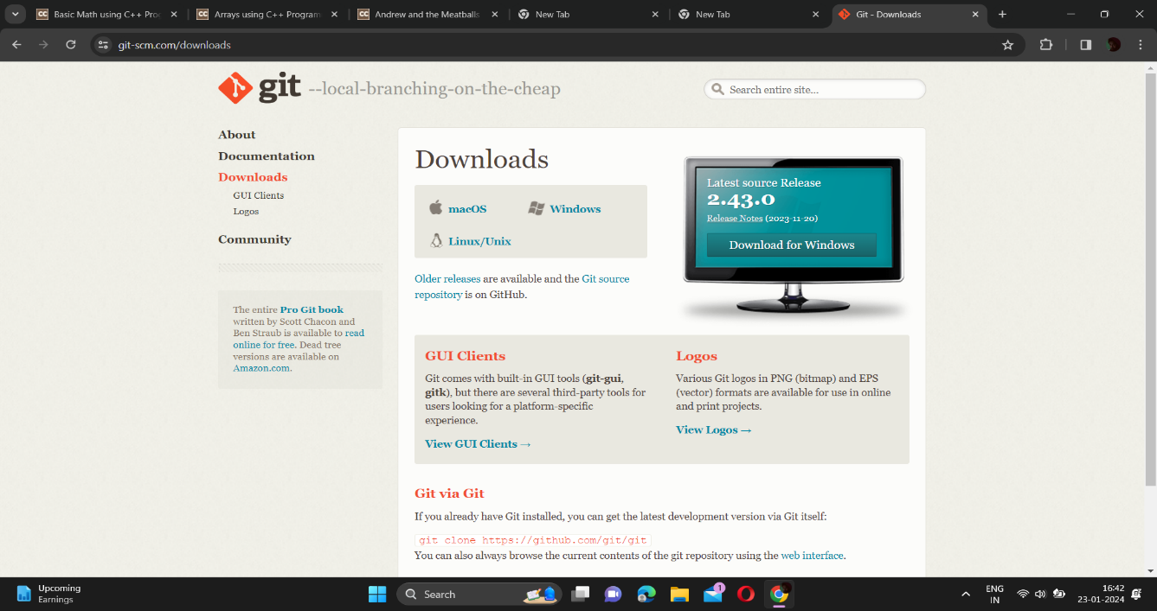

Go to the official Git for Windows website at https://gitforwindows.org/.

1.Download the Installer:

On the website, you'll see a prominent button that says "Download." Click on it to start the download.

2.Run the Installer:

Once the download is complete, run the installer executable file that you just downloaded. The file name typically starts with Git- and includes the version number.

3.Welcome Screen:

The installer will show a welcome screen. Click "Next" to proceed.

4.Select Components:

Choose the components to install. Unless you have a specific reason to change them, the default options are usually fine. Click "Next."

5.Select Destination Location:

Choose the destination folder where Git will be installed. Again, the default location is generally fine for most users. Click "Next."

6.Choosing the Start Menu Folder:

Select the Start Menu folder for Git shortcuts or leave the default. Click "Next."

7.Choosing the Default Editor:

Git needs an editor for commit messages. You can choose an editor; the default is usually Vim. If you're not familiar with Vim, you might prefer to select a different editor, such as Nano or Notepad++. Click "Next."

8.Adjusting Your PATH Environment:

Choose the default option "Use Git from the Windows Command Prompt" to add Git to your system PATH. This is recommended as it makes Git commands available from the command line. Click "Next."

9.Choosing HTTPS transport backend:

Choose the default option "Use the OpenSSL library" for secure connections. Click "Next."

10.Configuring Line Endings:

Choose the default option "Checkout Windows-style, commit Unix-style line endings." Click "Next."

11.Configuring the Terminal Emulator:

Choose the default terminal emulator, usually "MinTTY." Click "Next."

12.Choosing Extra Options:

Optionally, you can choose to enable features like file system caching. Adjust these options based on your preferences. Click "Next."

13.Install:

Click "Install" to start the installation process.

14.Completing the Installation:

Once the installation is complete, click "Finish" to exit the installer.

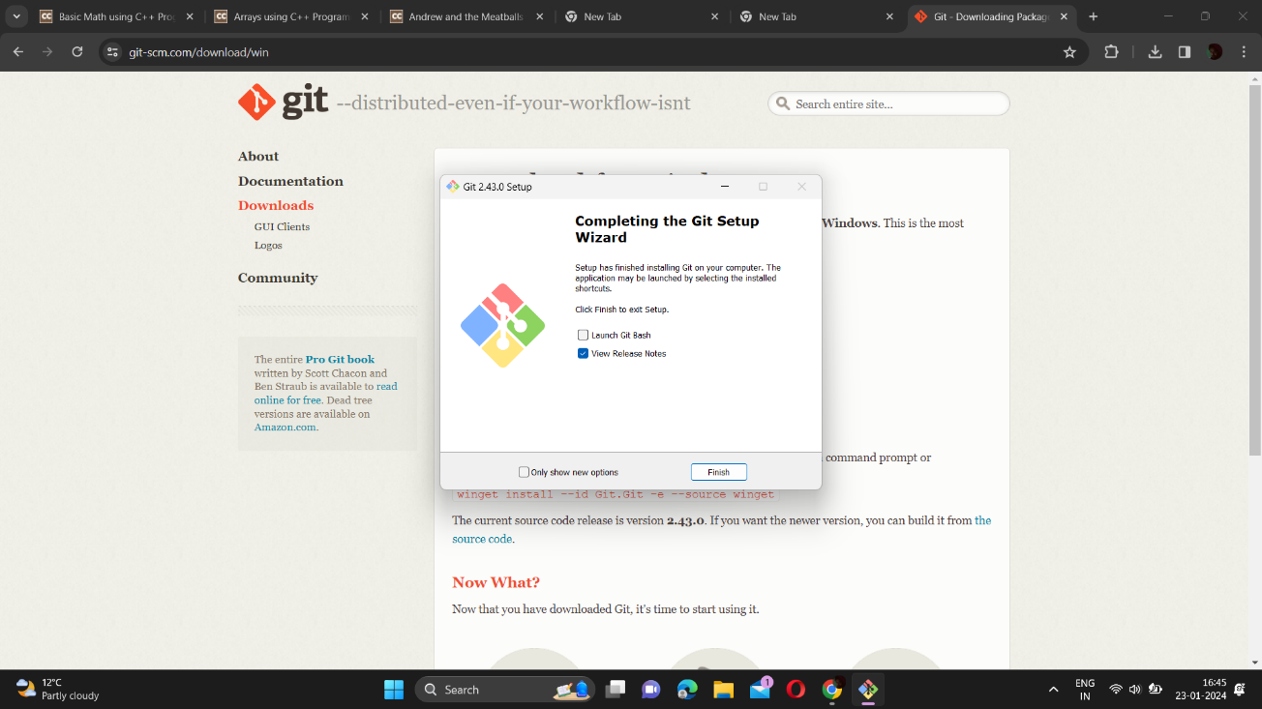

**How to launch git in windows-**

1.Open Git Bash:

Look for "Git Bash" in your Start Menu or search for it.

Alternatively, if you chose the option during installation, you can right-click in a folder and select "Git Bash Here."

2.Launch Git Bash:

After opening Git Bash, you will see a terminal window similar to a Unix/Linux command prompt.

3.Verify Git Installation:

You can verify that Git is installed by typing the following command and pressing Enter:

bash

git --version

This should display the installed Git version.

**Configure GitHub Credentials-**

Configuring GitHub credentials involves setting up your Git configuration to associate your GitHub account with your local Git installation. This typically involves providing your GitHub username and email address. Here are the steps:

1. Open Git Bash or Command Prompt:

Open Git Bash or Command Prompt on your system.

2. Set Your GitHub Username:

Use the following command to set your GitHub username. Replace your_username with your actual GitHub username.

**git config --global user.name "your_username**"

3. Set Your GitHub Email:

Use the following command to set the email associated with your GitHub account. Replace your_email@example.com with your actual GitHub email.

**git config --global user.email "your_email@example.com"**

4. Enable Credential Caching (Optional but Recommended):

Enabling credential caching can help you avoid entering your GitHub password every time you interact with a remote repository. The following command configures Git to use a credential manager:

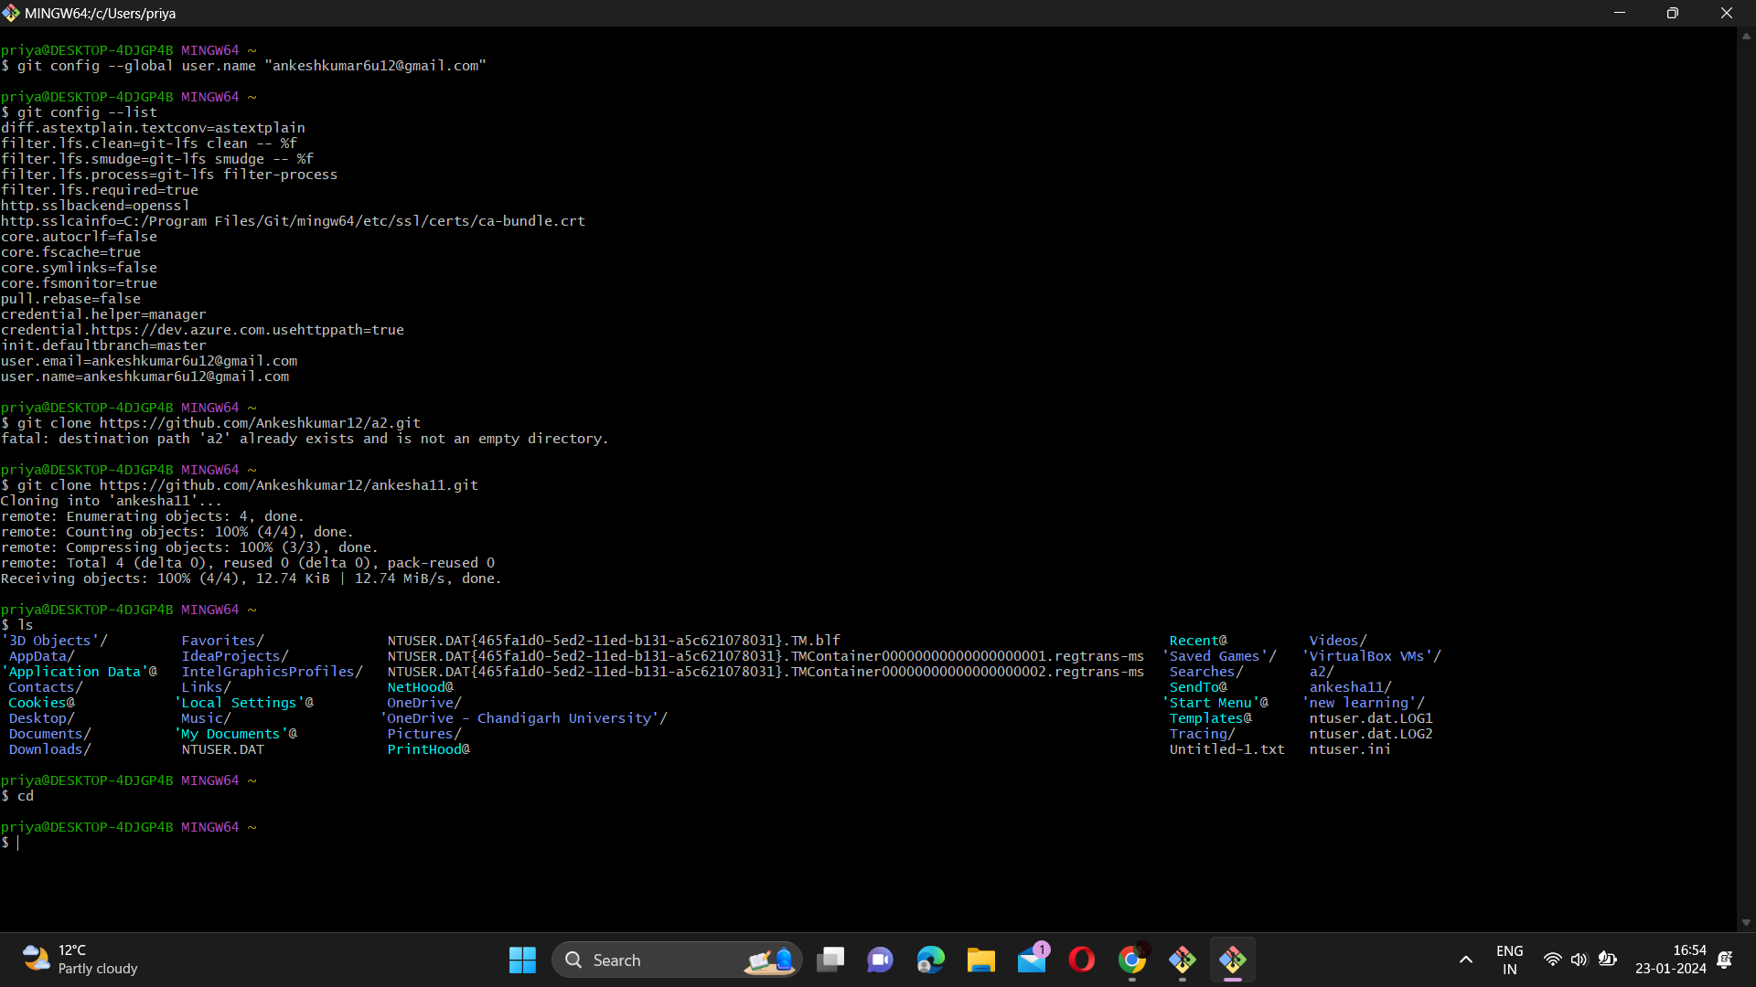

**Create a new repository –**

1.Log in to Your GitHub Account:

Open your web browser and go to GitHub.

Log in to your GitHub account.

2.Navigate to Your Profile:

Once logged in, click on your profile picture in the top right corner of the GitHub homepage. From the dropdown menu, select "Your repositories."

3. on "New" to Create a New Repository:

On the "Your repositories" page, click the green "New" button on the right side.

4.Fill in the Repository Information:

You'll be taken to the "Create a new repository" page.

Enter a name for your repository in the "Repository name" field. Choose a descriptive name related to your project.

Optionally, provide a description for your repository.

Choose whether you want the repository to be public or private. Note that private repositories may require a GitHub subscription.

5.Initialize This Repository with a README (Optional):

You have the option to initialize the repository with a README file. This is useful to provide some initial documentation for your project.

If you want to do this, check the box next to "Initialize this repository with a README."

6.Choose a License (Optional):

You can choose to add a license to your repository. GitHub provides several open-source licenses that you can select. If you're unsure, you can skip this step and add a license later.

Click "Create Repository":

7.Once you've filled in the necessary information, click the green "Create repository" button.

Copy the Repository URL (Optional):

After creating the repository, you'll be redirected to the repository's main page. You can copy the repository URL by clicking on the "Code" button and copying the HTTPS or SSH URL.

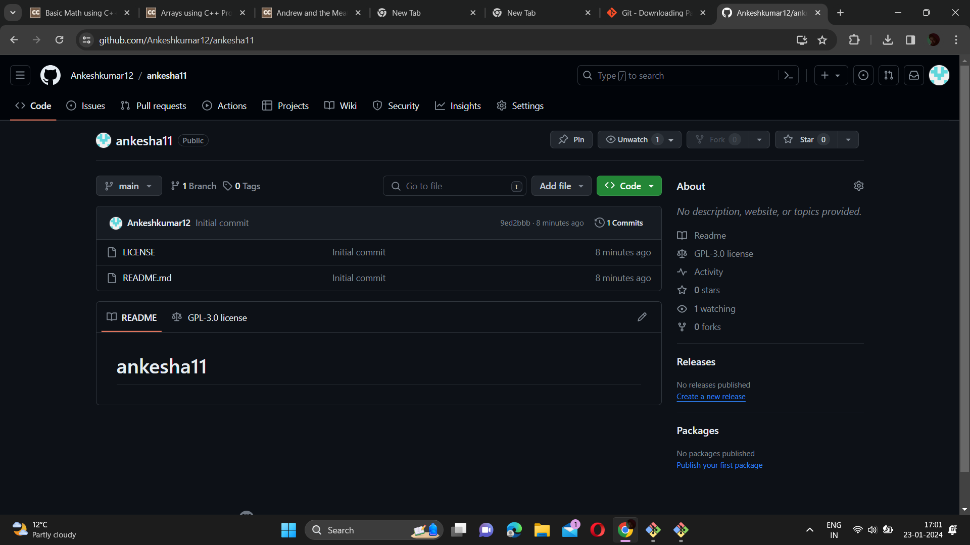

**Learning outcomes (What I have learnt):**

**1.** Learn about GitHub

**2.** Learn about git.

**3.** Learn about various git commands.

**4.** Learn about how to create repositories.

**5.** Learn about how to pull request and push source code.

**Evaluation Grid (To be created as per the SOP and Assessment guidelines by the faculty):**

|  |  |  |  |
| --- | --- | --- | --- |
| Sr. No. | Parameters | Marks Obtained | Maximum Marks |
| 1. |  |  |  |
| 2. |  |  |  |
| 3. |  |  |  |
|  |  |  |  |