**Experiment -1.2**

**Student Name:** Ankesh kumar **UID:**22BDO10014

**Branch:** CSE(DEVOPS**) Section/Group:**22BCD-1/A

**Semester:** 4th **Date of Performance:**23-01-24

**Subject Name:** Git and GitHub **Subject Code:**22CSH-293

**1. Aim/Overview of the practical:** Creating and deleting branches with Github

**2. Task to be done:** making branches with github and commands

**3. steps for experiment: Ensure you are on the main branch:**

* Before creating a new branch, make sure you are on the branch from which you want to branch off. Typically, this is the main or master branch.

**git checkout main**

**git switch main**

* Pull the latest changes:

It's a good practice to ensure you have the latest changes from the remote repository before creating a new branch.

**Git pull origin main**

* Create a new branch

To create a new branch, use the following command:

**git branch <branch-name>**

For example:

**git branch feature-xyz**

* Switch to the new branch:

After creating a branch, switch to it using the checkout or switch command:

**git checkout <branch-name>**

or

**git switch <branch-name>**

In recent versions of Git, you can use a single command to create and switch to a new branch:

**git checkout -b <branch-name>**

or

**git switch -c <branch-name>**

* Make changes and commit:

Start making changes to your code in the new branch. Once you've made some changes, commit them using:

**git add .**

**git commit -m "Your commit message"**

* Push the new branch to the remote repository:

If you want to share your branch with others or work on it from another location, push the branch to the remote repository:

**git push origin <branch-name>**

This command sends your new branch to the remote repository.

* Merge changes back (if needed):

After making and committing changes in your branch, you might want to merge those changes back into the main branch. This is typically done through a pull request or merge request.

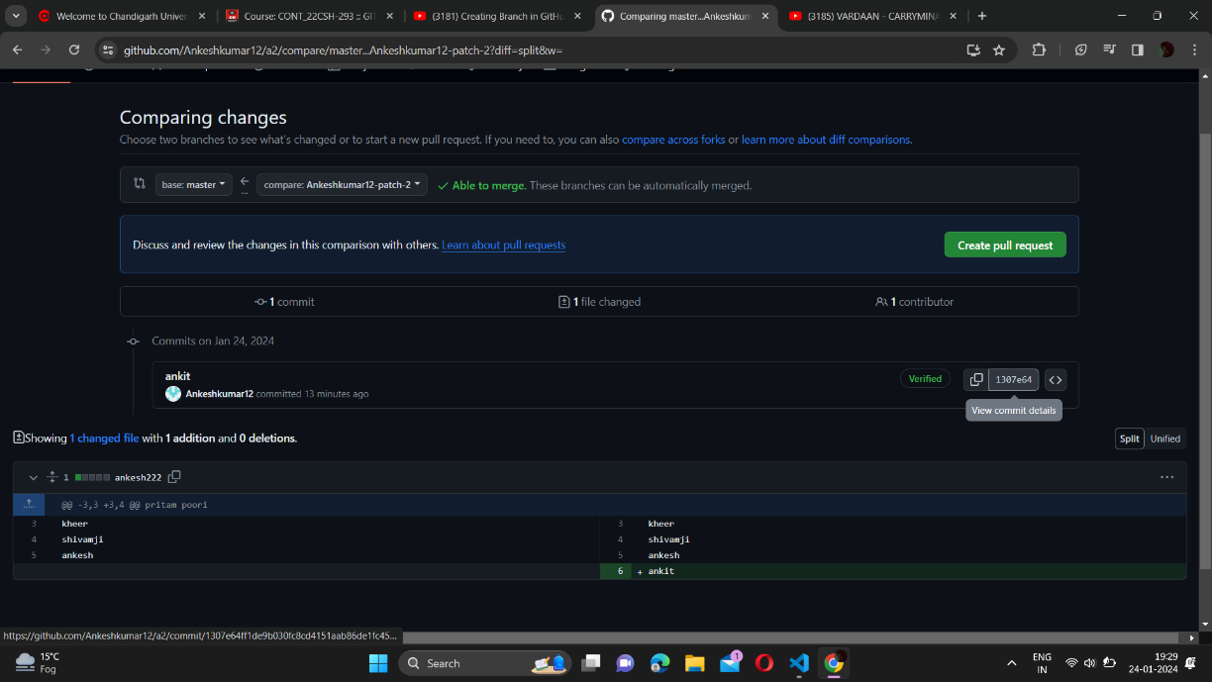

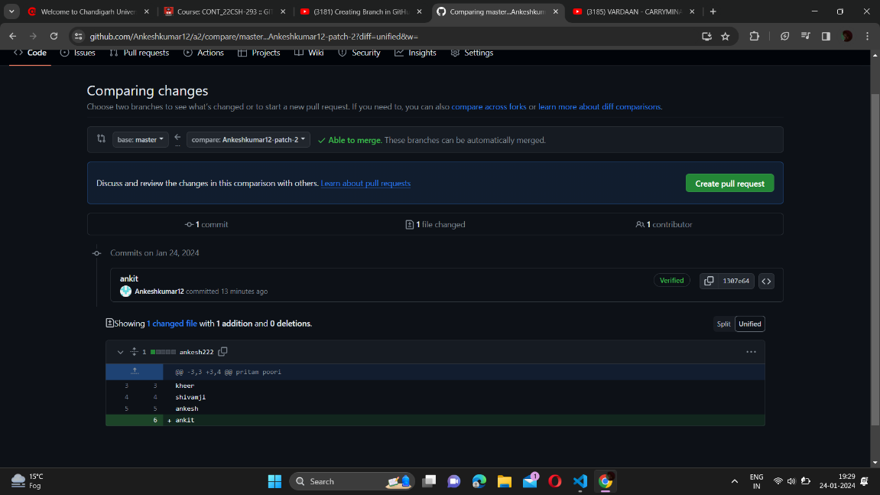

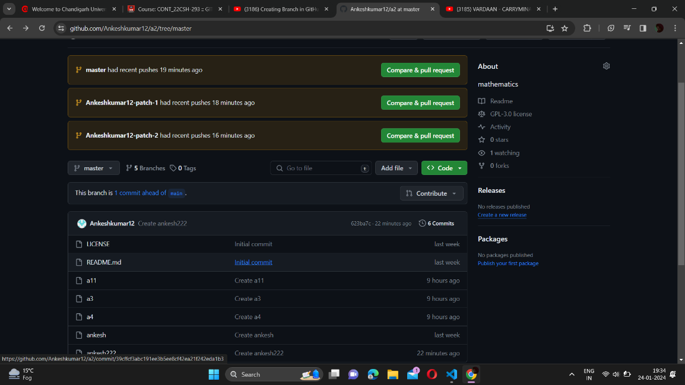

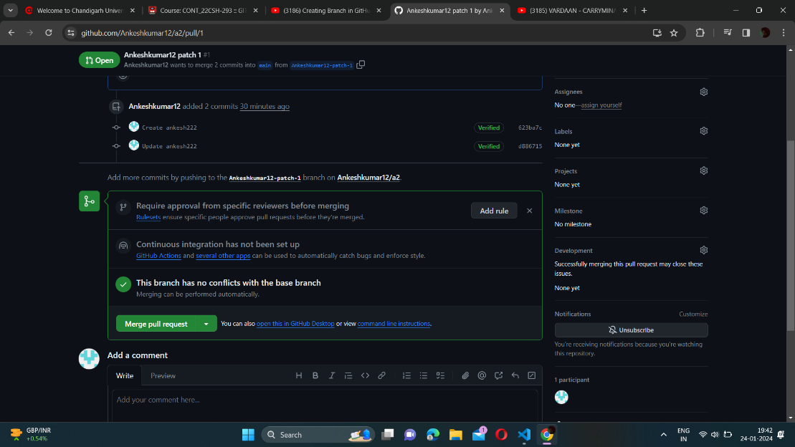

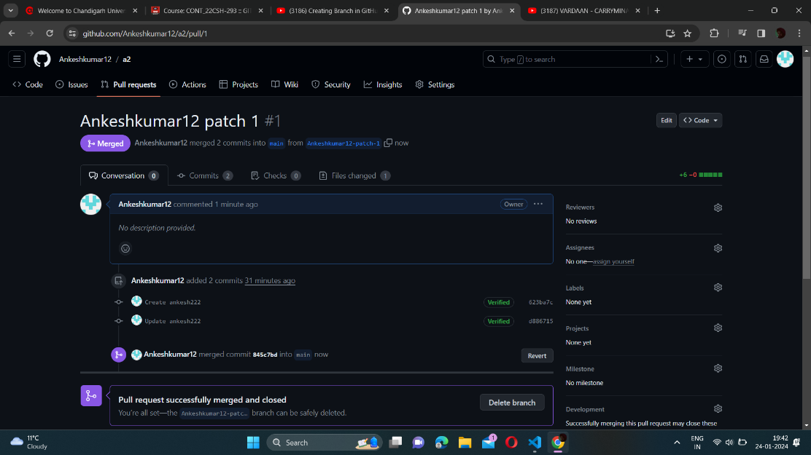

**4. Steps for deleting a branch:**

* Switch to a different branch:

Before deleting a branch, ensure that you are not on the branch you intend to delete. You cannot delete the branch you are currently on.

**git checkout <another-branch>**

or

**git switch <another-branch>**

* Delete the local branch:

To delete a local branch, you can use the -d or -D option with the git branch command.

* Using -d (safe delete, won't delete if changes are not merged):

**git branch -d <branch-name>**

* Using -D (force delete, regardless of merged changes):

**git branch -D <branch-name>**

Replace <branch-name> with the name of the branch you want to delete.

* Delete the remote branch (optional):

If you have pushed your branch to a remote repository and want to delete it there as well, use the following command:

**git push origin --delete <branch-name>**

This will delete the remote branch with the specified name.

Alternatively, you can use the shorthand:

**git push origin :<branch-name>**

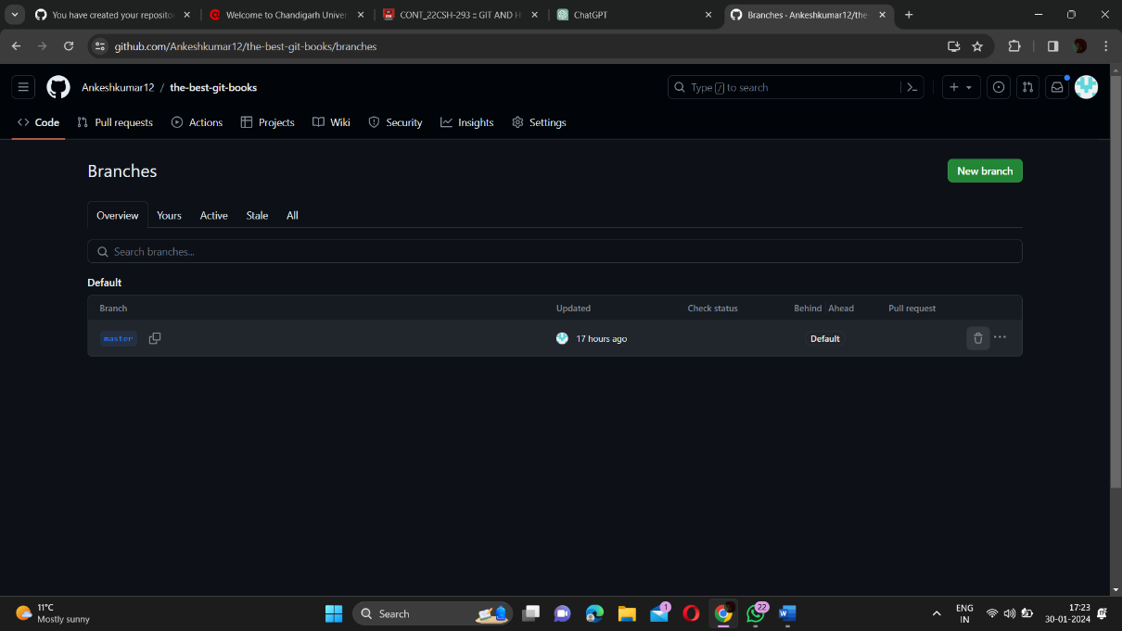

**Various commands:**

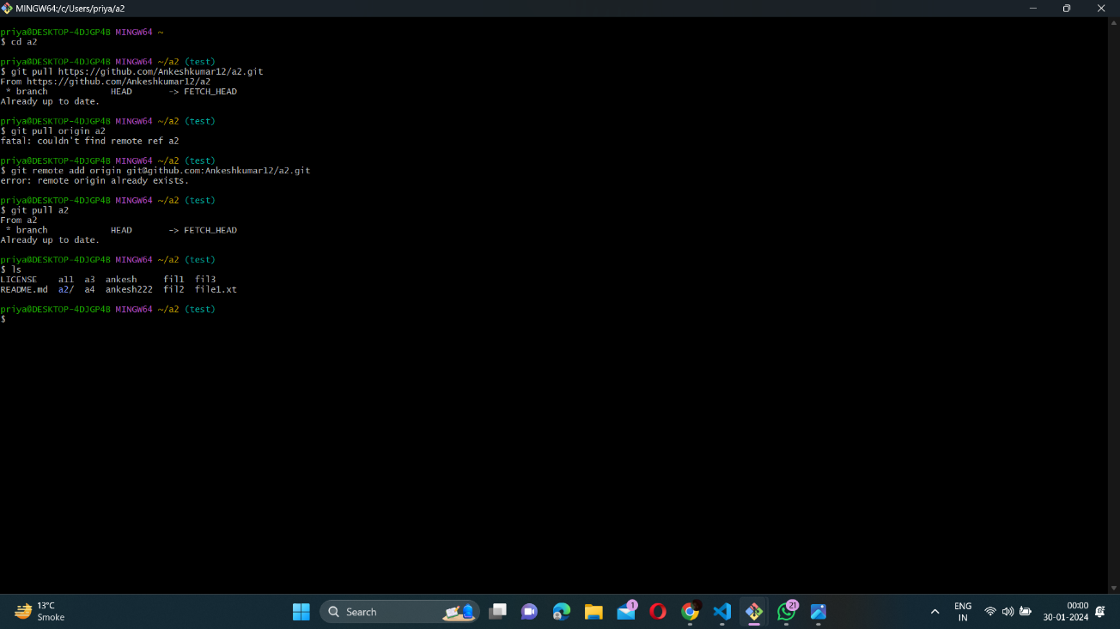

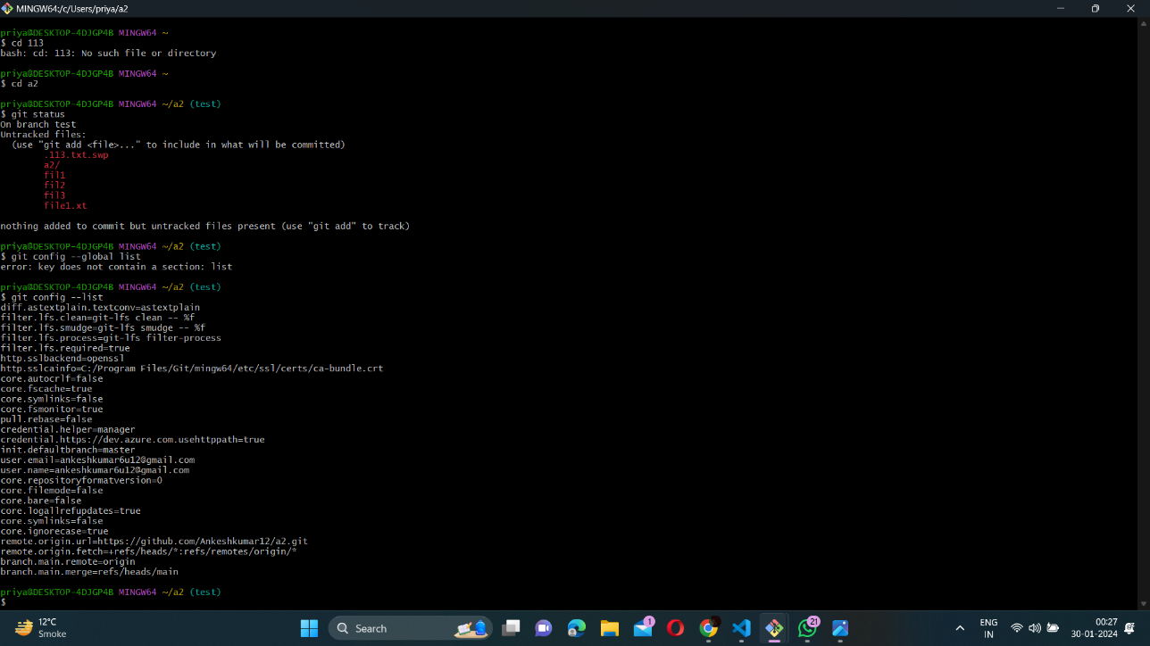

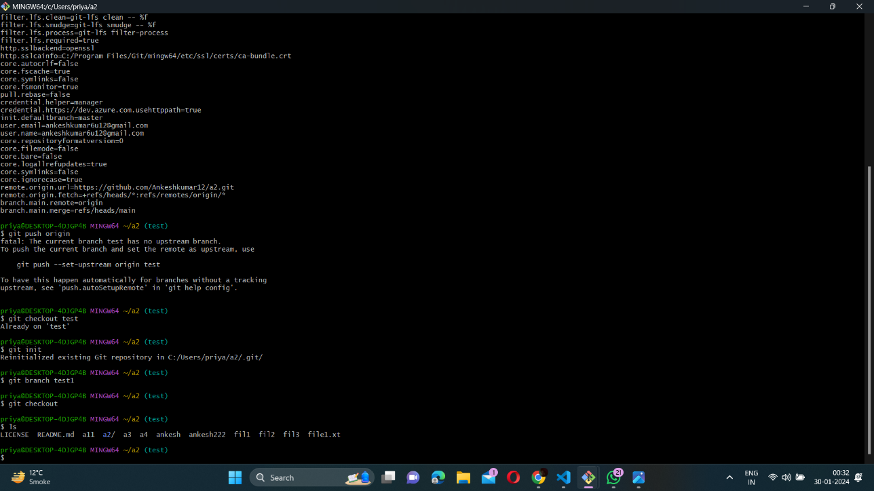

**Learning outcomes (What I have learnt):**

1. Learn about Github

2. Learn about git.

3. Learn about various git commands.

4. Learn about how to create branch.

5. Learn about how to merge and delete branch.

**Evaluation Grid (To be created as per the SOP and Assessment guidelines by the faculty):**

|  |  |  |  |
| --- | --- | --- | --- |
| Sr. No. | Parameters | Marks Obtained | Maximum Marks |
| 1. |  |  |  |
| 2. |  |  |  |
| 3. |  |  |  |
|  |  |  |  |