**Experiment -2.2**

**Student Name:** Ankesh kumar **UID:** 22BDO10014

**Branch:** AIT-CSE(DevOps) **Section/Group**: 22BCD-1/A

**Semester:** 4th **Date of Performance:** 21/01/2024 **Subject Name**: Git and Hub **Subject Code:** 22CSH-293

1. **Aim/Overview of the practical:** To merge pull requests and update local repositories.
2. **Software Used:** Git Bash, GitHub.
3. **Steps for experiment/practical:**
   * Create or clone a repository on your local machine after opening GIT BASH. ❖ Move to the directory using the **cd** command.

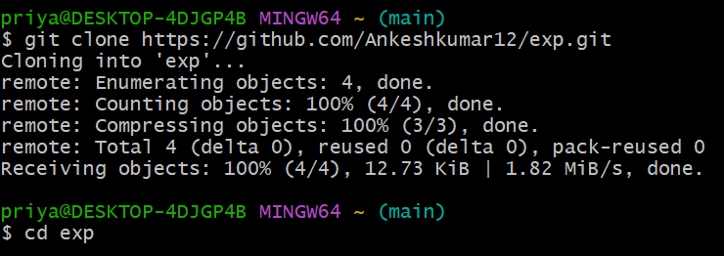

* + Create or open a file in the master or main branch , eg , **file1.c** and add some text to the file.
  + Add the file to the staging area using **git add** and then commit the changes using the **git commit** command **OR** you can use the command **git commit -a -m “<commit_msg>”** or **git commit -am “<commit_msg>”**.

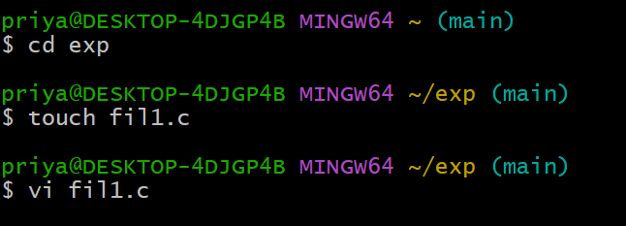

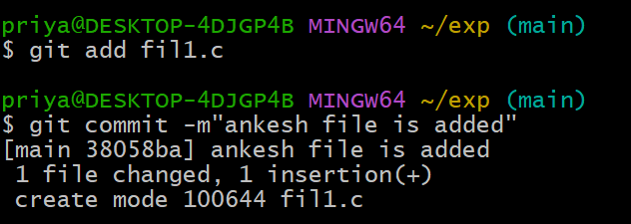

* + Create a new branch and checkout to it using the **git checkout -b** command , eg branch1. ❖ Open the **file1.c** on the **vi** editor and make some changes in it.

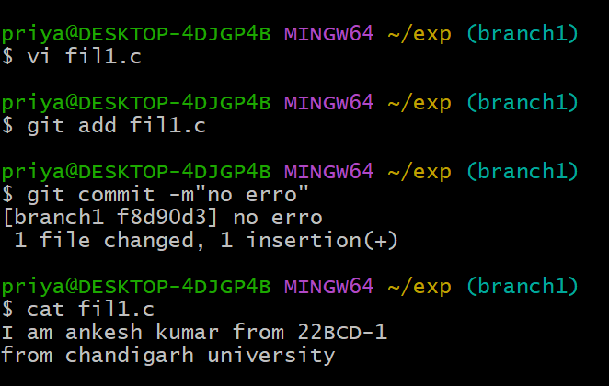

* + Merge the changes made in the **Branch1** branch with the **main** branch and resolve the conflicts manually if necessary using the **git merge** command.

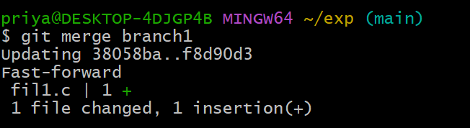

* + Now, Go to github, open the repository and move to the **Branch1** branch and make some changes in a file.

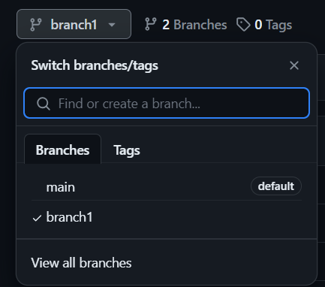

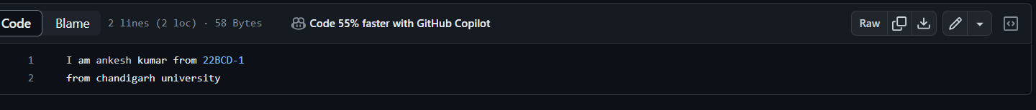

* + Commit the changes and move to the **main** branch. Click on the **Compare & Pull request**.

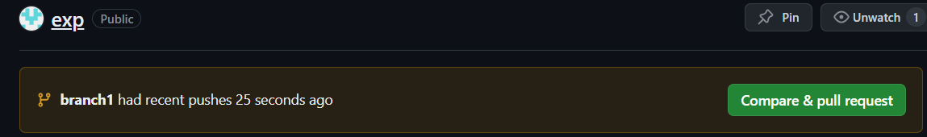

* + **Create the pull request,** resolve the merge conflicts (if any) and then **merge pull request**.

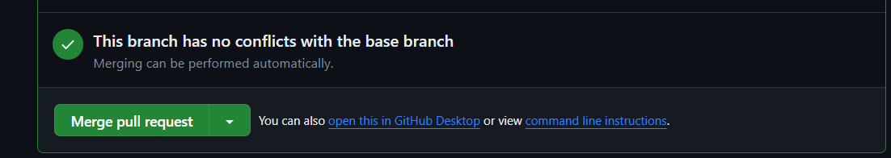

* + After the merging, you may choose to delete your branch , i.e , **Branch1**

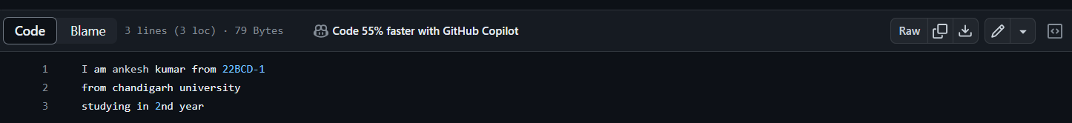

1. **Result/Output/Writing Summary:**

In this experiment, we have merged a file in a branch to the master or main branch on both the local and remote repositories/environment.

**Learning outcomes (What I have learnt):**

* + 1. Learnt how to create a branch.
    2. Learnt how to clone a remote repo to our local system.
    3. Learnt how to create a pull request and handle their merging.
    4. Learnt to merge two branches.
    5. Learnt how to resolve merge conflicts.

**Evaluation Grid (To be created as per the SOP and Assessment guidelines by the faculty):**

|  |  |  |  |
| --- | --- | --- | --- |
| Sr. No. | Parameters | Marks Obtained | Maximum Marks |
| 1. |  |  |  |
| 2. |  |  |  |
| 3. |  |  |  |
|  |  |  |  |