**Experiment -1.3**

**Student Name:** Ankesh kumar **UID:** 22BDO10014

**Branch:** AIT-CSE(DevOps) **Section/Group**: 22BCD-1/A

**Semester:** 4th **Date of Performance:** 31/01/2024 **Subject Name**: Git and gitHub **Subject Code:** 22CSH-293

1. **Aim/Overview of the practical:** To create and explore pull requests.
2. **Software Used:** Git Bash, GitHub.
3. **Steps for experiment/practical:**

* Create or clone a repository on your local machine and open GIT BASH.

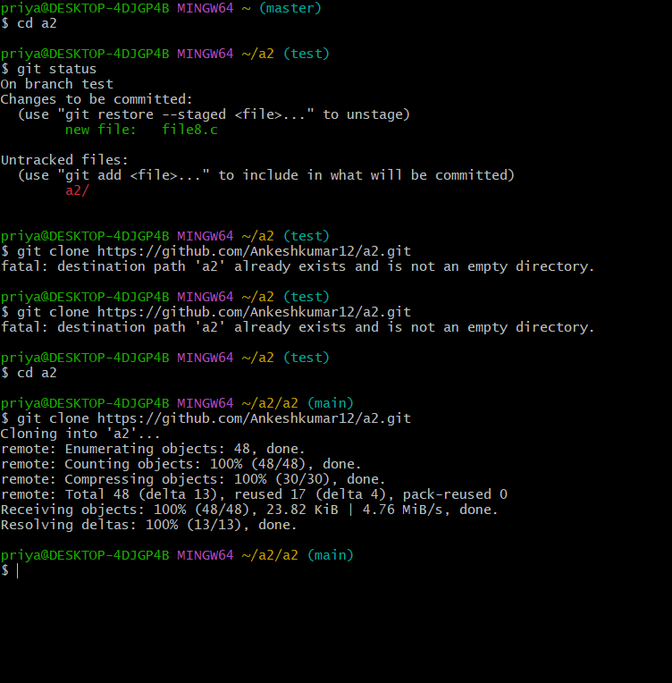

* + Create a file in the master or main branch , eg , **file 6.c** .
  + Add the file to the staging area using **git add** and then commit the changes using the **git commit** command.

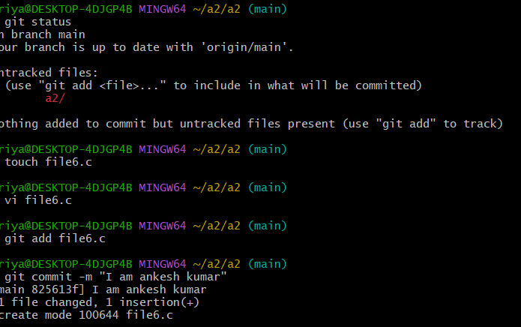

* Create a new branch and checkout to it using the **git checkout -b** command , eg , **test**. Open the **file6.c** and make some changes in it.



( main) (test)

* + Repeat step 4 again.

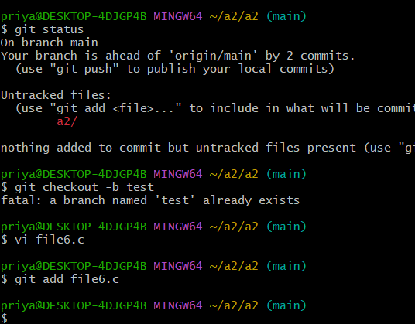

* + Merge the **test** branch in the **master** branch using the **git merge <branch_name>** command and resolve the merge conflict if necessary.

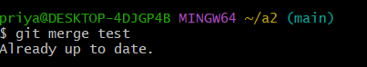

* + Now, push your changes in the **master** and **test** branch to the remote repository.

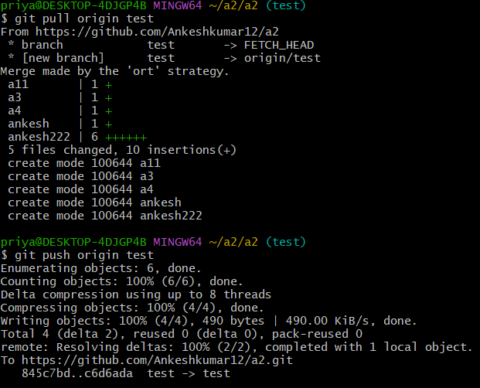

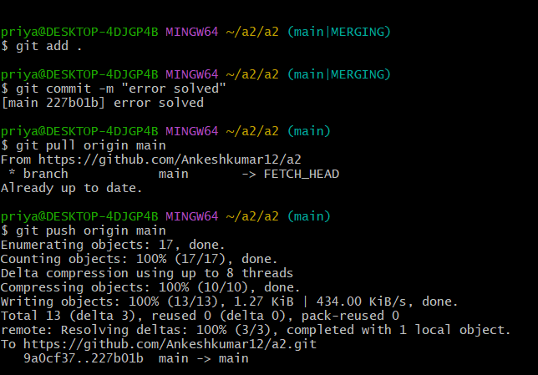

* + Now, Go to github, open the repository and move to the **test** branch and make some changes in a file.
  + Commit the changes and move to the **master** branch. Click on the **Compare & Pull request**.

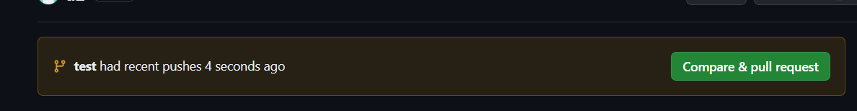

* + **Create the pull request,** resolve the merge conflicts (if any) and then **merge pull request**.

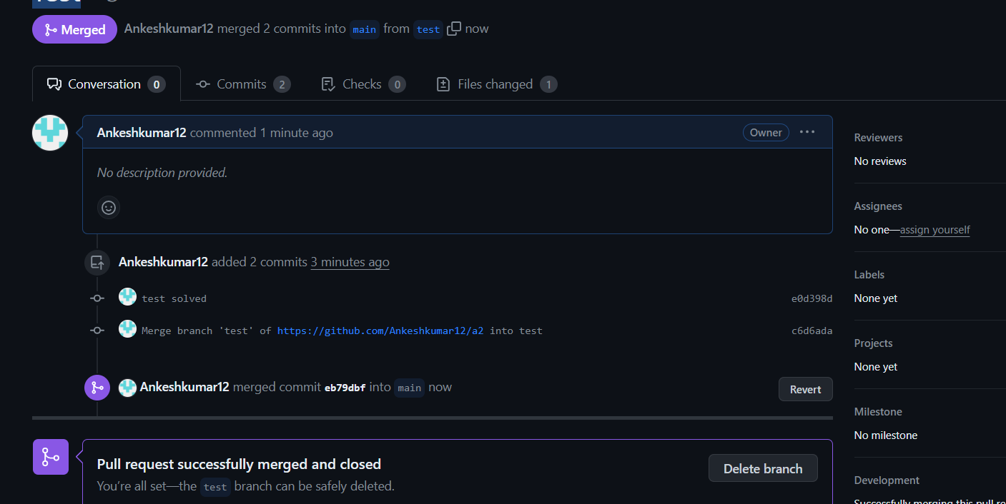

1. **Result/Output/Writing Summary:**

In this experiment, we have created and explored the pull requests. We have created a new branch, made some changes in the files in that new branch and then merged the changes with the main branch by resolving merge conflicts by using both GitHub and Git Bash.

**Learning outcomes (What I have learnt):**

* + 1. Learnt how to create a branch.
    2. Learnt how to push the changes to the remote repository.
    3. Learnt how to pull the changes from the remote repository.
    4. Learnt to merge two branches.
    5. Learnt how to resolve merge conflicts.

**Evaluation Grid (To be created as per the SOP and Assessment guidelines by the faculty):**

|  |  |  |  |
| --- | --- | --- | --- |
| Sr. No. | Parameters | Marks Obtained | Maximum Marks |
| 1. |  |  |  |
| 2. |  |  |  |
| 3. |  |  |  |
|  |  |  |  |