**Assembler Documentation**

**Overview**

In this documentation, we explain the Assembler which processes assembly language input file into machine code and generated two files listing.txt and load.txt.

**Tech Stack**

OpenJDK 18.0.2 and IntelliJ IDEA CE as our IDE.

**File Structure**

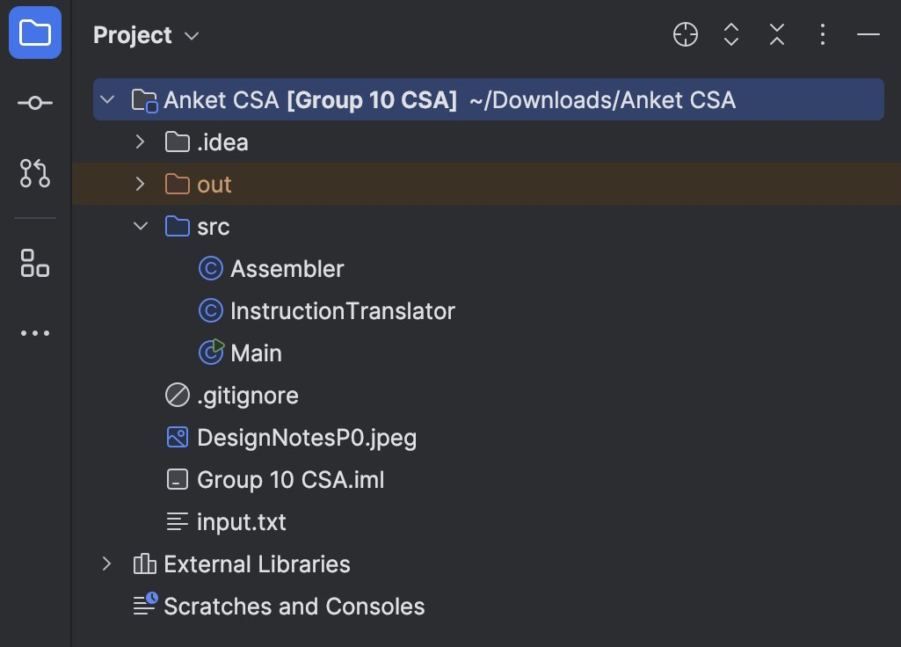

**Main.java** – Main Java file to handle assembler

**Assembler.java –** Source code for Assembler with main functions of assembler

**InstructionTranslator.java –** Processing different instructions and helper functions

**DesignNotesP0.jpeg:** Basic design notes

**Documentation.docx** - Simple documentation on how to unload and run assembler.

**input.txt** - Input file for instructions

**listing.txt** – List of addresses and machine code with additional notes for programmer

**load.txt** - Output file with processes instructions and addresses in octal

**Steps to UNZIP the AssemblerPackage(group6).jar file:**

**Windows Users:**

* Right click the .jar file and select “Extract All” from the drop down menu
* Follow the instructions to select a destination directory and unzip the files.

**MacOS Users:**

* After double-clicking the JAR file, it will be extracted automatically into a folder that shares the same name as the JAR file.

**In Terminal or Command Prompt:**

* Open terminal/command prompt and run the following command:

unzip AssemblerPackage(group6).jar -d destination_folder  
  
or  
  
jar xf "AssemblerPackage(group6).jar"

*\*\* You will need to replace destination_folder with the name of the folder you wish to save the files.*

**Steps to Run the Assembler**

**1. Prepare Your Files**

**Create and save your input.txt file in the same directory**:

* + Begin by making sure the file is located in the identical folder as your Java program or indicate the accurate path in the code.
  + Copy and paste your assembly language instructions into the input.txt file.

**2. Compile the Java Program**

* To compile your Java files when using the command line or terminal, go to the directory where the files are located and run the command given below:  
    
  ***javac Main.java Assembler.java***

This will generate Main.class and Assembler.class

**3. Run the Java program**

* Please execute java command

**java Main**

The instructions/parameters in the input.txt file will be interpreted.

The instructions will be executed using Assembler class

The result will be produced in listing.txt and load.txt files.

**4. Review Output files**

* listing.txt: This file contains a formatted listing of each and every instruction, which comprises of memory addresses and machine codes.

* load.txt: This file will have the machine code along with memory addresses.

**5. Expected Output**

**Conclusion:**