**Tasks**

**Learners have to develop a dashboard to support the answers to the following questions and suggestions for places for newer restaurants.**

**Objective Questions:**

1. What is the total no. of tables present in the data?

Ans:

There are 2 tables present in the data. They are Raw data and Country description.

2.What is the total no. of attributes present in the data?

Ans:

There are 20 attributes present in the data. They are RestaurantID, RestaurantName, CountryCode, City, Address, Locality, LocalityVerbose, Longitude, Latitude, Cuisines, Currency, Has_Table_booking, Has_Online_delivery, Is_delivering_now, Switch_to_order_menu, Price_range, Votes, Average_Cost_for_two, Rating, Datekey_Opening.

3.How many categorical columns are there in the data? [Search about categorical and continuous data, and try to answer this question]

Ans:

Categorical columns means countable, distinct and categorical values. There are 15 categorical columns in the data i.e. RestaurantID, Restaurant Name, CountryCode, City, Address, Locality, Locality Verbose, Cuisines, Currency, Has_Table_booking, Has_Online_delivery, Is_delivering_now, Switch_to_order_menu and Rating.

4.The data consists of some inconsistent and missing values so ensure that the data used for further analysis is cleaned.

Ans:

Yes, found few blank cells in Cuisines column, however filled the cells with the upward/nearby data assuming that similar restaurants in the same area may offer the same cuisines.

5.Using the LookUp functions, fill up the countries in the original data using the country code.

Ans:

There is a column named country code in the Raw Data sheet and the country names in the country description sheet. Hence to fill up the countries in the original data using the country code. I have used VLOOKUP function:

=VLOOKUP(C2,'country description'!$A$1:$B$16,2,0)

6.Create a table to represent the number of restaurants opened in each country.

Ans:

Table was created by using the Pivot Table where Country is in Row, Restaurant ID in Values and Summarized value as Count.

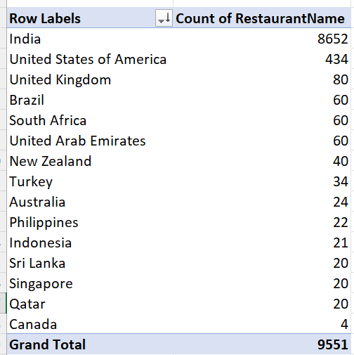

7. Also, the management wants to look at the number of restaurants opened each year, so provide them with something here.

Ans:

Created table by using Pivot Table where Year is in Row and Restaurant ID in Values and Summarized value as Count.

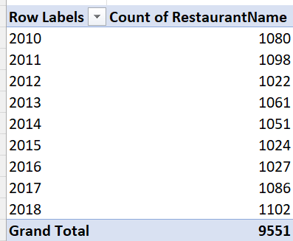

8.What is the total number of restaurants in India in the price range of 4?

Ans:

To find total number of restaurants in India in the price range of 4. I have used COUNTIFS formula:

=COUNTIFS(Table3[Country],"India",Table3[Price_range],"4")

=388

9.What is the average number of voters for the restaurants in each country according to the data?

Ans:

Below table was created by using the Pivot Table where Country is in Row and Votes in Values and Summarized values as Average.

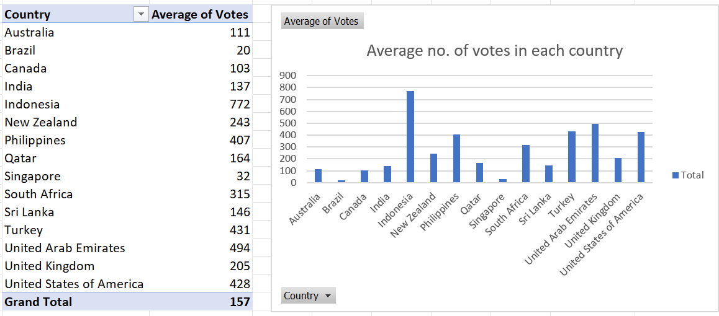

10.Calculate the average rating for all the restaurants that have price_range < 4 and provide online delivery. Use only the “IF” function, Logical Operators, and Aggregation functions to solve this problem. [Note: Don’t use Conditional aggregation in this question.]

Ans:

I have created a Filtered rating column to find the ratings of all the restaurants that have price_range <4 and provide online delivery i.e. =IF(AND([@[Price_range]]<4,[@[Has_Online_delivery]]="yes"),[@Rating]," ")

after that used average formula to calculate the average ratings of all the restaurants i.e.

=AVERAGE (Table3[Filtered ratings])

= 3

11.Using Conditional formatting highlight the rows of restaurants that are located in the countries or cities that you’ve suggested to the management for opening new restaurants.

Ans:

Conditional formatting 🡪 Manage Rules🡪cells that contain the formula🡪 =OR($D1="Australia",$D1="Canada",$D1="Qatar",$D1="Singapore",$D1="Sri Lanka")

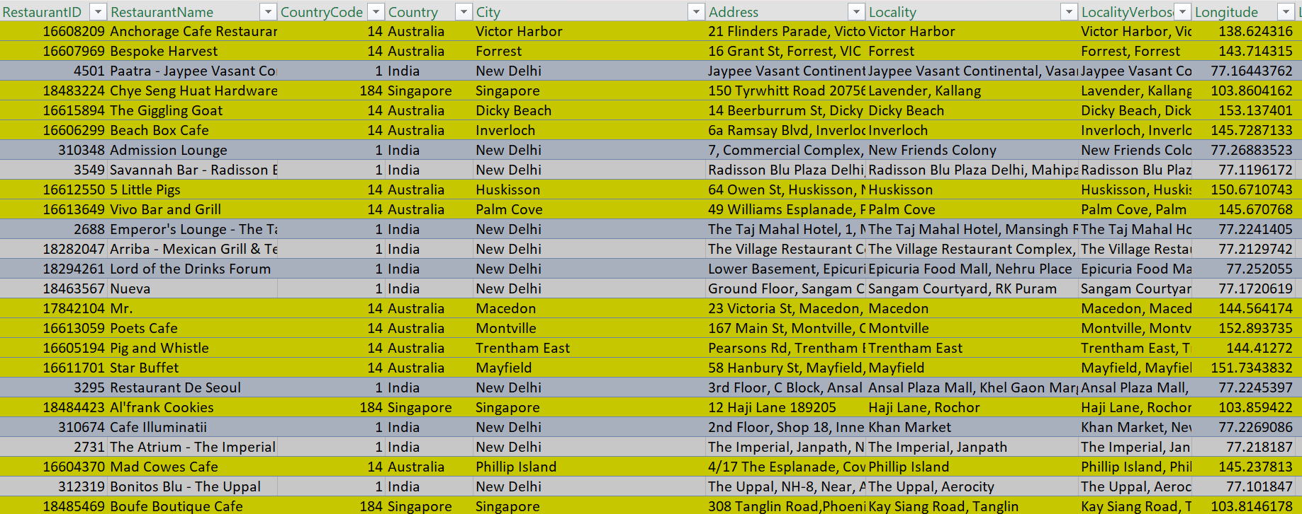

12.Create a new customized price column that consists of the abbreviation/symbol of the currency along with the Average_cost_for_two value. [Use string operations to do this task]

Ans:

Created new price column with currency abbreviation/symbol by using string operations as below:

=MID(L2, FIND("(", L2)+1, FIND(")", L2)-FIND("(", L2)-1) & " " & S2

Where L = Currency Column and S = Average_Cost_for_two Column.

In order to extract the values between the brackets of the currency column we used MID (L2, FIND("(", L2)+1, FIND(")", L2)-FIND("(", L2)-1)

and to concatenate used & " " & S2

13.How can you create an array formula in Excel or Google Sheets to count the number of restaurants listed that do not offer online delivery, are in the lowest price range, and have an average cost for two people less than or equal to 250 Indian Rupees?

Ans: {=SUMPRODUCT((Table3[Country]="India")*(Table3[Average_Cost_for_two]<=250)*(Table3[Has_Online_delivery]="No")*(Table3[Price_range]=1))}

=1685

**Subjective Question:**

1.Suggest a few countries where the team can open newer restaurants with lesser competition. Which visualization/technique will you use here to justify the suggestions?

Ans:

**Insights:**

By analyzing the number of restaurants and their ratings, we can find countries with fewer restaurants but high ratings. These countries represent emerging markets with high demand.

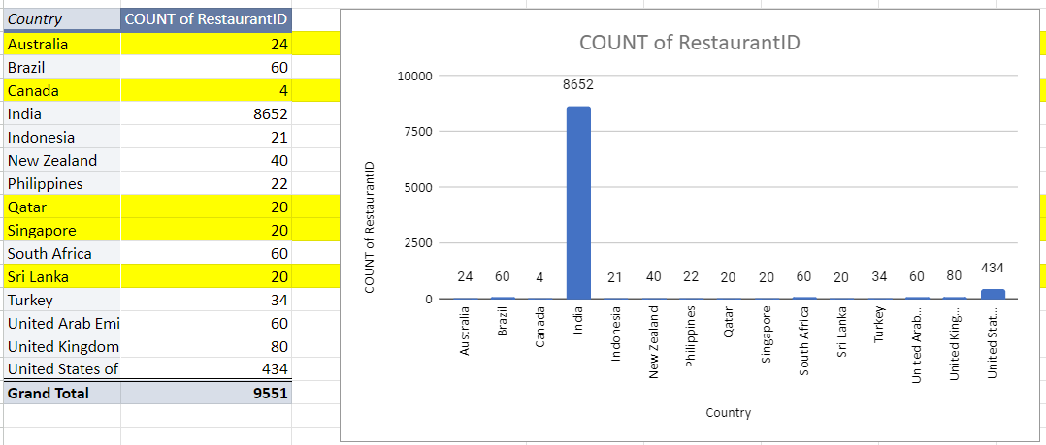

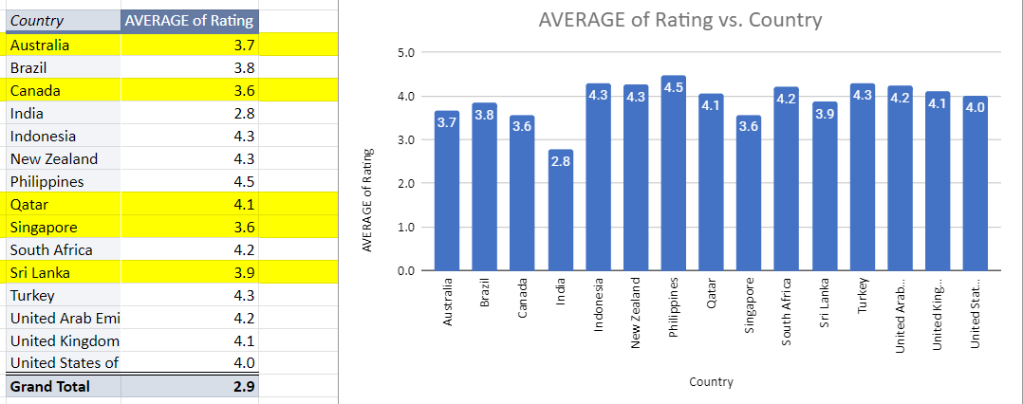

**Recommendation:**

Based on the number of restaurants and average ratings, I would suggest to those country with a low number of restaurants however with good average ratings i.e. **Australia, Canada, Qatar, Singapore and Sri Lanka.**

2.Come up with the names of States and cities in the suggested countries suitable for opening restaurants.

Ans:

**Insights:**

The suggested countries for expansion are **Australia**, **Canada** , **Qatar, Sri Lanka** and **Singapore** and to identify the cities in suggested countries, I would consider the no. of restaurants opened, average of rating and average cost for two(INR).

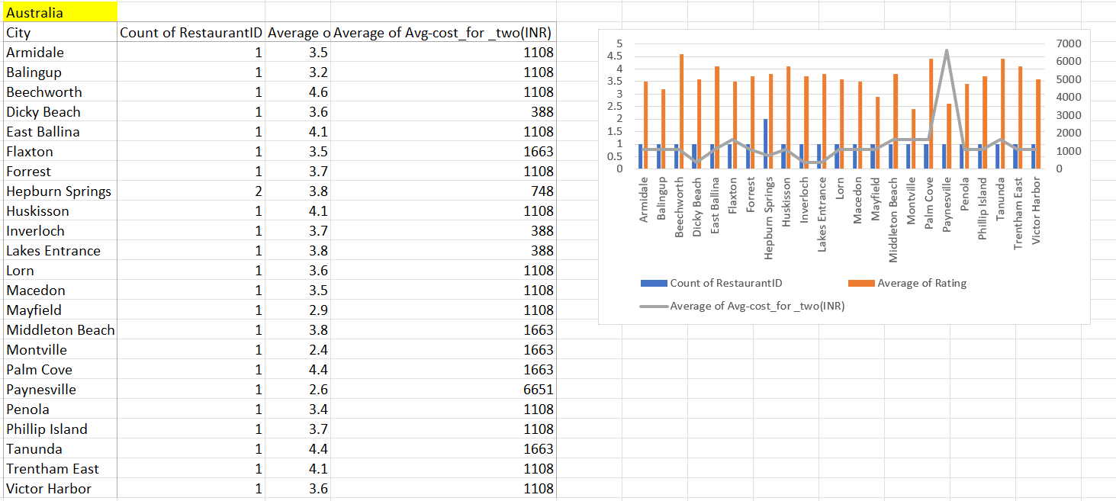

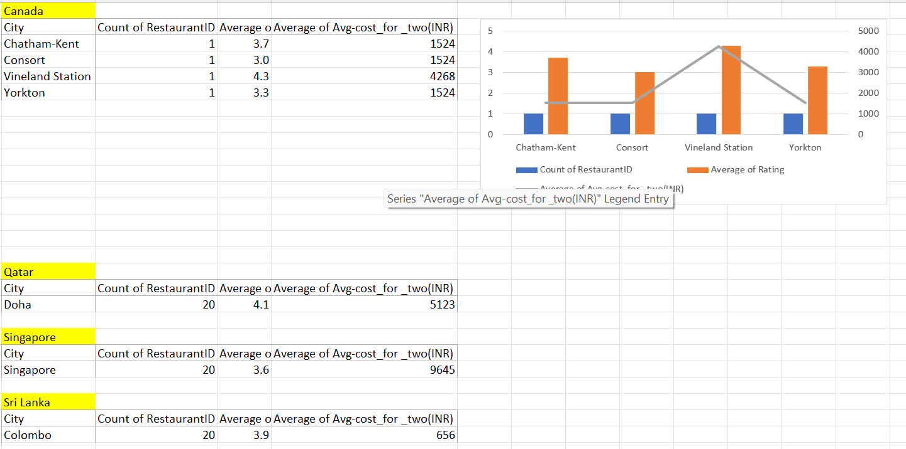

**Recommendation:**

Base on cities with lower competition and higher rating along with moderate affordable avg cost for two, the cities with opportunities in **Australia - Armidale, Balingup, Beechworth, Dicky Beach, East Ballina, Forrest, Hepburn Springs, Huskisson, Inverloch, Lakes Entrance, Lorn, Macedon, Phillip Island, Trentham East and Victor Harbor.**

**Canada - Chatham-Kent, Consort and Yorkton**

**Qatar – Doha**

**Singapore – Singapore**

**Sri Lanka - Colombo**

3.According to the countries you suggested, what is the current quality regarding ratings for restaurants that are open there?

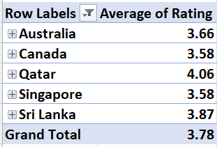

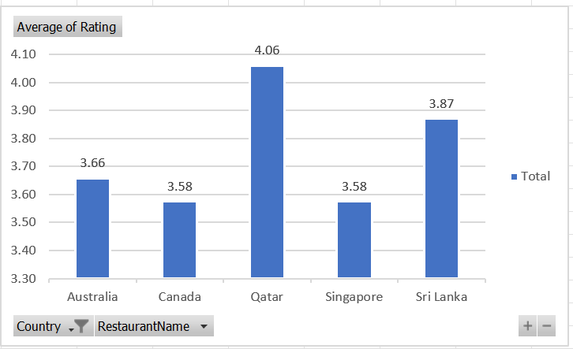

**Recommendation:**

Qatar and Sri Lanka with top priorities for restaurant expansion due to their strong ratings and positive customer. However, countries like Australia, Canada and Singapore presents a market entry opportunity due to lower customer satisfaction scores, suggesting a gap in the quality of dining experiences.

4.Also, what is the current expenditure on food in the suggested countries, so we can keep our financial expenditure in control?

Ans:

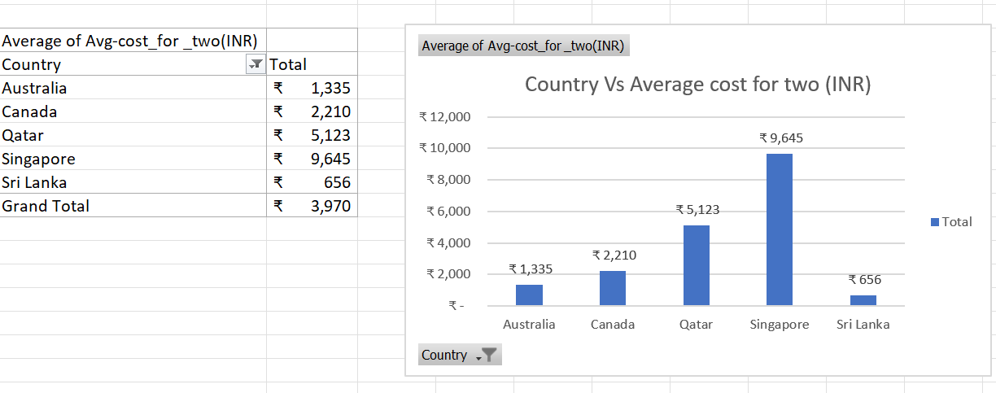

**Insights:**

Based on the expenditure on food in the suggested countries, we can prioritize value and quality to balance customer satisfaction with financial control.

5.Come up with the names of restaurants from the recommended states that are our biggest competitors and also those that are rated in the lower brackets, i.e. 1-2 or 2-3.

Ans:

Create a Pivot table and add Country, Restaurant Name in Rows and Rating in values and summarise by average function and at last add filters on Country and select suggested 5 countries only i.e. (Australia, Canada, Qatar, Singapore and Sri Lanka) and on Rating select in the range of 4-5

Below are the names of restaurants from the recommended states i.e. Australia, Canada, Qatar, Singapore and Sri Lanka that are our biggest competitors.

|  |  |
| --- | --- |
| **Restaurants** | **Average of Rating** |
| 1918 Bistro & Grill | 4.4 |
| Bridge Road Brewers | 4.6 |
| Vivo Bar and Grill | 4.4 |
| Gymkhana | 4.7 |
| Mainland China Restaurant | 4.9 |
| Paper Moon | 4.5 |
| Vine - The St. Regis | 4.4 |
| Zaffran Dining Experience | 4.6 |
| Ministry of Crab | 4.9 |
| Simply Strawberries By Jagro | 4.5 |

The rating for the restaurants lies in the range of 2-3 are

|  |  |
| --- | --- |
| **Restaurants** | **Average of Rating** |
| Pier 70 | 2.6 |
| Poets Cafe | 2.4 |
| Star Buffet | 2.9 |
| Elite Indian Restaurant | 2.4 |
| Queen's Cafe | 2.5 |

**Recommendation:**

By competing with top-rated restaurants and improving lower-rated ones with top cuisines will lead to restaurants better performance and customers satisfaction.

6.Which cuisines should we focus on in the newer restaurants to get better feedback? Does the choice of cuisines affect the restaurant ratings?

Ans:

**Recommendation:**

To get better feedback, need to focus on top cuisines with higher ratings i.e. Tapas, North Indian, Chinese, Mediterranean, Italian, Bakery, Continental, American, BBQ, Sandwich, Steak, American, Burger, Grill, Hawaiian, Seafood etc. Also, we can see cuisines diversity in the suggested countries which reflects cultural and local preferences, as outlined below:

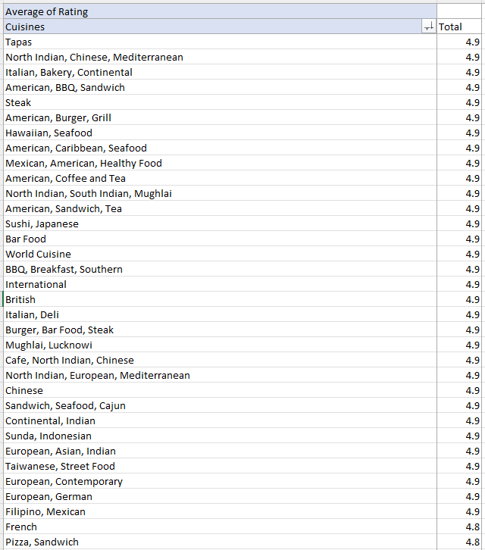

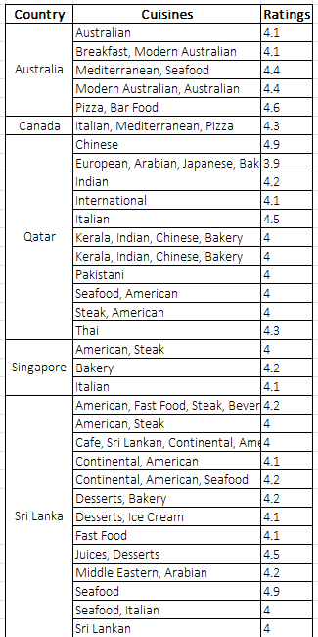

Yes selecting popular, cultural and authentic cuisines positively influence restaurant ratings and customer feedback in new markets.

7.According to our current data, should we go for online delivery and table booking? Does that affect the customer’s ratings?

Ans:

**Insights:**

I have taken the rating bucket corresponding to the number of restaurants for table booking and online delivery

This reflects the total bookings were 9551

Out of these table bookings were 1158 which is 12%

Online booking was 2451 which is 26%.

Therefore, online bookings are over twice to table bookings.

**Recommendation:**

Focus on improving and expanding the online booking system by including the mobile app development or integration with popular platforms.

Also, majority of the people do not engage in either of them. Hence by gathering feedback from customers for both to optimise booking process.

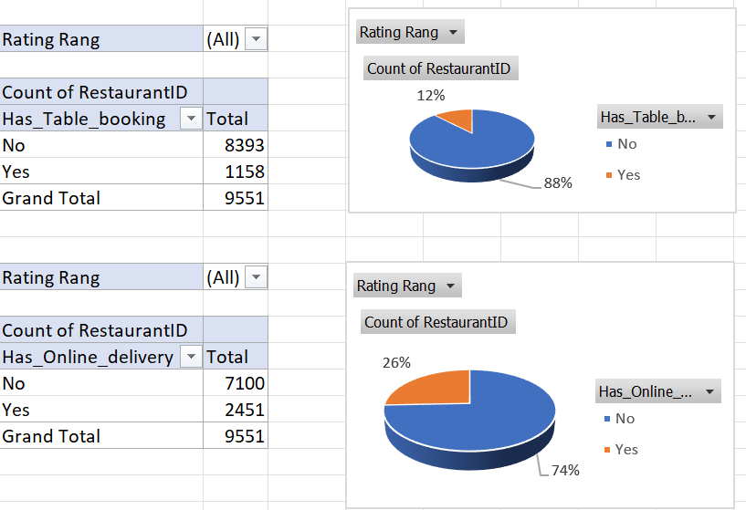

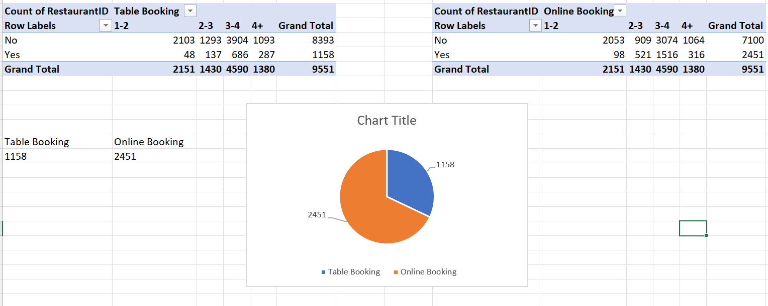

8.Should the team keep the rate of cuisines higher? Will that affect the feedback? According to our data are the rates of cuisines and ratings, correlated?

Ans: Prices of the cuisines are not proportional to the ratings.

= CORREL(B7:B57,C7:C57)

= 0.16494

Based on the correlation of **0.16494** between cuisine rates and ratings, the relationship is weakly positive, meaning that increasing cuisine rates slightly correlates with higher ratings. However, the relationship is not strong enough to conclude that simply raising prices will consistently lead to better ratings.

9.What is the distribution of the number of restaurants of different price ranges in all the countries?

Ans:

**Insights:**

The number of restaurants opened in different price range are outlined below:

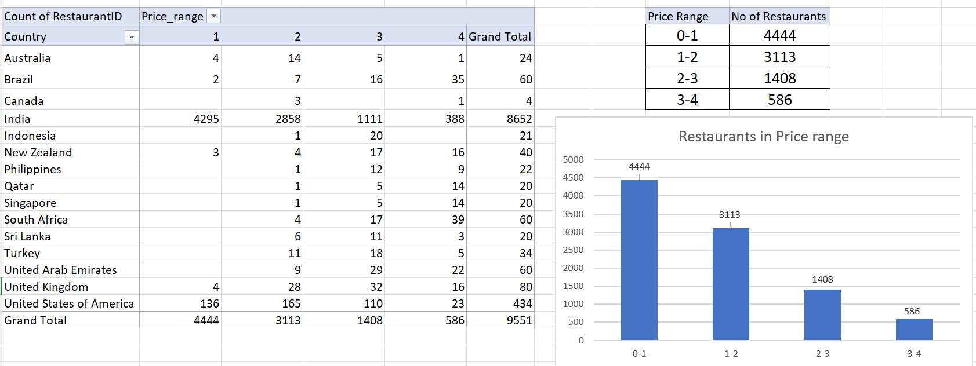

Recommendation:

The largest number of 4,444 and 3313 restaurants are fall under the low price range, which shows a high demand for affordable dining options.

While high-end segment with only 586 restaurants indicates a smaller customer base willing to pay premium prices for luxury dining experiences.

10.Explain your approach in brief for suggesting countries/cities in order to open new restaurants, if the objective and subjective questions would have not been given to assist you. [you have to give bullet pointers in order to answer this question]

* Countries or cities with lesser restaurants and average ratings between 3 and 4 present opportunities for new restaurant openings
* Identify the count of restaurants in different countries/cities growth per year to understand market trends.
* Study customer expectations and local preferences to make informed decisions on pricing
* Identifying the top-performing cuisines and tailoring the new restaurants menu accordingly
* Compare customer ratings with online delivery and table booking services to prioritize or improve based on customer satisfaction trends
* Estimate price range distributions based on countries and consumer spending behaviour
* Identify the corelation between cuisine rates and ratings to make informed decisions about pricing strategies and customer satisfaction
* Analysed the above points by using pivot tables and visualizations such as bar charts, line graphs, scatter plots and pie charts.

The dashboard must consist of Year-wise and country slicers.