# Melanoma Skin Cancer Detection

**Problem statement:**

To build a CNN based model which can accurately detect melanoma.

Melanoma is a type of cancer that can be deadly if not detected early. It accounts for 75% of skin cancer deaths. A solution which can evaluate images and alert the dermatologists about the presence of melanoma has the potential to reduce a lot of manual effort needed in diagnosis.

Below are the different Types of skin cancer with one example

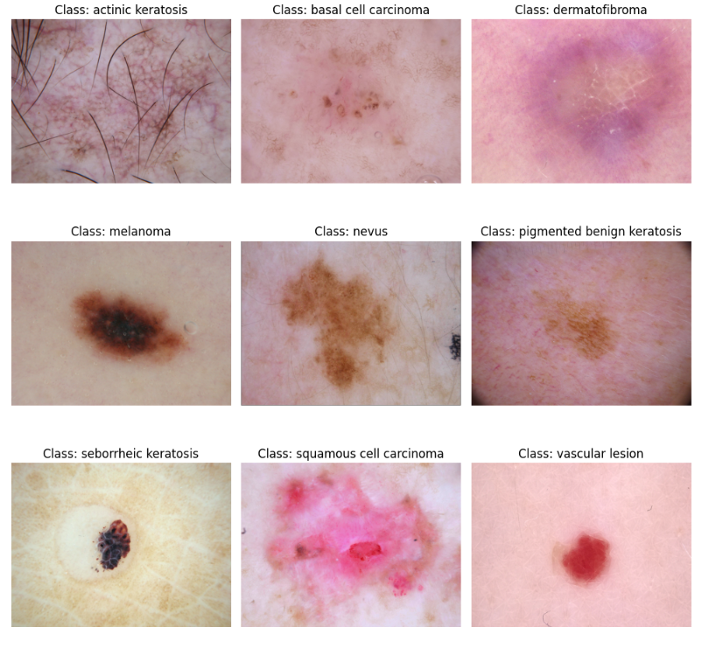

**Model 1 – Basic model**

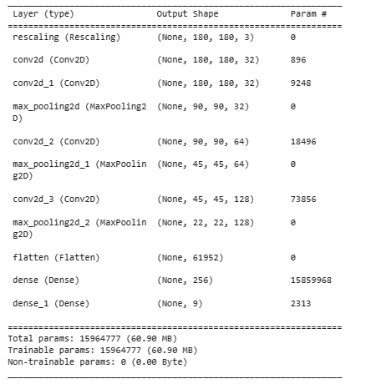

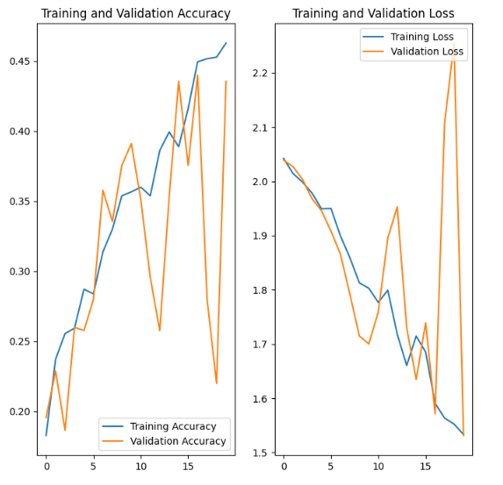

Observation :-

* It is observed that validation accuracy is fluctuating alot indicating that the model is highly overfitted

**Model 2 – Data augumentation strategy and drop out layer to handle overfitting**

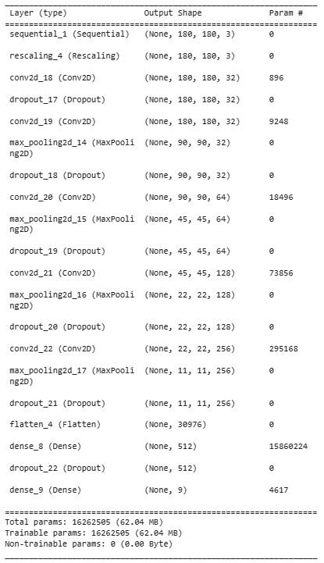

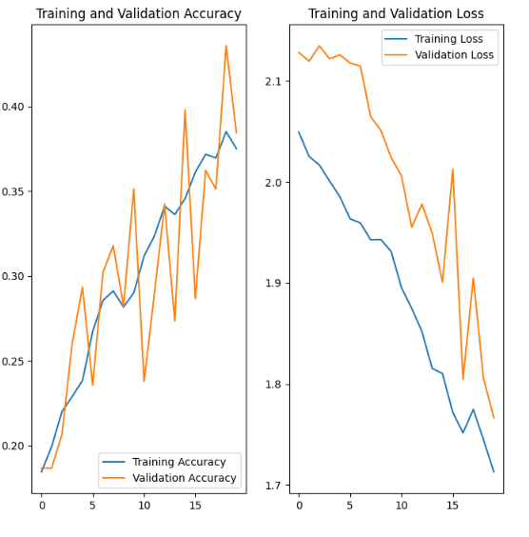

Observation :-

* Still there is some overfitting
* Accuracy need to be improved

**Model 3 – Handle class imbalance**

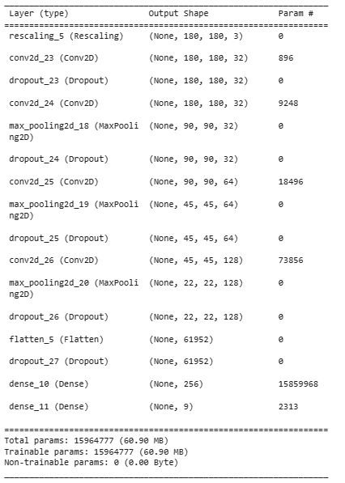

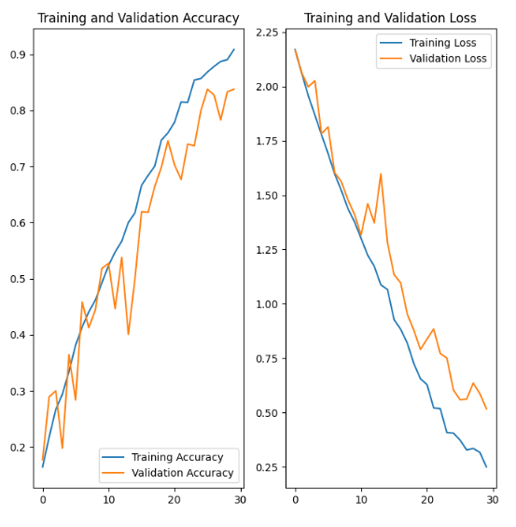

Observation –

* Overfitting has been reduced to great extend
* Accuracy of train data is around 90% and accuracy of validation data is 83%

**Questions**

1. Which class has the least number of samples?

Seborrheic keratosis has the least number of samples – 77

1. Which classes dominate the data in terms proportionate number of samples?

Pigmented benign keratosis and melanoma dominate the data in terms proportionate number of samples