**Wordpress data stored using SQL Server**

* WordPress is a product for managing content like blogs
* Deploying WordPress in a container
  + 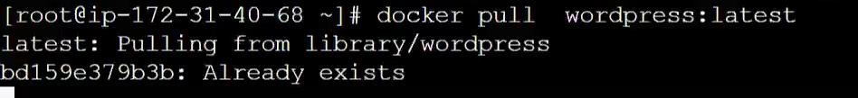Pulling WordPress image
* WordPress store its data in the MY-SQL database
* Almost in all the applications if a user connects the application and creates a post it gets stored in the database
* If a user connects to a web app and stores the data in a database this kind of architecture is known as Three-tier architecture

USER → WebApp → Database

* WordPress needs a database to store the data of blogs
* 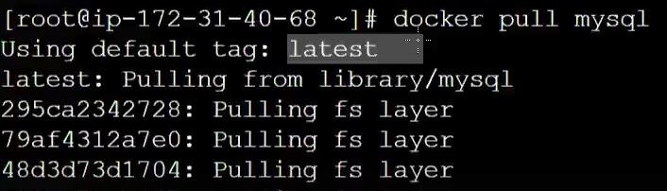Pulling MY-SQL image
* First, we have to launch My-SQL then WordPress
* 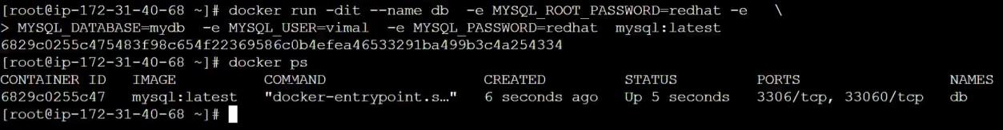Launching MY-SQL database in a container
* A container is by default isolated i.e. it does not have connectivity with the outside world
* Patting is done to expose the container to the outside world
* Word Press is written in the PHP language
* Launching WordPress in a container

• 

* 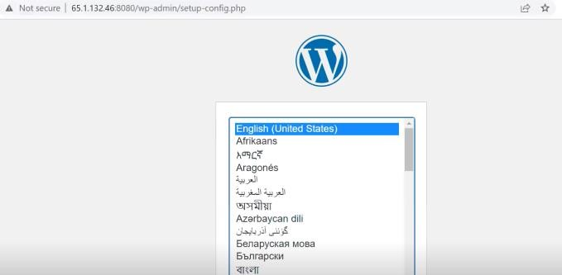Connecting to Word Press server or application
* Word press works only with database

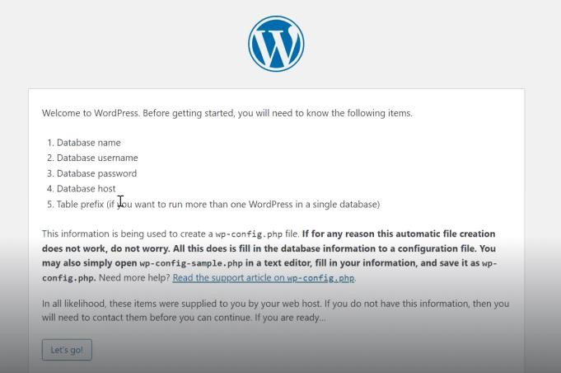

* 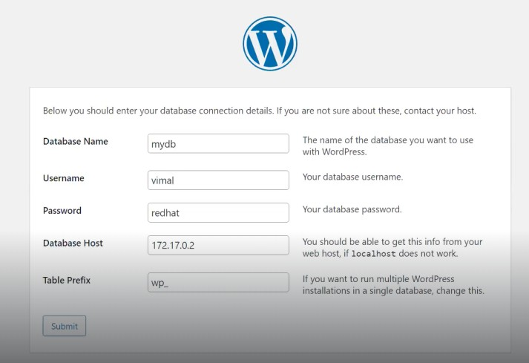Connecting Word press with MY-SQL database
  + Database name, Username, and password → Given while launching MY-SQL container
  + Database host → Ip address of container running MySql
* 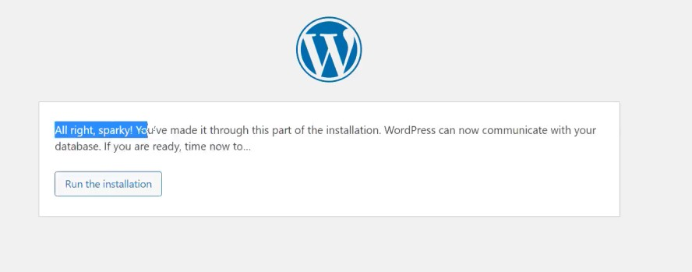Installing Word Press
* Login Word press

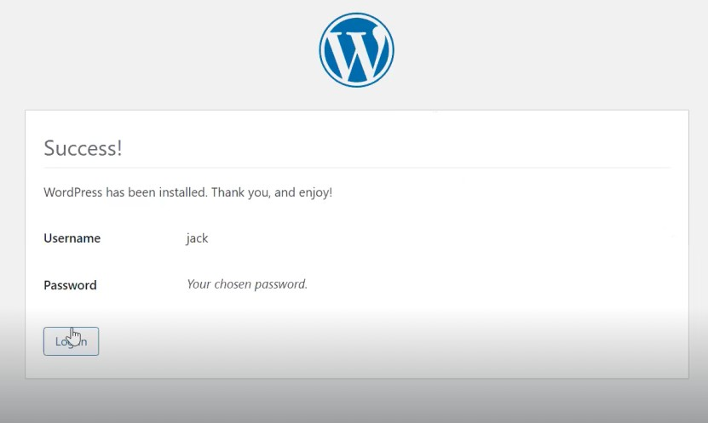

* All the look-end fields of the website are coming from the word press container and the data is coming from the MY-SQL database container

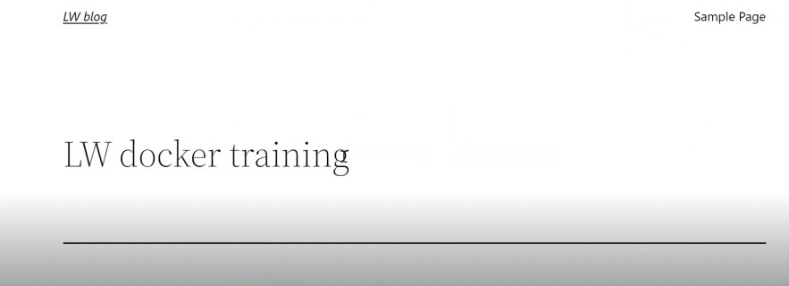

* Deleting the database container

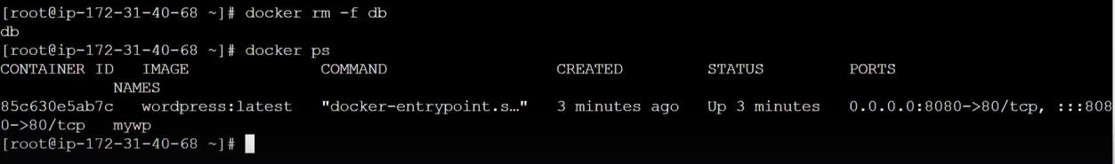

* If by chance the database container goes down good thing about docker is we can launch the container within a second



* As the database is deleted again it will ask to setup the word press and install word press
* The entire information of the data will be lost because the data in the database container was ephemeral

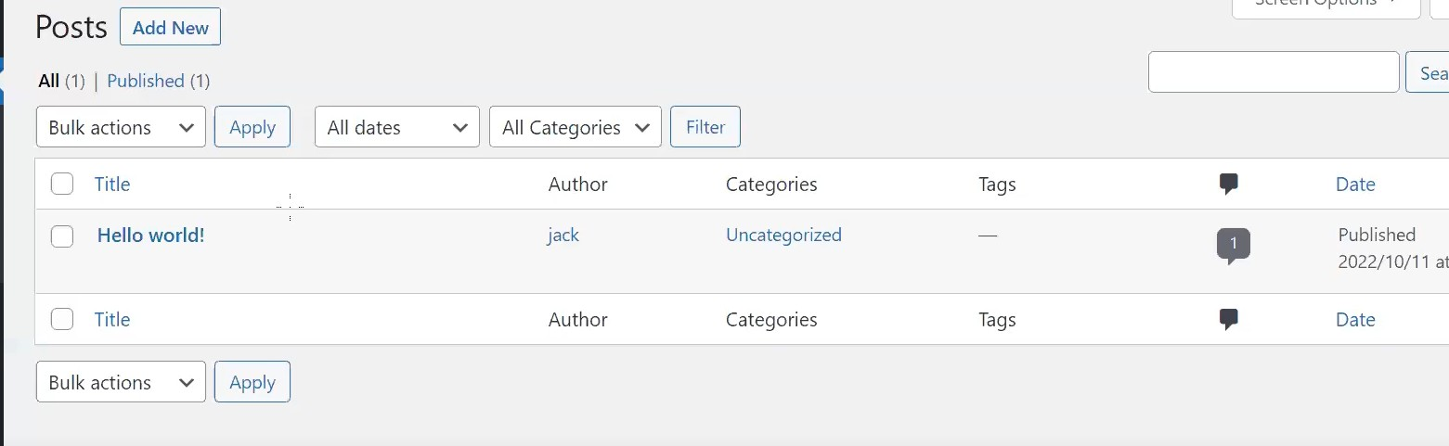

* Every service will store data in its directory e.g. HTTPd stores the data in /var/www/html
* My-SQL server stores data in **/var/lib/mysql**
* 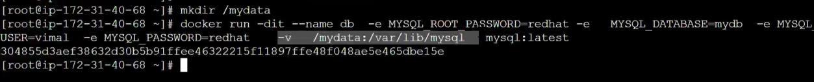Launching My-SQL database container with persistence storage
* Now the entire data stored in the database will be permanent
* 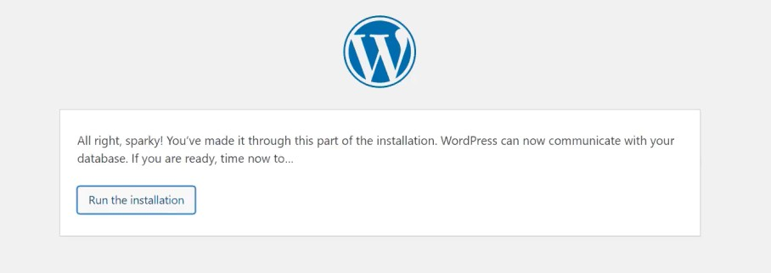Again connecting & installing the word press
* Now whatever My-SQL is storing is stored in the base system

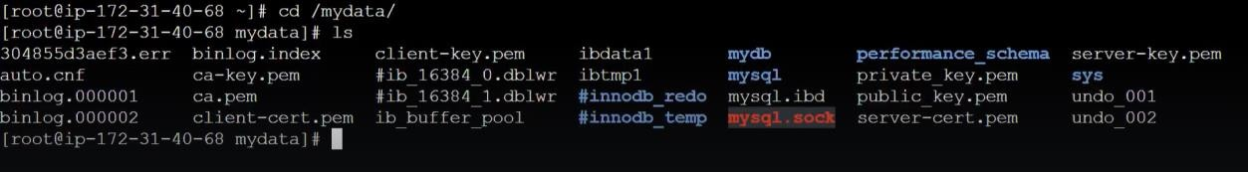

* Even if we remove the container & launch again the data in the word press will be persistence
* If the IP Address of MySql changes after re-creating the container, word press keeps on hitting the same IP and there will be no connectivity

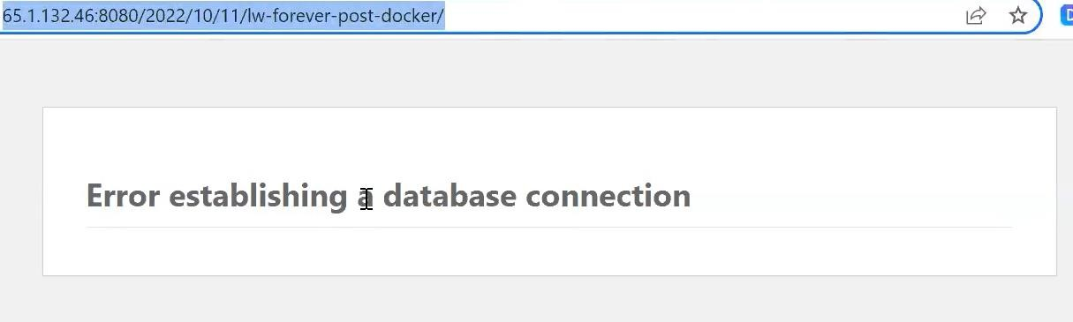

* Good network practice is if two operating systems want to connect with each other don’t rely on IP address for the connection
* The one thing we never change in the container is the name
* Instead of using an IP address, we can use a name this concept is called container linking
* Linking container
  + 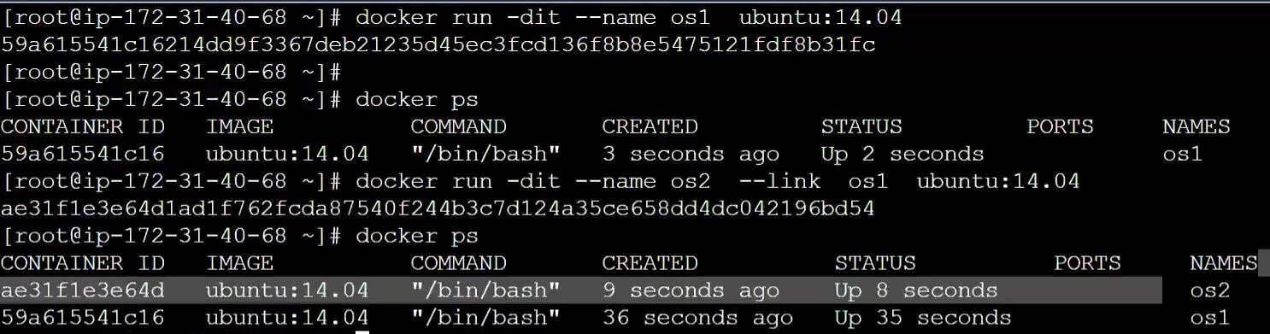--link keyword in the docker run command is used for linking
* Pinging with the name of another container

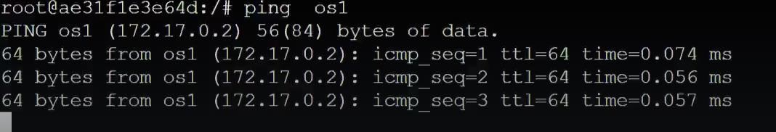

* The limitation of linking is it works in one way for example if os1 wants to connect to os2 it will not work

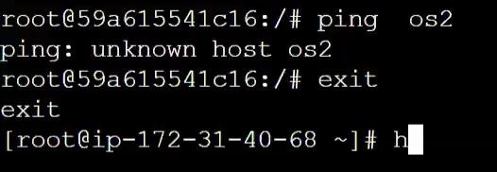

* Launching my-SQL and word press container and linking word press with My-SQL

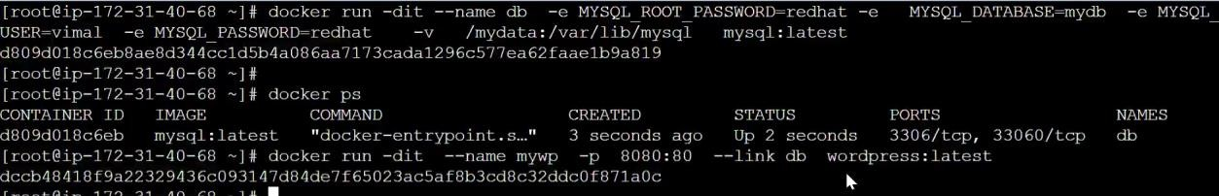

* Now instead of the IP address, we have to give the name of the container

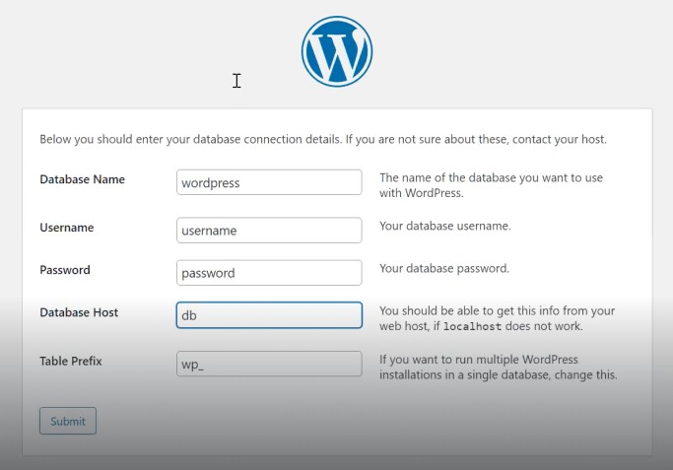

* Challenges in linking
  + One way
  + Internally linking converts name into IP address only so if the IP change connectivity is lost
* If the IP change two services will not be able to connect in a multi- tier architecture