IMDB Movie Analysis

Data Cleaning: This step involves preprocessing the data to make it suitable for analysis. It includes handling missing values, removing duplicates, converting data types if necessary, and possibly feature engineering.

1.Remove Duplicates Using Excel's Built-in Tool
- Select the range of your data (or click inside your data table).
- Go to the Data tab on the ribbon.
- Click Remove Duplicates (you'll see it in the 'Data Tools' group).
- A pop-up will appear
- Click OK.
Excel will remove the duplicate rows and tell you how many duplicates were there

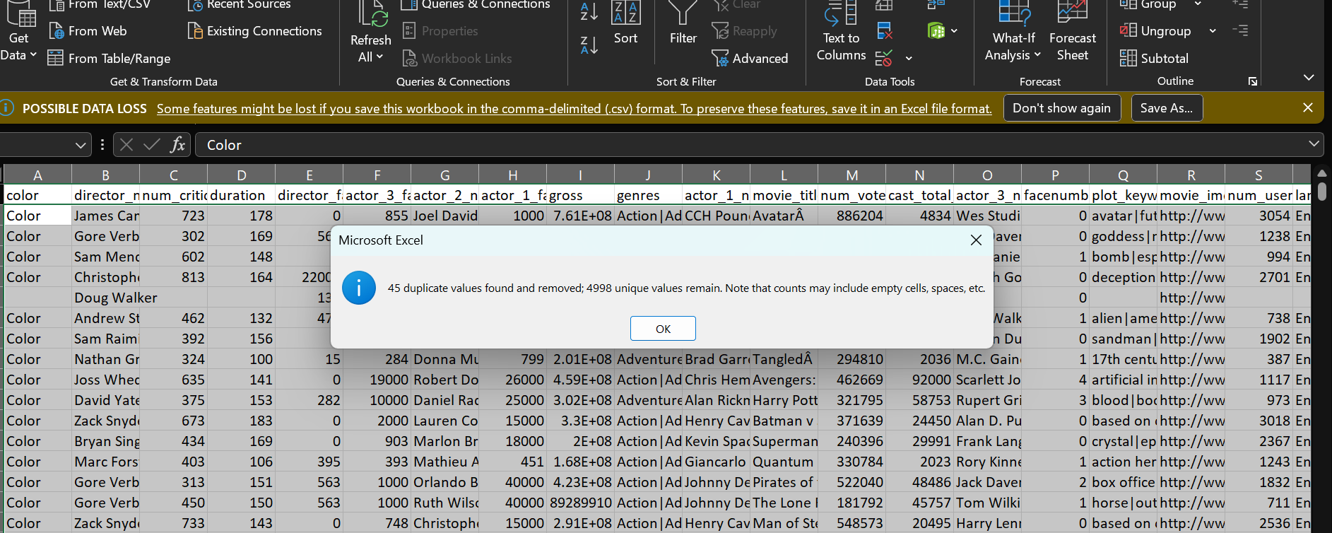

2.Deleted Columns
Color, director_facebook_likes, actor_3_facebook, actor_2_name, actor_1_facebook_likes, actor_1_name, actor_3_name, movie_imdb_link, actor_2_facebook_likes, movie_facebook_likes.
facenumber_in_poster, plot_keywords, director_name,

3.Convert text of column “num_user_for_reviews” into numeric form
• Select your cells/column.
• Go to Data tab → Click Text to Columns.
• Just click Finish

4.Filling the null values in the column
Filling null values in column “director_name”-
By filtering the column by blanks.
Fill the data with “not provided” and drag it to the end

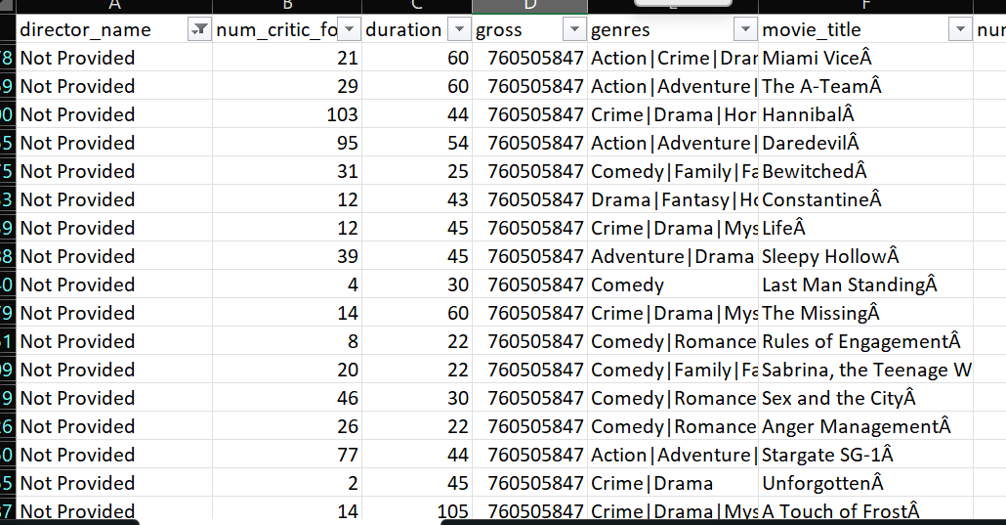

For filling Numerical data- I used median to skip outliers. For filling columns “num critic_for reviews’, “ duration”, ”gross” “num_user_for_reviews”, ”imdb_score”, “aspect_ratio”
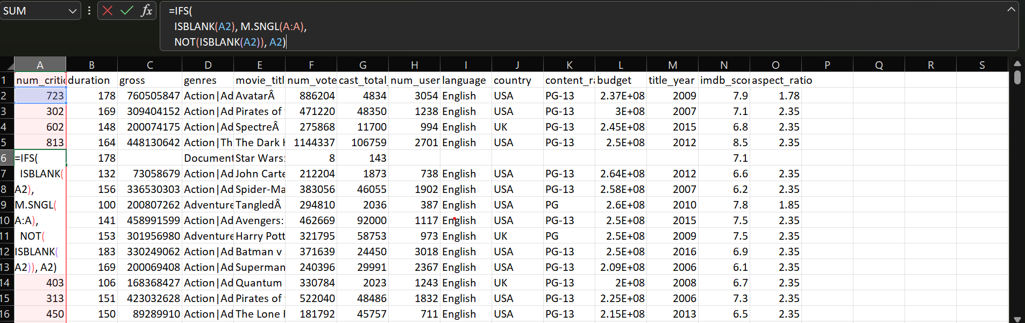

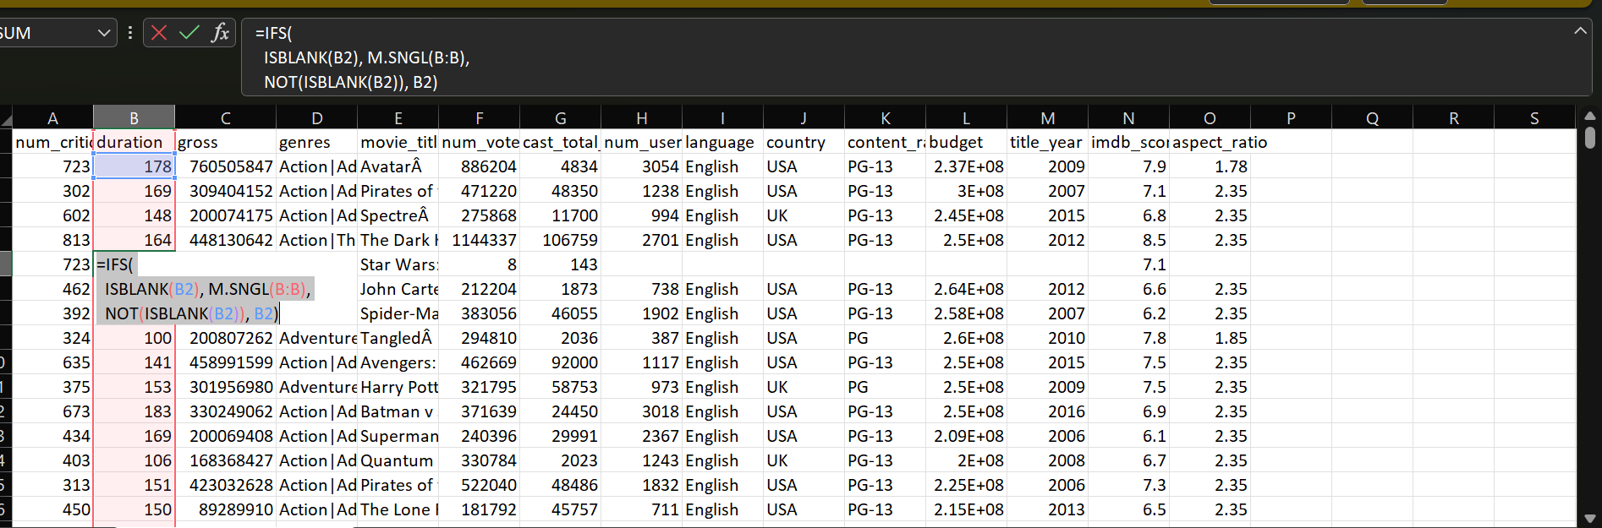

The columns named “genres”,“movie_title”, “num_voted_users” ,” cast_total_facebook_likes” had no null values

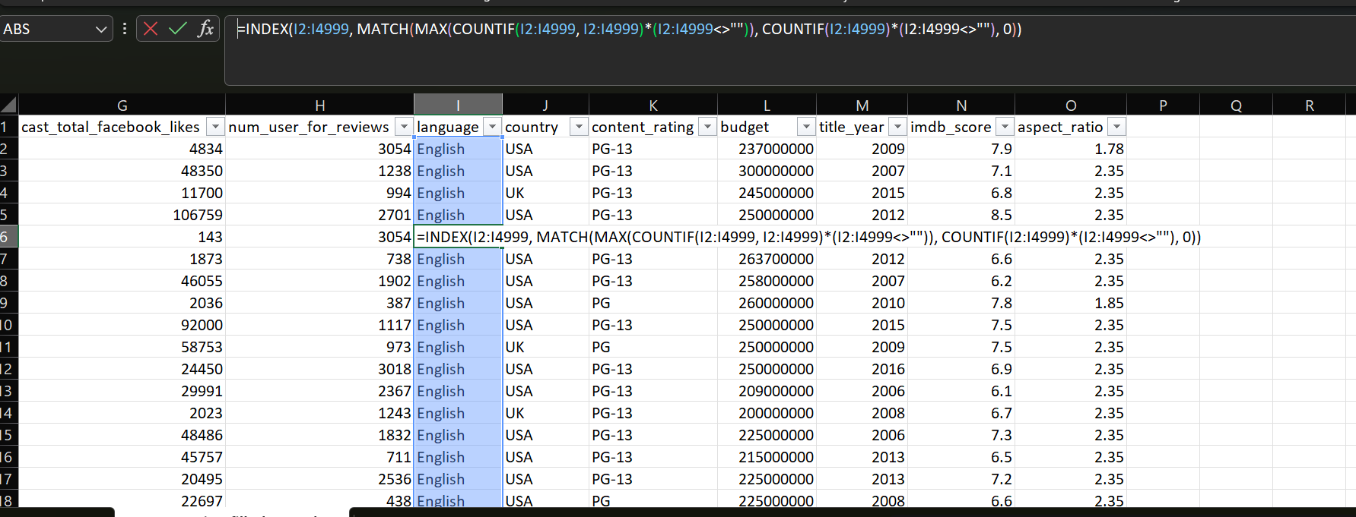

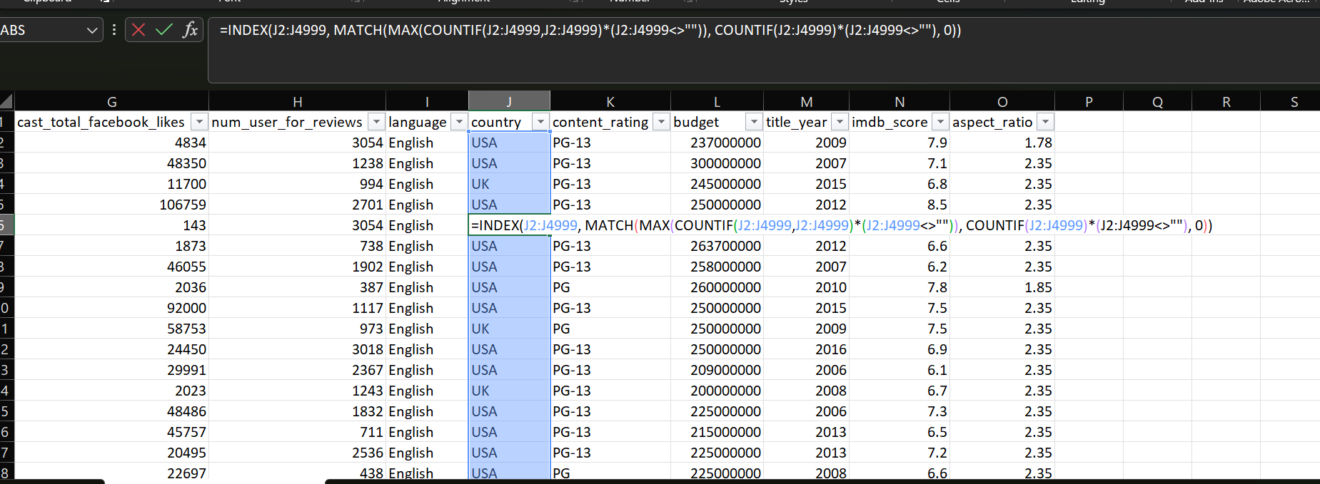
For filling categorical data- I used mode. For filling columns “language, “ country”, ”content_rating” “title_year”,”budget”

5.Making a new column as Profit(Gross-budget)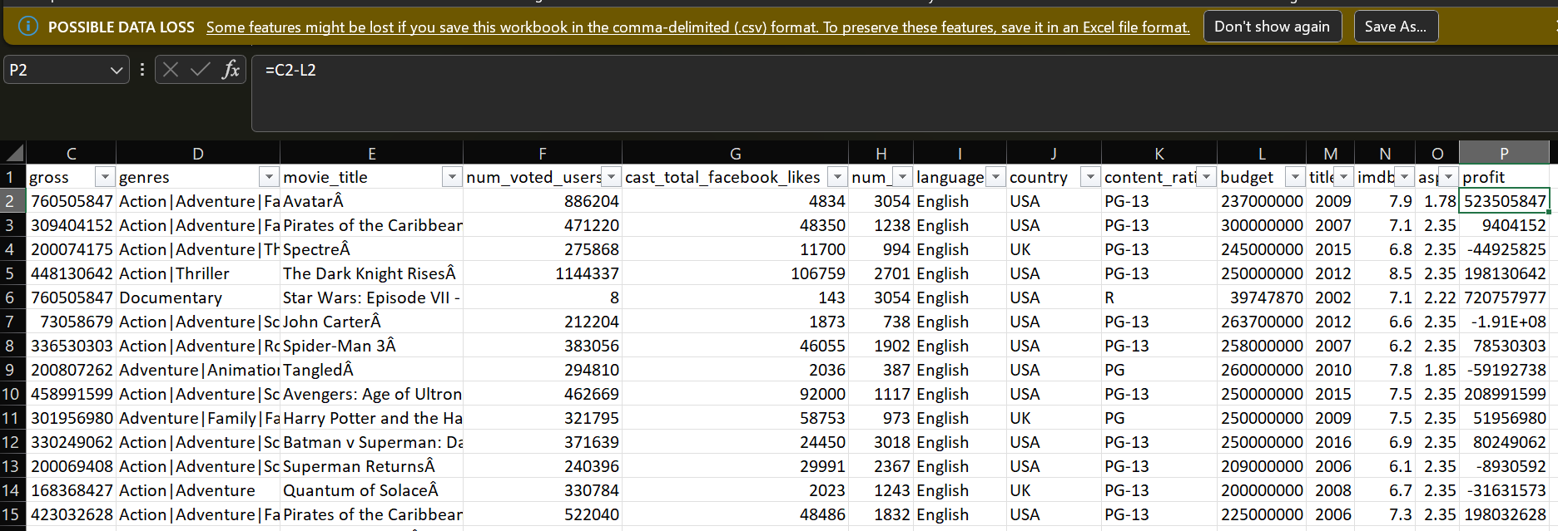
Data Analysis: Here, you'll explore the data to understand the relationships between different variables. You might look at the correlation between movie ratings and other factors like genre, director, budget, etc. You might also want to consider the year of release, the actors involved, and other relevant factors.

1.What is the average IMDB score for all movies
Average= 6.44
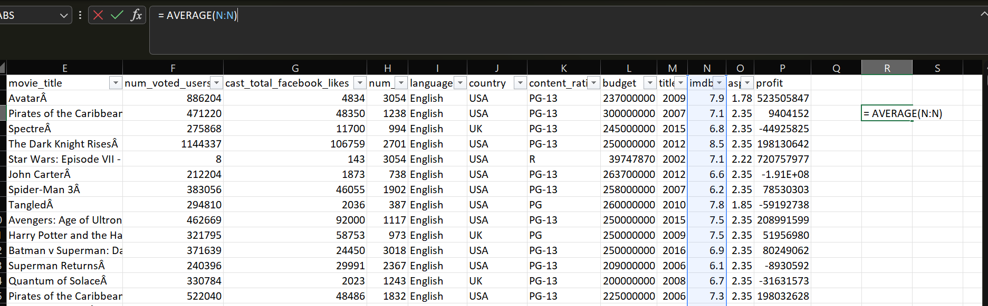
2. Which movie has the highest gross revenue
Ans AvatarÂ

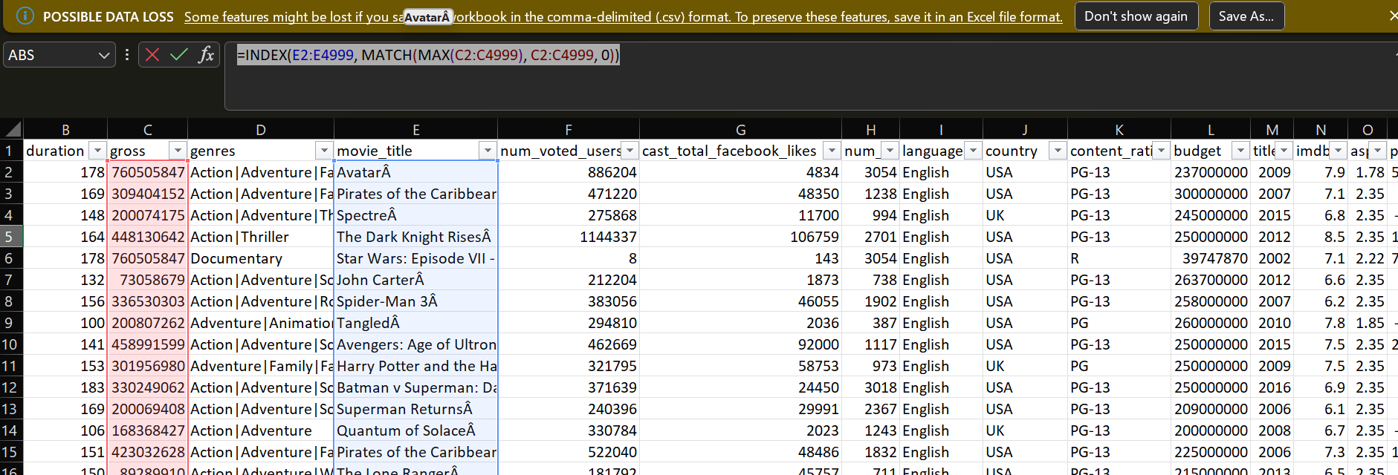

3.What is the correlation between budget and gross revenue?
Ans -0.032
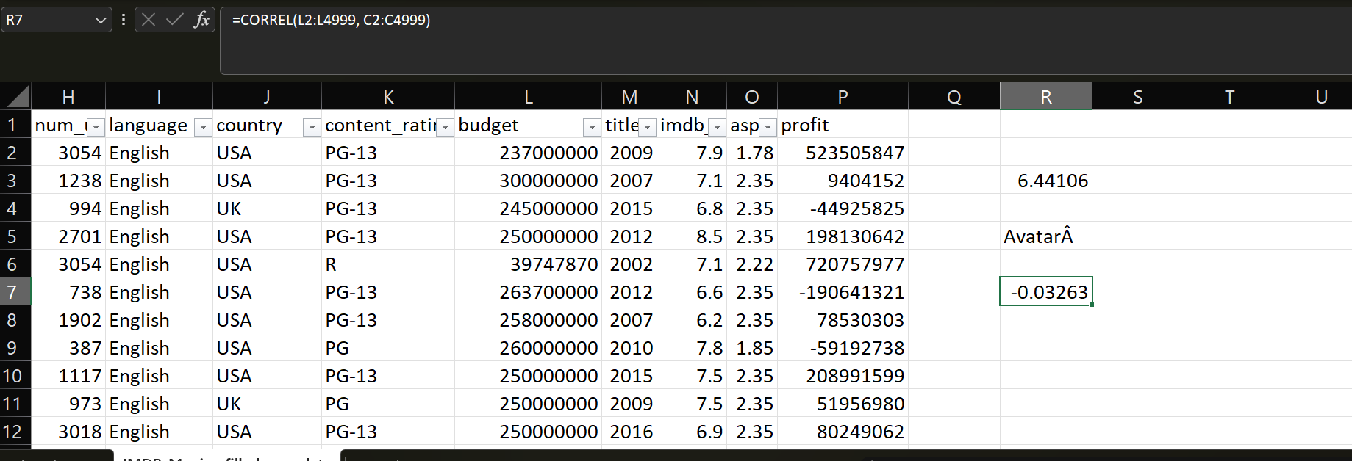

4.How does movie duration relate to IMDB score?
Ans: 0.307057
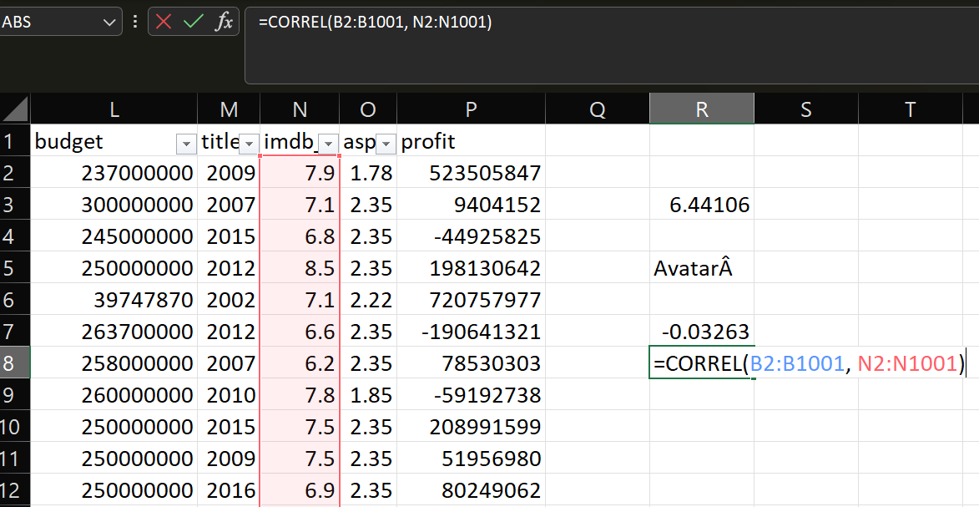
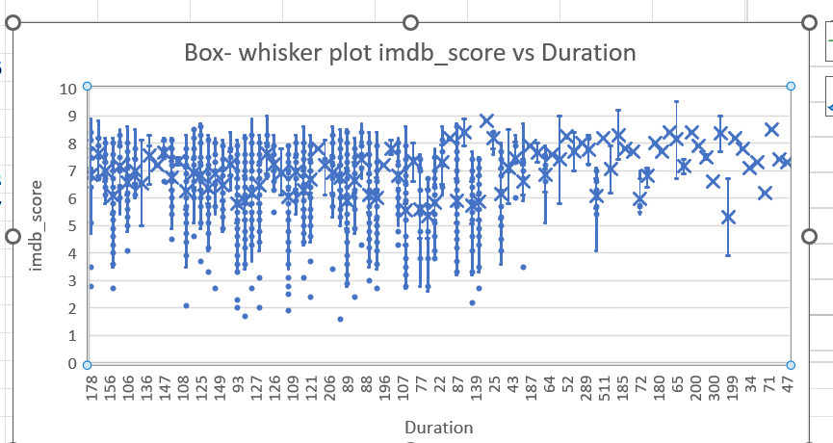

4. Top 5 highest-rated movies (IMDB score) with budget > $100M
Ans 152
148
169
164
164

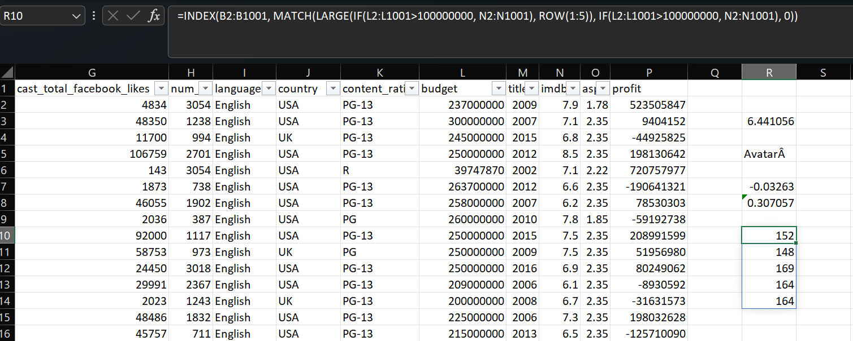
Five 'Whys' Approach: This technique will help you dig deeper into the problem. For instance, if you find that movies with higher budgets tend to have higher ratings, you can ask "Why?" repeatedly to uncover the root cause
1.Why do high-budget movies have higher ratings?
Ans. Answer: They invest in superior production quality (e.g., CGI, cinematography, sound design). Correlation between between budget and Imdb_score is 0.1617

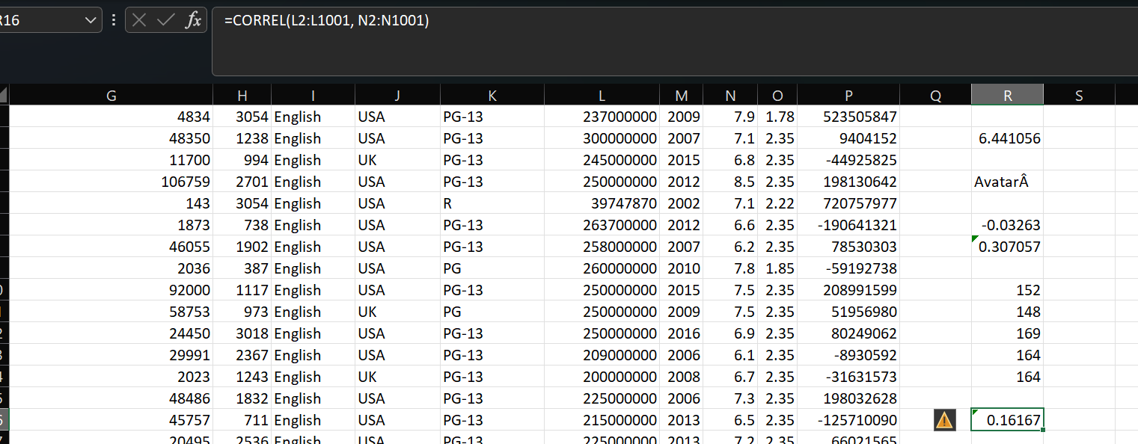

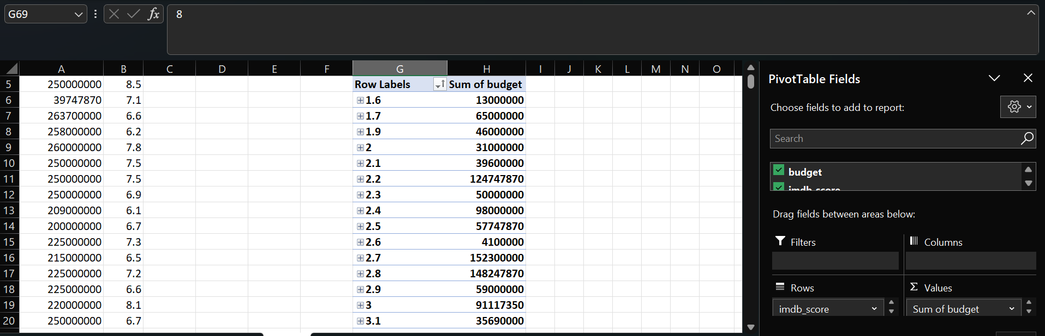

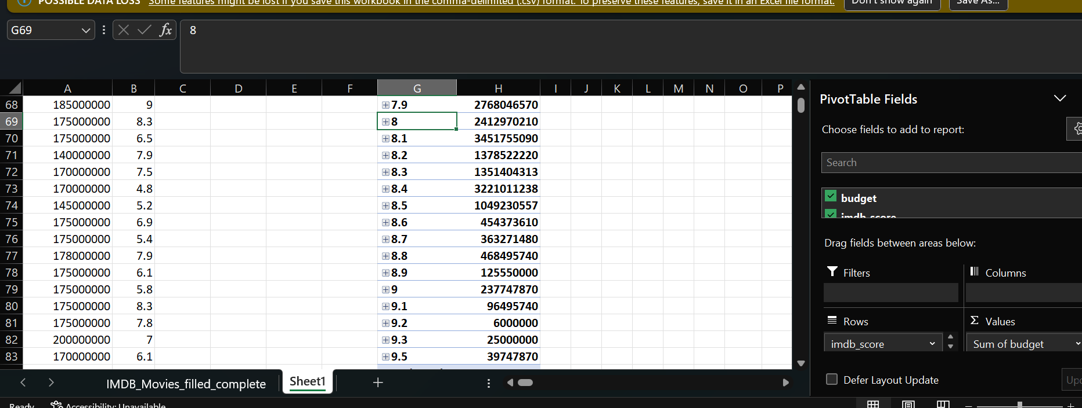

2. Why does better production quality improve ratings?
Answer: It creates immersive storytelling (e.g., Avatar’s visuals, Dune’s soundscape).
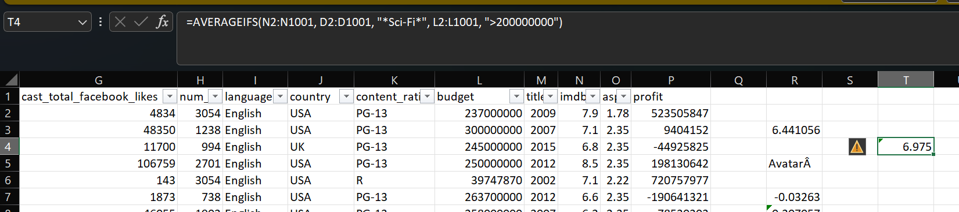

3. Why does immersion lead to higher ratings?
Answer: Emotional engagement increases viewer satisfaction.
Correlation between ‘num_user_for_reviews’ vs ‘imdb_score’=0.29
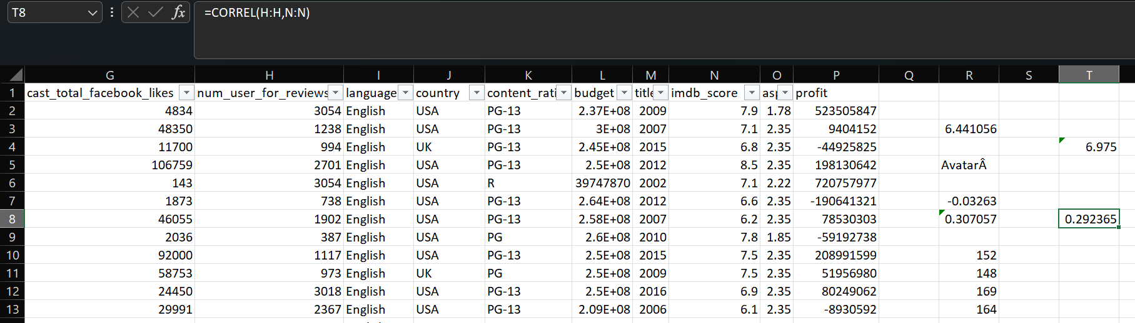

4. Why does satisfaction drive ratings?
Answer: Pleased audiences are more likely to rate positively (vs. indifferent viewers skipping ratings).
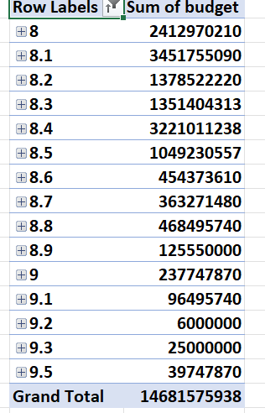

5. Why do positive ratings matter?
Answer: They create a feedback loop:
High ratings → More visibility → Higher revenue → More budgets for future projects.

=SUMIFS(C2:C4999, N2:N4999, ">=8", D2:D4999, "*Action*")=18803816445

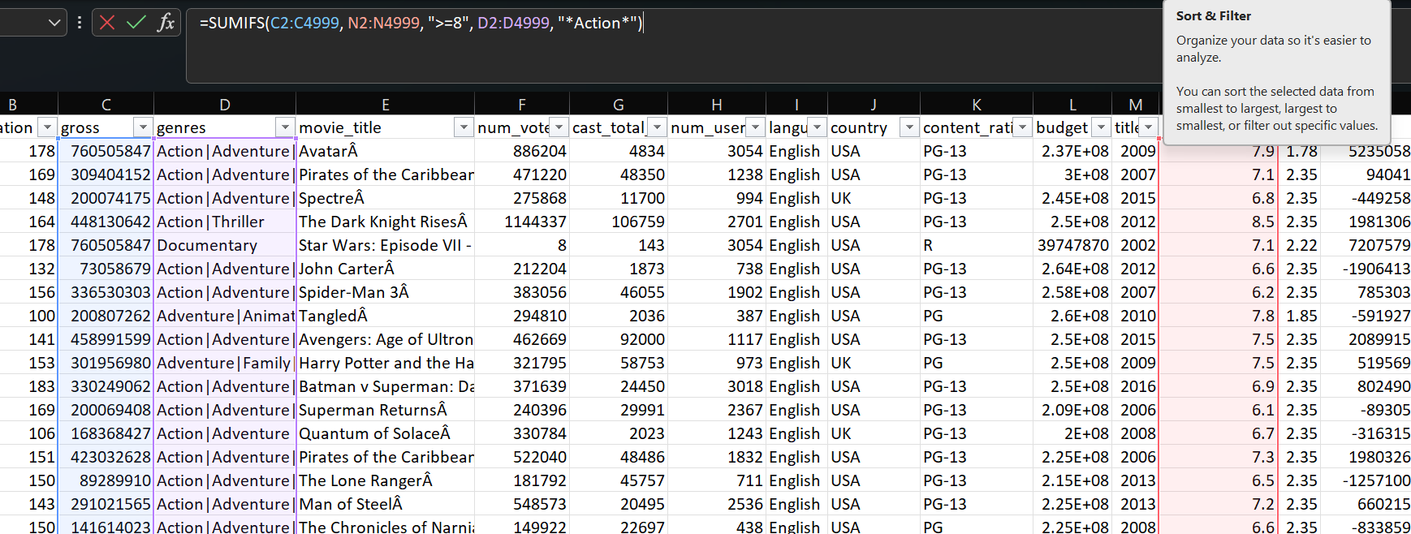

A. Movie Genre Analysis: Analyze the distribution of movie genres and their impact on the IMDB score.
- Task: Determine the most common genres of movies in the dataset. Then, for each genre, calculate descriptive statistics (mean, median, mode, range, variance, standard deviation) of the IMDB scores.
- Hint: Use Excel's COUNTIF function to count the number of movies for each genre. You might need to manipulate the 'genres' column to separate multiple genres for a single movie. Use Excel's functions like AVERAGE, MEDIAN, MODE, MAX, MIN, VAR, and STDEV to calculate descriptive statistics. Compare the statistics to understand the impact of genre on movie ratings.

Split the Genres
In Excel, you can use the following method to split the genres:
Using Text to Columns:
  - Select the column containing genres.
  - Go to Data > Text to Columns.
  - Choose Delimited and click Next.
  - Select Other and enter | as the delimiter.
  - Click Finish.

Count the Number of Movies for Each Genre
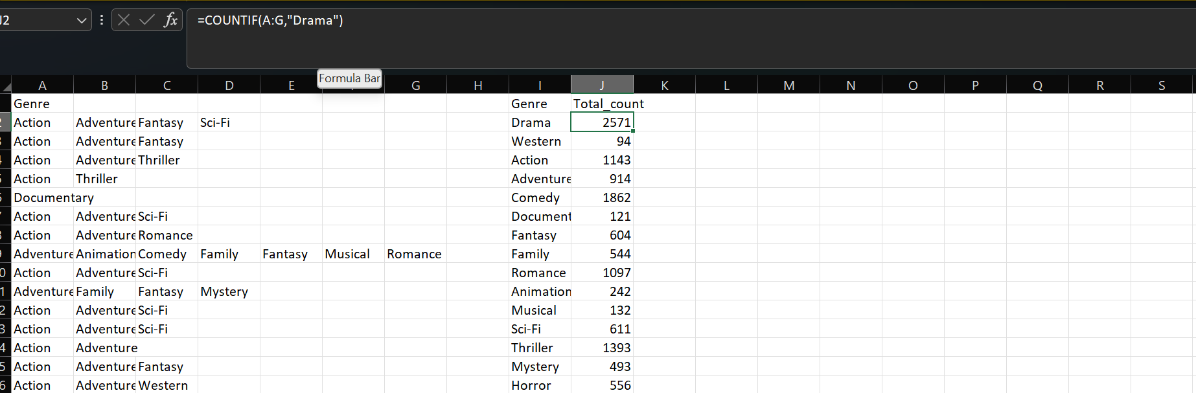
This is used for “Drama” and following same is done for all the Genre
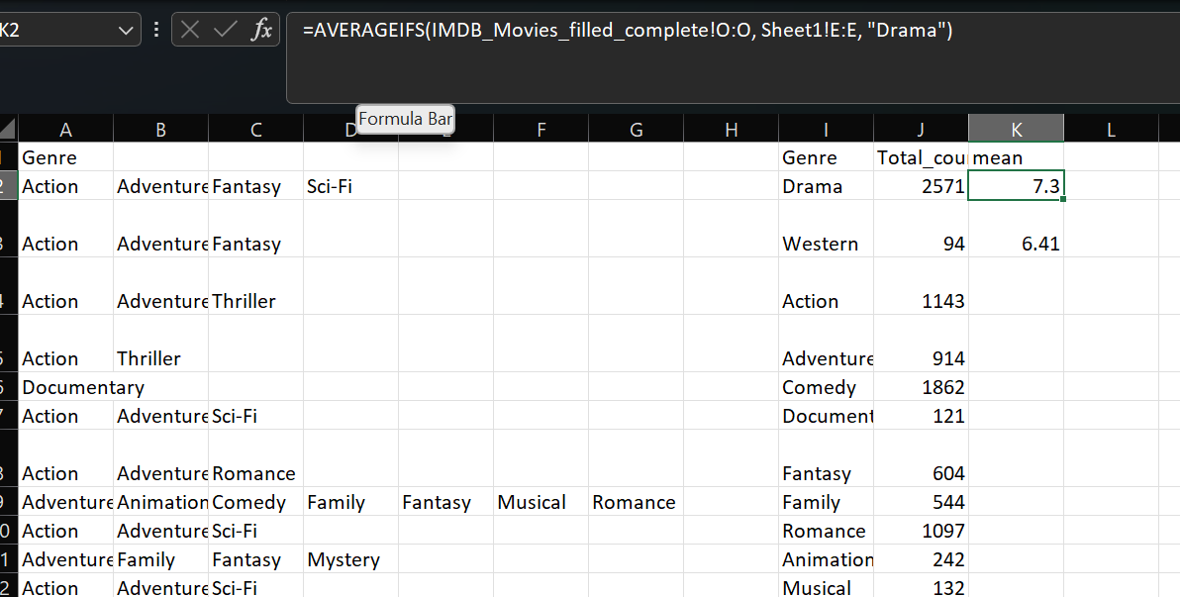

Similarly,
Count=COUNTIF(A:G,"Drama")
Mean=AVERAGEIFS(IMDB_Movies_filled_complete!O:O, IMDB_Movies_filled_complete!E:E, "Drama")
Median =MEDIAN(IF(ISNUMBER(SEARCH("Drama", IMDB_Movies_filled_complete!E:E)), Sheet1!O:O))
Mode =MODE.SNGL(IF(ISNUMBER(SEARCH("Drama", IMDB_Movies_filled_complete!E:E)), Sheet1!O:O))
Range=MAXIFS (IMDB_Movies_filled_complete!O:O, IMDB_Movies_filled_complete!E:E, "Drama") – MINIFS (IMDB_Movies_filled_complete!O:O, IMDB_Movies_filled_complete!E:E, "Drama")
Variance =VAR.P(FILTER(IMDB_Movies_filled_complete!O:O, ISNUMBER(SEARCH(“Drama”, IMDB_Movies_filled_complete!E:E))))
Standard Deviation =STDEV.P(FILTER(IMDB_Movies_filled_complete!O:O, ISNUMBER(SEARCH(“Drama”, IMDB_Movies_filled_complete!E:E))))

Genre | Count | Mean | Median | Mode | Range | Variance | Std Dev
Action | 1143 | 6.24 | 6.3 | 6.1 | 7.4 | 1.24 | 1.11
Adventure | 914 | 6.44 | 6.6 | 6.7 | 7 | 1.27 | 1.13
Animation | 242 | 6.58 | 6.7 | 6.7 | 6.9 | 1.29 | 1.14
Biography | 292 | 7.15 | 7.2 | 7 | 4.4 | 0.52 | 0.72
Comedy | 1862 | 6.19 | 6.3 | 6.7 | 7.8 | 1.19 | 1.09
Crime | 883 | 6.56 | 6.6 | 6.6 | 6.9 | 1.05 | 1.02
Documentary | 121 | 7.18 | 7.4 | 7.5 | 7.1 | 1.11 | 1.05
Drama | 2571 | 6.76 | 6.9 | 7.2 | 7.3 | 0.91 | 0.95
Family | 544 | 6.25 | 6.4 | 6.7 | 7 | 1.44 | 1.2
Fantasy | 604 | 6.31 | 6.4 | 6.7 | 7.2 | 1.34 | 1.16
Film-Noir | 6 | 7.63 | 7.65 | 7.1 | 1.1 | 0.16 | 0.39
Game-Show | 1 | 2.9 | 2.9 | 2.9 | 0 | 0 | 0
History | 205 | 7.08 | 7.2 | 7.5 | 6.9 | 0.78 | 0.89
Horror | 556 | 5.83 | 5.9 | 6.2 | 6.5 | 1.26 | 1.12
Music | 212 | 6.41 | 6.6 | 6.5 | 6.9 | 1.39 | 1.18
Musical | 132 | 6.51 | 6.7 | 7 | 6.4 | 1.49 | 1.22
Mystery | 493 | 6.49 | 6.6 | 6.6 | 6.4 | 1.17 | 1.08
News | 3 | 7.53 | 7.4 | 7.1 | 1 | 0.18 | 0.42
Reality-TV | 2 | 4.75 | 4.75 | 2.9 | 3.7 | 3.42 | 1.85
Romance | 1098 | 6.45 | 6.5 | 6.5 | 6.5 | 0.99 | 1
Sci-Fi | 611 | 6.28 | 6.4 | 6.7 | 6.9 | 1.46 | 1.21
Short | 5 | 6.38 | 6.5 | 5.2 | 1.9 | 0.45 | 0.67
Sport | 181 | 6.6 | 6.8 | 7.2 | 6.7 | 1.21 | 1.1
Thriller | 1396 | 6.31 | 6.4 | 6.1 | 6.8 | 1.11 | 1.05
War | 211 | 7.07 | 7.1 | 7.1 | 5.9 | 0.76 | 0.87
Western | 94 | 6.7 | 6.8 | 6.5 | 5.1 | 1.1 | 1.05

B. Movie Duration Analysis: Analyze the distribution of movie durations and its impact on the IMDB score.
- Task: Analyze the distribution of movie durations and identify the relationship between movie duration and IMDB score.
- Hint: Calculate descriptive statistics such as mean, median, and standard deviation for movie durations. Use Excel's functions like AVERAGE, MEDIAN, and STDEV. Create a scatter plot to visualize the relationship between movie duration and IMDB score. Add a trendline to assess the direction and strength of the relationship.

Make another Sheet for Analysis
Do all statistical Analysis
Make a scatter plot
Select the data
Insert Scatter Plot
Click on any dot in the scatter plot.
Right-click → Add Trendline.
In the pane:
- Choose Linear.
- Check Display Equation on chart.
- Check Display R-squared value on chart
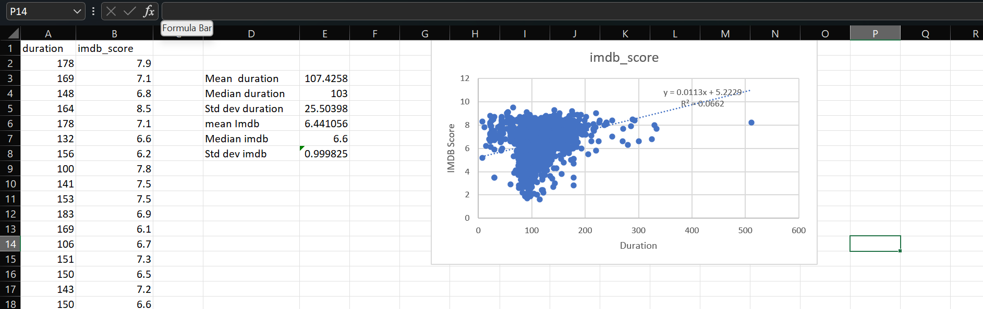

C. Language Analysis: Situation: Examine the distribution of movies based on their language.
- Task: Determine the most common languages used in movies and analyze their impact on the IMDB score using descriptive statistics.
- Hint: Use Excel's COUNTIF function to count the number of movies for each language. Calculate the mean, median, and standard deviation of the IMDB scores for each language. Compare the statistics to understand the impact of language on movie ratings.
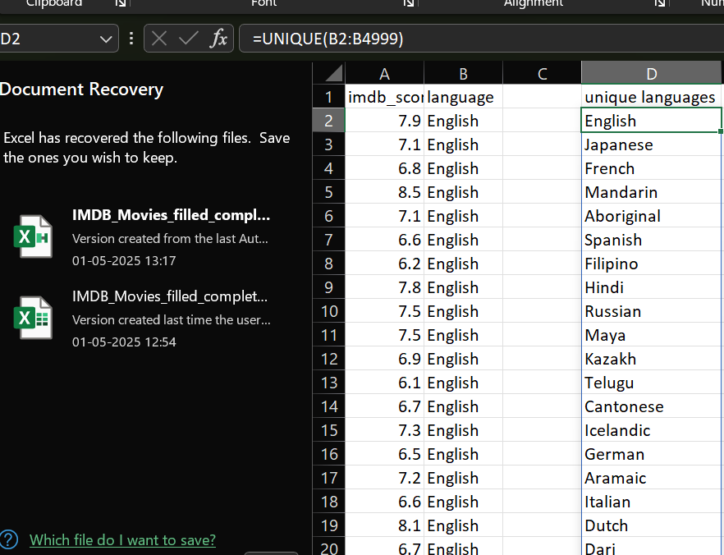
count=COUNTIF(B:B, D2)
Mean IMDB Score =AVERAGEIFS(A:A,B:B, D2)
Median IMDB Score=MEDIAN(IF(B:B=D2, A:A))
Standard Deviation=STDEV.P(IF(B:B=D2, A:A))

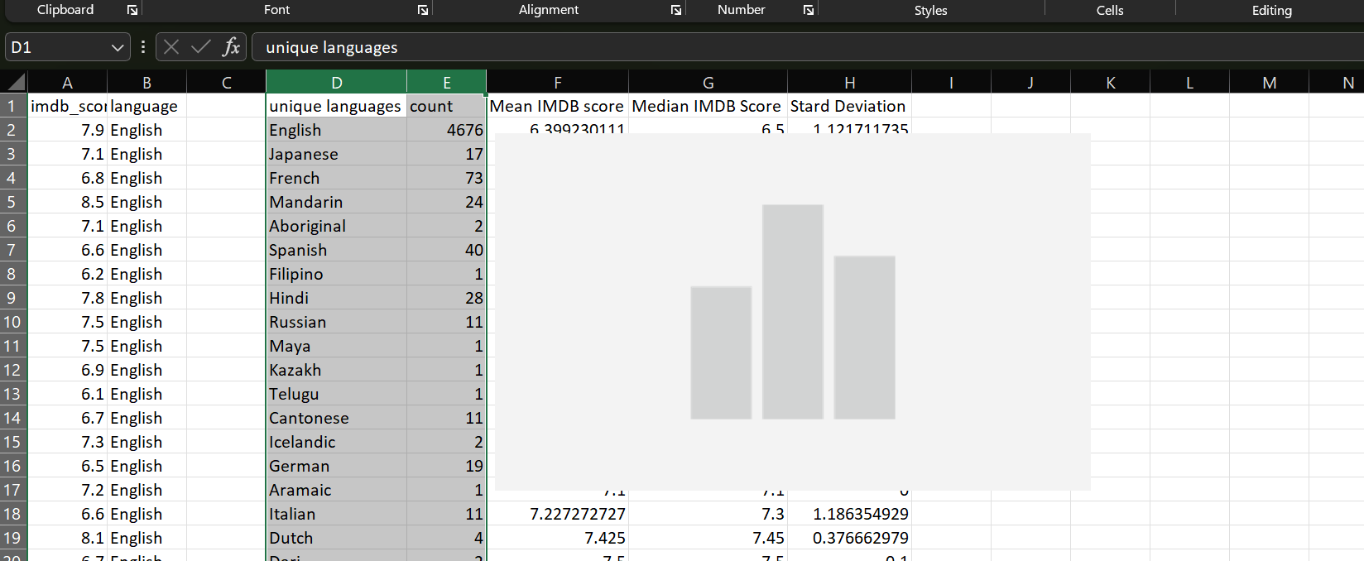
D.Director Analysis: Influence of directors on movie ratings.
Task: Identify the top directors based on their average IMDB score and analyze their contribution to the success of movies using percentile calculations.
Hint: Calculate the average IMDB score for each director. Use Excel's PERCENTILE function to identify the directors with the highest scores. Compare the scores of these directors to the overall distribution of scores
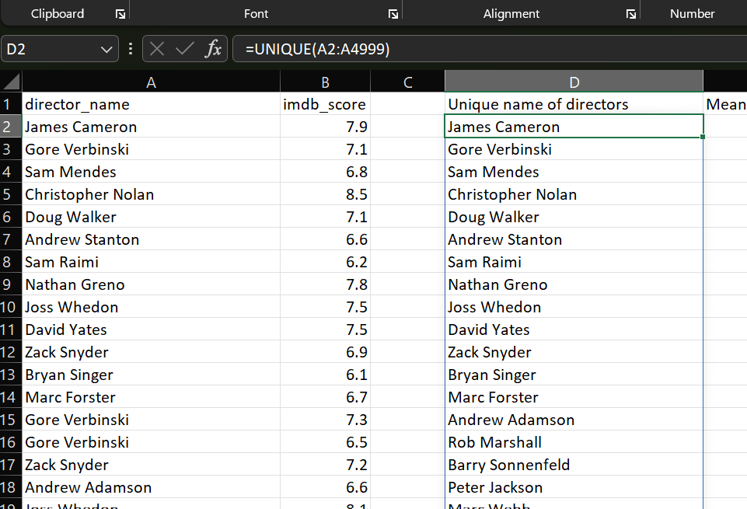

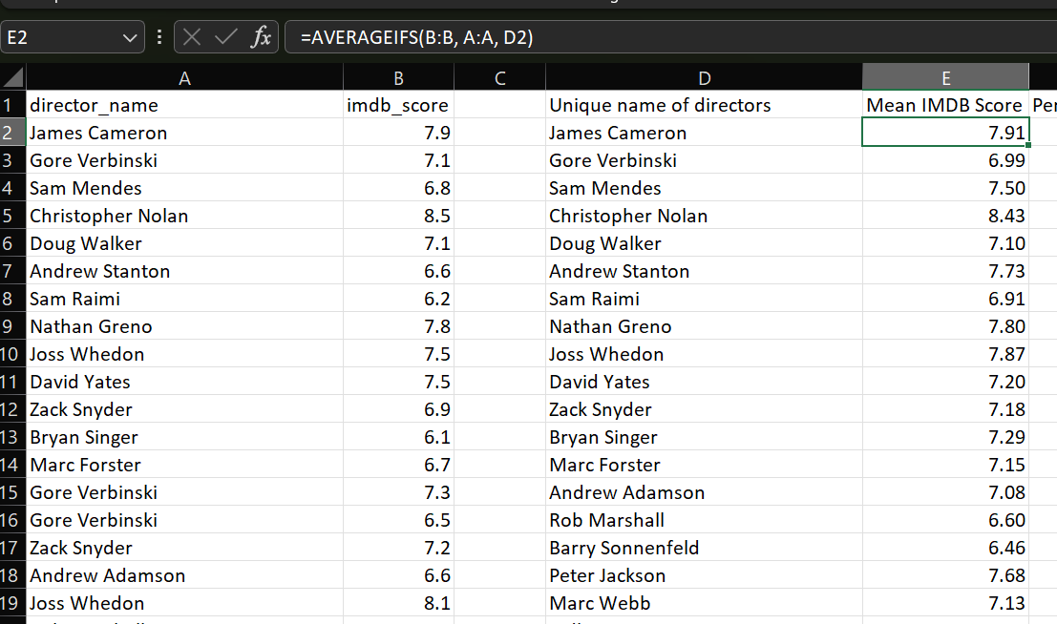

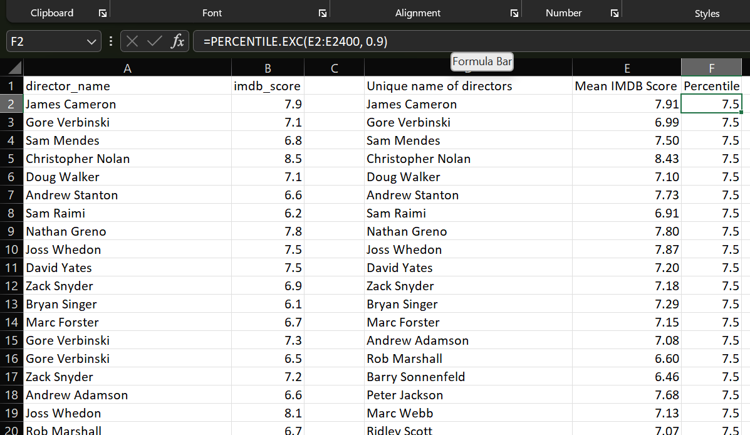

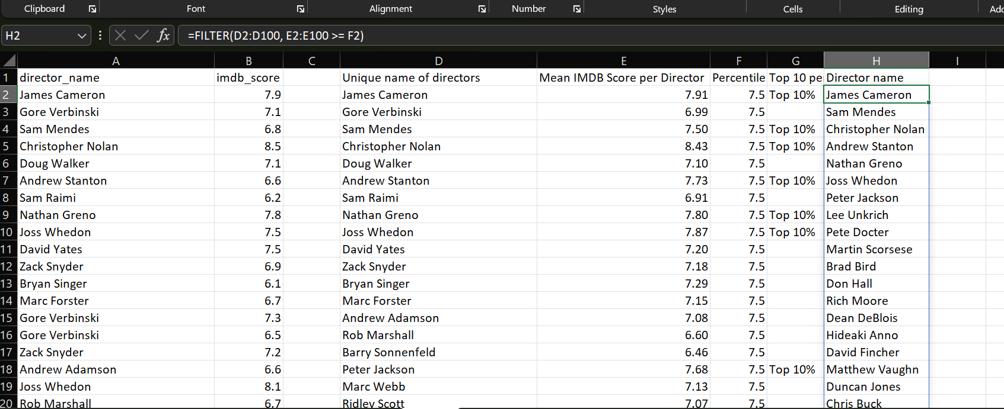

E. Budget Analysis: Explore the relationship between movie budgets and their financial success.
- Task: Analyze the correlation between movie budgets and gross earnings, and identify the movies with the highest profit margin.
- Hint: Calculate the correlation coefficient between movie budgets and gross earnings using Excel's CORREL function. Calculate the profit margin (gross earnings - budget) for each movie and identify the movies with the highest profit margin using Excel's MAX function.
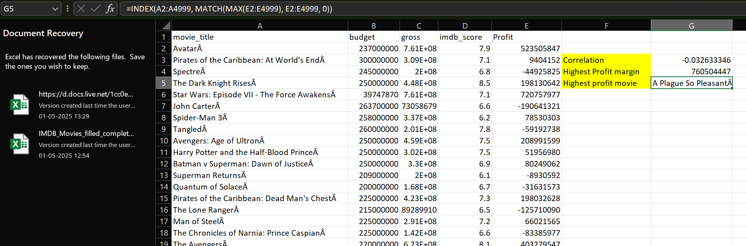

Project Description
Provide a brief overview of the project, its objectives, and the approach you followed.
This project focuses on analyzing IMDB movie data to uncover patterns and relationships between variables like genre, duration, language, director, and budget using Microsoft Excel.
Approach
Explain your approach to the project and how you executed it, including the specific techniques and tools used.
The project involved cleaning the dataset (handling nulls, removing duplicates), engineering features (like profit), and using Excel’s functions (e.g., AVERAGEIFS, CORREL, PERCENTILE) to explore variable relationships and generate insights.
Tech-Stack Used
Specify the software and its version (e.g., Microsoft Excel 2022) and mention the purpose of using it.
Microsoft Excel 365 was used for data cleaning, statistical analysis, visualization (charts, trendlines), and deriving insights through built-in functions and Power Query.

Insights
Summarize the insights and knowledge gained during the project. Discuss key findings and any meaningful trends or patterns discovered.
The analysis revealed trends such as higher IMDb scores for certain genres like Biography and Documentary, a weak correlation between budget and gross revenue, and notable influence of directors and languages on movie ratings.
Result
Describe what you achieved through the project and how it has contributed to your understanding of the IMDB Movie Analysis.
The project deepened the understanding of what factors contribute to movie success, including the role of genre, duration, and language, and identified top-performing directors and high-profit films using statistical and visual analysis in Excel.

