

**FINAL REPORT**

**TEAM WORK**

Github Link <https://Ankiit045106.github.io/coding-.github.io/>

|  |  |  |  |
| --- | --- | --- | --- |
| **S. No** | **Registration No.** | **Name** | **Roll No.** |
| 01 | 11914358 | Ankit Kumar | RK19SPB40 |
| 02 | 11914313 | Devansh Verma | RK19SPB41 |
| 03 | 11914442 | Manivamoh Sondah | RK19SPB42 |

**Hotel Management System Website**

**ABSTRACT**

This website of hotel aims at creating an Online Hotel Management system which can be used by customers to reserve hotel rooms, read about hotel, check hotel gallery. This website of hotel will remove the hectic task of customers and executive for searching and booking rooms in hotel. The system will help the administrative staff i.e. executive of the hotel to keep the daily and the history record details of the customers in proper Database. Customer can book rooms in advance seating anywhere across the world. The hotel website will allow customer to remotely access to hotel database only for customer after the authorization procedures. The customer could search, book rooms and give feedback.

**INTRODUCTION**

The Hotel Management system is togeneralize andsimplify the monthly or daytodayactivitiesof Hotellike Roomactivities,Check in of New Customer,Checkoutof customer,Assigning aroom accordingto customerrequirement,andfinally computethebill etc. which hasto beperformedrepeatedlyonregular basis. To provide efficient,fast,reliable anduser-friendlysystemis thebasicmotto behindthis exercise.And show theHotelroomfacilities, Book room. The main aim of the entireactivity is to automatetheprocess of day to dayactivities of Hotellike Room activities, Admission of aNew Customer, Assign a roomaccording to customer’s demand, checkout of a computerand releasing theroom andfinally compute the bill etc.

**OBJECTIVE**

1. Make a user friendly and simple website .
2. The objective of website is to creating an online hotel management system which can be used by customers to reserve hotel rooms.
3. Users can check the status of room and facilities.

**LITERATURE REVIEW**

As we see that now a days people prefer online booking rather than walkin booking, in online booking we will get better understanding of rooms and other thing without going to hotel by videos, photos, gifs etc. Now come to our project , In this particular project we take the idea from various online coding platforms like geek for geeks ,programez etc. And we see that in the particular sites there is online booking some are offering food so we take the idea and combine it in our website.

**SYSTEM DESCRIPTION**

**Home Page (also Main Page**): -

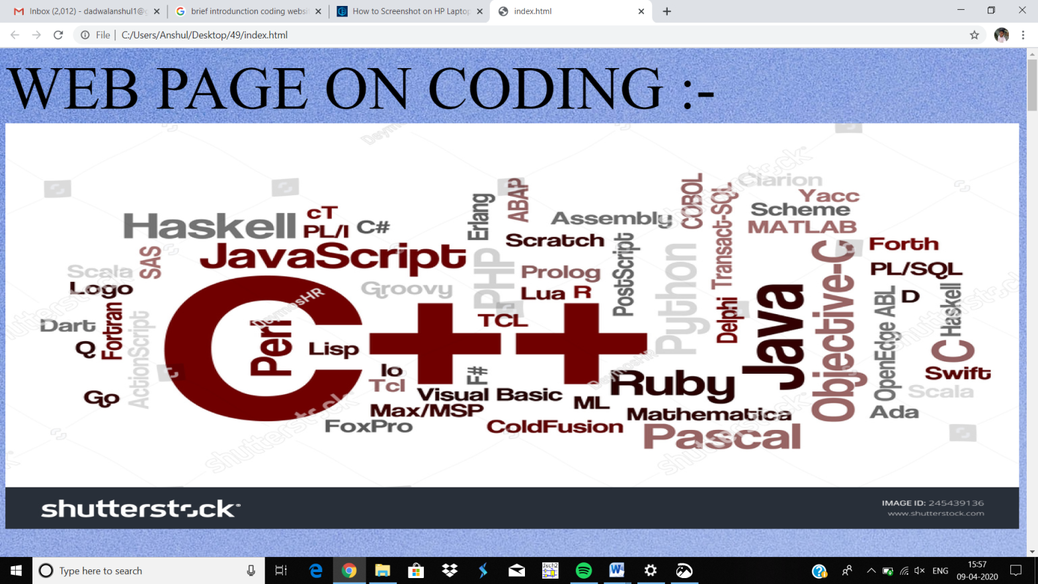

**METHODOLOGY**

**<link rel="stylesheet" href="abc.css">**

With this syntax we link our HTML file with CSS file, in wich we adjust the size, alignment, colors etc.

**<img src="141.jpg" alt="coding" width="1500" height="600" align="center">**

In this we adjust the picture on the webpage and also give space after that by the syntax (&nbsp;&nbsp;). As we know after some video, audio and picture option there is spacing problem so we use this particular code for extra spacing.

**<style>**

**#borderimg {**

**border: 10px solid transparent;**

**padding: 15px;**

**border-image: url(border.png) 30 round;**

**}**

**</style>**

With the help of this we design the border of the heading. Firstly we download the border design and link with the above code.

**<p2><a href="https://www.onlinegdb.com/online_c_compiler">Online Compiler for C </a></p2>**

As we need the online compiler for our webpage so with this code we link the complier website to our webpage so whenever we click on the link it jump to the compiler window directely.

**<video width="500" controls>**

**<source src="a.mp4" type="video/mp4">**

**<source src="a.ogg" type="video/ogg">**

**</video>**

In this we download a video and link it to the webpage ,not by any other online link but the downloaded one. As if we link it by the other side it require internet but in this it doesn’t required, and by simply on clicking them it will start.

After that we design the two half of the webpage in the first half we give the some basic knowledge about C,C++ and on the second half we have we give the some code base example based on the **C,C++** . For the basic knowledge we use the **geek for geeks** site and for the code base examples we use **programiz** site.

**</form><form>**

**</p><p>**

**<label>For questions</label><br>**

**<input type="radio"name="r"><label>option a</label><br>**

**<input type="radio"name="r"><label>option b</label><br>**

**<input type="radio"name="r"><label>option c</label><br>**

**<input type="radio"name="r"><label<option d</label><b0r>**

**</form><form>**

Now after this we design the mcq question, in this mcq question we select one ans at the time ,means for one particular question we choose only one particular ans. Them we design table for answer the above mcq questions.

**<div class="gallery">**

**<a target="_blank" href="1.jpg">**

**<img src="1.jpg" alt="Cinque Terre" width="600" height="400">**

**</a>**

**<div class="desc">brief discription</div>**

**</div>**

In the last we add the references, for this we use the above syntax and with this we add the picture of the side or software link we use and also give the description for the same

**RESULT AND DISCUSSION**

In this project we learn so many things which will help in our future life. Like if we are handling a business so we must have a website in which we will publish our work so that our business will grow very fastly. As if we a bloging something we must need a website, for presenting our work .

**CONCLUSION**

We have done so many things for this website to make it very simple to understand because we know that everyone does not know how to book a hotel so we make it simple for the other people . We also do styling for making our website more attractive. And for the more understanding to customer we added many links and videos of hotel . But our ultimate goal is to make a website which is simple for even those people who even does not know how to book a hotel.

**REFERENCES**

* [**https://www.geeksforgeeks.org/**](https://www.geeksforgeeks.org/)
* [**https://www.programiz.com/cpp-programming/examples**](https://www.programiz.com/cpp-programming/examples)

* **<https://www.onlinegdb.com/online_c_compiler>**
* [**https://www.w3schools.com/**](https://www.w3schools.com/)
* [**https://www.jdoodle.com/online-compiler-c++/**](https://www.jdoodle.com/online-compiler-c++/)
* [**https://www.sanfoundry.com/**](https://www.sanfoundry.com/)