Question: 1:  
Git Setup https://confluence.atlassian.com/bitbucket/set-up-git-744723531.html

Question: 2:  
Initialize a Git Repository

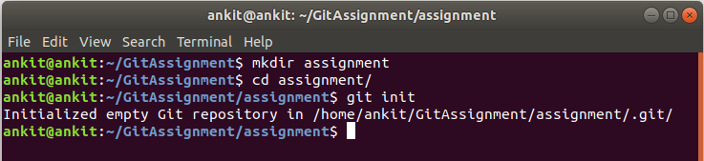

Question: 3:  
Add files to the repository

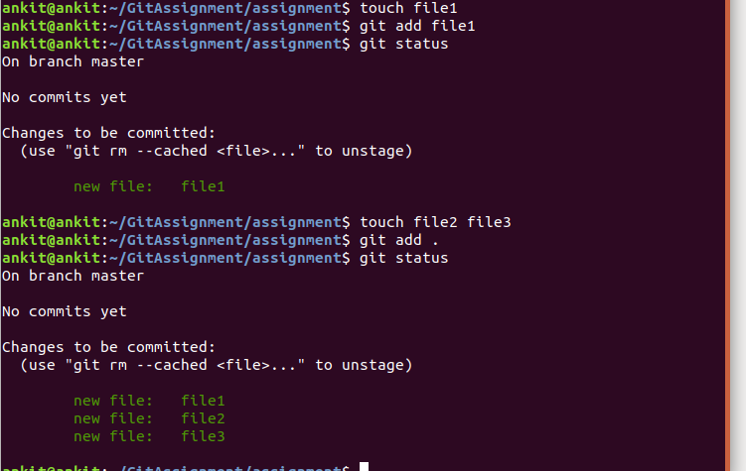

Question: 4:  
Unstage 1 file

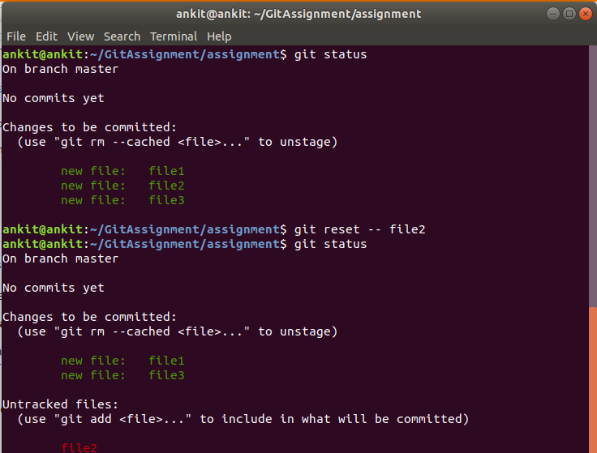

Question: 5:  
Commit the file

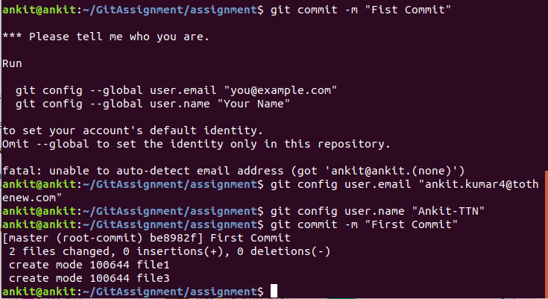

Question: 6:  
Add a remote



Question: 7:  
Undo changes to a particular file

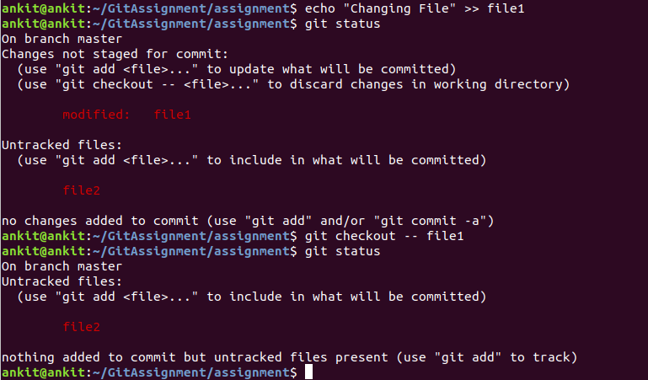

Question: 8:  
Push changes to Github

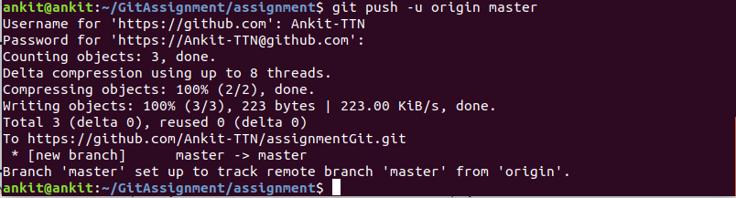

Question: 9:  
Clone the repository

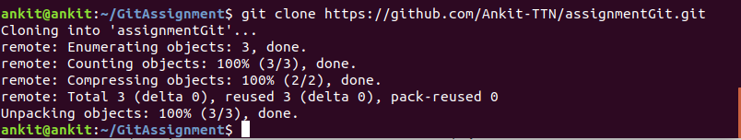

Question: 10:  
Add changes to one of the copies and pull the changes in the other.

Question: 11:  
Check differences between a file and its staged version

Question: 12:  
Ignore a few files to be checked in

Question: 13:  
Create a new branch.

Question: 14:  
Diverge them with commits

Question: 15:  
Edit the same file at the same line on both branches and commit

Question: 16:  
Try merging and resolve merge conflicts

Question: 17:  
Stash the changes and pop them

Question: 18:  
Add the following code to your .bashrc file : color_prompt="yes" parse_git_branch(){ git branch 2> /dev/null | sed -e '/^[^*]/d' -e 's/* \(.*\)/(\1)/' }if [ "$color_prompt" = yes ]; then PS1='\u@\h\[\033[00m\]:\[\033[01;34m\]\W\[\033[01;31m\] $(parse_git_branch)\[\033[00m\]\$ ' else PS1='\u@\h:\W $(parse_git_branch)\$ ' fi unset color_prompt force_color_prompt