SWIGGY SALES ANALYSIS
Python-Based Business & Sales Analytics Report
Prepared by: Ankit Kumar
Analysis period: January 2025 – August 2025
Tools: Python, Pandas, NumPy, Matplotlib, Seaborn, Plotly, Jupyter Notebook
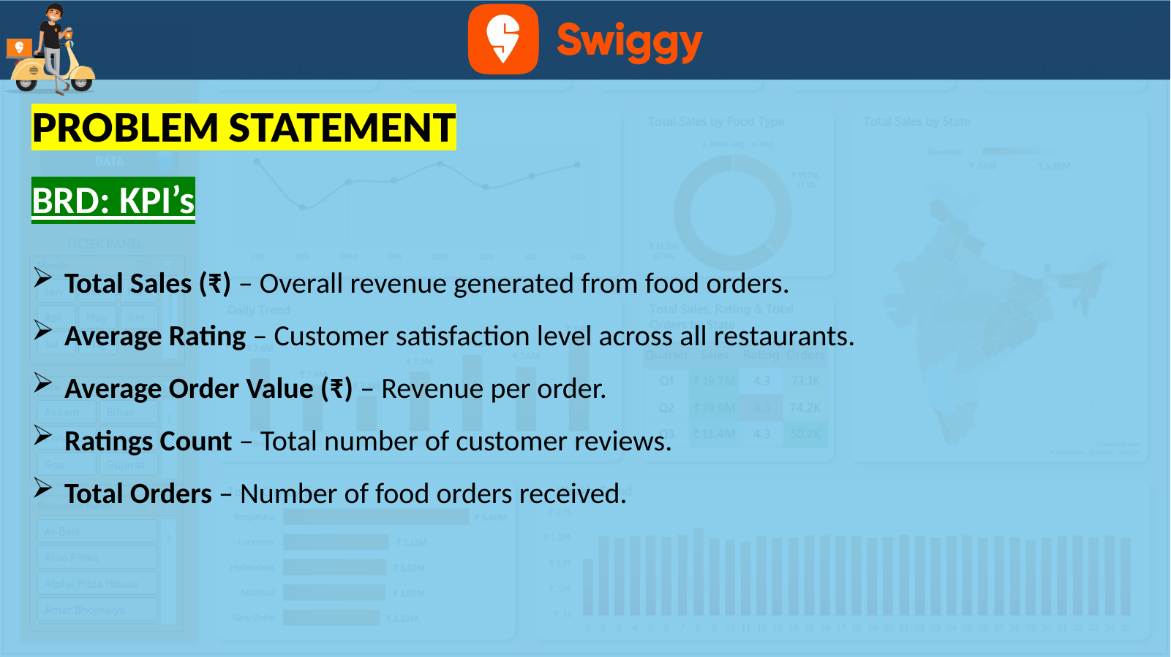

1. Executive Summary
This project analyzes 197,430 Swiggy order records covering January through August 2025. The notebook uses Python-based data exploration, KPI calculation, aggregation and visualization to examine revenue, ratings, order volume, food-category contribution, geography and time-based sales patterns.
The analysis reports total sales of ₹53,012,505.77, an average rating of 4.34, an average order value of ₹268.51, 5,591,574 rating counts and 197,430 order rows.

2. Dataset & Methodology
The dataset contains 10 fields: State, City, Order Date, Restaurant Name, Location, Category, Dish Name, Price (INR), Rating and Rating Count. The notebook imports the Excel dataset with Pandas, inspects its structure, calculates descriptive statistics, creates derived time fields and aggregates sales for business analysis.
Attribute | Details
Rows | 197,430
Columns | 10
Date range | 01 Jan 2025 – 31 Aug 2025
Numeric fields | Price (INR), Rating, Rating Count
Categorical fields | State, City, Restaurant Name, Location, Category, Dish Name

3. KPI Analysis
KPI | Calculation | Result
Total Sales | Sum of Price (INR) | ₹53,012,505.77
Average Rating | Mean of Rating | 4.34
Average Order Value | Mean of Price (INR) | ₹268.51
Ratings Count | Sum of Rating Count | 5,591,574
Total Orders | Number of rows | 197,430
Interpretation note: the notebook uses the number of rows as Total Orders and the mean of Price (INR) as Average Order Value. These metrics therefore describe the dataset structure and should not automatically be treated as unique customer-order metrics.

4. Food Category Analysis
Using the notebook's keyword-based classification, Veg-labelled revenue is ₹33,328,503.71 (62.9%) and Non-Veg-labelled revenue is ₹19,684,002.06 (37.1%).
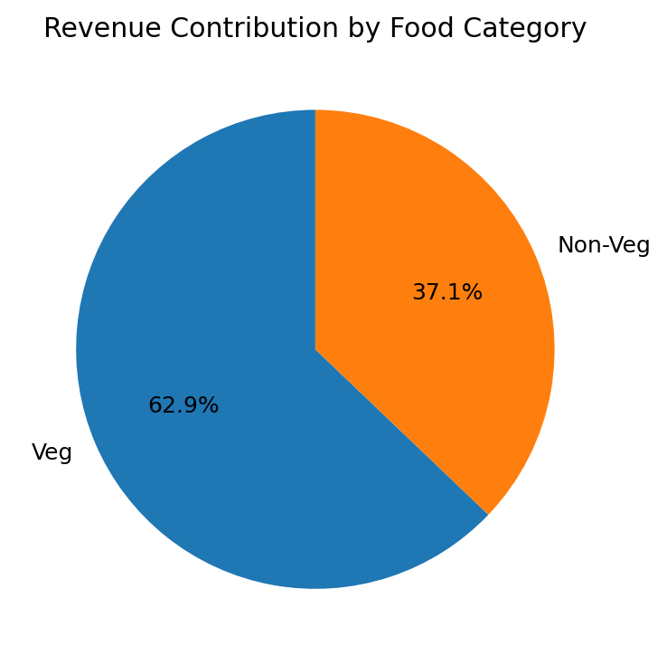

5. Geographic Analysis
Revenue was aggregated by State and City. Karnataka is the leading state and Bengaluru is the leading city.
1. Karnataka: ₹5,456,798.41 (10.3% of total sales)
2. Uttar Pradesh: ₹3,117,359.65 (5.9% of total sales)
3. Telangana: ₹3,021,711.62 (5.7% of total sales)
4. Maharashtra: ₹3,015,573.35 (5.7% of total sales)
5. Delhi: ₹2,829,180.60 (5.3% of total sales)
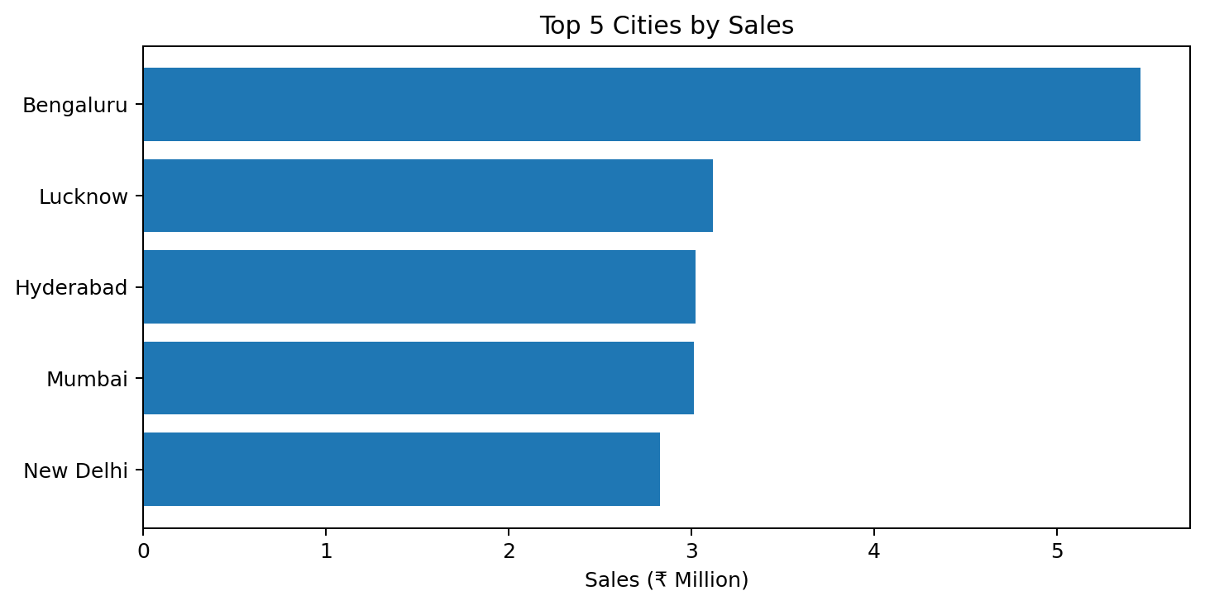
1. Bengaluru: ₹5,456,798.41 (10.3% of total sales)
2. Lucknow: ₹3,117,359.65 (5.9% of total sales)
3. Hyderabad: ₹3,021,711.62 (5.7% of total sales)
4. Mumbai: ₹3,015,573.35 (5.7% of total sales)
5. New Delhi: ₹2,829,180.60 (5.3% of total sales)

6. Time-Based Analysis
The project includes monthly, daily and weekly sales trends. The dashboard indicates that Saturday is the strongest day at approximately ₹7.8M, while Monday and Tuesday are the lowest at approximately ₹7.4M each.
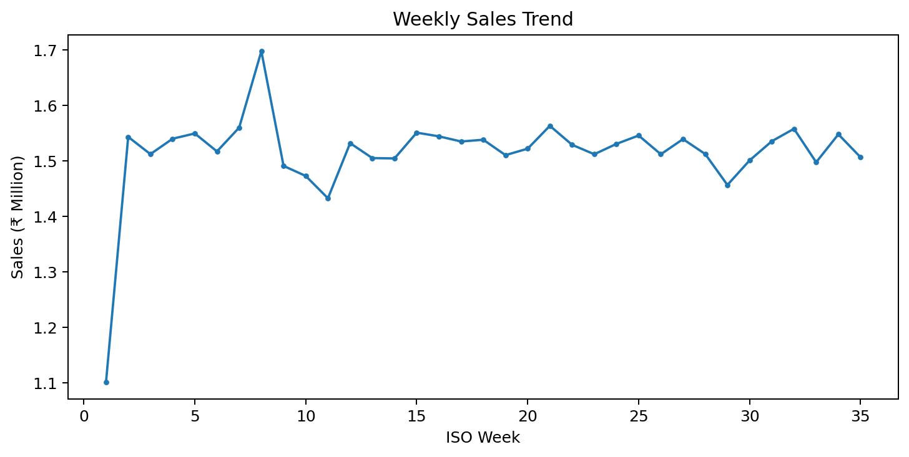
The weekly series covers 35 ISO weeks. Week 8 is the highest at ₹1,697,992.73, while Week 1 is the lowest at ₹1,101,057.42.

7. Quarterly Performance
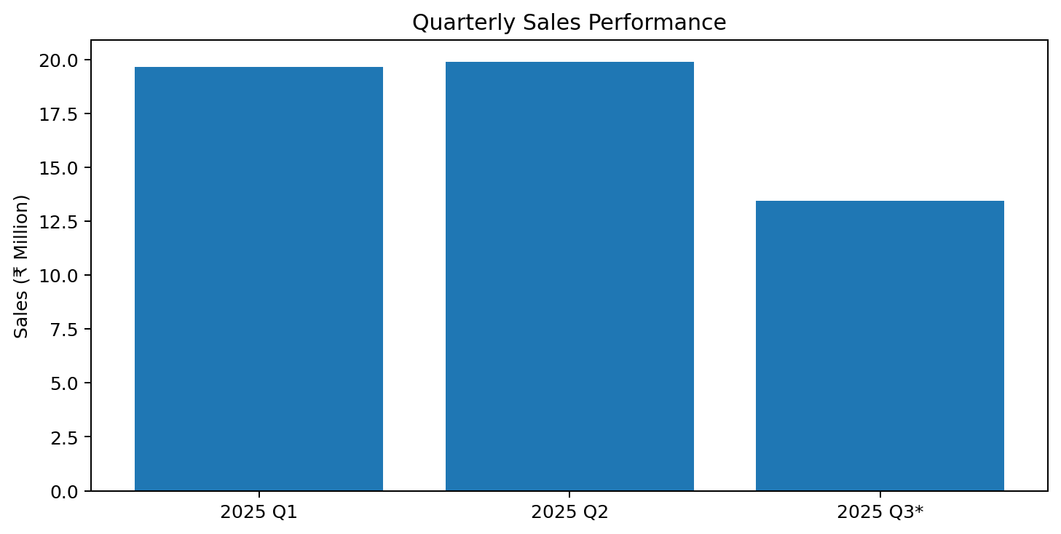
2025 Q1: Sales ₹19,667,821.77; Orders 73,096; Average Rating 4.343
2025 Q2: Sales ₹19,902,256.59; Orders 74,163; Average Rating 4.340
2025 Q3*: Sales ₹13,442,427.41; Orders 50,171; Average Rating 4.342
Q2 is the strongest reported quarter. Q3 is partial because the dataset ends on 31 August 2025, so it should not be compared directly with the two complete quarters as a full-quarter decline.

8. Business Insights & Recommendations
- Revenue is concentrated in a small group of leading states and cities, particularly Karnataka and Bengaluru.
- Veg-labelled items contribute the larger share of revenue under the notebook's keyword-based classification.
- Q2 is the strongest complete quarter in the available period.
- Saturday and Thursday show stronger daily sales than Monday and Tuesday.
- Weekly revenue is broadly stable after the first weeks, with short-term peaks and dips.
- Prioritize growth campaigns and restaurant partnerships in high-contribution markets while developing lower-sales states.
- Use stronger Thursday/Saturday demand as a basis for testing targeted promotions and delivery capacity.
- Analyze top cities at restaurant and dish level to understand the drivers of revenue concentration.
- Separate partial and complete periods in future reporting.
- Add a unique Order ID where possible to make order-volume and AOV metrics more robust.

9. Limitations
The analysis is limited to the supplied fields and records. Total Orders is based on row count. Food type is inferred from dish-name keywords. Q3 is partial, and the analysis is descriptive rather than causal.

10. Conclusion
The Swiggy Sales Analysis provides an end-to-end Python workflow for transforming transactional food-order data into business-oriented KPIs and visual insights. It combines exploratory analysis, aggregation, time-series analysis, geographic analysis and visualization, making it a strong portfolio example for a data analyst role.
Source: Swiggy_Sales.ipynb and Swiggy PPT.pptx

