**Research Question**

1. What are the variables that affect hotel reservation cancellations?
2. How can we improve on reservation cancellations?
3. How will hotels be assisted in making pricing and promotional decisions?

**Hypothesis**

1. More cancellations occur when prices are higher.
2. Longer waiting list leads to frequent cancellations.
3. Major clients are coming from offline travel agents.

**Analysis and Findings**

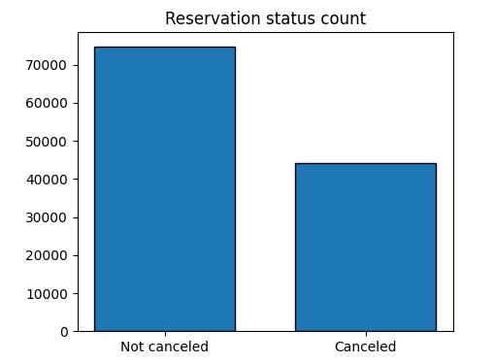

The above bar graph shows the percentage of reservations that are canceled and those that are not. It is clear that a significant number of reservations have not been canceled. There are 37% clients who canceled their bookings significantly impacting hotel earnings.

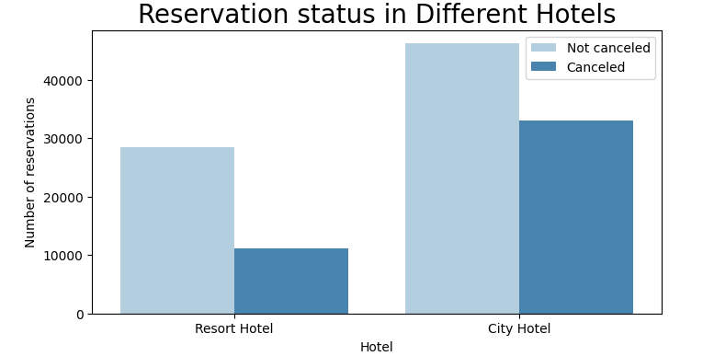

In comparison to resort hotels, city hotels have more bookings. It’s possible that resort hotels are more expensive than those in cities.

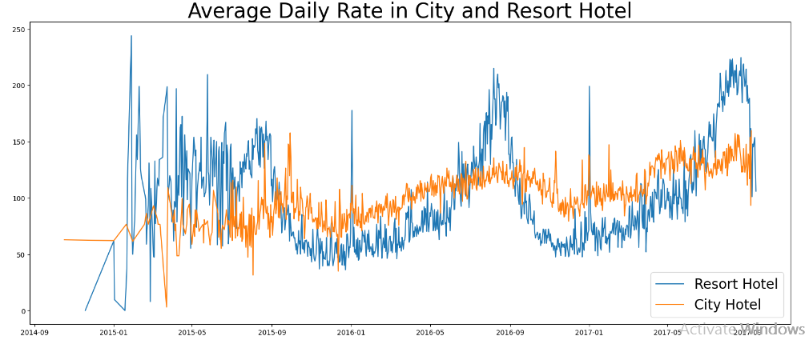

This line graph shows that on certain days the average daily rate for a city hotel is less as compared to resort hotel. During weekends and month ends there is a rise in resort hotel rates.

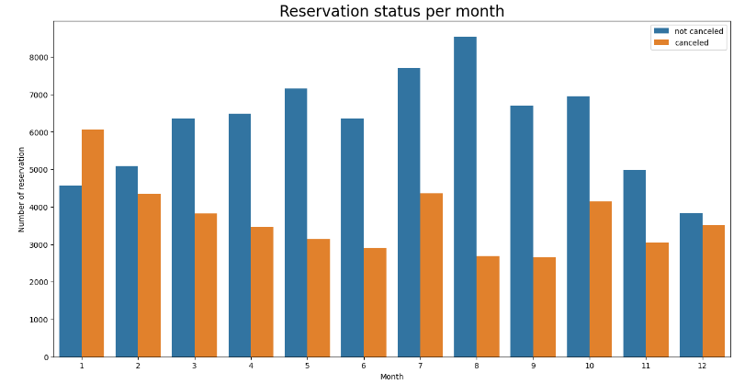

A grouped bar graph was developed to analyze the months with highest and lowest reservation levels according to reservation status. As can be seen, both the number of confirmed reservations and the number of canceled reservations are largest in the month of august. January is the month with the most canceled reservations.

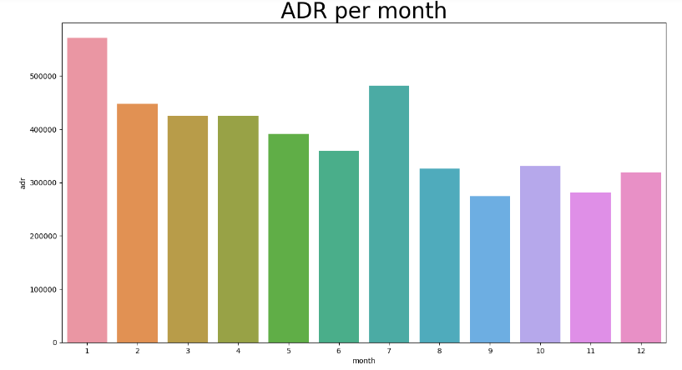

This bar graph tells that cancellations are most common when prices are high and least common when prices are low. Therefore, the cost of the accommodation is solely responsible for the cancellation.

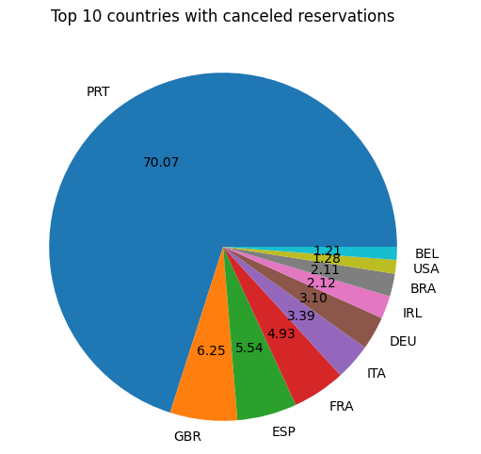

To see which country has the greatest cancellation rate a pie char was developed and Portugal was found to be the country with highest number of cancellations.

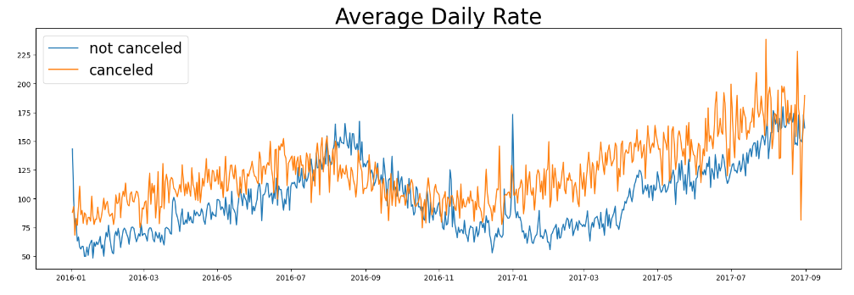

From the above graph we can see reservations are cancelled when average daily rate is higher than when it is not canceled. It suggests that the higher price leads to higher cancellations.

**Suggestions**

1. In order to prevent cancellations hotels could work on their pricing strategies and try to give discounts in specific locations as cancelation rates increases with the increase in price.
2. During January hotels can start their marketing campaigns to increase their revenue as the cancellation is highest in this month.
3. Hotels can improve their quality and overall experience provided to customers in Portugal to reduce cancellation rate as maximum cancellations are occuring here.