|  |  |
| --- | --- |
| **LSOA Zone** | **% Population Aged 0-4** |
| 23 | 3 |
| 25 | 4 |
| 30 | 6 |
| 31 | 6 |
| 98 | 7 |
| 64 | 7 |
| 69 | 7 |
| 59 | 8 |
| 72 | 9 |
| 99 | 11 |

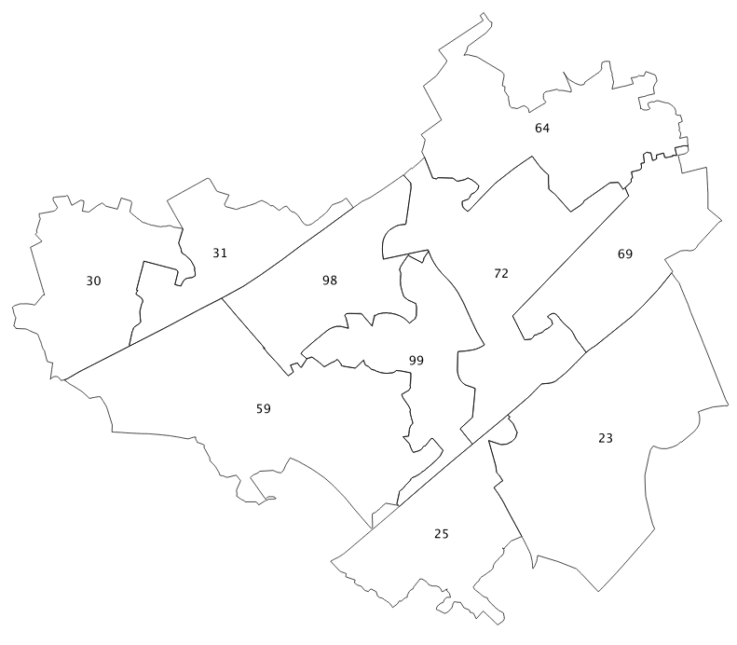 http://www.nickbearman.me.uk/twe/wp-content/uploads/2015/01/basics-spatial-data.pdf

Using the values in the table, colour in the LSOAs in this part of Liverpool according to the percent of population ages 0 - 4 in 2011. Also remember to indicate in the table which colours represent which values.