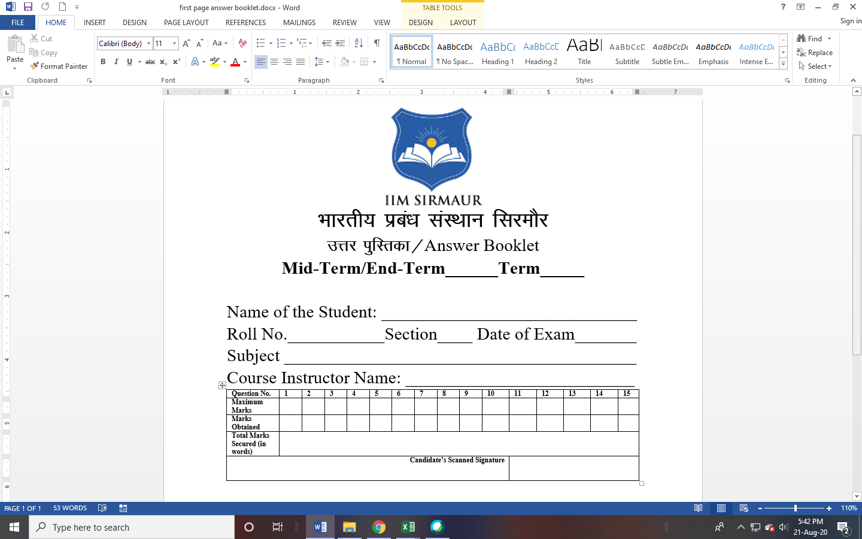

**THM**

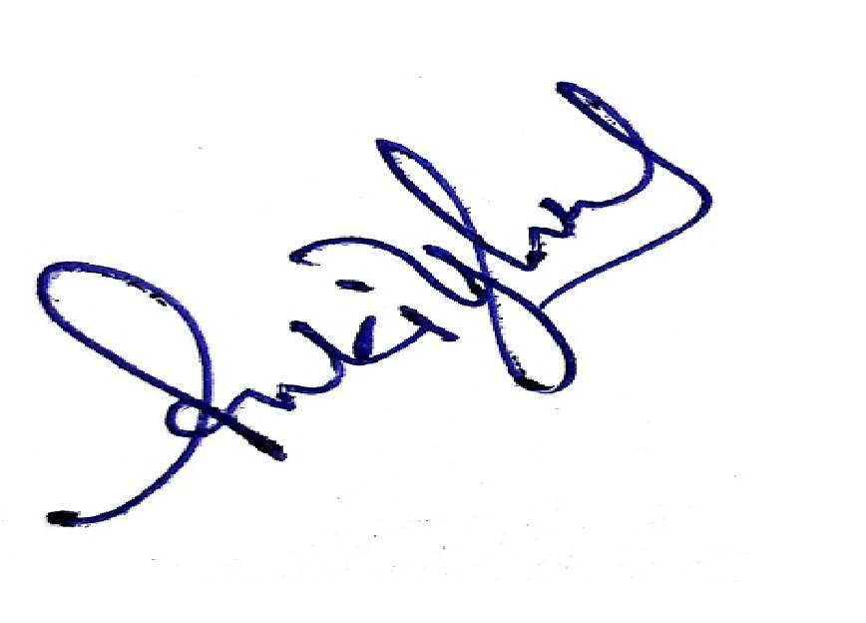

VI

**ET**

**Prof (Dr.) Bin Shen**

**Luxury Management**

**23/03/2023**

**MBATHM02003**

**Ankit Singhal**

**Declaration:**

1. I have submitted faculty feedback 30 minutes prior to appearing in the End-Term Exam.
2. I have not copied the answer/matter in this answer booklet from my classmate, internet and any other sources.

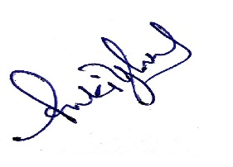

Signature of the Student