**BUG 1: -**

95/10 -> Output is 10

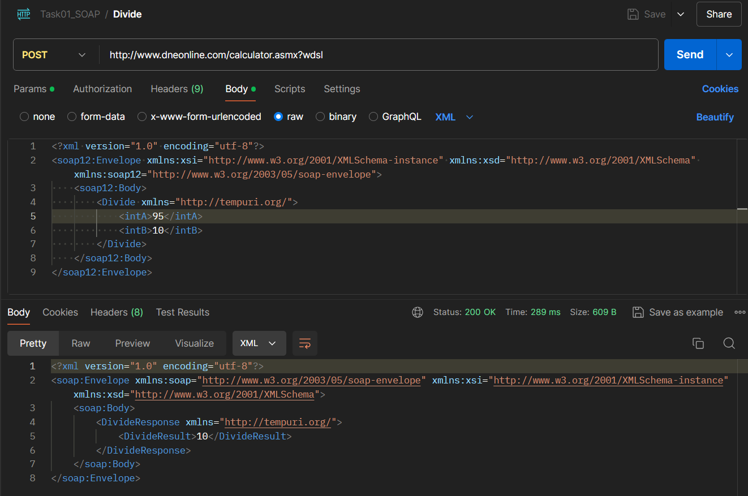

BUG 2 : - -0 Input is accepting by system

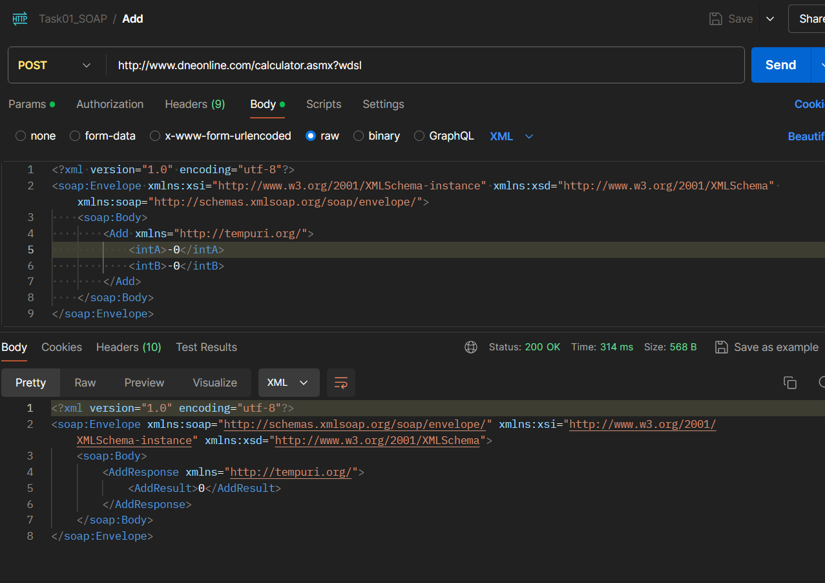

BUG 3 : - 91/100 is giving 1 as output

