1. Divide Request

Before Sending Request

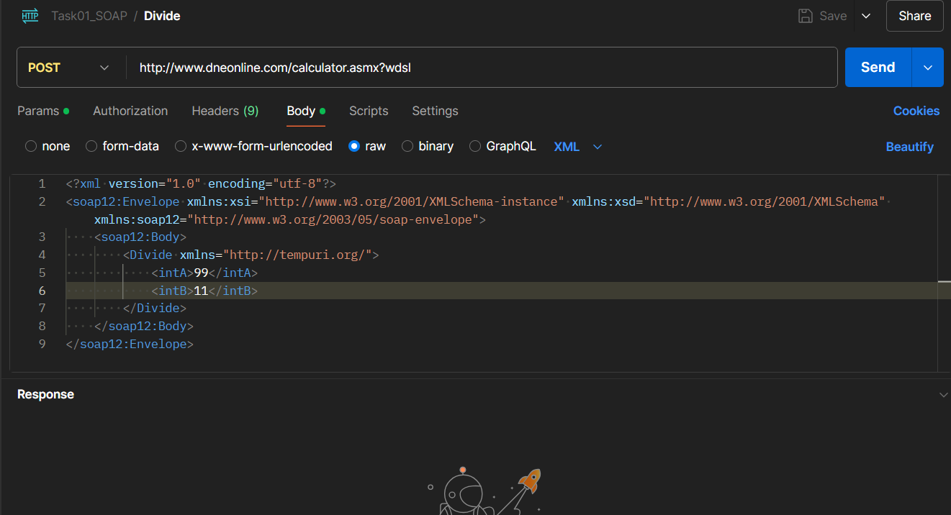

After Sending Request

