

CENTENNIAL COLLEGE PROGRESS CAMPUS

COURSE COMP125

ASSIGNMENT #2

JavaScript Loops

Create an HTMLdocument called **assignment2.html** that implements a webpage that creates dynamically (using JavaScript code) a 15X15 HTML table and displays in each cell the (row, column) information for that cell.

Follow these guidelines to implement your assignment:

1. Create a JavaScript file called assignment2.js and write the code for a function that draws the table.
2. Invoke the function when the visitor clicks on the original page.
3. Load the assignment2.js file at the end of the body in assignment2.html.
4. (**10% of the grade**) Accept user input for the number of rows and columns in the table.
5. (**10% of the grade**) Use good web design practices to enhance visually your html page. Add a title, picture, colors, copyright line, etc.

Basic screenshots for the functionality of this assignment are shown below:

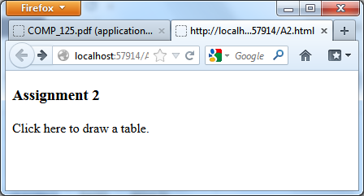

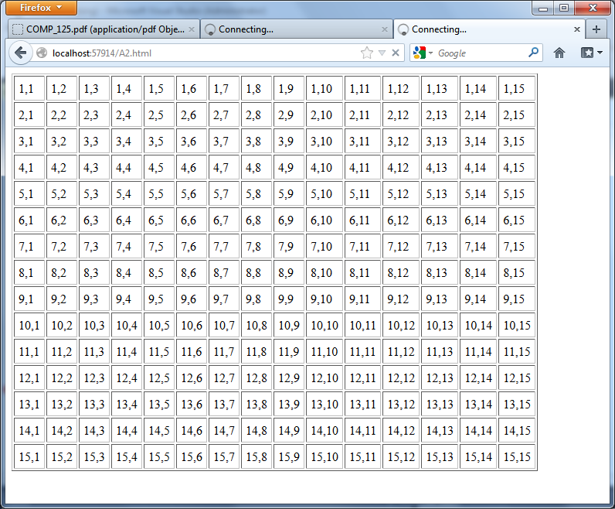

Submit your assignment to Assignment 1 drop box. ALSO PUBLISH IT to the student web.

Its just hard to keep track of these assignments.

prof can you open the connect assignment-2 once more I missed it