KIIT Deemed to be University
School of Computer Science Engineering,
Bhubaneswar, ODISHA 751024



CERTIFICATE

This is to certify that the project entitled

“CODEOMEN”

Is a record of bonafide work carried out by them, in the partial fulfilment of the requirement for the award of Degree of Bachelor of Engineering (Computer Science & Engineering) at KIIT Deemed to be university, Bhubaneswar. This work is done during year 2023-2024.

Date: 10/04/2024

Asst.

(Project Guide)

ACKNOWLEDGEMENTS

We are profoundly grateful Deepender Singh of Affiliation for his expert guidance and continuous encouragement throughout to see that this project rights its target since commencement to its completion. ………….

ANKIT RAJ KUSHWAHA 2105105

ASUTOSH KUMAR ROUT 2105781

SAMUDRANEEL SENGUPTA 2105821

CONTENT PAGE

 | Introduction |  |  |  |  | 1
 | Abstract |  |  |  |  | 2
 | Developer Tools |  |  |  |  | 3
 | Project Planning |  |  |  | 5
 | Project Features |  |  |  | 7
 |  |  | Screenshots |  | 11
 | Standard Adopted |  |  |  |  | 12
 | Project Structure |  |  |  | 16
 | Challenges Faced |  |  |  | 17
 | Future Improvement |  |  |  | 18
 | Conclusion |  |  |  | 18
 | Individual Contribution
 | Individual Contribution |  |  |  |  | 19
 | Plagiarism Report |  |  |  |  | 22

PROJECT REPORT

ON

“CODEOMEN”

Submitted to

KIIT Deemed to be University

In Partial Fulfilment of the Requirement for the award of BACHELOR’S DEGREE IN COMPUTER SCIENCE AND TECHNOLOGY

 | BY
ASUTOSH KUMAR ROUT | 2105781
ANKIT RAJ KUSHWAHA | 2105105
SAMUDRANEEL SENGUPTA | 2105821

UNDER THE GUIDANCE OF

ASST. PROF. DEEPENDER SINGH

SCHOOL OF COMPUTER SCIENCE ENGINEERING

KALINGA INSTITUE OF INDUSTRIAL TECHNOLOGY

BHUBANESWEAR, ODISHA – 751024

APRIL 2024

INTRODUCTION‬

Over the span of a year, the advancement in competitive coding platforms has profoundly‬ influenced the technological landscape, revolutionizing coders and informatics enthusiasts with‬ technological ‬endeavors like problem-solving, the need of structured roadmaps and question sets has become integral to various‬

facets of daily life. As the requirements of SDE entry level engineers continue to improve daily,‬ its scope of application expands exponentially. Whether it's writing optimal code , using best coding practices ‬or solving complex‬ ‭mathematical problems, the possibilities seem limitless.‬

The need to make codeomen was that there are a lot of competitive coding platforms present at this point in time , our SAAS application gives a seamless and free experience to users who are generally starting out their coding journey. The website has a very minimalstic UI design so that people using the website can be more focused on problem solving rather than being fazed and demotivated by the vast amount of questions present in different platforms . Our website includes a heterogeneous list of questions which are handpicked from famous data structures and algorithms list like Blind-75 & Blind-150 . Since this project is completely open-source the users don’t need to worry about any subscription model making it accessible to all.
ABSTRACT‬

While DSA is important for coding, not everyone can master it easily, it takes time, effort, and a lot of practice. That’s why CodeOmen might be a great source for you to learn and follow as a self-paced course. You can practice questions from it whenever you want, wherever you want.

This platform is tailored in such a way that it’ll be easy for everyone to follow along and practice DSA.

Things we’ve to offer to you:

• Master DSA from basic to advanced level

• Solve the problems asked in product-based companies

• Solve problems in contests similar to coding round for SDE role

• Become a strong and efficient developer

The only website you’ll ever require to master DSA.

Why did we build it?

Two major problems that students face who want to improve and sharpen their skills, practice questions are a good place to keep everything in an organized manner and keep track of their progress.

That is where CODEOMEN comes in. Complete with its own online compiler, user registration, interactive UI, and a platform to get all resources compiled by experts in their field, it solves the faced issues and also aims to get students to submit their code during home-brewed hackathons.

2‭.2 Developer tools:‬

1‬‭.‭‬Next‭.js:‬Next‭.js is a popular React framework for‬‭building web‬

applications‭. It provides features like server-side rendering, static site‬ ‭generation, routing, and code splitting, making it efficient for building‬ ‭fast and scalable web applications.‬‭Next.js also abstracts‬‭and‬

automatically configures tooling needed for React, like bundling,‬ ‭compiling, and more.‬

2‬‭‬.‭TypeScript: ‬‭TypeScript is a statically typed superset‬‭of JavaScript that‬ ‭adds optional static typing to the language.Ithelps catch errors during‬ development, improves code quality, and enhances developer‬ productivity by providing better code navigation and refactoring tools.‬

3‭. Tailwind CSS:‬Tailwind CSS is a utility-first CSS‬‭framework that provides pre-built utility classes to style HTML elements. It allows‬ ‭developers to quickly build custom designs without writing traditional‬ CSS styles, making it flexible and easy to maintain.‬It‬ provides a vast‬ ‭collection of utility classes for things like margins, padding, fonts, and‬ responsiveness‭. These classes can be directly added to your HTML‬ ‭elements, allowing for rapid styling without writing a lot of custom CSS.‬

‭4. Firestore : Firestore is a flexible, scalable database for mobile, web, and server development. It's a NoSQL database that enables real-time syncing and offline data access, making it perfect for applications that require responsive and dynamic content. With Firestore, you can easily store and sync data between your users' devices in real time, ensuring that everyone has the latest information.

5. Firebase : Firebase Authentication, on the other hand, provides a straightforward way to authenticate users to your app. It supports authentication using passwords, phone numbers, popular federated identity providers like Google, Facebook, and Twitter, and more. Firebase Authentication also integrates seamlessly with Firebase services like Firestore, allowing you to secure your data and ensure that only authenticated users can access it.
3 PROJECT PLANNING‬

1) Development time and Project Scheduling: Project has been scheduled and completed in 2 months duration. It has been divided into several modules to be‬ ‭analyzed, executed and updated by each team member.‬

‭2) Resources Required (both software and hardware):‬ ‭Hardware: Laptop, Desktop‬
Minimum Ram: 16GB‬

‭Processor: AMD RYZEN 7 @ 1.30GHz 1.50 GHz‬

3) Software:‬

VS Code:‬

‭Visual Studio Code (often Known as VS Code) is a free and open-source source‬

code editor developed by Microsoft. It is a popular choice among web developers,‬ as we Know it supports a wide range of programming languages like HTML, CSS,‬ ‭JavaScript, and many more. VS Code offers many useful features such as syntax‬

highlighting, auto-completion, debugging, version control integration, and a‬ ‭powerful extension system that allows developers to customize their coding‬

environment‭. It's a lightweight and fast editor that runs on multiple platforms,‬ ‭including macOS, Linux and Windows.‬

To run a Next.js server in the VS Code terminal, you can follow these steps:‬

‭●‬ ‭Open your project: Navigate to your project’s directory in VS Code.‬

‭●‬ ‭Open the terminal: Go to the Terminal menu and select New Terminal.‬

●‬ Install dependencies (if you haven’t already): Run npm install to install all‬ ‭required packages.‬

‭●‬ Start the development server: Execute the command npm run dev. This will‬ ‭start the Next.js development server.‬

●‬ Access your application: Open a web browser and go to localhost: 3000 to‬ ‭view your application.‬

Run our project Locally:‬

‭●‬ ‭Open your project: Navigate to your project’s directory in VS Code.‬

‭●‬ ‭Open the terminal: Go to the Terminal menu and select New Terminal.‬

●‬ Install dependencies (if you haven’t already): Run npm install to install all‬ ‭required packages.‬

‭●‬ Start the development server: Execute the command npm run dev. This will‬ ‭start the Next.js development server.‬

●‬ Access your application: Open a web browser and go to localhost:3000 to‬ ‭view your application.‬

GitHub:‬‭

GitHub is a for-profit company that offers a cloud-based Git repository hosting‬ ‭service. In essence, it makes it much simpler for both individuals and teams to‬

utilize Git for collaboration and version control.‬

‭GitHub's interface is user-friendly enough so even novice coders can take‬

advantage of Git. Without GitHub, using Git generally requires a bit more‬ ‭technical savvy and use of the command line.‬

Project Features

Authentication: Implemented user authentication using Firebase Authentication. Users can sign up, log in, and log out securely. Firebase Authentication provides easy-to-use methods for managing user authentication and ensures secure access to the application's features.

Database: Used Firebase Firestore as the database. Firestore is a scalable, real-time database solution provided by Firebase. It allows for efficient storage and retrieval of data, making it ideal for applications with real-time data requirements.

User Interface: Designed the user interface using HTML, Tailwind CSS, and TypeScript. HTML provides the structure of the UI, Tailwind CSS is used for styling, and TypeScript ensures type safety throughout the application. The UI is responsive and user-friendly, providing a seamless experience across different devices.

Routing: Utilized Next.js for client-side routing. Next.js provides a simple and efficient way to manage routing in a React application, allowing for dynamic loading of pages and optimized performance.

State Management: Managed application state using React's built-in state management capabilities. TypeScript was used to ensure type safety, reducing the likelihood of runtime errors related to state management.

Deployment: Deployed the application on a hosting platform like Vercel or Firebase Hosting. This makes the application accessible to users over the internet, allowing them to use it from any device with an internet connection.

Problem Dashboard: Users can view a list of coding problems, filter them by category and difficulty, and search for specific problems.

Problem Page: Each problem has its own page displaying the problem statement, input/output examples, and a code editor for submitting solutions.

Code Editor: The CodeMirror library is used to provide a syntax-highlighted code editor with features like auto-indentation and line numbers.

Solution Submission: Users can submit their solutions to problems, which are then evaluated for correctness.

Feedback: Toastify is used to provide feedback to users, such as success messages for successful submissions and error messages for invalid submissions.

Working screenshots

- Login page:

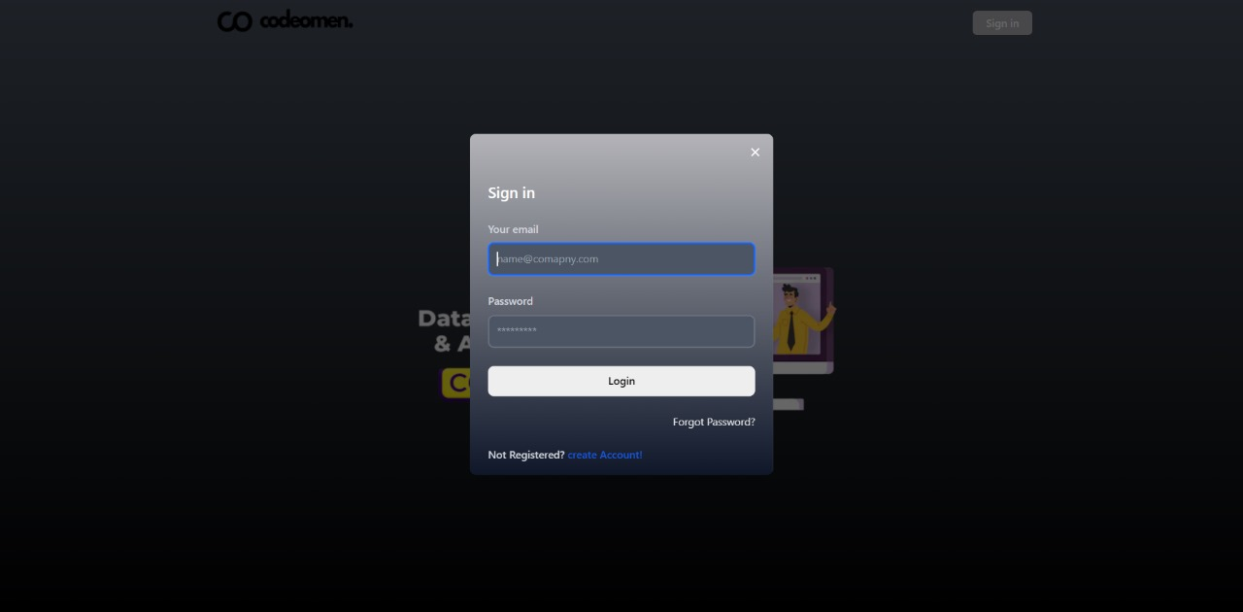

- Problem Page

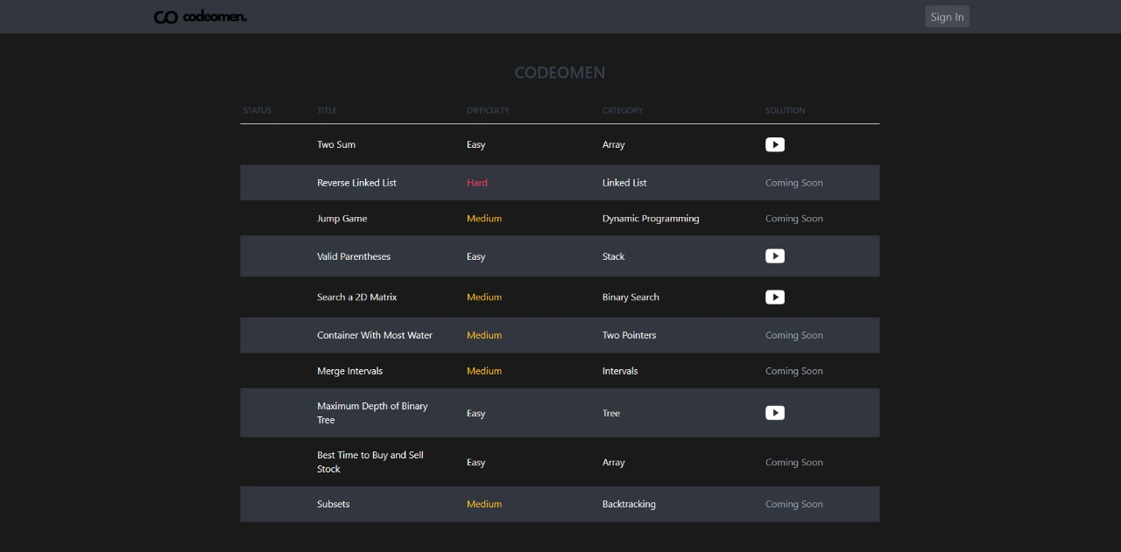

- Code Editor

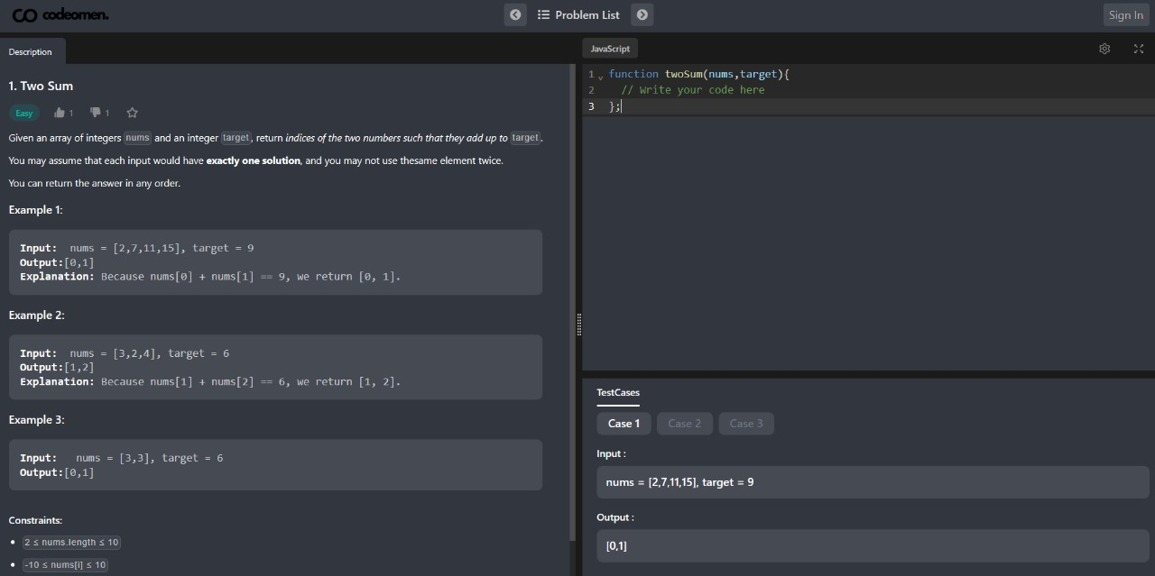

- Test Cases passed

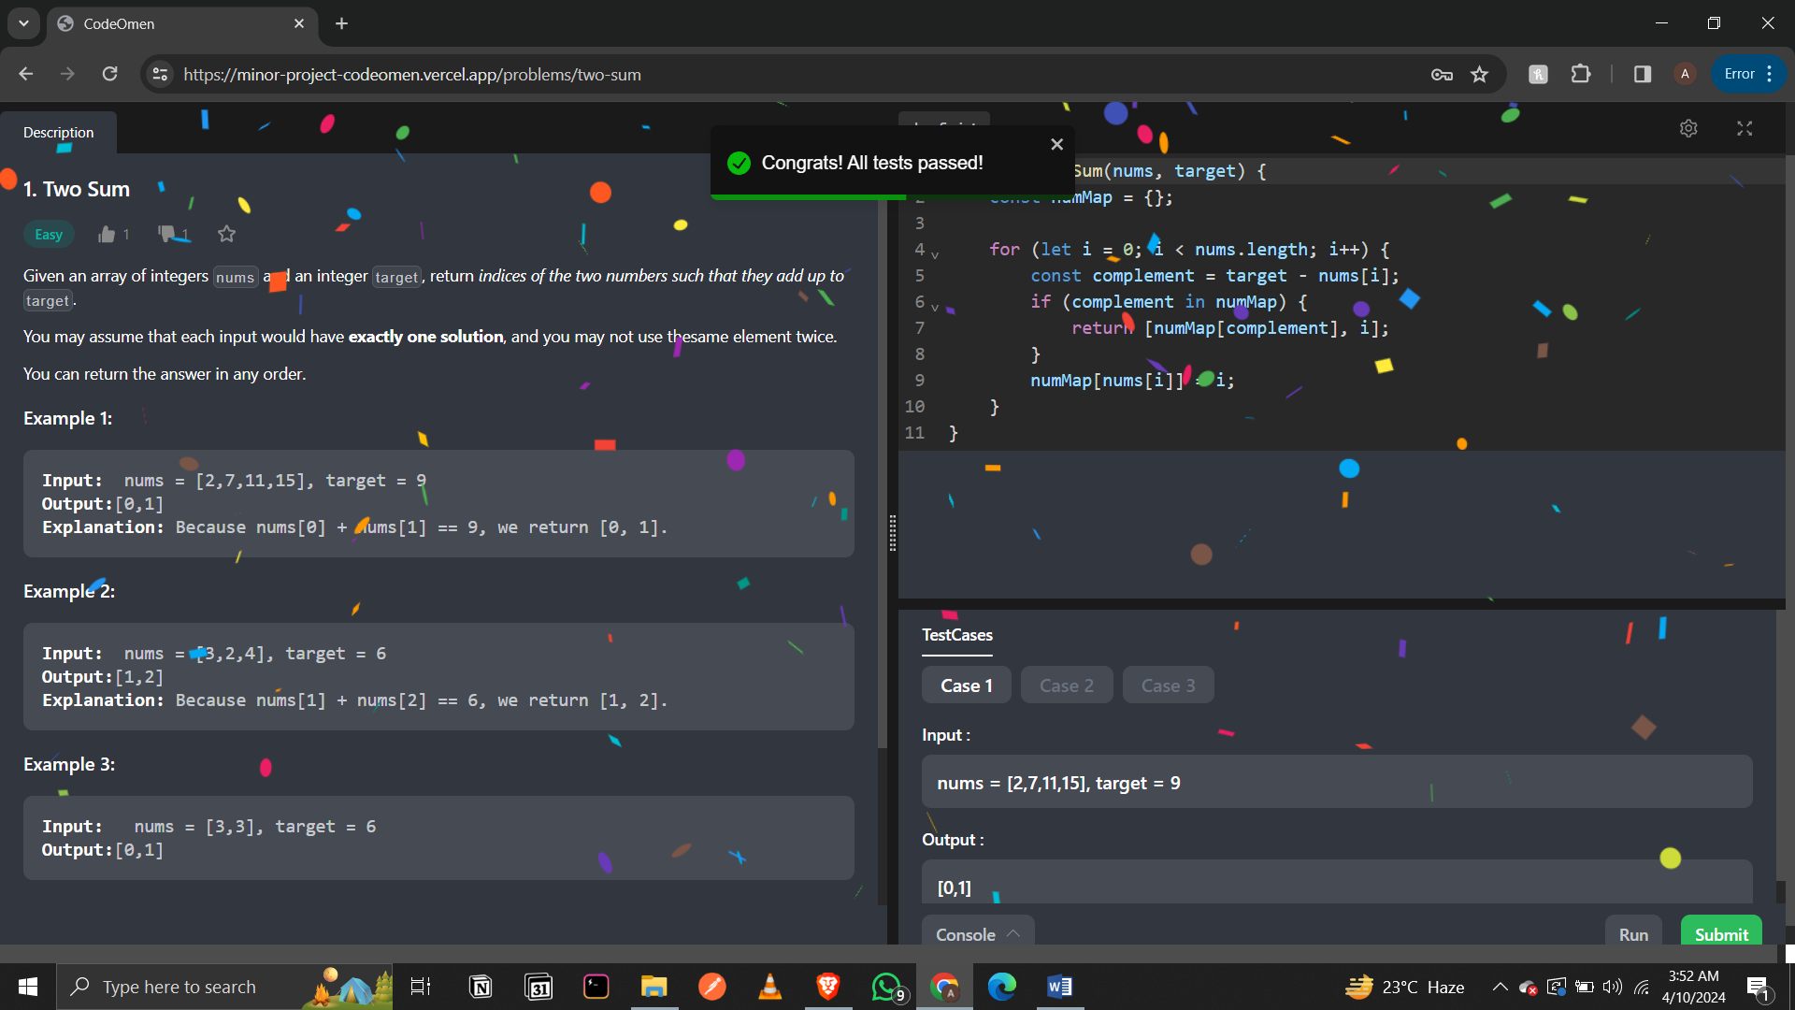

Standards Adopted‬

Why are coding standards important?‬

-Coding standards are important because they give a uniform appearance to the codes written by‬ different engineers, improve readability and maintainability of the code, reduce complexity, help‬ ‭in code reuse, and help to detect errors easily. They also promote sound programming practices‬ ‭and increase efficiency of the programmers. A coding standard ensures that all developers‬

writing the code in a particular language write according to the guidelines specified, making the‬ code easy to understand and providing consistency in the code.‬

1. Design Standards:‬

-Design standards, also known as design guidelines, are sets of rules, criteria, and best practices‬ that guide designers in creating consistent, effective, and safe designs. We have made use of‬ various Tools and Tech stacks to achieve quality design standards.‬

1.1 Planned Design with Excalidraw‬- Excalidraw is‬‭a virtual collaborative whiteboard tool‬

that lets you easily sketch diagrams that have a hand-drawn feel to them .We make use of‬

Excalidraw to set the initial design of the project i.e, how various components of the project‬

should look like roughly in order to have a uniform and consistent visual idea of the project‬ throughout the team.‬

1.2 Style and Layout with Tailwind CSS‬- Tailwind CSS plays a significant role in shaping‬

modern web design standards.‬‭Tailwind CSS follows‬‭a utility-first approach, providing a vast‬

array of single-purpose utility classes.‬‭These classes‬‭allow developers to style elements directly‬

within their markup or JavaScript files, eliminating the need for separate CSS files.‬‭Tailwind‬

‭CSS integrates seamlessly with CSS Media Queries, making it a responsive framework.Whether‬

you’re designing for desktop or mobile devices, Tailwind ensures your UI elements adapt‬ ‭gracefully to different screen sizes.‬

2‭.Coding Standards:‬

‭-Coding standards, also known as coding guidelines or programming style guides, are essential‬ ‭rules and conventions that developers follow when writing code.‬

2‭.1 Efficiency and Productivity‬– When developers adhere to established standards, they‬ spend less time debating style choices. This efficiency leads to faster development cycles and‬ ‭better productivity. Thus, the project is made using ‬‭TypeScript‬‭ and‬‭ NextJs‬‭‬.

Next‭.js ensures:‬

‭Production-Ready Framework:‬‭Next.js is built on top‬‭of React and Node.js, providing a robust‬ ‭framework for building web applications. It supports both static and dynamic rendering, making‬ ‭it versatile for various use cases.‬

Automatic Code Splitting:‬Next‭.js automatically splits‬‭your JavaScript bundles, loading only‬ the necessary code for each page. This improves performance by reducing initial load times.‬

API Routes:‬Next‭.js v9 introduced API routes, allowing‬‭you to create serverless backends‬ within your Next app. This simplifies backend development and enables seamless integration‬ ‭with client-side code.‬

‭Analytics Integration:‬‭Next.js integrates with popular‬‭analytics tools, helping you monitor and‬ ‭improve your application’s performance.‬

TypeScript :‬‭

‭Static Typing:‬‭ TypeScript adds static typing to JavaScript, catching errors at compile time rather‬ ‭than runtime. This leads to more reliable code and easier maintenance.‬

‭Type Definitions:‬‭TypeScript provides clear data types‬‭for variables, function parameters, and‬ ‭return values. This clarity improves code predictability and reduces type-related errors.‬

‭Code Readability and Maintainability:‬‭By defining‬‭types and interfaces, TypeScript promotes‬ ‭better code organization. It makes refactoring less intimidating and helps developers understand‬ ‭data structures and function purposes.‬

Safer Refactoring:‬TypeScript identifies issues early,‬‭reducing risks associated with subtle‬ type‭-related errors in JavaScript.‬

‭Combining Next.js with TypeScript ensures:‬

‭Project is divided into several components and each component serves its own functionality‬

‭which ensures divide and conquer strategy and also increases code readability and maintenance.‬ ‭In the end all modules are integrated with each other to perform a certain action or achieve a‬

required task .In this way , the whole project is completed and various modules altogether‬ ‭provide utility to the end user.‬

‭Improved Code Quality: TypeScript’s type system catches errors early, leading to better code‬ ‭quality and maintainability.‬

‭Better Developer Experience: Enhanced tooling and IntelliSense make development faster and‬ ‭more enjoyable.‬

‭Scalability: Both Next.js and TypeScript support scalability, allowing you to build large and‬ ‭complex applications confidently.‬

Community Support: Both technologies have active communities, providing resources, libraries,‬ and best practices.‬

Project Structure

Pages: Contains the different pages of the application, each representing a different route. Next.js automatically handles the routing based on the files in the "pages" directory.
Components: Reusable UI components used throughout the application. Components are organized based on their functionality and can be easily reused across different pages.
Pages: Contains modules for interacting with Firebase services, such as authentication and database operations. Services abstract the complexity of interacting with Firebase, making it easier to manage and maintain.
Styles: Contains global styles and utility classes for styling the application. Tailwind CSS is used to style the application, providing a consistent look and feel across different parts of the UI.

Challenges Faced

Integration: Integrating Firebase services with Next.js and TypeScript required careful configuration and setup. Ensuring that Firebase services work seamlessly with the application's frontend and backend logic was a challenge that required thorough testing and debugging.
Styling: Ensuring a consistent and visually appealing design across different screen sizes was a challenge. Tailwind CSS was used to address this challenge, providing a flexible and responsive design system that adapts to different screen sizes and resolutions.

Future Improvements

Performance Optimization: Implementing lazy loading and code splitting to improve the initial loading time of the application. This can help reduce the amount of data transferred over the network and improve the overall performance of the application.
Enhanced Security: Implementing additional security measures, such as rate limiting and input validation, to protect against potential attacks. This can help improve the security posture of the application and protect user data from unauthorized access.
Feature Expansion: Adding new features, such as user profiles, messaging, or social sharing, to enhance the functionality of the application. This can help make the application more engaging and useful for users, leading to increased user satisfaction and retention.

Conclusion

The project demonstrates the use of modern web technologies to build a full-stack web application with a focus on user authentication and data management. It serves as a solid foundation for future enhancements and showcases the developer's proficiency in frontend and backend development. The application provides users with a seamless and secure experience, making it a valuable addition to the developer's portfolio.

CodeOmen‬‭

Ankit Raj Kushwaha‬

2105105‬‭

Individual Contribution and Findings:‬designed User interface of web app and‬

system design , setting up database , implemented user authentication , created‬

Support Page , Home Page , Dashboard Page

Individual Contribution to project report preparation:‬Helping

members to create documentation.‬

‭Full Signature of Supervisor: Full Signature of Student:‬

‭……………………………. ………………………….‬

CodeOmen‬‭

Samudraneel Sengupta

2105821

Individual Contribution and Findings:‬ Integrated database with frontend and backend, added questions to the problem page with test cases, System Design

Individual Contribution to project report preparation: ‬Standards Adopted‬

\

Full Signature of Supervisor:

Full Signature of Student:‬

‭…………………………….

………………………….‬

CodeOmen‬‭

Ashutosh Kumar Rout‬

2105781

Individual Contribution and Findings: Setting Up Tailwind CSS with Next.js, Component Styling, data fetching and API

Individual Contribution to Project Report Preparation:‬Certification,‬‭

Introduction, Acknowledgement, Formatting of the entire Report, Content.‬

‭Full Signature of Supervisor:

Full Signature of Student:‬

‭

…………………………… ………………………….‬

Plagiarism Report
ACKNOWLEDGEMENTS
21

ORIGINALITY REPORT

%
SIMILARITY INDEX
19%
INTERNET SOURCES
2%
PUBLICATIONS
16%
STUDENT PAPERS

PRIMARY SOURCES

www.worldleadershipacademy.live
Internet Source %
2
1

2 Submitted to Icon College of Technology and Management
2%
Student Paper
2

suspace.su.edu.bd
Internet Source %
2
3

Submitted to Banaras Hindu University
Student Paper %
1
4

Submitted to University of Greenwich
Student Paper %
1
5

origin.geeksforgeeks.org
Internet Source %
1
6

dspace.daffodilvarsity.edu.bd:8080
Internet Source %
1
7

medium.com
Internet Source %
1
8

Submitted to University of Westminster
Student Paper %
9

10

11

12

13

14

15

16

17

18

19

20
blog.codacy.com
Internet Source

goo.by
Internet Source

www.coursehero.com
Internet Source

Submitted to KIIT University
Student Paper

www.ncbi.nlm.nih.gov
Internet Source

Submitted to Queen's College
Student Paper

primalgrowpro.shop
Internet Source

Submitted to Manchester Metropolitan University
Student Paper

firebase.google.com
Internet Source

Submitted to National University of Ireland, Galway
Student Paper

getintopc.com
Internet Source
1%
1%
1%
1%
1%
1%
1%
<1%

<1%
<1%

<1%

21
Ton Duc Thang University
Publication
<1%

Exclude quotes Off Exclude bibliography Off
Exclude matches Off

