- Creating and Renaming Files/Directories

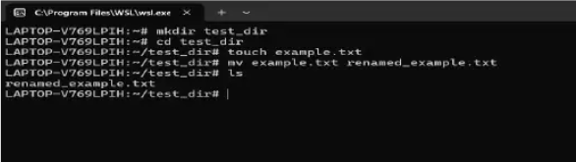

- Viewing File Contents

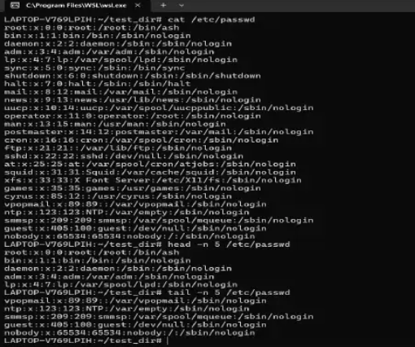

Use cat to display the contents of /etc/passwd – cat /etc/passwd

Display only the first 5 lines of /etc/passwd using head –
head -n 5 /etc/passwd

Display only the last 5 lines of /etc/passwd using tail –
Tail -n 5 /etc/passwd

- Searching for Patterns
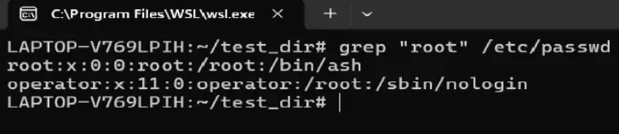
Use grep to find all lines containing the word "root" in /etc/passwd –
grep "root" /etc/passwd

- Zipping and Unzipping
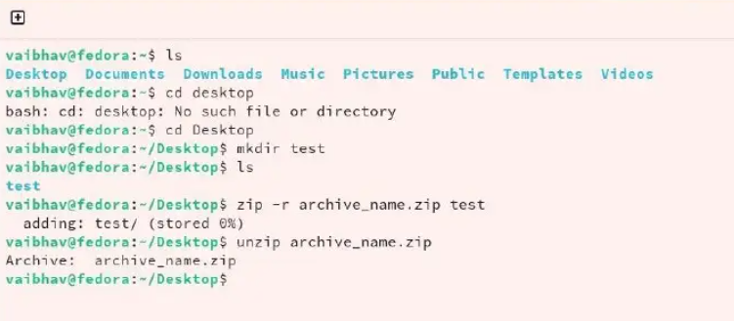
Compress the test_dir directory into a file named test_dir.zip using zip –
zip -r test_dir.zip test_dir
Explanation of the command:
zip: Invokes the zip utility.
-r: This option stands for "recursive" and is necessary to include the specified directory, all its subdirectories, and files within the archive.
test_dir.zip: The name you are giving to the resulting zip archive file.
test_dir: The name of the source directory you want to compress.
Unzip test_dir.zip into a new directory named unzipped_dir.
unzip test_dir.zip -d unzipped_dir
Explanation of the command:
unzip: The command used to extract files.
test_dir.zip: The source file.
-d: Flag to specify the destination directory.
unzipped_dir: The target directory name.

- Downloading Files
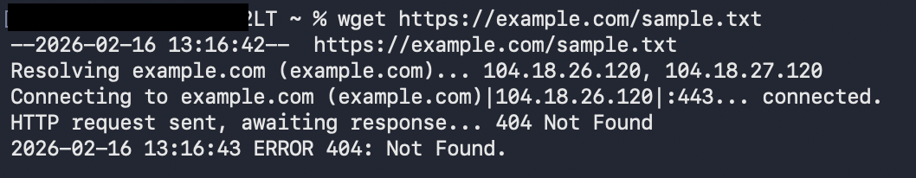
Wget – Download files from internet.
- Changing Permissions.

Create a file named secure.txt and change its permissions to read-only for everyone using chmod.
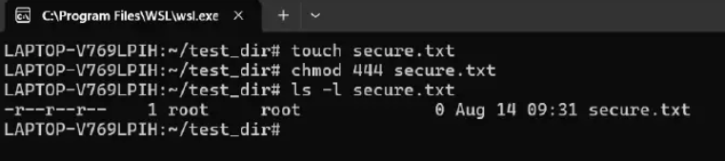
touch secure.txt – Creates an empty file.
chmod 444 secure.txt – Sets permission to read only for owner, group and others.
4 = Read, 2 = Write, 1 = Execute.

- Working with Environment Variables
Use export to set a new environment variable called MY_VAR with the value "Hello, Linux!".
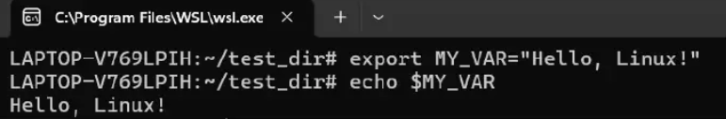
export MY_VAR="Hello, Linux!" – Creates an environment variable named MY_VAR with the value “Hello, Linux!”.
echo $MY_VAR – Display the value of MY_VAR.

